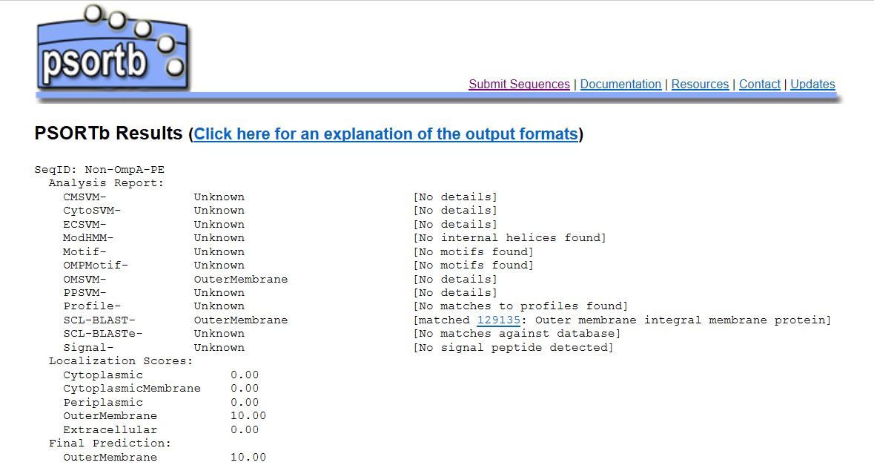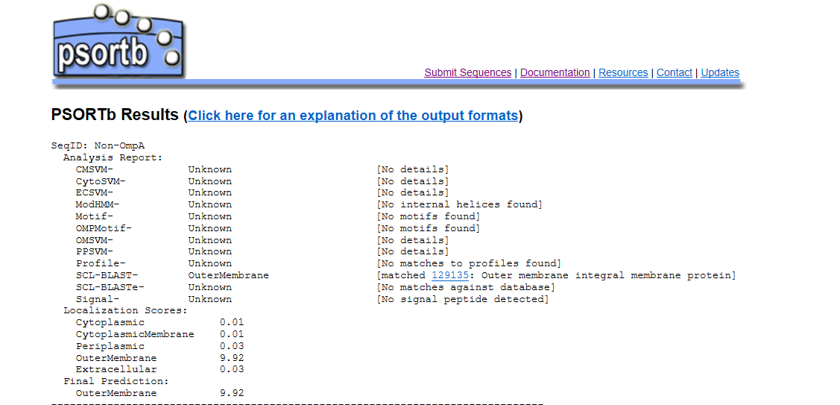

Fig. 1 Results of subcellular localization prediction of Non-OmpA and Non-OmpA-PE by PSORTb v.3.0 http://www.psort.org/psortb/index.html

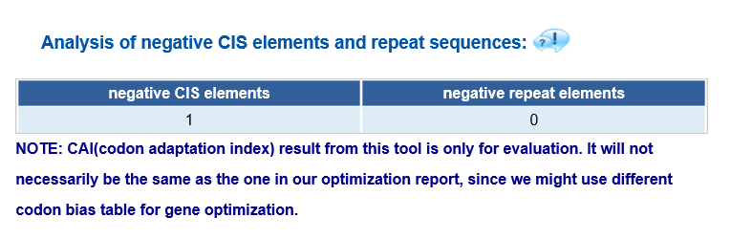
Fig. 2 Prediction of presence negative CIS elements in protein E by Genscript https://www.genscript.com/

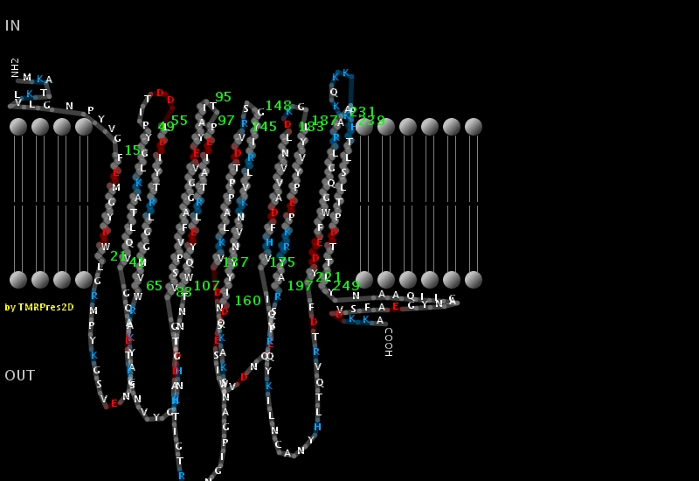

Fig. 3
Structure of Non-OmpA-PE was predicted by TMRPres2D.

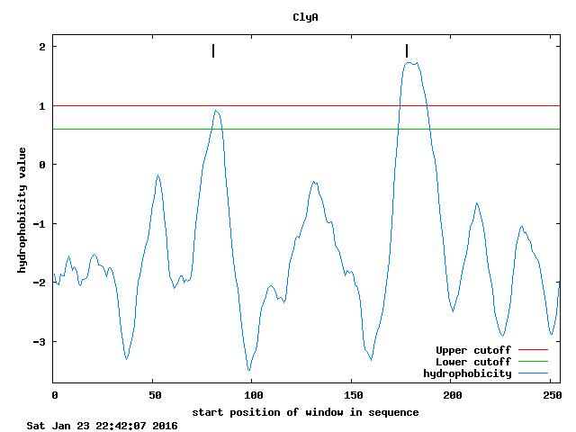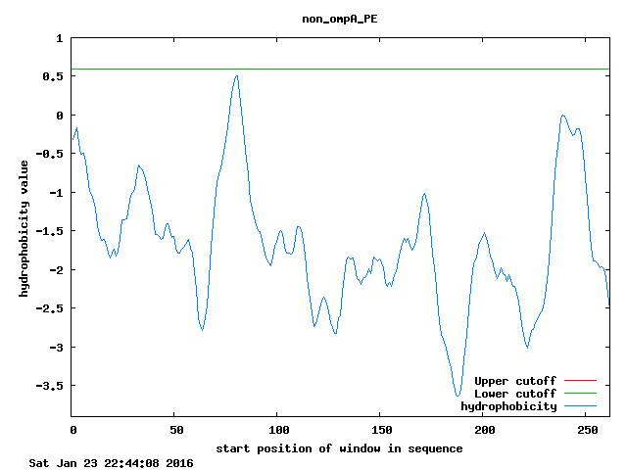

Fig. 4
Comparison of hydrophbicities of the ClyA and Non-OmpA-PE with using membrane proteins prediction program (TopPred) in N-terminal region.

