Supplementary material
AMB Express
Biotransformation of ferulic acid to protocatehuic acid by Corynebacterium glutamicum ATCC21420 engineered to express vanillate O-demethylase.
Naoko Okai¹, Takaya Masuda², Yasunobu Takeshima¹, Kosei Tanaka³, Ken-ichi Yoshida¹, Masanori Miyamoto², Chiaki Ogino⁴, and Akihiko Kondo^{1,5、＊}

¹ Graduate School of Science, Technology, and Innovation, Kobe University, 1-1 Rokkodaicho, Kobe 657-8501, Japan
² Raw Materials and Polymers Technology Department, Raw Materials and Polymers Division, Teijin Limited, 2345 Nishihabu-cho, Matsuyama-shi, Ehime, 791-8536, Japan
³ Organization of Advanced Science and Technology, Kobe University, 1-1 Rokkodaicho, Kobe 657-8501, Japan
⁴ Department of Chemical Science and Engineering, Graduate School of Engineering, Kobe University, 1-1 Rokkodaicho, Kobe 657-8501, Japan
⁵ Biomass Engineering Program, RIKEN, 1-7-22 Suehiro-cho, Tsurumi-ku, Yokohama 230-0045, Japan
* Corresponding author; Akihiko Kondo
E-mail : akondo@kobe-u.ac.jp (A. Kondo)
Tel: +81-78-803-6196; Fax: +81-78-803-6196

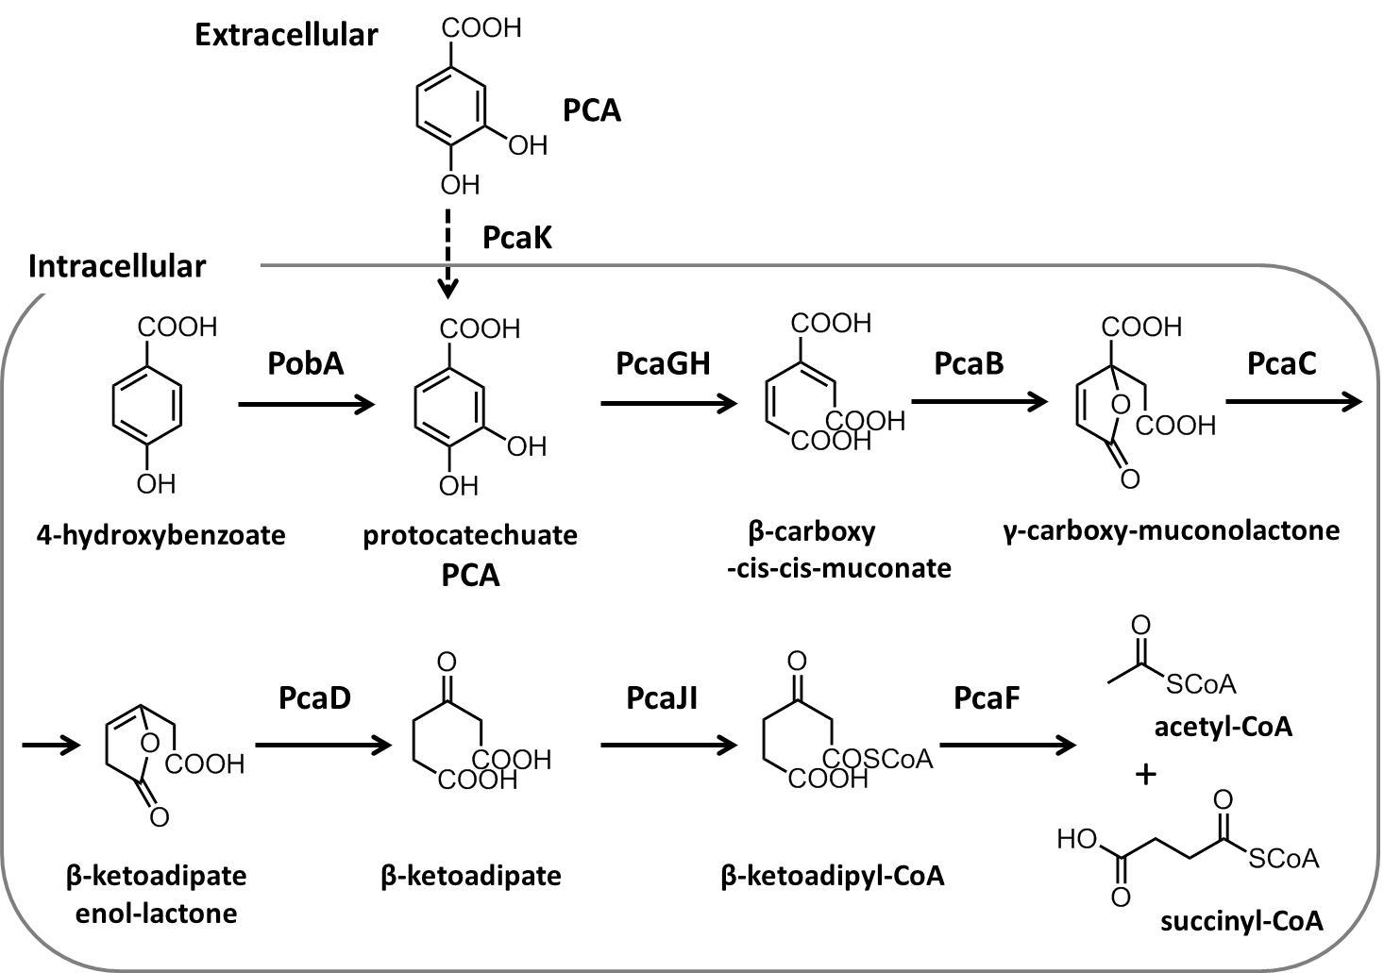
Figure S1. Catabolic pathway and PCA import system of Corynebacterium glutamicum.
The reactions of the beta-ketoadipate pathway and PCA transporter in C. glutamicum. 4-Hydroxybenzoic acid (HBA) is converted to PCA by the reaction of 4-HBA hydroxylase (PobA). Extracellular PCA is imported by PcaK in the type strain. PCA is then catabolized to the TCA cycle intermediates acetyl-CoA and succinyl-CoA via the β-ketoadipate pathway catalyzed by PCA enzymes.

