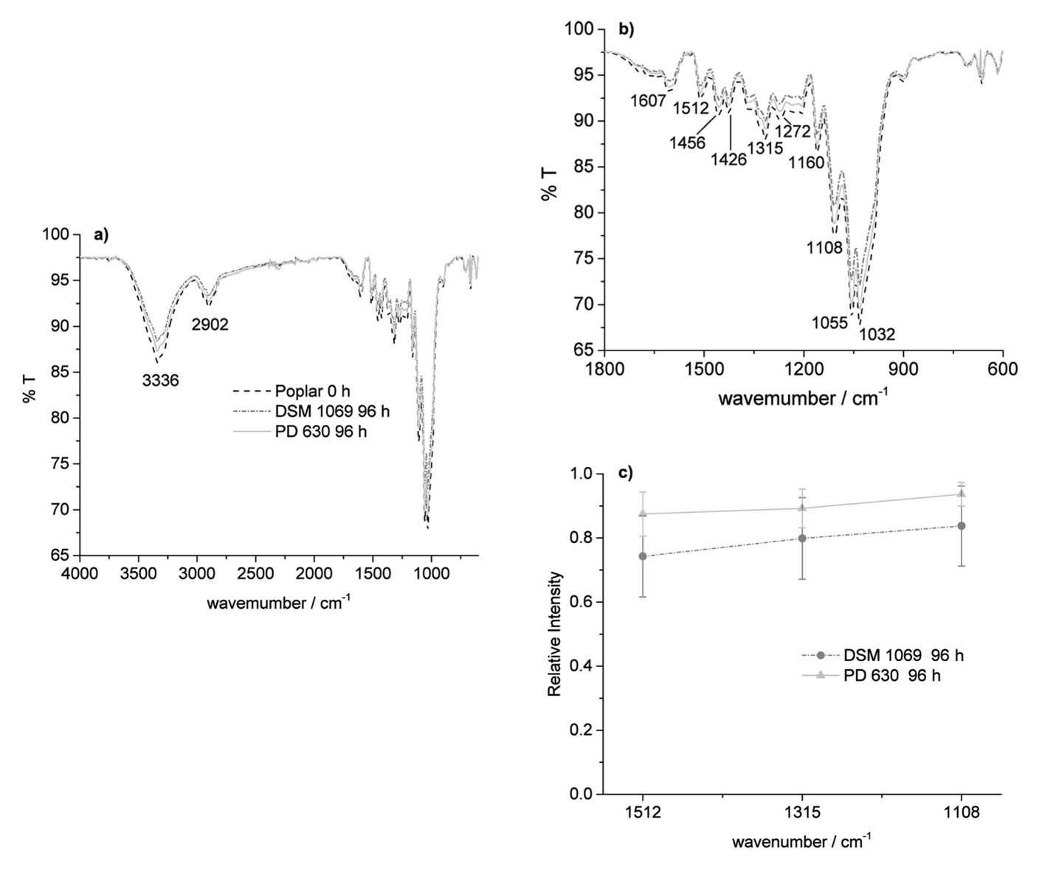
Fig. S2 a) FTIR spectra of poplar solid residue (obtained after DAP-SSF pretreatment) a) before and after treatment with two different strains of R. opacus for 96 h, (b) zoomed in fingerprint region of the spectra, and c) comparison of the relative intensity of the peaks at 1512, 1315 and 1108 cm⁻¹; each spectrum represented is the average of at least two spectra recorded for each sample

