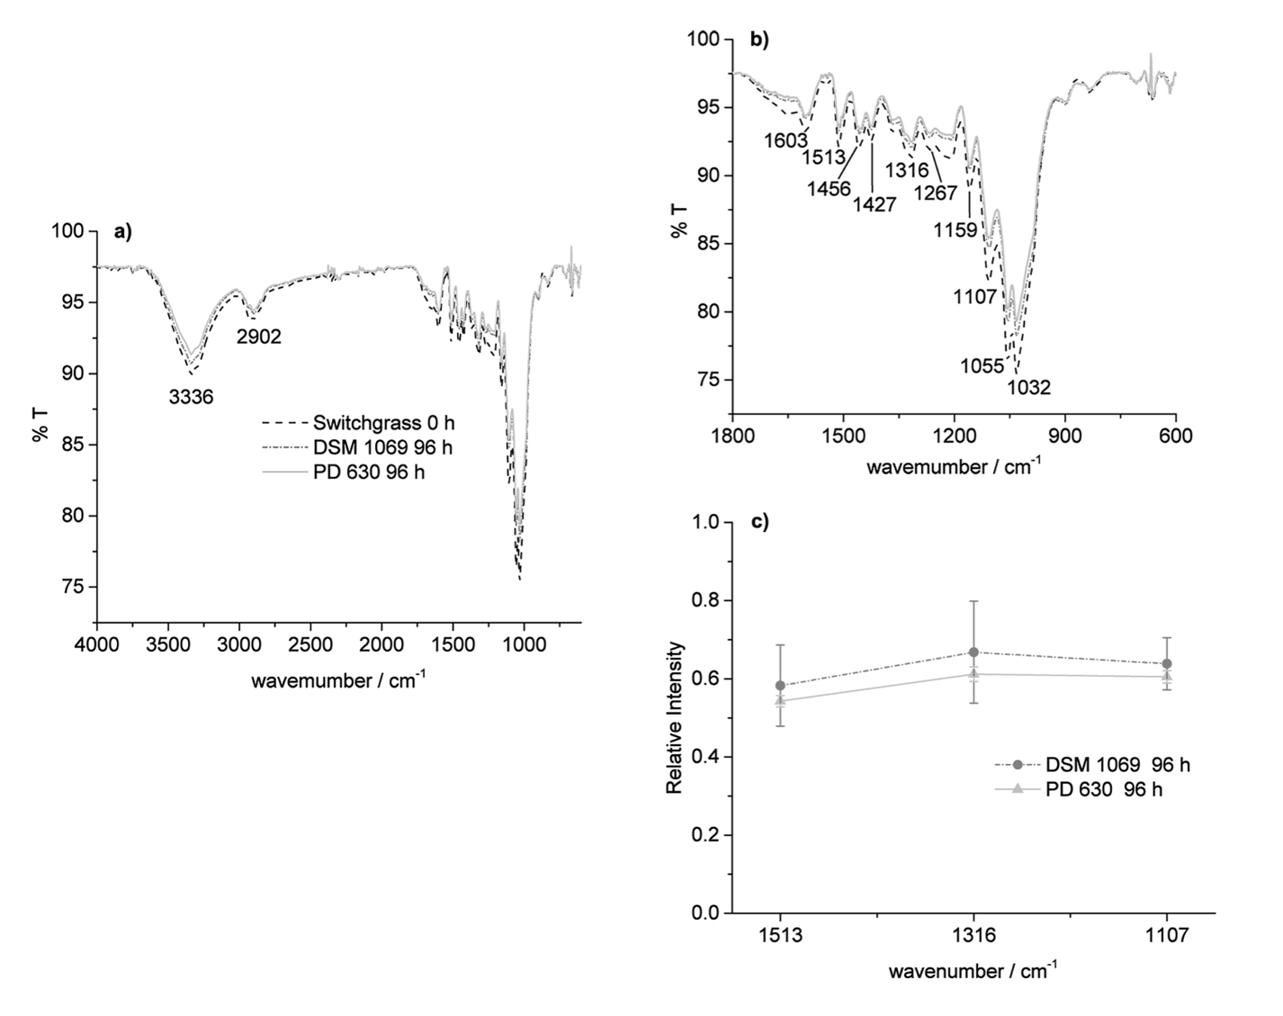
Fig. S3 FTIR spectra of switchgrass residue (obtained after DAP-SSF pretreatment) before and after treatment with two different strains of R. opacus for 96 h, b) zoomed in fingerprint region of the spectra, and c) comparison of the relative intensity of the peaks at 1513, 1316 and 1107 cm⁻¹; each spectrum represented is the average of at least two spectra recorded for each sample

