Additional data

AMB Express

Complete conversion of all typical glycosylated protopanaxatriol ginsenosides to aglycon protopanaxatriol by β-glycosidases from Dictyoglomus turgidum and Pyrococcus furiosus

Eun-Joo Yang , Tae-Hun Kim , Kyung-Chul Shin , Deok-Kun Oh

Corresponding author: D.-K. Oh
Department of Bioscience and Biotechnology, Konkuk University, Seoul 05029, Republic of Korea, E-mail: deokkun@konkuk.ac.kr, Tel.: +82-2-454-3118; Fax: +82-2-444-5518

a
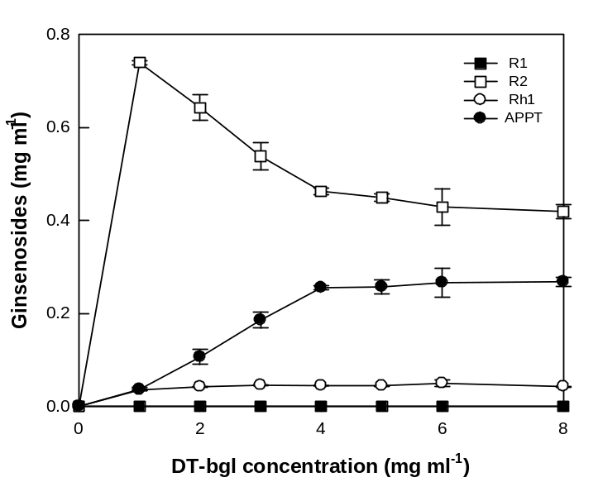

b
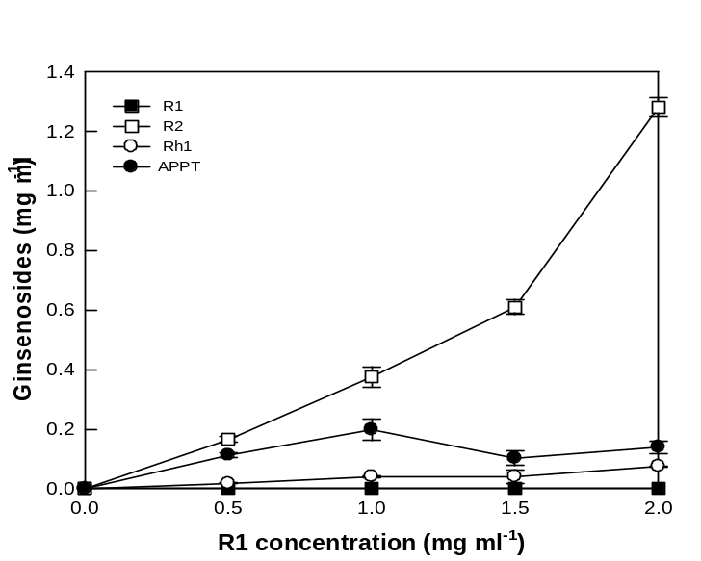
Fig. S1 Effects of enzyme and substrate concentrations on the production of APPT from ginsenoside R1 as a substrate by DT-bgl. a Effect of enzyme concentration. The reactions were performed at 80°C in 50 mM citrate/phosphate buffer (pH 6.0) containing R1 and 4.0 mg ml⁻¹ DT-bgl for 1.5 h. b Effect of substrate concentration. The reactions were performed at 80°C in 50 mM citrate/phosphate buffer (pH 6.0) containing 1.0 mg ml⁻¹ R1 and DT-bgl for 1.5 h. Data represent the means of three experiments, and error bars represent the standard deviation.
a
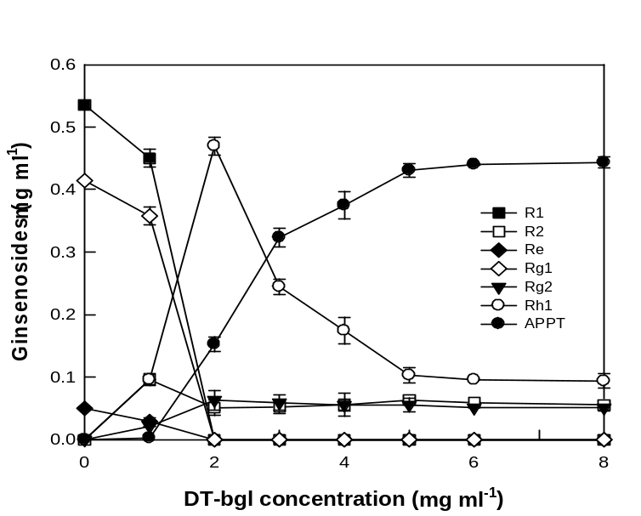
b
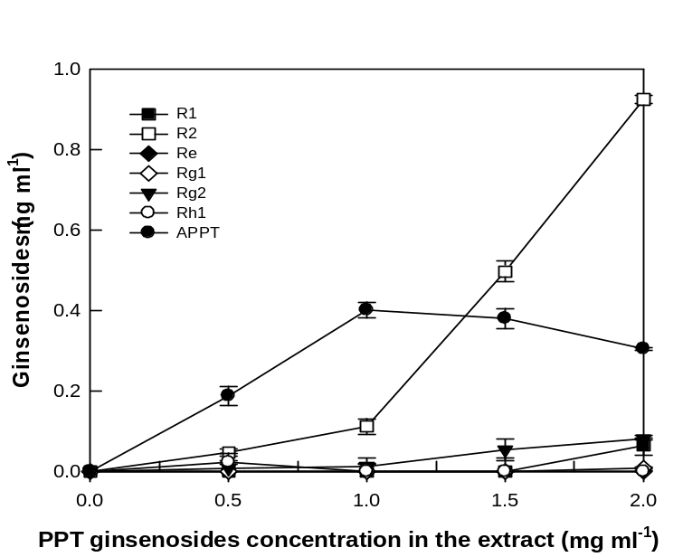
Fig. S2 Effects of enzyme and substrate concentrations on the production of APPT from total PPT-type ginsenosides in notoginseng root extract as a substrate by DT-bgl. a Effects of enzyme concentration. The reactions were performed at 80°C in 50 mM citrate/phosphate buffer (pH 6.0) containing 1.0 mg ml⁻¹ total PPT-type ginsenosides and 4.0 mg ml⁻¹ DT-bgl for 5 h. b Effect of substrate concentration. The reactions were performed at 80°C in 50 mM citrate/phosphate buffer (pH 6.0) containing total PPT-type ginsenosides and 4.0 mg ml⁻¹ DT-bgl for 5 h. Data represent the means of three experiments, and error bars represent the standard deviation.
a
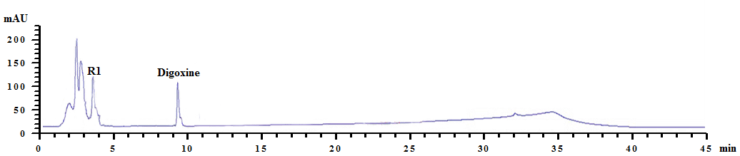
b
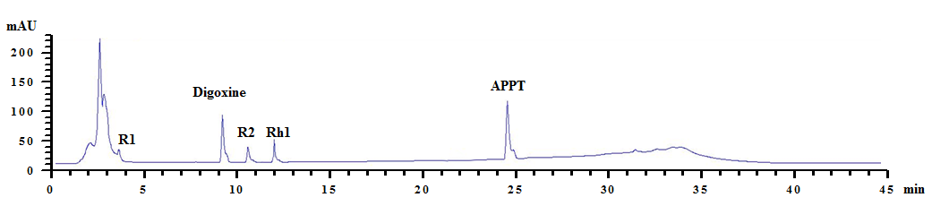
c
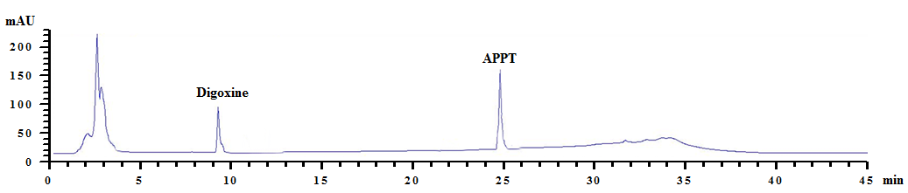

Fig. S3 HPLC profiles during the conversion of ginsenoside R1 to APPT using DT-bgl combined with PF-bgl. a 0 h. The ginsenoside R1 peak represents a single substrate. b 2 h. The ginsenoside R2, Rh1, and APPT peaks represent two intermediates and a product, respectively. c 4 h. The APPT peak represents a single product.

a
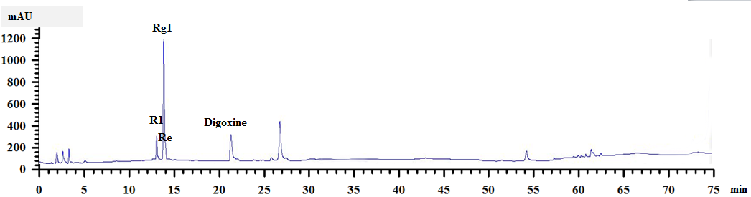
b
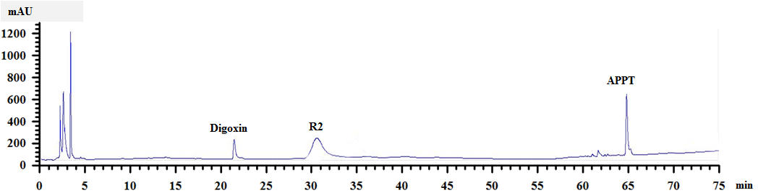
c
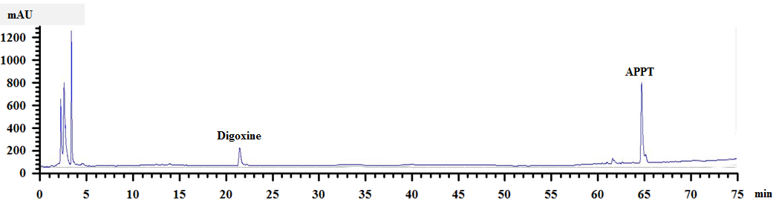

Fig. S4 HPLC profiles during the biotransformation of notoginseng root extract by DT-bgl combined with PF-bgl. a 0 h. Notoginseng was contained the R1, Re and Rg1 peaks. b 2 h. The ginsenoside Rg2 and APPT peaks represent intermediates and a product, respectively. c 3 h. The APPT peak represents a single product.

a
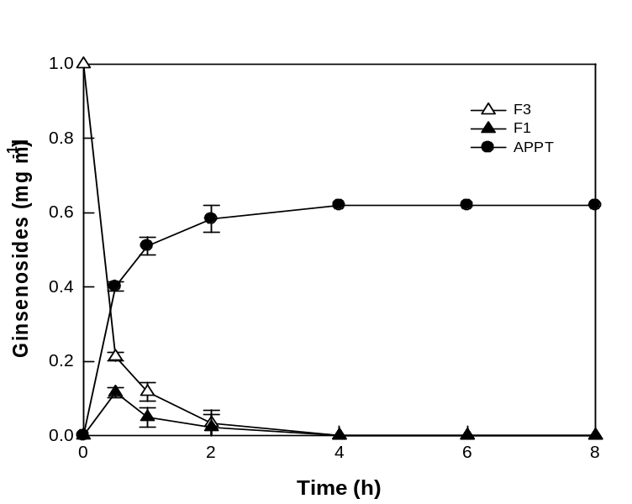

b
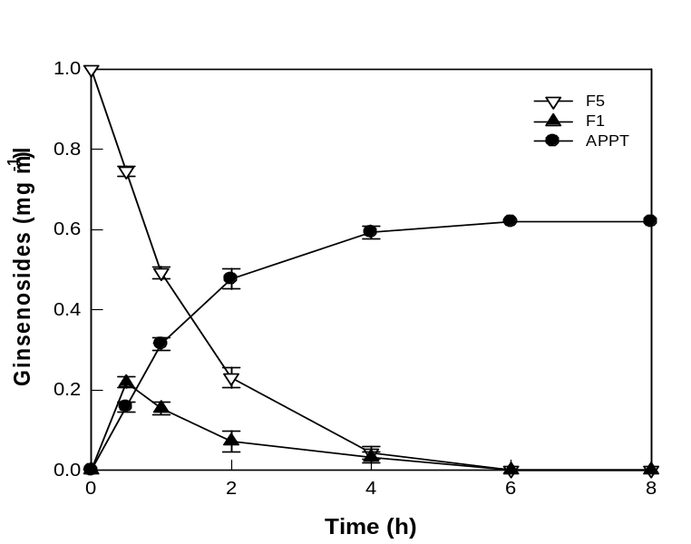

Fig. S5 Time-course reactions for the biotransformations of ginsenosides F3 and F5 as substrates to APPT by DT-bgl combined with PF-bgl. The reactions were carried out with 1.0 mg ml⁻¹ F3 or F5, 4.0 mg ml⁻¹ DT-bgl, and 5 µg ml⁻¹ PF-bgl for 5 h. a Time-course reactions for the biotransformation of ginsenoside F3. b Time-course reactions for the biotransformation of ginsenoside F5. Data represent the means of three experiments, and error bars represent the standard deviation.

