Additional file

AMB Express

In-situ Electrochemical Analysis of Microbial Activity

Ariane L. Martin¹, Pongsarun Satjaritanun², Sirivatch Shimpalee², Blake A. Devivo², John Weidner², Scott Greenway⁴, J. Michael Henson¹ and Charles E. Turick^{3*}

¹ Department of Biological Sciences, Life Sciences Facility, Clemson University,
Clemson, SC USA

² Department of Chemical Engineering and Computing, 541 Main Street
Columbia, University of South Carolina, Columbia, SC, USA

³Savannah River National Laboratory, Environmental Science and Biotechnology,
Aiken, SC, USA

⁴Savannah River Consulting, 301 Gateway Drive, Aiken, SC, USA

* Corresponding author: Phone: (803) 507-2714, e-mail: charles.turick@srnl.doe.gov

Fig. S1 Voltammograms of C. phytofermentans during growth. Reduction peaks were evident in the presence of C. phytofermentans during growth with variations in the peak current throughout the growth cycle. Insets demonstrate the part of the growth curve that the CVs represent.

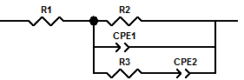
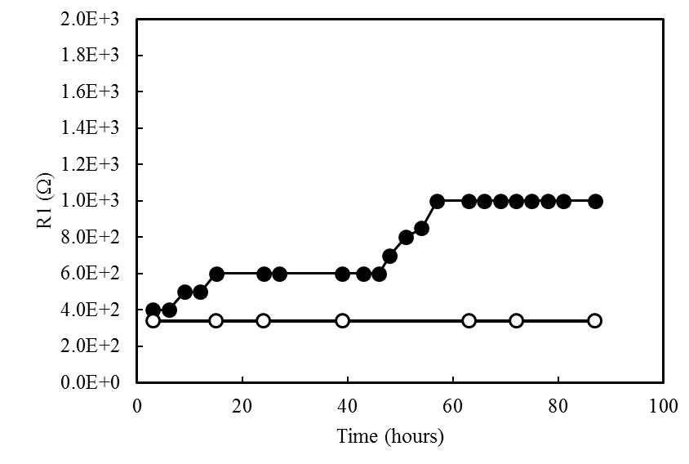

Fig S2. Changes in R1 during growth of C. phytofermentans (black circles) relative to abiotic controls (white circles).

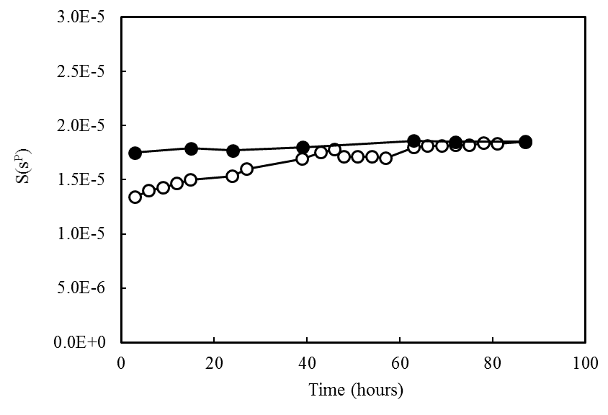

Fig. S3. Changes in CPE-1 and CPE-2 during growth of C. phytofermentans (black circles) relative to abiotic controls (white circles).

