Comparative analysis of the intestinal bacterial community and expression of gut immunity genes in the Chinese Mitten Crab (Eriocheir sinensis)

Jing Dong, Ruiyang Zhang, Yingying Zhao, Gaofeng Wu, Jinling Liu, Xiaochen Zhu, Lin Li*, Xiaodong Li*

Liaoning Provincial Key Laboratory of Zoonosis, College of Animal Science & Veterinary Medicine, Shenyang Agricultural University, Shenyang, Liaoning, 110866, P.R. China.

*Corresponding authors:
Lin Li: lilin619619@163.com, Fax: 86-88487156, Tel.:86-13840169129;
Xiaodong Li: lxd001@ceraap.com, Fax: 86-88487156, Tel.:86-13700072918

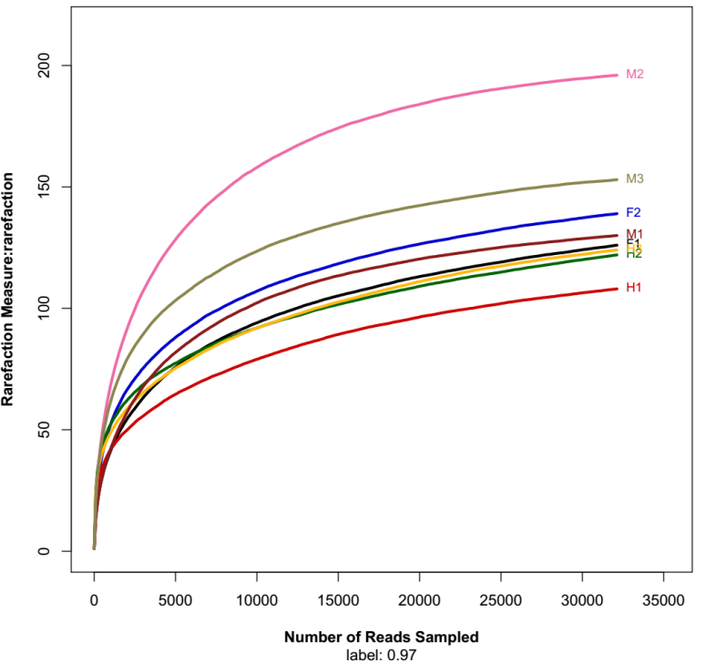
Fig. S1 Rarefaction analysis of microbiota from foregut (F1, F2), midgut (M1, M2, M3) and hindgut (H1, H2, H3).Operational taxonomic units (OTUs) were classified based on 97% sequence similarity. The rarefaction curves for all samples reached the near plateau phase, suggesting good sampling depth.

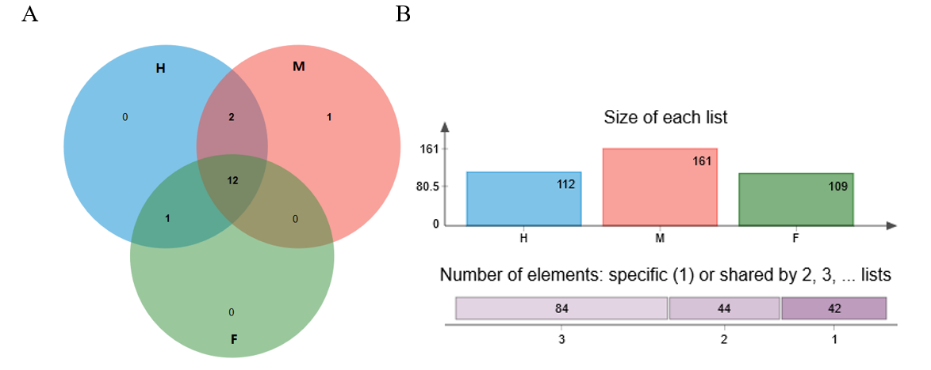
Fig. S2 Venn diagram of the phylum (A) and the genus level (B) bacterial 16S rRNA gene metagenomic data sets from the digestive tract of crabs at 97% similarity. F, M and H indicate foregut, midgut and hindgut, respectively.

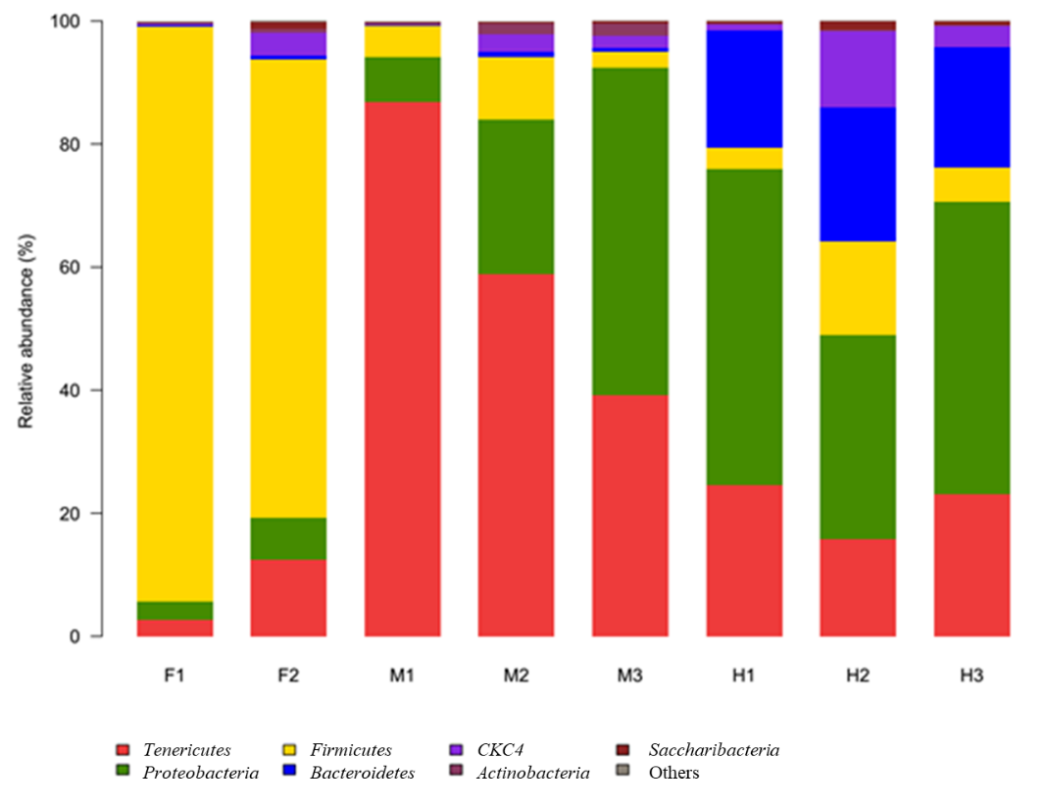
Fig. S3 The relative abundance of phylum in the composition of digestive tract-associated microbiota of crabs. F: foregut, M: midgut, H: hindgut.

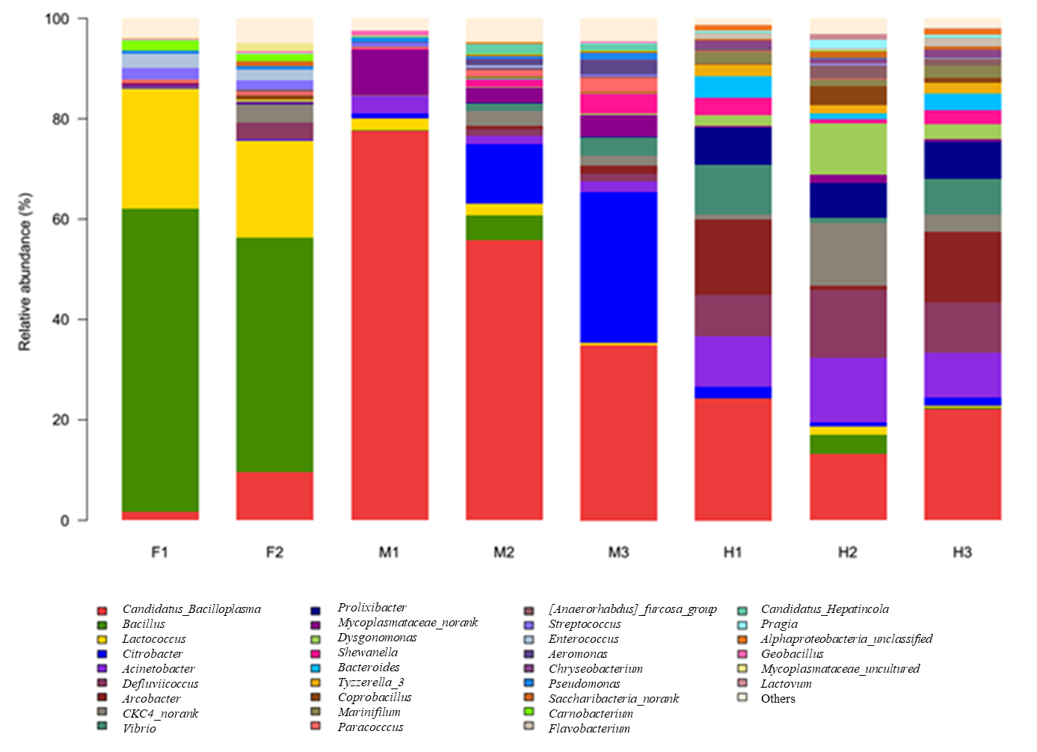

Fig. S4 The relative abundance of genus level in the composition of digestive tract-associated microbiota of crabs. F: foregut, M: midgut, H: hindgut.

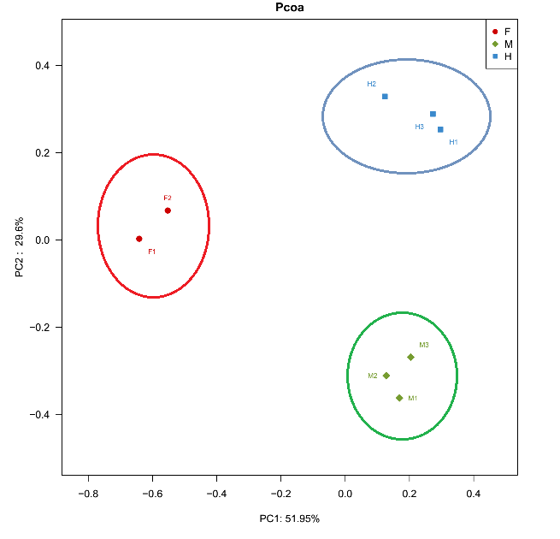
Fig. S5 Principal coordinate analysis (PCoA) of bacterial communities in the digestive tract samples. F: foregut, M: midgut, H: hindgut.

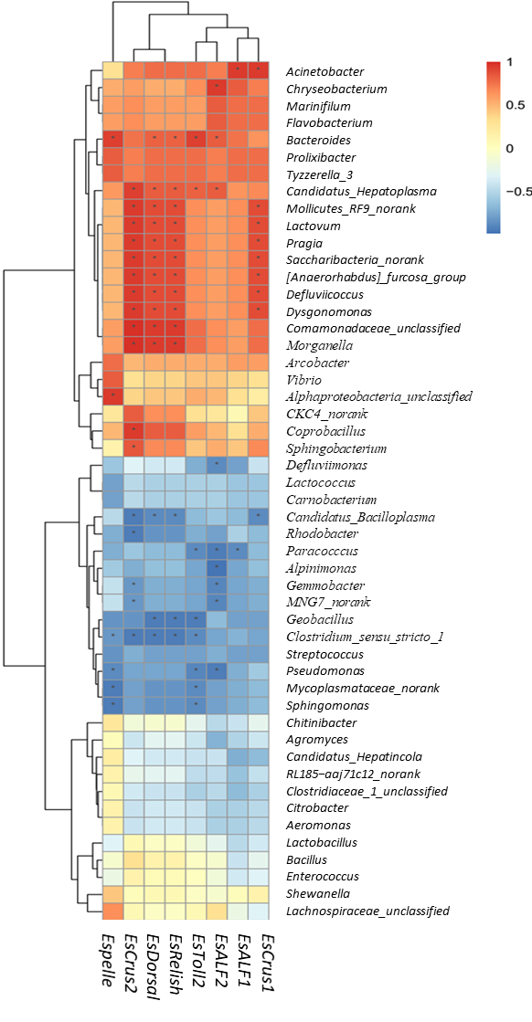
Fig. S6 Correlation analyses between intestinal microbiota (at the genus level) and the levels of gut immune genes expression. Only the predominant bacterial genera (relative abundance ≥ 1 % in at least one sample) for which abundance was signifcantly associated with eight immune genes expression are presented. R values are correlation coefficient shown in different colors in the figure, the red color represents a positive correlation, the blue color represents a negative correlation. P < 0.05 *.

Table S1 Primers used for quantitative real-time PCR analysis
Gene Name | Forward and Reverse Sequences | Amplicon Size, bp | Effeciency % | accession numbers | Reference
EsToll2 | F: CATACCAGGACGACGAAC | 135 | 101 | KC011816 | This study
EsToll2 | R: AGACATTGAGCGAGGAGA | 135
EsPelle | F: TAAGCCAGCAAACAACGGAGCA | 246 | 95 | KP795393 | Huang et al., 2015
EsPelle | R: GAGTCACAGGCAAAGAAGGGGA | 246
EsDorsal | F: CGTCAGCAGCACAGCAGAGAAT | 273 | 105 | KC900086 | Yu et al., 2013
EsDorsal | R: CCCGTATTTCCTCCCTCAACTTCAG | 273
EsRelish | F: TCTCCCTACTCTGACCATTCC | 163 | 101 | GQ871279 | Li et al., 2013
EsRelish | R: TTCCCACCATCTCACTCTTGT | 163
EsALF1 | F: GACGCAGGAGGATGCTAAC | 107 | 100 | DQ793214 | Huang et al., 2015
EsALF1 | R: TGATGGCAGATGAAGGACAC | 107
EsALF2 | F: GACCCTTTGCTGAATGCTTGA | 125 | 102 | GU014699 | Huang et al., 2015
EsALF2 | R: CTGCTCTACAATGTCGCCTGA | 125
EsCrus1 | F: GCTCTATGGCGGAGGATGTCA | 115 | 104 | GQ200832 | Huang et al., 2015
EsCrus1 | R: CGGGCTTCAGACCCACTTTAC | 115
EsCrus2 | F: GCCCACCTCCCAAACCTAT | 201 | 103 | GQ200833 | Huang et al., 2015
EsCrus2 | R: GCAAGCGTCACAGCAGCACT | 201
Es-β-Actin | F: GCATCCACGAGACCACTTACA | 265 | 102 | HM053699 | Yu et al., 2013
Es-β-Actin | R: CTCCTGCTTGCTGATCCACATC | 265

Primers references
Huang Y, Chen YH, Zhang YZ, Feng JL, Zhao LL, Zhu HX, Wang W, Ren Q (2015) Identification, characterization, and functional studies of a Pelle gene in the Chinese mitten crab, Eriocheir sinensis, Fish Shellfish Immunol 45:704-716
Yu AQ, Jin XK, Li S, Guo XN, Wu MH, Li WW, Wang Q (2013) Molecular cloning and expression analysis of a dorsal homologue from Eriocheir sinensis. Dev Comp Immunol 41:723-727
Li F, Wang L, Zhang H, Zheng P, Zhao J, Qiu L, Zhang Y, Song L (2010) Molecular cloning and expression of a Relish gene in Chinese mitten crab Eriocheir sinensis. Int J Immunogenet 37:499-508

Table S2 Effects of foregut (F), midgut (M) and hindgut (H) on the diversity of digestive tract bacterial community at the 3% dissimilarity level. Values shown are means ± SEM, the same column with different letters indicate significantly different (P<0.05).
 | OTU | ACE | Chao | Shannon | Simpson
F | 130.33±3.79^{ab} | 147.33±1.53ª | 151.00±6.56ª | 1.37±0.15ª | 0.50±0.09ª
M | 161.67±29.48^{b} | 177.00±23.81^{b} | 179.33±18.15^{b} | 2.30±0.14^{b} | 0.24±0.04^{b}
H | 116.67±8.08ª | 140.67±9.45ª | 133.33±8.96ª | 2.88±0.16^{c} | 0.09±0.02^{c}

