Additional file 1:
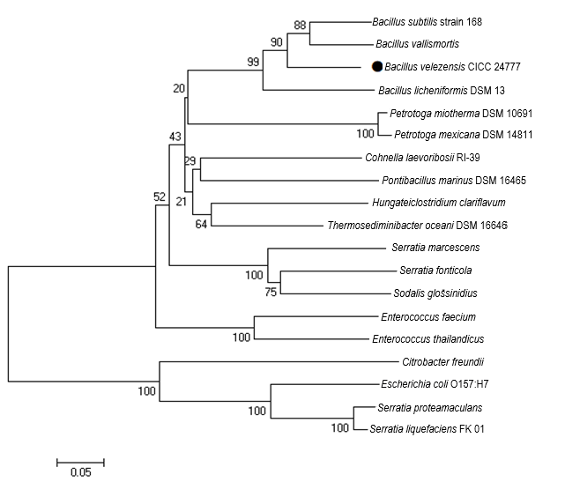
Fig S1. The phylogenetic tree analysis of D-lyxose isomerases of 19 amino acid sequences. Numbers on nodes represent percentage bootstrap values for 1000 replicates. Bacillus subtilis strain 168 D-LI (GenBank ID: AIY91703); Bacillus vallismortis D-LI (NCBI reference sequence: WP_010330845.1); Bacillus licheniformis DSM 13 D-LI (GenBank ID: AAU22106.1); Petrotoga miotherma DSM 10691 D-LI (GenBank ID: PNS01248.1); Petrotoga mexicana DSM 14811 D-LI (GenBank ID: PNR99621.1); Cohnella laevoribosii RI-39 D-LI (GenBank ID: ABI93960.1); Pontibacillus marinus DSM 16465 D-LI (GenBank ID: KGX84558.1); Hungateiclostridium clariflavum D-LI: (NCBI reference sequence: WP_014255395.1); Thermosediminibacter oceani DSM 16646 D-LI (GenBank ID: ADL08607.1); Serratia marcescens D-LI (GenBank ID: BBG69721.1); Serratia fonticola D-LI (NCBI reference sequence: WP_021178408.1); Sodalis glossinidius D-LI (NCBI reference sequence: WP_011410362.1); Enterococcus faecium D-LI (GenBank ID: SJX71758.1); Enterococcus thailandicus D-LI (GenBank ID: OJG94896.1); Citrobacter freundii D-LI (GenBank ID: GCB41955.1); Escherichia coli O157:H7 D-LI (GenBank ID: Q8X5Q7); Serratia proteamaculans D-LI (GenBank ID: BAJ07463.1); Serratia liquefaciens FK 01 D-LI (GenBank ID: GAK25190.1). ● For this study.

Fig. S2 Multiple alignment of the amino acid sequences of BvLI and other D-LIs from various microbiology. According to complex structure of E. coli D-LI bound to D-fructose (PDB no. 3MPB), (△) the residues involved in the substrate binding sites; (○) the residues involved in the metal coordination and substrate binding sites. ECLI: E. coli O157:H7 D-LI (GenBanK ID: Q8X5Q7); SpLI: Serratia proteamaculans KCTC 2936 D-LI (GenBanK ID: BAJ07463.1); PsLI: Providencia stuartii KCTC 2568 D-LI (GenBanK ID: EDU58657); DtLI: Dictyoglomus turgidum DSM 6724 D-LI (GenBanK ID: YP_002352606.1); ClLI: Cohnella laevoribosii RI-39 D-LI (GenBanK ID: ABI93960.1); ToLI: Thermosediminibacter oceani DSM 16646 D-LI (GenBanK ID: ADL08607.1); BlLI: Bacillus licheniformis DSM 13 D-LI (GenBanK ID: AAU22106.1); BsLI: Bacillus subtilis strain 168 D-LI (GenBanK ID: AIY91703); BvLI: Bacillus velezensis D-LI (GenBanK ID: MK836420). The alignment was performed by using ESPript (http://espript.ibcp.fr/ESPript/ESPript/).

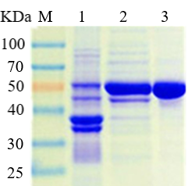
Fig. S3 SDS-PAGE analysis of purified recombinant BlAI. Lane M: protein marker; Lane 1, induced cell debris; Lane 2: crude extract of induced cell lysate; Lane 3: purified recombinant BlAI.

Fig. S4 The effects of Co²⁺ and Mn²⁺ concentration on the activity of recombinant BvLI. Data represent the mean±standard deviation from triplicate experiments.

Table S1. Comparsion of K_{cat} of various D-LIs.
Origins | K_{cat} (min⁻¹)  D-lyxose D-mannose L-ribose |  |  | References
Cohnella laevoribosii  RI-39 | 114,120 | 2766 | 1584 | Cho et al. (2007)
Providencia stuartii  KCTC 2568 | 1,880,400 | 158,400 | NR | Kwon et al. (2010)
Serratia proteamaculans KCTC 2936 | 1,848,600 | 970,200 | NR | Park et al. (2010a)
Escherichia coli O157:H7 | 822 | 762 | NR | Van et al. (2010)
Bacillus licheniformis DSM 13 | 5880 | 2580 | NR | Patel et al. (2011)
Dictyoglomus turgidum  DSM 6724 | 3570 | 178 | NR | Choi et al. (2012)
Thermosedimini-  bacter oceani DSM 16646 | 3108 | 5686 | NR | Yu et al. (2016)
Bacillus velezensis CICC 24777 | 1335.89 | 1213.46 | 975.45 | This study
NR Not reported

