Additional file to submission to:
AMB Express

Manuscript title:
Identification of genes involved in xylose metabolism of Meyerozyma guilliermondii and their genetic engineering for increased xylitol production

Author information:
Denise Atzmüller¹, Nadine Ullmann², Alexander Zwirzitz^{1, *}
¹ University of Applied Sciences Upper Austria, Stelzhamerstraße 23, 4600 Wels, Austria
² Austrian Biotech University of Applied Sciences, Konrad-Lorenz-Straße 10, 3430 Tulln, Austria
* corresponding author: alexander.zwirzitz@fh-wels.at, phone: +43 50804 44479, fax: +43 5080 944463 ORCID: 0000-0002-0703-0005

Additional file 1: Figure S1
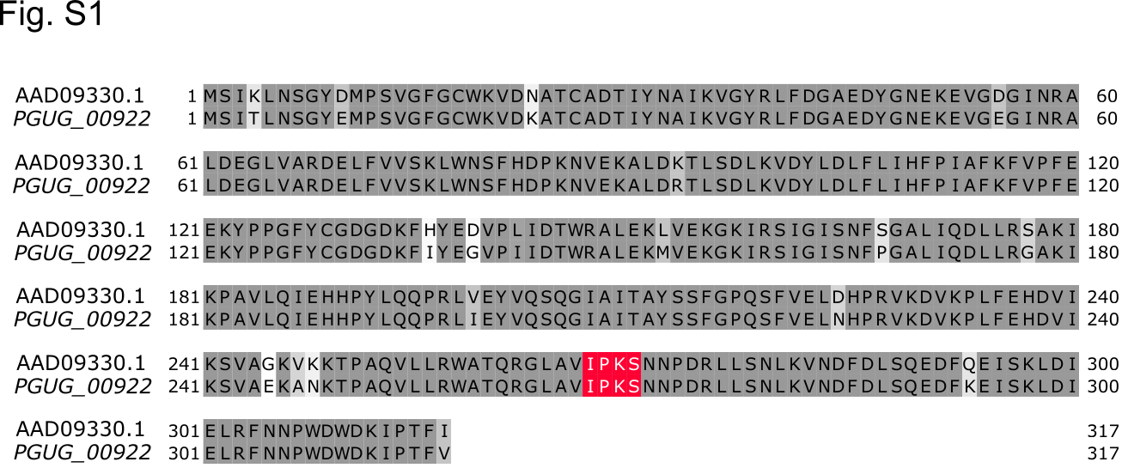
Fig. S1 – Amino acid sequence alignment with the previously identified M. guilliermondii XYL1 gene
Amino acid alignment of M. guilliermondii PGUG_00922 with the previously identified XYL1 gene. Identical amino acids are marked in grey, similar amino acids in light grey, and different amino acids are unmarked (white). The conserved IPKS sequence motif that determines co-factor specificity is marked in red

Additional file 1: Figure S2
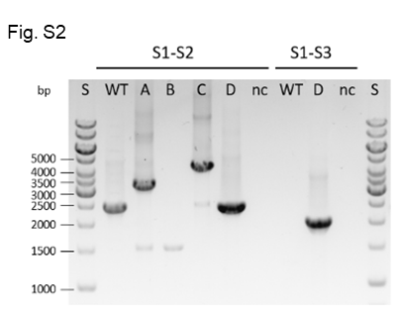
Fig. S2 - Confirmation of XDH1 gene knockout
Verification of xdh1-knockout by PCR amplification with primer S1-S2 and S1-S3 from isolated genomic DNA; S1-S2 2.5 kb for WT (KU141F1), 3.3 kb for A (xdh1∆::URA5), 1.5 kb for B (xdh1Δ), 4.3 kb for C (xdh1∆::XYL1-URA5), 2.5 kb for D (xdh1∆::XR), no band for nc (negative control = without template); S1-S3 2.0 kb for D (xdh1∆::XR), no band for WT (KU141F1) and nc (negative control = without template) and; S: Size standard; The binding sites of primers S1, S2 and S3 are indicated in Fig. 2

Additional file 1: Table S1
Table S1 - primers used in this study
# | Name | Sequence (5’-3’) | Restriction sites
P1 | ApaI-XDHup_F | AATGGGCCCCCCGGGACTTGACCAGCCC | ApaI
P2 | XDHup-BamHI_R | AATGGATCCGAACAGAGTTCCTACAGCTATTACTACGGC | BamHI
P3 | XDHdown-BglII_F | ATTAAGATCTTTCACTTCACCATCATGTCG | BglII
P4 | XDHdown-XhoI_R | AATACTCGAGATACGACAAATTATCTTGCCAGATGACTT | XhoI
P5 | PstI-XR_F | AATCTGCAGATGTCTATTACTTTGAACTCAG | PstI
P6 | XR-BamHI_R | AATGGATCCTTACACAAAAGTTGGAATCTTG | BamHI
P7 | pU-KO_F | GTGAATTGTAATACGACTCAC | -
P8 | pU-KO_R | AGGAAACAGCTATGACCATG | -
P9 | BamHI-XR_F | AATGGATCCATGTCTATTACTTTGAACTCAG | BamHI
P10 | XR-NheI_R | ATTGCTAGCTTACACAAAAGTTGGAATCTTG | NheI
S1 | XDH1-KO-screen_F | CTACTTGGTGGCTTGAATATG | -
S2 | XDH1_seq_rev | CGACATGATGGTGAAGTGAA | -
S3 | REP_seq_R | GCCTCTCCACCCAAGCG | -

Table S1 - Primers used in this study
DNA sequence with highlighted restriction enzyme cleavage sites of the primers used in this study

