AMB Express

The title:
Construction of cell-plastics as neo-plastics consisted of cell-layer provided green alga Chlamydomonas reinhardtii covered by two-dimensional polymer

The full names of the authors (do not include academic degrees)
Akihito Nakanishi*^{†1,2}, Kohei Iritani* ³, Yuri Sakihama⁴, Nanami Ozawa², Ayano Mochizuki², Marina Watanabe²
(*Co-first author, †corresponding author)

The author's institutional affiliations where the work was conducted
¹Graduate School of Bionics, Tokyo University of Technology, Hachioji, Japan
²School of Bioscience and Biotechnology, Tokyo University of Technology, Hachioji, Japan
³Department of Applied Chemistry, School of Engineering, Tokyo University of Technology, Hachioji, Japan
⁴Tokyo University of Technology, Hachioji, Japan

Address correspondence to:
A. Nakanishi
Graduate School of Bionics, Tokyo University of Technology,
School of Bioscience and Biotechnology, Tokyo University of Technology
1404-1 Katakuramachi
Hachioji, Tokyo, 192-0982, Japan
Phone: +81 42-637-2427
E-mail: nakanishiah@stf.teu.ac.jp

Supplemental data
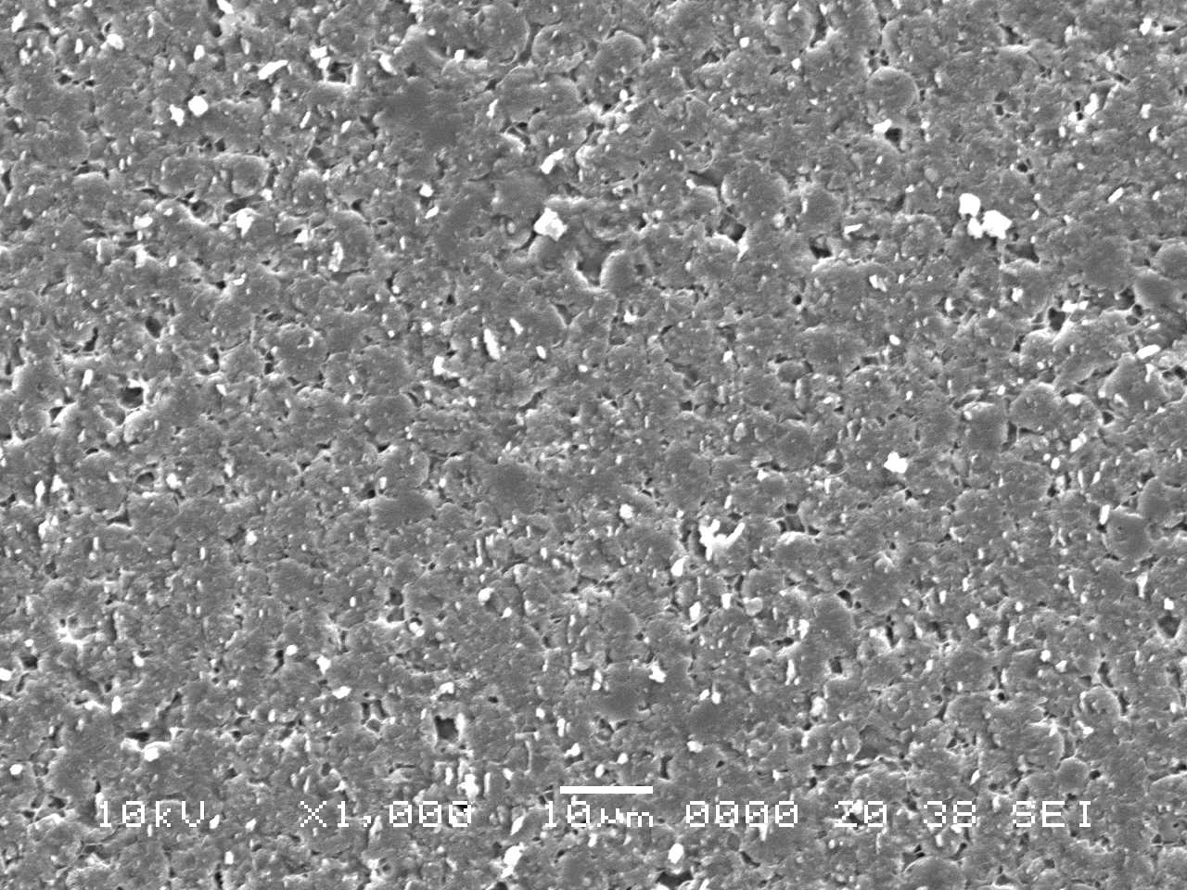
Fig. S1
SEM images of surfaces of cell-plastics without intercellular filler. Magnifications were ×1,000.

Experimental Details for Synthesis of compounds
1. General
All solvents were distilled before use. All commercially available reagents were used as received. Fig. S2 shows synthetic scheme of monomer 1. Compound 4 was prepared according to previous reports (Hosseini et al. 2016). ¹H (400 MHz) and ¹³C (100 MHz) NMR spectra were measured on a Bruker UltraShield Plus 400 spectrometer. When chloroform-d were used as a solvent, the spectra were referenced to residual solvent proton signals in the ¹H-NMR spectra (7.26 ppm) and to the solvent carbon signals in the ¹³C-NMR spectra (77.0 ppm). Figs. S3 and S4 show ¹H and ¹³C NMR spectra of compound 3 and monomer 1, respectively. Preparative HPLC separation was undertaken with a JAI LC-9204 recycling chromatographs using 600 mm × 40 mm JAIGEL-1H-40 and 2H-40 (for JAI LC-9204) GPC columns with CHCl₃ as the eluent.

2. Synthesis of monomer 1
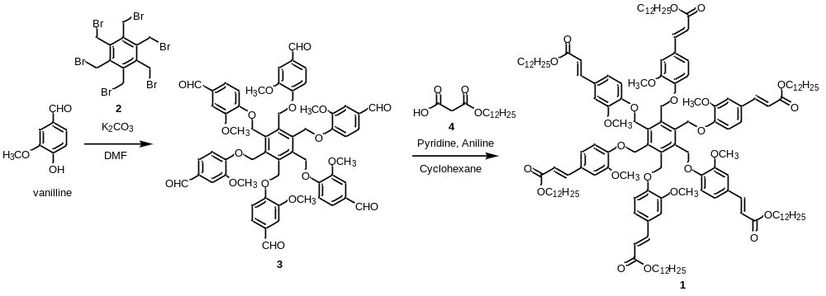
Fig. S2 Synthesis of monomer 1.

Syntheses of Compounds
Compound 3
A solution of vanilline (2.50 g, 16.4 mmol) and 2 (1.16 g, 1.82 mmol) in DMF (30 mL) was heated under 100 °C in the presence of K₂CO₃ (2.24 g, 16.2 mmol) for 24 h. After cooling to room temperature, the mixture was added to water dropwise for reprecipitation. After the filtration, compound 3 (1.86 g, 96%) was given as a light yellow solid.
¹H-NMR (400 MHz, CDCl₃, 25 °C) δ 9.83 (s, 6H), 7.38 (d, J = 1.8 Hz, 6H), 7.34 (dd, J = 8.1 Hz and 1.8 Hz, 6H), 7.03 (d, J = 8.2 Hz, 6H), 5.36 (s, 12H), 3.80 (s, 18H); ¹³C-NMR (100 MHz, CDCl₃, 25 °C) δ 190.7, 153.0, 150.2, 137.7, 131.0, 126.3, 112.9, 109.2, 65.0, 55.7.

Monomer 1
Compound 3 (249 mg, 0.234 mmol), 4 (752 mg, 2.76 mmol) were stirred in cyclohexane (2.5 mL). To the solution, pyridine (0.175 mL, 2.17 mmol) and aniline (0.250 mL, 2.74 mmol) were added. After string at 80 °C for 18 h, the mixture was added to water. The product was extracted by CH₂Cl₂. The organic phase was washed with water and brine, and dried over Na₂SO₄. After removal of the solvent under vacuum, the crude mixture was purified by preparative HPLC and reprecipitation (CH₂Cl₂/hexanes) to give 1 (268 mg, 49%) as an orange solid.
¹H-NMR (400 MHz, CDCl₃, 25 °C) δ 7.58 (d, J = 16 Hz, 6H), 7.09–6.80 (m, 18H), 6.29 (d, J = 16 Hz, 6H), 5.30 (brs, 12H), 4.26–4.06 (m, 12H), 3.71 (brs, 18H), 1.91–0.95 (m, 120H), 0.92–0.79 (m, 18H); ¹³C-NMR (100 MHz, CDCl₃, 25 °C) δ 167.1, 150.1, 144.2, 137.9, 129.1, 122.1, 116.5, 114.6, 113.6, 110.1, 65.3, 64.7, 55.5, 31.9, 29.61, 29.58, 29.5, 29.32, 29.29, 28.7, 26.0, 22.7, 14.1.

3. ¹H and ¹³C Spectra of Compounds
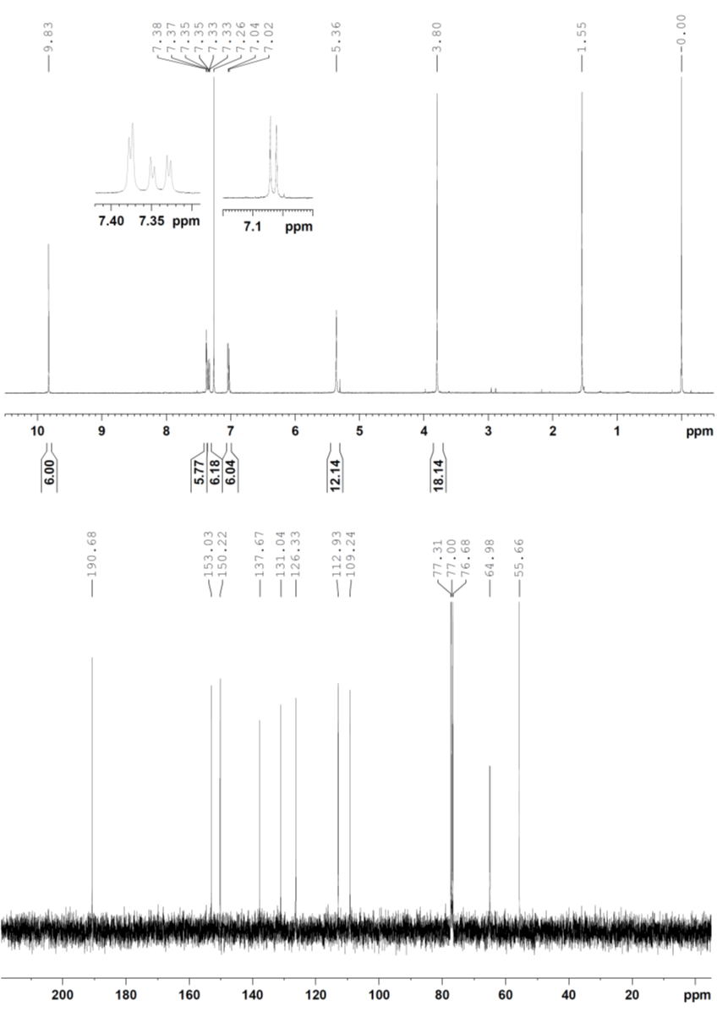
Fig. S3 ¹H and ¹³C NMR spectra of 3 in CDCl₃ at 25 °C.
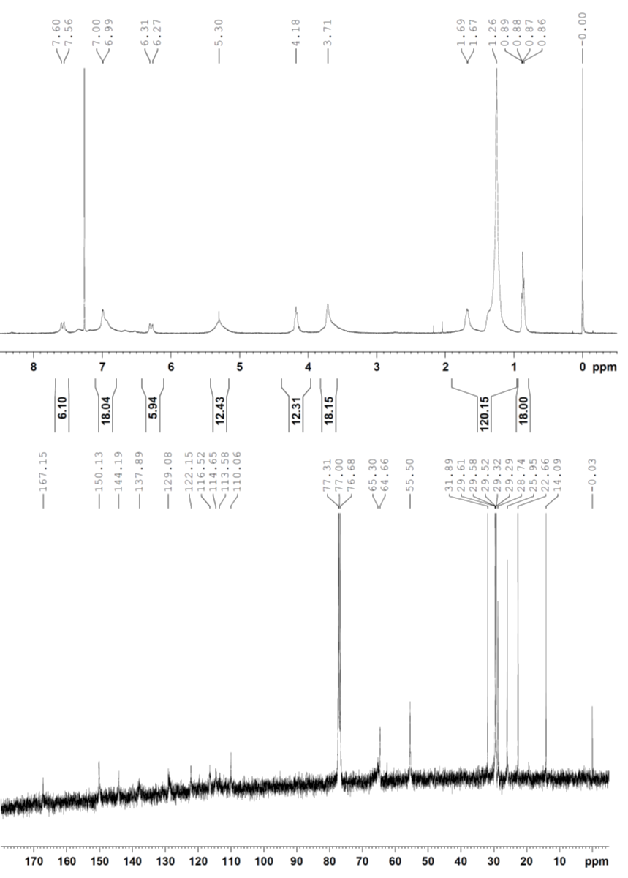
Fig. S4 ¹H and ¹³C NMR spectra of 1 in CDCl₃ at 25 °C.

Reference
Hosseini R, Moosavi F, Rajaian H, Silva T, Magalhães e Sikva D, Soares P, Saso L, Edraki N, Miri R, Borges F, Firuzi O (2016) Discovery of neurotrophic agents based on hydroxycinnamic acid scaffold. Chem Biol Drug Des 88:926-937

