Supplementary Data

AMB Express

Production of transglutaminase in glutathione-producing recombinant Saccharomyces cerevisiae

Yoko Hirono-Hara¹, Miyuu Yui¹, Kiyotaka Y. Hara^{1,2,*}

y-hirono@u-shizuoka-ken.ac.jp
miyuu2018@icloud.com
k-hara@u-shizuoka-ken.ac.jp

¹Department of Environmental and Life Sciences, School of Food and Nutritional Sciences, University of Shizuoka, 52-1 Yada, Suruga-ku, Shizuoka 422-8526, Japan
²Graduate Division of Nutritional and Environmental Sciences, University of Shizuoka, 52-1 Yada, Suruga-ku, Shizuoka 422-8526, Japan

Yoko Hirono-Hara and Miyuu Yui contributed equally to this work.

*Correspondence: Kiyotaka Y. Hara, Graduate Division of Nutritional and Environmental Sciences, University of Shizuoka, 52-1 Yada, Suruga-ku, Shizuoka 422-8526, Japan
E-mail: k-hara@u-shizuoka-ken.ac.jp
Tel/fax: +81-54-264-5659
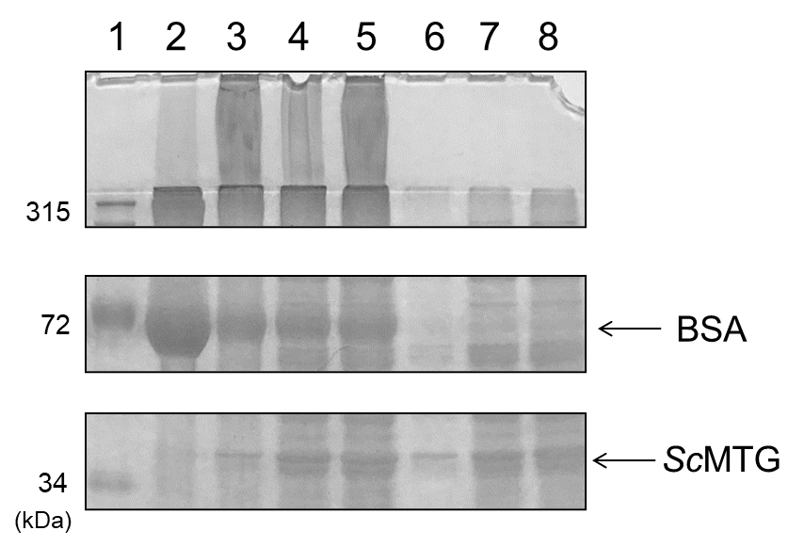
Fig. S1 Cross-linking assay using BSA as a substrate after incubation for 120 min with several volumes of SmTG solution extracted from the BY4741-TG strain. Lane 1, molecular size marker; lane 2, BSA only; lanes 3, 4 and 5, 1×, 5× and 10×SmTG (+BSA), respectively; lanes 6, 7 and 8, 1×, 5× and 10×SmTG (−BSA), respectively
SmTG
BSA
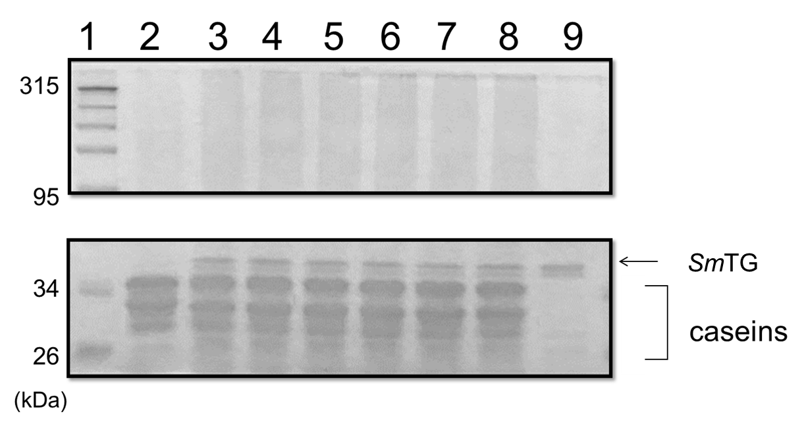
Fig. S2 Effect of adding reduced glutathione to polymerization of caseinate by SmTG. SDS-PAGE profiles show the protein pattern of caseinate after incubation with SmTG. 1×SmTG extracted from the BY4741-TG strain was used. Lane 1, molecular size marker; lane 2, caseinate only; lanes 3, 4, 5, 6, 7 and 8, caseinate, SmTG and 0, 0.2, 0.4, 0.8, 1.6 and 3.2 mM glutathione, respectively; lane 9, SmTG only. The polymerized caseins (molecular weight > 100 kDa) presented in the top panel were recovered and measured as shown in Fig. 2
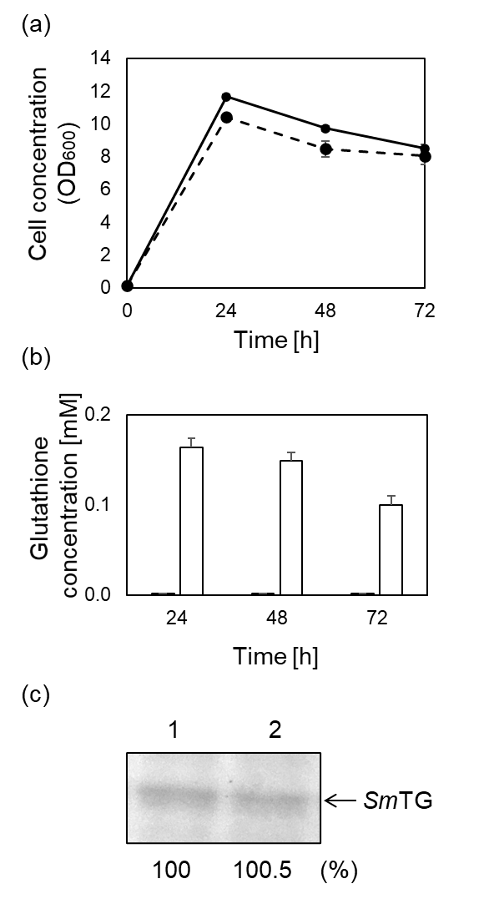
Fig. S3 Growth and glutathione production of S. cerevisiae expressing SmTG. (a) Time course of cell growth. Solid and dotted lines represent the BY4741-TG and GCI-TG strains, respectively. (b) Glutathione concentrations in 1×SmTG solutions extracted from the BY4741-TG strain (black) and GCI-TG strain (white). (c) Expression level of SmTG after cultivation for 24 h. lane 1, BY4741-TG strain; lane 2, GCI-TG strain. Expression level of SmTG was calculated from the intensity of each SmTG band and represented as relative values (%). The values are means and the error bars show the SD (n = 3)

