Additional file
Methanogenic biodegradation of C₉ to C₁₂ n-alkanes initiated by Smithella via fumarate addition mechanism
Jia-Heng Ji^{1, †}, Lei Zhou^{1, †}, Serge Maurice Mbadinga¹, Muhammad Irfan^{1, 2}, Yi-Fan Liu¹, Pan Pan¹, Zhen-Zhen Qi¹, Jing Chen¹, Jin-Feng Liu¹, Shi-Zhong Yang¹, Ji-Dong Gu³, Bo-Zhong Mu^{1, 4, *}

¹State Key Laboratory of Bioreactor Engineering and School of Chemistry and Molecular Engineering, East China University of Science and Technology, 130 Meilong Road, Shanghai 200237, P.R. China
²Department of Chemical, Polymer and Composite Materials Engineering, University of Engineering and Technology, KSK Campus, Lahore 54890, Pakistan
³School of Biological Sciences, The University of Hong Kong, Pokfulam Road, Hong Kong Special Administrative Region, P.R. China
⁴Engineering Research Center of Microbial Enhanced Oil Recovery, East China University of Science and Technology, 130 Meilong Road, Shanghai 200237, P.R. China

*Corresponding Author:
Bo-Zhong Mu: E-mail: bzmu@ecust.edu.cn; Phone: +86 21 64252063; Fax: +86 21 64252485

†These authors contributed equally to this work.
Figure S1. GC-MS analysis of a diethyl 2-(1-methyloctyl)succinate (C₉ alkylsuccinate) standard. (a) GC partial ion chromatogram following selection for the m/z 128 ion of a diethyl 2-(1-methyloctyl)succinate standard, (b) Mass spectral profiles of diethyl 2-(1-methyloctyl)succinate (retention time, 17.60 min).

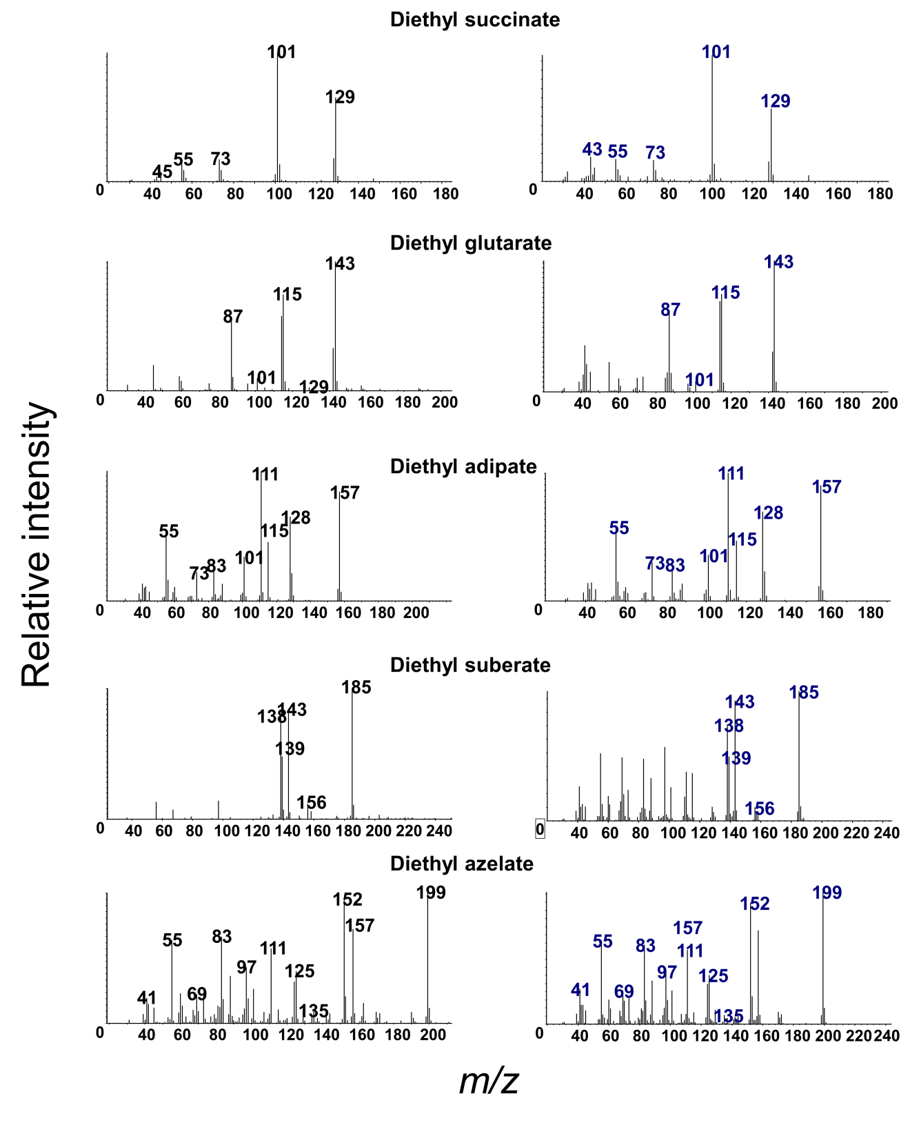
Figure S2. Mass spectral profiles of dicarboxylic acids identified in alkane-amended enrichment cultures. Left panel: compound detected in the alkane-amended enrichment cultures. Right panel: ethyl-derivatized authentic standards.

Figure S3. Mass spectral profiles of fatty acids (ethyl derivatives) identified in alkane-amended enrichment cultures.
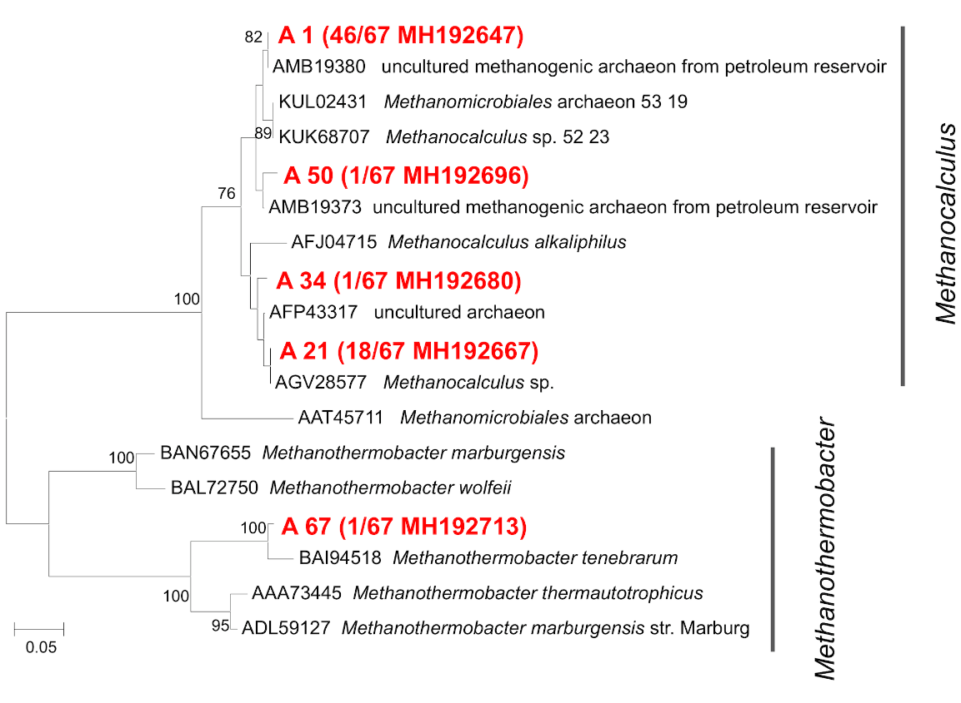
Figure S4. Phylogenetic tree of deduced amino acid sequences of methyl coenzyme-M reductase genes (mcrA) from alkane-amended enrichment culture (in red). Topology of the tree was obtained by the neighbor-joining method. Bootstrap values (n=1,000 replicates), values below 75% are not shown.

