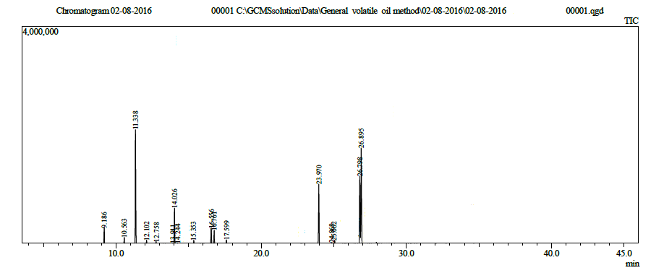
Fig S1: GC/MS chromatogram of Myrrh hexane extract

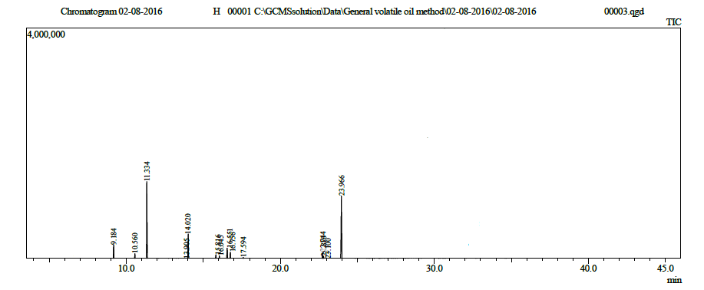
Fig S2: GC/MS chromatogram of Myrrh essential oil

