Additional file 1

Involvement of catalase and superoxide dismutase in hydrophobic organic solvent tolerance of Escherichia coli

Noriyuki Doukyu^{1,2*} and Katsuya Taguchi ^{1,2}
Department of Life Science, Toyo University, 1-1-1 Izumino, Itakura-machi, Gunma, 374-0193, Japan¹
Bio-Nano Electronic Research Center, Toyo University, 2100, Kujirai, Kawagoe, Saitama, 350-8585, Japan²

*Corresponding author
Noriyuki Doukyu
Department of Life Science, Toyo University, 1-1-1 Izumino, Itakura-machi, Gunma, Japan
E-mail: dokyu@ toyo. jp
Tel.: +81-276-829219
FAX: +81-276-829219

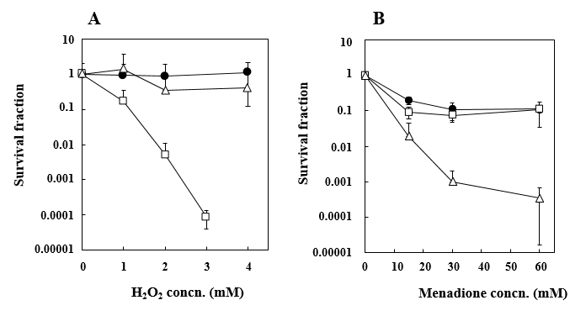

Figure S1 Effects of H₂O₂ and menadione on the cell viability of E. coli BW25113 and its mutants deficient in ROS-scavenging enzymes. Each strain was exposed to H₂O₂ (A) and menadione (B). After incubation with H₂O₂ and menadione for 1 h, viable cells were measured by examining the formation of colonies on LB agar medium. The survival fraction was calculated as the number of colonies treated with H₂O₂ or menadione divided by that of untreated cells. Symbols: filled circles, BW25113; open squares, BW25113ΔkatEΔkatG; open triangles, BW25113ΔsodAΔsodB. Values indicate the means and standard deviations of the results from three independent experiments.

