Additional file 1. Additional data
Table S1 Pearson correlation of Cd concentration in plants of B. napus with plant physiological properties. Note: A: Negative correlation; ns: Not significant; *: Correlation is significant at the 0.05 level (2-tailed); **: Correlation is significant at the 0.01 level (2-tailed), the same below.
Pearson correlation | Leaf_Cd | Root_Cd | Height | Weight |  | Leaf_area | Sugar | Protein | chlorophyll | SOD | POD | CAT
Leaf_Cd  Root_Cd | 1
Root_Cd | ** | 1
Height | A** | A** | 1
Weight | A** | A** | ** |  | 1
Leaf_area | A** | A** | ** |  | ** | 1
Sugar | A** | A** | ** |  | ** | ** | 1
Protein | ** | * | A* |  | A** | A** | A** | 1
Chlorophyll | A** | A** | ** |  | ** | ** | * | ns | 1
SOD | ** | ** | A** |  | A** | A** | A** | ns | A* | 1
POD | ns | ns | ns |  | ns | ns | ns | ns | ns | ** | 1
CAT | A** | A** | ** |  | ** | ** | ** | ns | ** | A** | A* | 1

Table S2 Pearson correlation of Cd concentration in plants of B. juncea with plant physiological properties.
 | Pearson correlation | Leaf_Cd | Root_Cd | Height | Weight | Leaf_area | Sugar | Protein | Chlorophyll | SOD | POD | CAT
Leaf_Cd |  | 1
Root_Cd |  | ** | 1
Height |  | A** | A** | 1
Weight |  | A** | A** | ** | 1
Leaf_area |  | A** | A** | ** | ** | 1
Sugar |  | A** | A** | ** | ** | ** | 1
Protein |  | * | * | A* | A** | A** | A** | 1
Chlorophyll |  | A** | A** | ** | ** | * | ** | ns | 1
SOD |  | ** | ** | A** | ns | ns | ns | ns | A* | 1
POD |  | ns | ns | ns | ns | ns | ns | ns | ns | ns | 1
CAT |  | A* | A* | ** | ** | ** | ** | ns | * | ns | ns | 1

Table S3 The bioaccumulation factor (BAF) and translocation factor (TF) of oilseed rapes (means±SD，n=6). Means within the same line that are followed by the different letter are significantly different at P < 0.05 based on one-way ANOVA.
 | B. napus |  | B. juncea
 | 10mg/kg | 30mg/kg | 10mg/kg | 30mg/kg
TF | 0.91±0.03a | 0.32±0.01c | 0.47±0.01b | 0.40±0.01d
BAF in leaf | 19.31±1.37a | 20.51±2.46a | 10.47±0.85b | 20.02±3.30a
BAF in root | 21.13±1.45c | 63.09±7.62a | 22.04±1.62c | 50.45±9.06b
Table S4 Pearson correlation of Cd concentration in soils of B. napus with rhizosphere physicochemical properties.
Pearson correlation | Soil_Cd | pH | TOC | TN | TP | NH₃-N | NO₃-N | AP | AK
Soil_Cd | 1
pH | A** | 1
TOC | A* | ns | 1
TN | A** | ns | ns | 1
TP | A* | ns | ns | ns | 1
NH₃-N | ns | ns | ns | ns | ns | 1
NO₃-N | A** | ns | ns | ** | * | ns | 1
AP | ns | ns | ns | ns | ns | ns | ns | 1
AK | ns | ns | ns | ns | ns | ns | ns | ns | 1

Table S5 Pearson correlation of Cd concentration in soils of B. juncea with rhizosphere physicochemical properties.
Pearson correlation | Soil_Cd | pH | TOC | TN | TP | NH₃-N | NO₃-N | AP |  | AK
Soil_Cd | 1
pH | A** | 1
TOC | ns | ns | 1
TN | A** | ** | ns | 1
TP | ns | ns | A* | ns | 1
NH₃-N | A* | ns | ns | ns | ns | 1
NO₃-N | ns | ns | ns | ns | ns | ns | 1
AP | A* | ns | ns | * | ns | ns | ns |  | 1
AK | ns | ns | ns | ns | ns | ns | ns |  | ns | 1

Table S6 Pearson correlation of Cd concentration in soils of B. napus with bulk soil physicochemical properties.
Pearson correlation | Soil_Cd | pH | TOC | TN | TP | NH₃-N | NO₃-N | AP | AK
Soil_Cd | 1
pH | A** | 1
TOC | ns | ns | 1
TN | A* | ** | ns | 1
TP | A* | ** | ** | ** | 1
NH₃-N | ns | ns | ns | ns | ns | 1
NO₃-N | A* | * | ns | ** | ** | ns | 1
AP | ns | ns | ns | ns | ns | ns | ns | 1
AK | ns | ns | ns | ns | ns | ns | ns | ns | 1

Table S7 Pearson correlation of Cd concentration in soils of B. juncea with bulk soil physicochemical properties.
Pearson correlation | Soil_Cd | pH | TOC | TN | TP | NH₃-N | NO₃-N | AP | AK
Soil_Cd | 1
pH | A** | 1
TOC | ns | ns | 1
TN | A** | ns | ns | 1
TP | ns | ns | ns | ** | 1
NH₃-N | A* | ns | ns | ** | ns | 1
NO₃-N | ns | ns | * | ** | ** | ns | 1
AP | ns | ns | ns | ** | ** | ns | ** | 1
AK | ** | ns | ns | ns | ns | ns | ns | ns | 1

Table S8 Pearson correlation of Cd in soils of B. napus with bacterial numbers.
Pearson correlation | Soil_Cd | Rhizosphere | Bulk soil
Soil_Cd | 1
Rhizosphere | ns | 1
Bulk soil | * | * | 1
Table S9 Pearson correlation of Cd in soils of B. juncea with bacterial numbers.
Pearson correlation | Soil_Cd | Rhizosphere | Bulk soil
Soil_Cd | 1
Rhizosphere | ns | 1
Bulk soil | ns | ns | 1

Table S10 Relationship between α-diversity of plant bacterial community in B. napus and environment variables. Abbreviations: Yj: phyllosphere samples; Yn: endophytes samples from leaves; Gn: endophytes samples from roots, the same below.
Samples | factor | Shannon | Simpson | Richness | Chao1
Yj | Height | ns | ns | ns | ns
Yj | Weight | ns | ns | ns | ns
Yj | Leaf_area | ns | ns | ns | ns
Yj | Sugar | ns | ns | ns | ns
Yj | Protein | ns | ns | ns | ns
Yj | Chlorophyll | ns | ns | ns | ns
Yj | SOD | ns | ns | ns | ns
Yj | POD | ns | ns | ns | ns
Yj | CAT | ns | ns | ns | ns
Yj | Leaf_Cd | ns | ns | ns | ns
Yn | Height | ns | ns | ns | ns
Yn | Weight | ns | ns | ns | ns
Yn | Leaf_area | ns | ns | ns | ns
Yn | Sugar | ns | ns | ns | ns
Yn | Protein | ns | ns | ns | ns
Yn | Chlorophyll | ns | ns | ** | ns
Yn | SOD | ns | ns | ns | ns
Yn | POD | ns | ns | ns | ns
Yn | CAT | * | ns | ns | ns
Yn | Leaf_Cd | ns | ns | ns | ns
Gn | Height | ** | * | * | ns
Gn | Weight | * | ns | * | ns
Gn | Leaf_area | ** | * | * | ns
Gn | Sugar | ** | ns | * | ns
Gn | Protein | ns | ns | ns | ns
Gn | Chlorophyll | ns | * | ns | ns
Gn | SOD | A** | A* | A** | A*
Gn | POD | A* | ns | ns | ns
Gn | CAT | * | ns | ns | ns
 | Root_Cd | A** | A* | A* | ns
 | pH | * | * | * | *
 | TOC | * | * | * | *
 | TN | ns | * | ns | ns
 | TP | ns | ns | ns | ns
 | NH₃-N | ns | ns | ns | ns
 | NO₃-N | ns | ns | ns | ns
 | AP | ns | ns | ns | ns
 | AK | ns | ns | ns | ns

Table S11 Relationship between α-diversity of plant bacterial community in B. juncea and environment variables.
Samples | factor | Shannon | Simpson | Richness | Chao1
Yj | Height | ns | ns | ns | *
Yj | Weight | ns | ns | ns | ns
Yj | Leaf_area | ns | ns | ns | ns
Yj | Sugar | ns | ns | * | *
Yj | Protein | ns | ns | ns | ns
Yj | Chlorophyll | ns | ns | * | *
Yj | SOD | ns | ns | ns | ns
Yj | POD | ns | ns | ns | ns
Yj | CAT | ns | ns | * | *
Yj | Leaf_Cd | ns | ns | ns | ns
Yn | Height | ns | ns | ns | ns
Yn | Weight | ns | ns | ns | ns
Yn | Leaf_area | ns | ns | ns | ns
Yn | Sugar | ns | ns | ns | ns
Yn | Protein | ns | ns | ns | ns
Yn | Chlorophyll | ns | ns | ns | ns
Yn | SOD | ns | ns | ns | ns
Yn | POD | ns | A* | ns | ns
Yn | CAT | ns | n | ns | ns
Yn | Leaf_Cd | ns | ns | ns | ns
Gn | Height | ns | ns | ns | ns
Gn | Weight | ns | ns | ns | ns
Gn | Leaf_area | ns | ns | ns | ns
Gn | Sugar | ns | ns | ns | ns
Gn | Protein | ns | ns | ns | ns
Gn | Chlorophyll | ns | ns | ns | ns
Gn | SOD | ns | ns | ns | ns
Gn | POD | ns | ns | ns | ns
Gn | CAT | ns | ns | ns | ns
Gn | Root_Cd | ns | ns | ns | ns
 | pH | ns | ns | ns | ns
 | TOC | A* | ns | ns | ns
 | TN | ns | ns | ns | ns
 | TP | ns | ns | ns | ns
 | NH₃-N | ns | ns | ns | ns
 | NO₃-N | ns | ns | ns | ns
 | AP | ns | ns | ns | ns
 | AK | ns | ns | ns | ns

Table S12 Relationship between α-diversity of soil bacterial community in B. napus and environment variables. Abbreviations:R: rhizosphere soil samples; NR: bulk soil samples, the same below.
Samples | factor | Shannon | Simpson | Richness | Chao1
R | Height | ** | ** | ** | ns
R | Weight | ** | ** | * | ns
R | Leaf_area | ** | ** | ** | ns
R | Sugar | ** | * | * | ns
R | Protein | ns | ns | ns | A*
R | Chlorophyll | ns | ns | ns | ns
R | SOD | A** | A** | A** | ns
R | POD | ns | ns | ns | ns
R | CAT | ** | * | * | ns
R | Soil_Cd | A** | A** | A** | ns
R | pH | * | * | * | ns
R | TOC | * | ns | ns | ns
R | TN | * | * | ns | ns
R | TP | * | ns | ns | ns
R | NH₃-N | ns | ns | ns | ns
R | NO₃-N | ** | ** | * | ns
R | AP | ns | ns | ns | ns
R | AK | ns | ns | ns | ns
NR | pH | ns | ns | ns | ns
NR | TOC | ns | ns | ns | ns
NR | TN | ns | * | ns | ns
NR | TP | ns | ns | ns | ns
NR | NH₃-N | ns | ns | ns | ns
NR | NO₃-N | * | * | ns | ns
NR | AP | ns | ns | ns | ns
NR | AK | ns | ns | ns | ns
NR | Soil_Cd | A* | A* | ns | ns

Table S13 Relationship between α-diversity of soil bacterial community in B. juncea and environment variables.
Samples | factor | Shannon | Simpson | Richness | Chao1
R | Height | ns | ** | ns | ns
R | Weight | * | ** | ns | ns
R | Leaf_area | ns | * | ns | ns
R | Sugar | ns | * | ns | ns
R | Protein | A* | A** | ns | A*
R | Chlorophyll | ns | * | ns | ns
R | SOD | A* | A* | ns | ns
R | POD | ns | ns | ns | ns
R | CAT | ns | ns | ns | ns
R | Soil_Cd | A* | A** | ns | ns
R | pH | ns | ns | ns | ns
R | TOC | ns | ns | ns | ns
R | TN | ns | ns | ns | ns
R | TP | ns | ns | ns | ns
R | NH₃-N | ns | ns | ns | ns
R | NO₃-N | ns | ns | ns | ns
R | AP | ns | ns | ns | ns
R | AK | ns | ns | ns | ns
NR | pH | ** | * | ** | **
NR | TOC | ns | ns | ns | ns
NR | TN | ns | ns | ns | ns
NR | TP | ns | ns | ns | ns
NR | NH₃-N | ns | ns | ns | ns
NR | NO₃-N | ns | ns | ns | ns
NR | AP | ns | ns | ns | ns
NR | AK | A* | A** | A** | A*
NR | Soil_Cd | A* | A* | A* | A**

Table S14 Dissimilarity tests of bacterial communities in plant and soil in B. napus from two different group types based on Jaccard distance method. Abbreviations: Yj, phyllosphere samples; Yn, endophytes samples from leaves; Gn, endophytes samples from roots; R, rhizosphere soil samples; NR, bulk soil samples; CK, treatment with 0 mg/kg Cd; C10, treatment with 10 mg/kg Cd; C30, treatment with 30 mg/kg Cd, the same below.
Groups |  | MRPP |  | ANOSIM |  | PERMANOVA
 |  | δ | P | R | P | R | P
Plant | Yj | 0.684 | 0.183 | 0.072 | 0.085 | 1.044 | 0.205
Plant | Yn | 0.727 | 0.202 | 0.031 | 0.324 | 1.054 | 0.231
Plant | Gn | 0.660 | 0.010 | 0.179 | 0.006 | 1.595 | 0.013
Plant | CK | 0.690 | 0.001 | 0.750 | 0.001 | 3.755 | 0.001
Plant | C10 | 0.680 | 0.001 | 0.929 | 0.001 | 4.144 | 0.001
Plant | C30 | 0.702 | 0.001 | 0.819 | 0.001 | 3.690 | 0.001
Soil | R | 0.468 | 0.003 | 0.317 | 0.001 | 1.298 | 0.003
Soil | NR | 0.453 | 0.001 | 0.378 | 0.001 | 1.397 | 0.001
Soil | CK | 0.456 | 0.009 | 0.380 | 0.005 | 1.334 | 0.016
Soil | C10 | 0.477 | 0.010 | 0.244 | 0.005 | 1.341 | 0.014
Soil | C30 | 0.449 | 0.003 | 0.865 | 0.005 | 1.762 | 0.004

Table S15 Dissimilarity tests of bacterial communities in plant and soil in B. juncea from two different group types based on Jaccard distance method.
Groups |  | MRPP |  | ANOSIM |  | PERMANOVA
 |  | δ | P | R | P | R | P
Plant | Yj | 0.658 | 0.069 | 0.103 | 0.052 | 1.127 | 0.051
Plant | Yn | 0.760 | 0.093 | 0.107 | 0.077 | 1.107 | 0.094
Plant | Gn | 0.640 | 0.024 | 0.123 | 0.046 | 1.139 | 0.021
Plant | CK | 0.673 | 0.001 | 0.845 | 0.001 | 4.473 | 0.001
Plant | C10 | 0.703 | 0.001 | 0.800 | 0.001 | 3.680 | 0.001
Plant | C30 | 0.683 | 0.001 | 0.785 | 0.001 | 3.842 | 0.001
Soil | R | 0.463 | 0.001 | 0.409 | 0.001 | 1.434 | 0.001
Soil | NR | 0.457 | 0.007 | 0.180 | 0.006 | 1.169 | 0.008
Soil | CK | 0.452 | 0.027 | 0.159 | 0.036 | 1.123 | 0.026
Soil | C10 | 0.469 | 0.012 | 0.154 | 0.042 | 1.254 | 0.020
Soil | C30 | 0.460 | 0.001 | 0.470 | 0.003 | 1.464 | 0.003

Table S16 Mantel analysis of the relationship between the B. napus’s bacterial community structure and environmental variables based on Bray Curtis (BC) and Jaccard (JC) method.
Samples | Environmental factors | r.BC | p.BC | r.JC | p.JC
Yj | Height | 0.002 | 0.468 | -0.053 | 0.595
Yj | Weight | 0.088 | 0.138 | 0.038 | 0.398
Yj | Leaf_area | 0.024 | 0.363 | -0.046 | 0.618
Yj | Sugar | -0.041 | 0.568 | -0.090 | 0.672
Yj | Protein | -0.023 | 0.466 | -0.041 | 0.529
Yj | Chlorophyll | 0.250 | 0.105 | 0.516 | 0.014
Yj | SOD | -0.028 | 0.541 | -0.126 | 0.944
Yj | POD | -0.011 | 0.460 | -0.050 | 0.561
Yj | CAT | -0.099 | 0.737 | -0.103 | 0.731
Yj | Leaf_Cd | 0.024 | 0.387 | -0.046 | 0.615
Yn | Height | -0.120 | 0.936 | 0.094 | 0.148
Yn | Weight | -0.107 | 0.922 | 0.206 | 0.013
Yn | Leaf_area | -0.039 | 0.632 | 0.197 | 0.010
Yn | Sugar | -0.114 | 0.829 | 0.152 | 0.113
Yn | Protein | 0.030 | 0.363 | 0.069 | 0.256
Yn | Chlorophyll | 0.025 | 0.419 | 0.163 | 0.149
Yn | SOD | -0.118 | 0.881 | -0.049 | 0.635
Yn | POD | 0.132 | 0.113 | -0.212 | 0.991
Yn | CAT | -0.012 | 0.502 | -0.084 | 0.738
Yn | Leaf_Cd | -0.124 | 0.941 | 0.107 | 0.123
Gn | Height | 0.362 | 0.012 | 0.264 | 0.020
Gn | Weight | 0.276 | 0.010 | 0.179 | 0.021
Gn | Leaf_area | 0.276 | 0.015 | 0.218 | 0.015
Gn | pH | 0.200 | 0.059 | 0.139 | 0.186
Gn | TOC | 0.261 | 0.046 | 0.090 | 0.240
Gn | TN | -0.059 | 0.614 | -0.145 | 0.842
Gn | TP | 0.038 | 0.314 | -0.060 | 0.547
Gn | NH₃-N | 0.093 | 0.213 | 0.134 | 0.188
Gn | NO₃-N | 0.025 | 0.342 | 0.027 | 0.360
Gn | AP | 0.050 | 0.232 | -0.039 | 0.525
Gn | AK | -0.089 | 0.741 | -0.127 | 0.725
Gn | Root_Cd | 0.398 | 0.011 | 0.302 | 0.016

Table S17 Mantel analysis of the relationship between the B. juncea’s bacterial community structure and environmental variables based on Bray Curtis (BC) and Jaccard (JC) method.
Samples | Environmental factors | r.BC | p.BC | r.JC | p.JC
Yj | Height | 0.095 | 0.136 | 0.041 | 0.322
Yj | Weight | 0.020 | 0.359 | 0.001 | 0.471
Yj | Leaf_area | 0.004 | 0.419 | 0.006 | 0.433
Yj | Sugar | -0.007 | 0.475 | 0.022 | 0.374
Yj | Protein | 0.051 | 0.370 | -0.077 | 0.652
Yj | Chlorophyll | -0.008 | 0.509 | 0.093 | 0.098
Yj | SOD | -0.129 | 0.817 | -0.250 | 0.987
Yj | POD | 0.204 | 0.058 | 0.130 | 0.149
Yj | CAT | -0.004 | 0.508 | 0.035 | 0.358
Yj | Leaf_Cd | 0.072 | 0.213 | 0.007 | 0.425
Yn | Height | -0.136 | 0.966 | -0.128 | 0.939
Yn | Weight | -0.205 | 1.000 | -0.060 | 0.752
Yn | Leaf_area | -0.088 | 0.829 | 0.101 | 0.139
Yn | Sugar | -0.162 | 0.951 | 0.005 | 0.507
Yn | Protein | -0.048 | 0.521 | -0.094 | 0.722
Yn | Chlorophyll | -0.131 | 0.99 | 0.008 | 0.430
Yn | SOD | -0.093 | 0.642 | -0.035 | 0.575
Yn | POD | 0.039 | 0.35 | -0.132 | 0.841
Yn | CAT | -0.141 | 0.806 | 0.049 | 0.346
Yn | Leaf_Cd | -0.174 | 0.996 | -0.121 | 0.883
Gn | Height | 0.008 | 0.428 | 0.018 | 0.392
Gn | Weight | 0.053 | 0.259 | 0.047 | 0.284
Gn | Leaf_area | 0.154 | 0.069 | 0.101 | 0.125
Gn | pH | 0.066 | 0.239 | 0.093 | 0.171
Gn | TOC | 0.170 | 0.114 | -0.057 | 0.617
Gn | TN | 0.057 | 0.292 | 0.114 | 0.174
Gn | TP | 0.206 | 0.084 | 0.120 | 0.187
Gn | NH₃-N | -0.042 | 0.602 | 0.106 | 0.242
Gn | NO₃-N | -0.179 | 0.945 | -0.246 | 0.986
Gn | AP | 0.057 | 0.340 | 0.010 | 0.432
Gn | AK | 0.069 | 0.241 | -0.083 | 0.759
Gn | Root_Cd | -0.042 | 0.663 | 0.053 | 0.281

Table S18 Mantel analysis of the relationship between the soil bacterial community structure in B. juncea and environmental variables based on Bray Curtis (BC) and Jaccard (JC) method.
Samples | Environmental factors | r.BC | p.BC | r.JC | p.JC
Rhizosphere soil | Height | 0.179 | 0.026 | 0.092 | 0.170
Rhizosphere soil | Weight | 0.235 | 0.010 | 0.117 | 0.090
Rhizosphere soil | Leaf_area | 0.240 | 0.011 | 0.223 | 0.026
Rhizosphere soil | pH | 0.078 | 0.239 | 0.094 | 0.179
Rhizosphere soil | TOC | -0.011 | 0.495 | -0.015 | 0.491
Rhizosphere soil | TN | 0.092 | 0.256 | 0.270 | 0.034
Rhizosphere soil | TP | 0.104 | 0.249 | 0.137 | 0.179
Rhizosphere soil | NH₃-N | -0.044 | 0.587 | 0.241 | 0.075
Rhizosphere soil | NO₃-N | 0.034 | 0.360 | -0.103 | 0.741
Rhizosphere soil | AP | 0.058 | 0.368 | 0.109 | 0.225
Rhizosphere soil | AK | -0.117 | 0.831 | -0.123 | 0.809
Rhizosphere soil | Soil_Cd | 0.232 | 0.023 | 0.102 | 0.183
Bulk soil | pH | 0.407 | 0.001 | 0.461 | 0.001
Bulk soil | TOC | 0.033 | 0.380 | 0.039 | 0.369
Bulk soil | TN | 0.007 | 0.429 | 0.035 | 0.397
Bulk soil | TP | -0.187 | 0.917 | -0.247 | 0.959
Bulk soil | NH₃-N | 0.045 | 0.348 | 0.062 | 0.324
Bulk soil | NO₃-N | -0.087 | 0.674 | -0.092 | 0.699
Bulk soil | AP | -0.001 | 0.429 | -0.047 | 0.590
Bulk soil | AK | 0.101 | 0.208 | 0.145 | 0.134
Bulk soil | Soil_Cd | 0.445 | 0.005 | 0.511 | 0.001

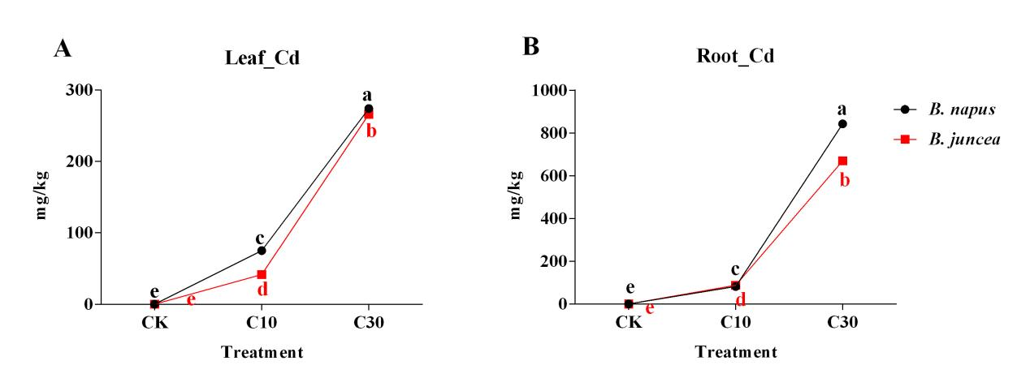
Figure S1 The accumulation of Cd in plant leaves (A) and roots (B). Error bars show standard deviation (n = 6). Means with different lowercase letters are significantly different at P < 0.05 based on one-way ANOVA, the same below. Abbreviations: CK, treatment with 0 mg/kg Cd; C10, treatment with 10 mg/kg Cd; C30, treatment with 30 mg/kg Cd, the same below.
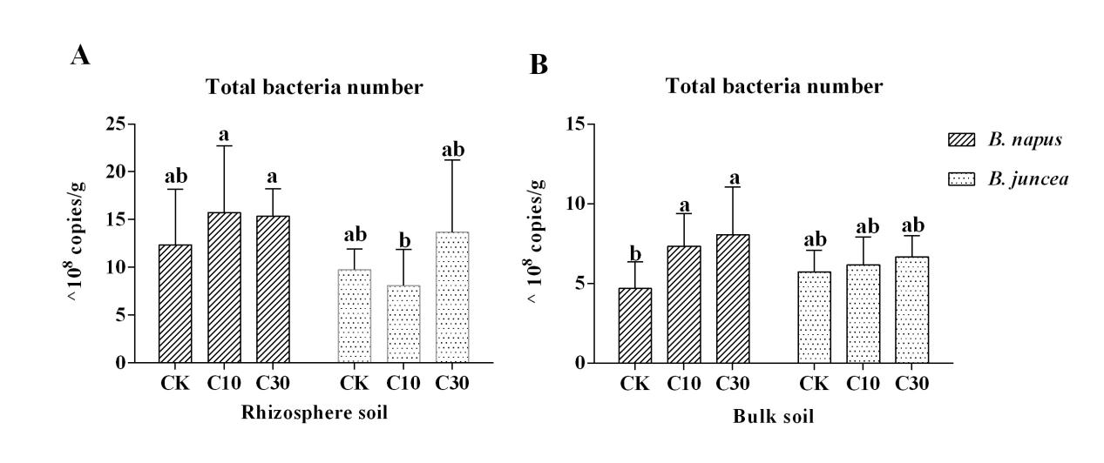
Figure S2 Variations of total bacteria copies in Cd contaminated soils of rhizosphere (A) and bulk soil (B).
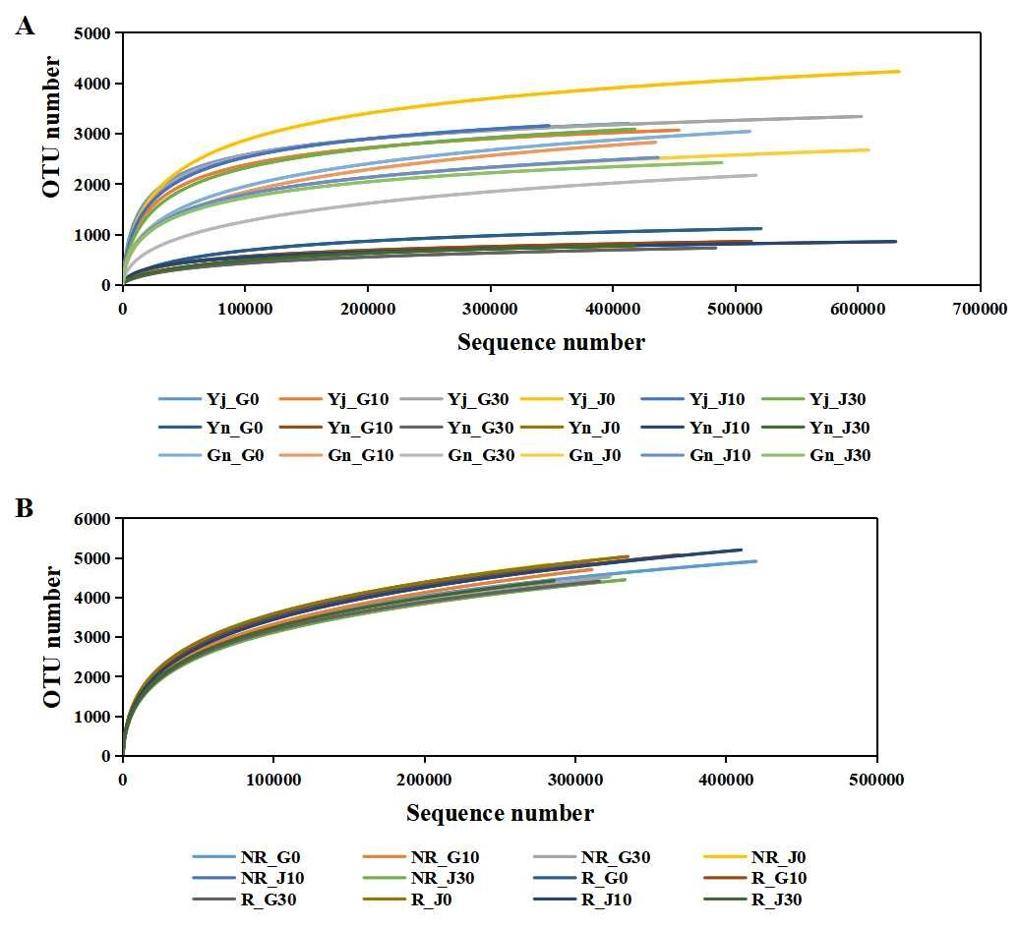
Figure S3 Rarefaction curve of the bacterial community in plants (A) and soils (B). Abbreviations: G0/J0, treatment with 0mg/kg Cd in B. napus /B. juncea; G10/J10, treatment with 10mg/kg Cd in B. napus /B. juncea; G30/J30, treatment with 30mg/kg Cd in B. napus /B. juncea ; Yj, phyllosphere samples; Yn, endophytes samples from leaves; Gn, endophytes samples from roots; R, rhizosphere soil samples; NR, bulk soil samples, the same below.
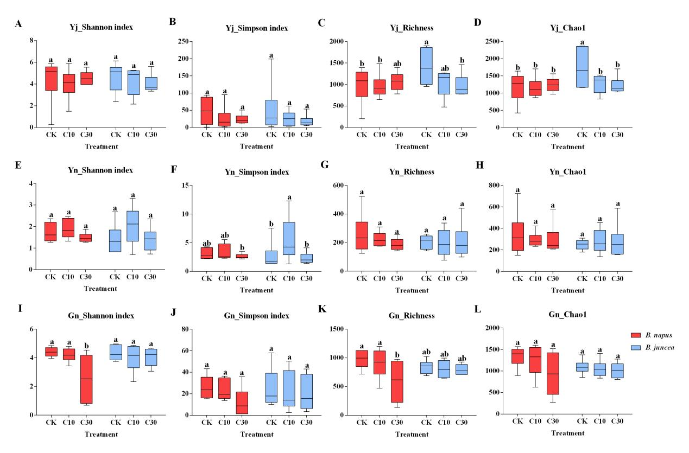
Figure S4 The effect of Cd on α-diversity of plant bacterial communities. Error bars show standard deviation (n = 6). Means with different lowercase letters are significantly different at P < 0.05 based on one-way ANOVA. Abbreviations: Yj, phyllosphere samples (A-D); Yn, endophytes samples from leaves (E-H); Gn, endophytes samples from roots (I-L).

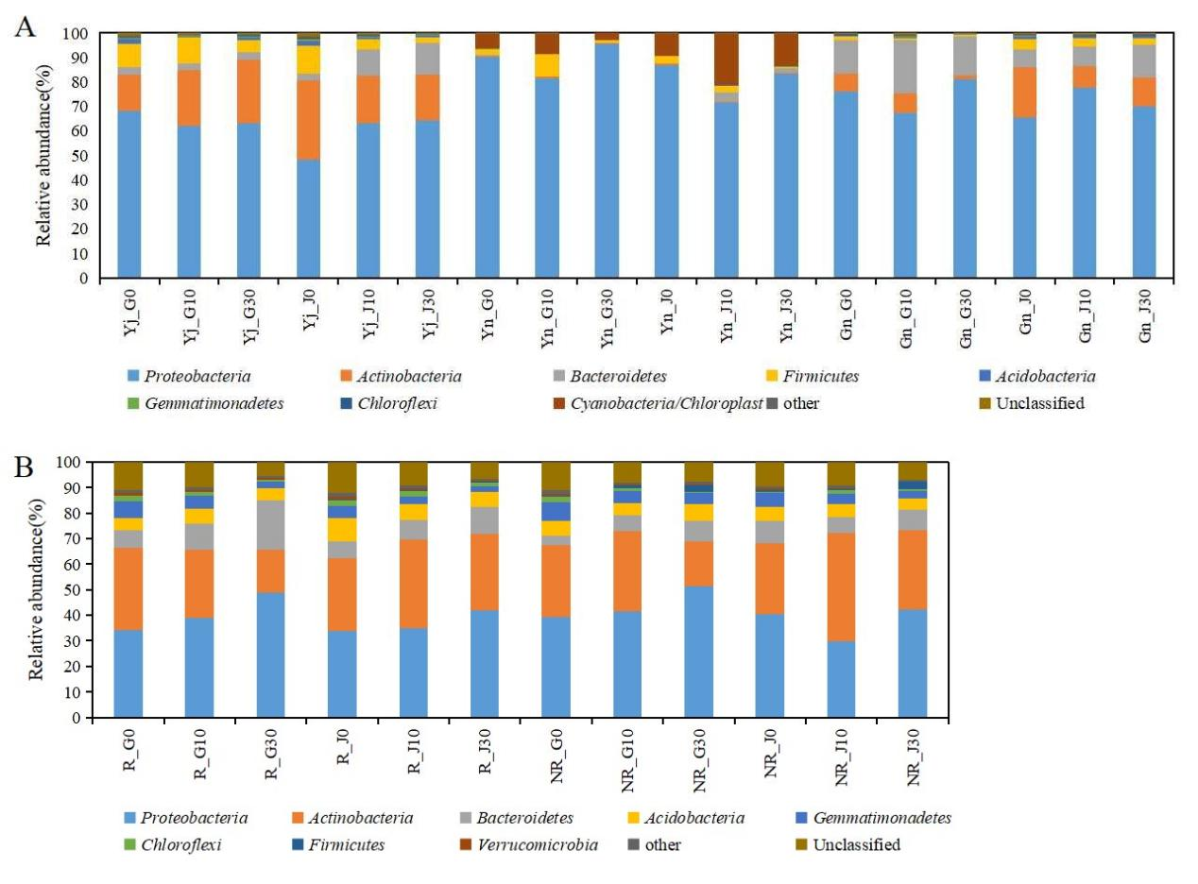
Figure S5 Relative abundance of the top 10 phyla in plant (A) and soil (B) associated bacterial communities

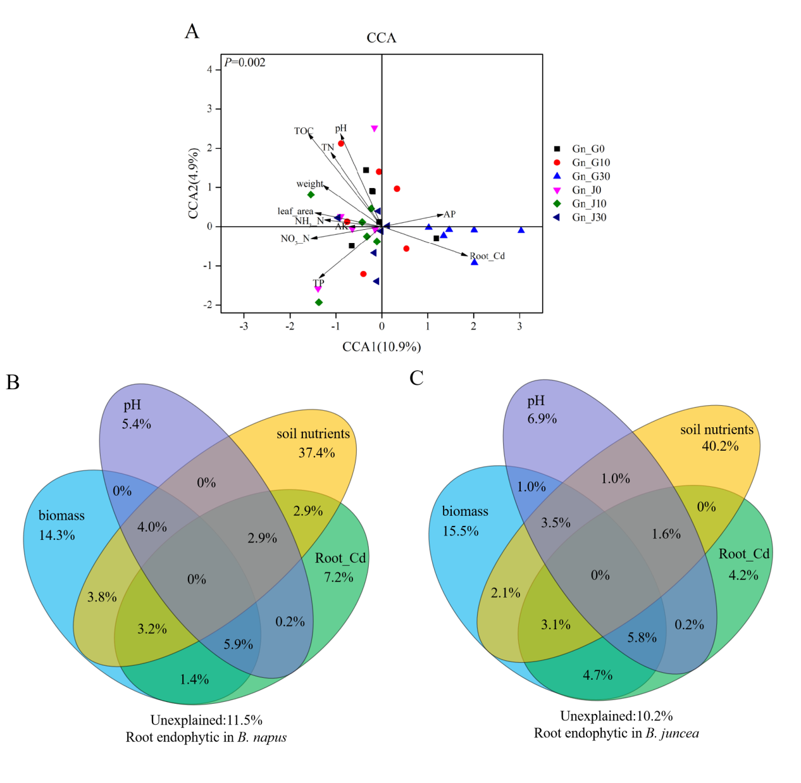
Figure S6 Canonical correspondence analysis (CCA) on root endophytic bacterial communities with the environmental variables (A) and CCA-based variation partitioning analysis (VPA) of bacterial communities explained by environmental variables (B&C).
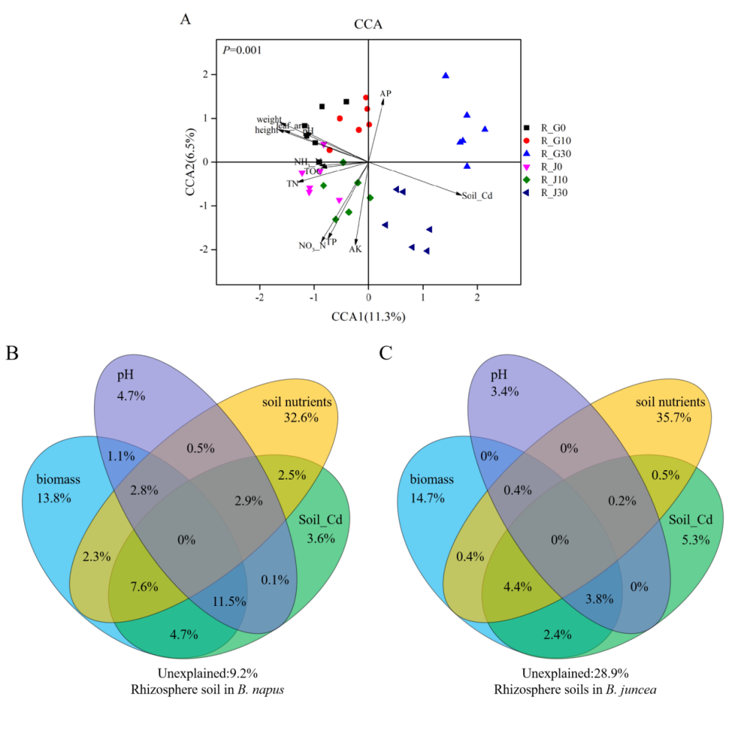
Figure S7 Canonical correspondence analysis (CCA) on rhizosphere soil bacterial communities with the environmental variables (A) and CCA-based variation partitioning analysis (VPA) of bacterial communities explained by environmental variables (B&C).

