AMB Express
Supporting Information:

Sterilization protocols and the effect of plant growth regulators on callus induction and secondary metabolites production in in vitro cultures of Melia azedarach L.

Fatemeh Ahmadpoor, Nasser Zare*, Rasool Asghari, Parisa Sheikhzadeh

Department of Plant Production and Genetics, Faculty of Agriculture and Natural Resources, University of Mohaghegh Ardabili, P.O. Box 179, Ardabil, Iran

*Corresponding author:

Dr. Nasser Zare

Associate Professor

Department of Plant Production and Genetics, Faculty of Agriculture and Natural Resources, University of Mohaghegh Ardabili, P.O. Box 179, Ardabil, Iran

E-mail: zarenasser@yahoo.com; nzare@uma.ac.ir

Tel: +98(45) 31505113, Fax: +98(45)33512204

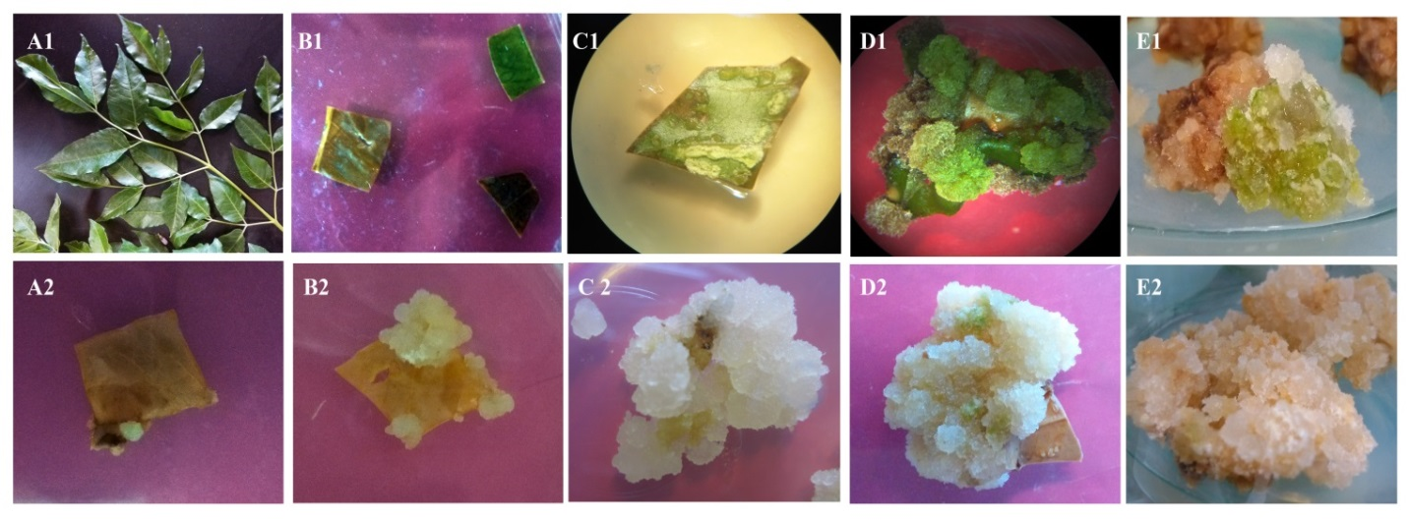
Figure S1- In vitro culture of M. azedarach L.; A₁: Leaf explants, B₁: Viable and browning leaf explants after disinfection and in vitro culture, C₁: Swollen leaf explants and initiation of callus induction on MS medium containing 1 mg/L NAA+1 mg/L Kin, D₁ and E₁: Callus induced on MS medium containing 1mg/L NAA+1 mg/L BAP and 3 mg/L NAA+1 mg/L BAP (is embryogenic callus), respectively, A₂ and B₂: Callus initiation and growth on MS+1 mg/L 2,4-D+1 mg/L Kin, C₂, D₂ and E₂: Callus growth on MS medium containing 1 mg/L 2,4-D + 1 mg/L Kin, 1 mg/L NAA+1 mg/L Kin and 3 mg/L 2,4-D+3 mg/L BAP, respectively.

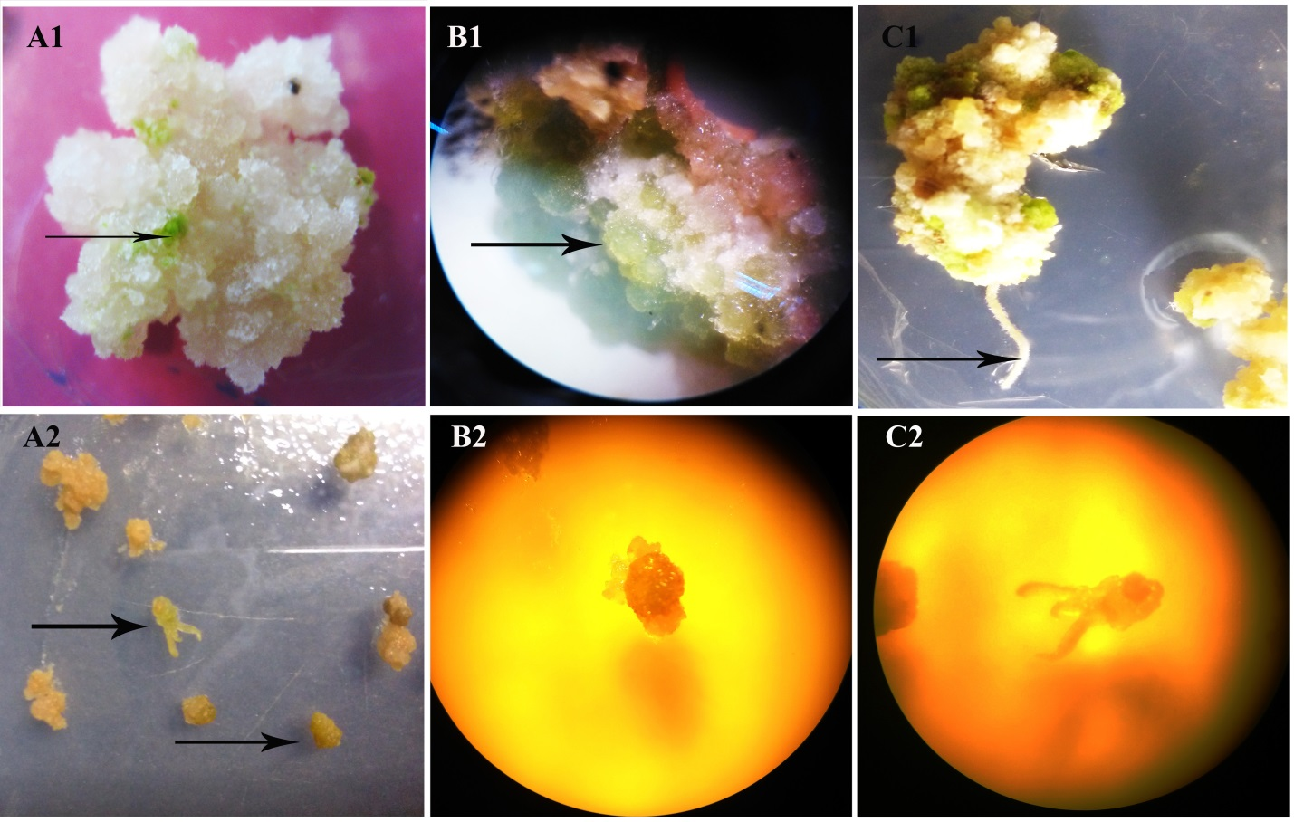
Figure S2- In vitro culture of M. azedarach L.; A₁: Callus induction on MS medium containing 3 mg/L NAA+1 mg/L Kin containing green cells in callus and B₁: 3 mg/L NAA+1 mg/L BAP containing green and globular shape spots in callus (are embryogenic callus), C₁: Embryogenic callus that have taken root, A₂: Globular and torpedo shape embryos, B₂: Globular embryos under a stereoscope and C₂: torpedo shape embryos under a stereoscope.

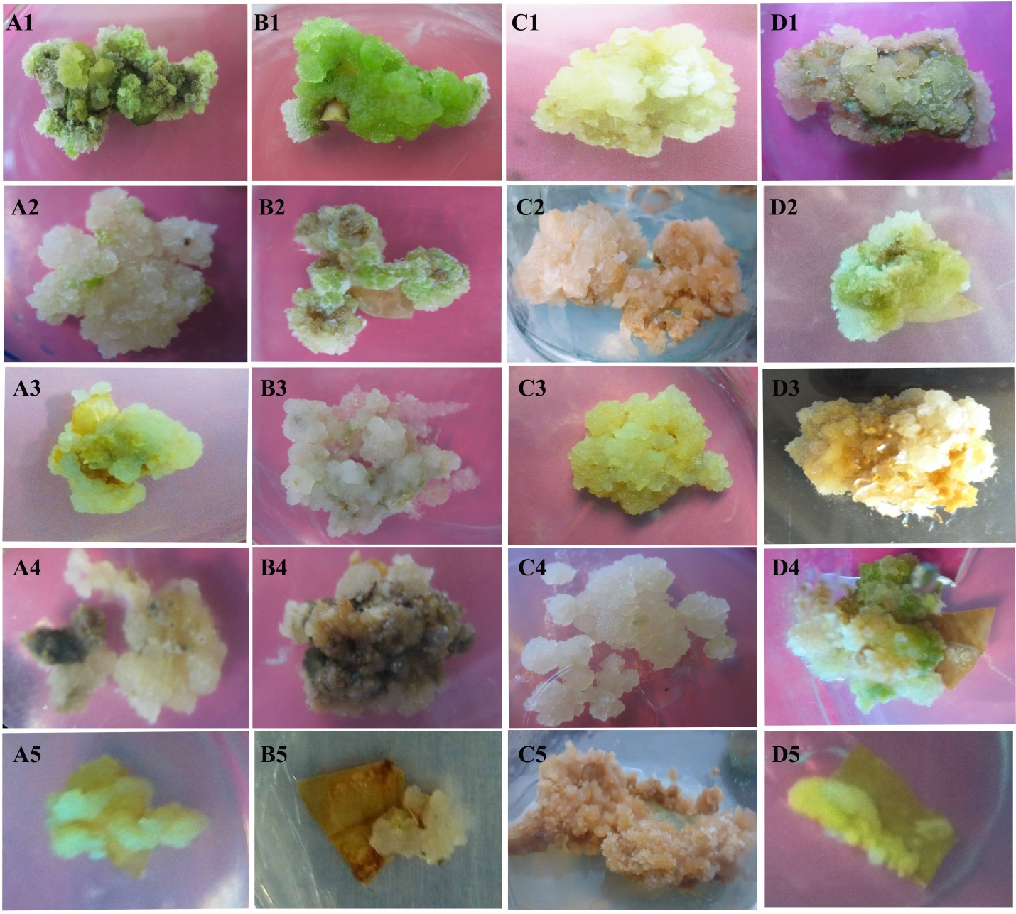Figure S3- In vitro culture of M. azedarach L.; Callus growth on MS+ A₁: 1 mg/L NAA+1 mg/L Kin, B₁: 1 mg/L NAA+1 mg/L BAP, C₁: 1 mg/L 2,4-D+1 mg/L Kin, D₁: 1 mg/L 2,4-D+1 mg/L BAP, A₂: 3 mg/L NAA+1 mg/L Kin, B₂: 3 mg/L NAA+1 mg/L BAP, C₂: 3 mg/L NAA+3 mg/L Kin, D₂: 3 mg/L NAA+3 mg/L BAP, A₃: 3 mg/L 2,4-D+1 mg/L Kin, B₃: 3 mg/L 2,4-D+1 mg/L BAP, C₃: 3 mg/L 2,4-D+3 mg/L Kin, D₃: 3 mg/L 2,4-D+3 mg/L BAP, A₄: 5 mg/L NAA+1 mg/L Kin, B₄: 5 mg/L NAA+1 mg/L BAP, C₄: 5 mg/L NAA+5 mg/L Kin, D₄: 5 mg/L NAA+5 mg/L BAP, A₅: 5 mg/L 2,4-D+1 mg/L Kin, B₅: 5 mg/L 2,4-D+1 mg/L BAP, C₅: 5 mg/L 2,4-D+5 mg/L Kin, D₅: 5 mg/L 2,4-D+5 mg/L BAP, respectively.

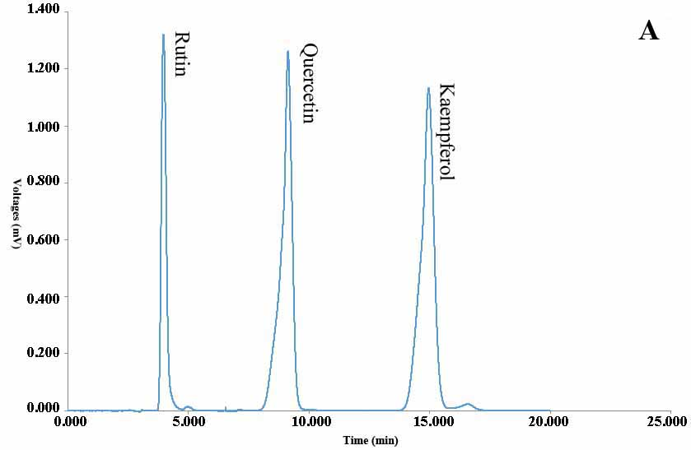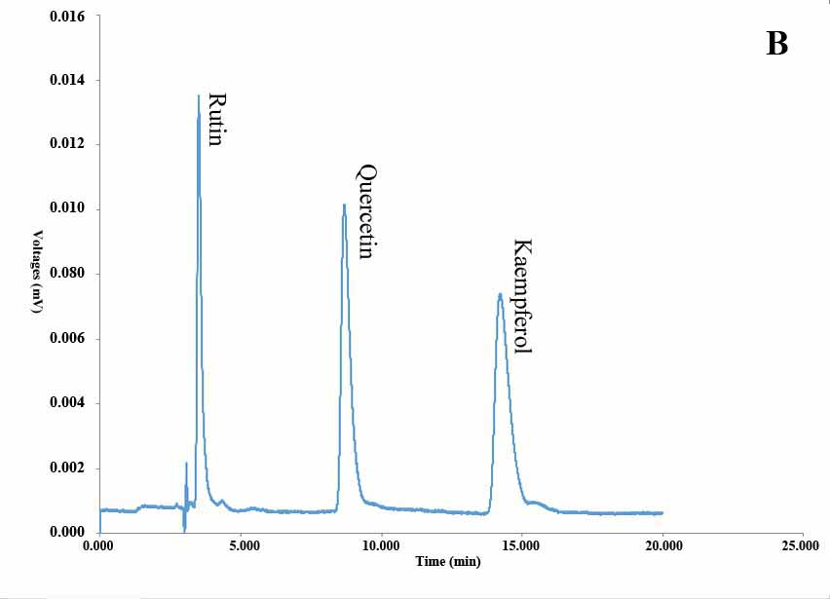
Figure S4- HPLC chromatogram of rutin, quercetin and kaempferol in the standard mixture (A) and M. azedarach L. calli grown on the MS medium containing 3mg/L NAA+ 3mg/L Kin (B)

Table S1- Different disinfection methods used in experiment 1 for sterilization of M. azedarach L. leaf explants
Method | pretreatment (3 g/L Benomyl) for 2 h | Pretreatment (with 3 g/L benomyl + 0.5% NaOCl) for 2 h | 7% (v/v) H₂O₂ for 10 min | 5% (v/v) H₂O₂ for 15 min | NaOCl 2% (pH=7) for 12 min | NaOCl 2% (pH=10) for 12 min | NaOCl 2% (without pH adjustment) for 12 min
Control | - | - | - | - | - | -
A₁ |  | - | - | - | - | -
A₂ |  | - |  | - | - | -
A₃ |  | - |  | - |  | - | -
A₄ | - |  | - | - | - | -
A₅ | - |  | - | - |  | - | -
A₆ | - | - | - |  | - | -
A₇ | - | - | - |  | - |  | -

Table S2- Different disinfection methods and inclusion of benomyl in culture medium used in experiment 2 for sterilization of M. azedarach L. leaf explants
Method | 5% H₂O₂ for 10 min | NaOCl 2% (pH=10) for 12 min | NaOCl 2% (without adjusted pH) for 12 min | Benomyl of medium (mg/L)
Control | - | - |  | -
B₁ |  | - |  | 100
B₂ |  |  | - | 100
B₃ |  | - |  | 500
B₄ |  |  | - | 500
B₅ | - | - |  | 100
B₆ | - |  | - | 100
B₇ | - | - |  | 500
B₈ | - |  | - | 500

Table S3- The effect of different disinfection methods on disinfection indices of leaf explants in M. azedarach L. (Experiment 1)
S.O.V | df | MS
S.O.V | df | Bacterial contamination  (%) | Fungal contamination  (%) | Clean explants (%) | Viability (%) | Browning (%) | Callus induction (%) | Weight of callus1 (mg/exp) | Weight of callus 2 (mg/exp) | Weight of callus 3 (mg/exp)
Sterilization | 7 | 0.124** | 0.473** | 1.026** | 0.885** | 0.892** | 0.635** | 41.441×10^{3 n.s} | 6.907×10^{5 n.s} | 61.599×10^{5 **}
PGR | 15 | 0.008 ^{n.s} | 0.015 ^{n.s} | 0.021 ^{n.s} | 0.054** | 0.055 ** | 0.057 * | 57.082×10^{3 *} | 7.677×10^{5 *} | 44.317×10^{5 **}
Sterilization × PGR | 105 | 0.011 * | 0.014 ^{n.s} | 0.019 ^{n.s} | 0.039** | 0.041** | 0.073 ** | 51.834×10^{3 **} | 6.119×10^{5 **} | 24.381×10^{5 **}
Error | 168 | 0.008 | 0.011 | 0.022 | 0.014 | 0.014 | 0.033 | 29.209×10³ | 3.866×10⁵ | 10.819×10⁵

* and ** = significant at 0.05 and 0.01 probability level, respectively; n.s. = not significant

Weight of callus1, 2 and 3 = weight of callus (mg/explants) in the 1rd, 2rd and 3rd month after the culture, respectively.

Table S4- Effect of PGRs treatment on total flavonoid, total phenol and anthocyanin contents in M. azedarach L. calli
S.O.V | df | Mean Square
S.O.V | df | TFC (mg/g FW) | TPC (mg/g FW) | AC (μg/g FW)
PGR | 17 | 2.675×10^{5**} | 0.274** | 1.340**
Error | 36 | 0.321×10⁵ | 0.029 | 0.266
** = Significant at the 0.01 probability level.
^{n.s.} = not significant.

Table S5- Effect of PGRs treatment on rutin, quercetin and kaempferol in M. azedarach L. by HPLC analysis
S.O.V | df | Mean Square
S.O.V | df | Rutin (mg/g FW) | Quercetin (mg/g FW) | Kaempferol (mg/g FW)
PGR | 7 | 189.725** | 18.722** | 17.248**
Error | 8 | 30.761 | 2.616 | 1.667
** = Significant at the 0.01 probability level.

