Supplementary Information

Table S1 ¹³C NMR dates of the products transformed from Rb1, Rb2, Rc and Rd.
Carbon site | CO | CMc1 | F2 | Gyp XVII
C-1 | 39.20 | 40.08 | 40.2 | 38.8
C-2 | 26.79 | 27.54 | 27.2 | 25.8
C-3 | 88.82 | 89.72 | 90.6 | 89.3
C-4 | 39.69 | 40.59 | 40.4 | 38.9
C-5 | 56.39 | 57.28 | 57.6 | 56.2
C-6 | 18.46 | 19.35 | 19.3 | 17.8
C-7 | 35.13 | 36.01 | 35.9 | 34.4
C-8 | 40.06 | 40.95 | 41 | 39.6
C-9 | 50.22 | 51.10 | 51.1 | 49.7
C-10 | 36.97 | 37.86 | 37.9 | 36.5
C-11 | 30.81 | 31.71 | 31 | 30.1
C-12 | 70.18 | 71.14 | 71.9 | 70.1
C-13 | 49.51 | 50.37 | 49.8 | 48.3
C-14 | 51.42 | 52.32 | 52.5 | 51.0
C-15 | 30.72 | 31.61 | 31.6 | 29.4
C-16 | 26.66 | 27.68 | 27.2 | 25.8
C-17 | 51.68 | 52.55 | 53.1 | 51.5
C-18 | 16.29 | 17.19 | 16.3 | 14.9
C-19 | 16.03 | 16.91 | 16.8 | 15.3
C-20 | 83.50 |  | 84.9 | 83.6
C-21 | 22.35 | 23.28 | 22.9 | 21.1
C-22 | 36.20 | 37.07 | 36.7 | 35.4
C-23 | 23.23 | 24.08 | 24.3 | 22.5
C-24 | 125.97 | 126.95 | 125.9 | 124.6
C-25 | 131.12 | 131.93 | 132.3 | 130.8
C-26 | 25.81 | 26.70 | 25.9 | 24.6
C-27 | 17.90 | 18.78 | 18 | 16.6
C-28 | 28.16 | 29.06 | 28.4 | 27.0
C-29 | 16.82 | 17.71 | 16.8 | 15.4
C-30 | 17.42 | 18.29 | 17.2 | 16.0
- Glucopyranosyl (inner)
1 | 107.00 | 107.90 | 106.8 | 105.3
2 | 75.82 | 75.96 | 75.4 | 73.9
3 | 78.41 | 80.20 | 78.2 | 76.9
4 | 71.94 | 73.04 | 71.2 | 70.3
5 | 78.80 | 79.32 | 77.7 | 76.3
6 | 63.14 | 64.03 | 62.5 | 61.3
20-Glucopyranosyl (inner)
1 | 98.16 | 99.03 | 98.3 | 96.7
2 | 74.93 | 75.96 | 75.6 | 73.7
3 | 79.27 | 79.75 | 78.3 | 77.1
4 | 71.85 | 72.83 | 71.6 | 70.2
5 | 76.79 | 77.50 | 77.9 | 74.2
6 | 69.25 | 69.43 | 62.8 | 68.8
20-Glucopyranosyl(outer)
1 |  |  |  | 103.6
2 |  |  |  | 76.5
3 |  |  |  | 75.4
4 |  |  |  | 70.2
5 |  |  |  | 76.5
6 |  |  |  | 61.3
20-Arabinofuranosyl
1 | 104.69 | 111.06
2 | 72.18 | 84.30
3 | 74.17 | 79.70
4 | 68.62 | 86.92
5 | 65.63 | 63.56
6

Fig. S1 Purification of BcelFp. Lane M, molecular mass marker; Lane 1, BcelFp after Ni-NTA affinity chromatography purification;
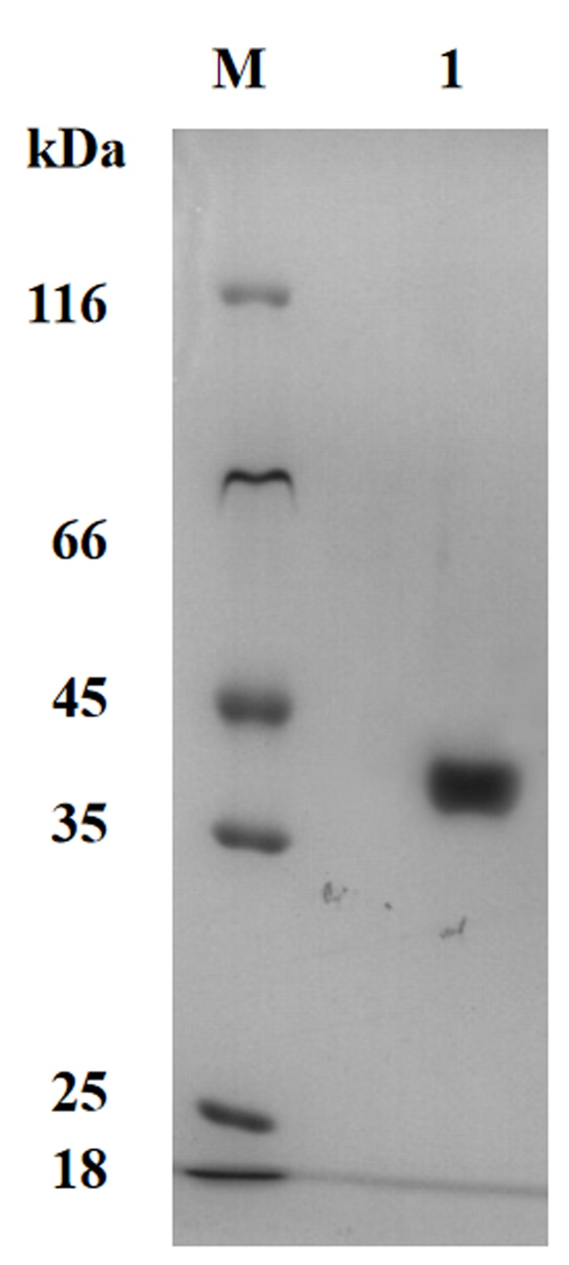

Fig. S2 MS/MS spectrum in negative ion mode of product 2 transformed from Rb2 using HPLC-Q-TOF-MS/MS analysis;
Fig. S3; MS/MS spectrum in negative ion mode of product 3 transformed from Rc using HPLC-Q-TOF-MS/MS analysis;

