Table S1. Structure and MICs (against S. aureus ATCC 43300) of the selected 6 hits.
Drugs | Structure | MIC (μg/mL)
Astemizole | 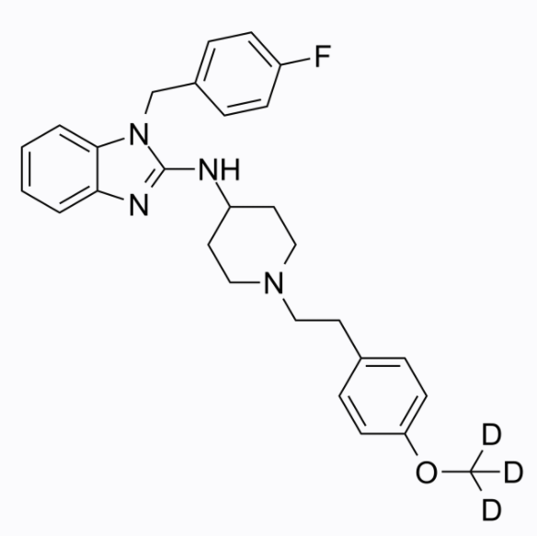 | 32
Fluralaner | 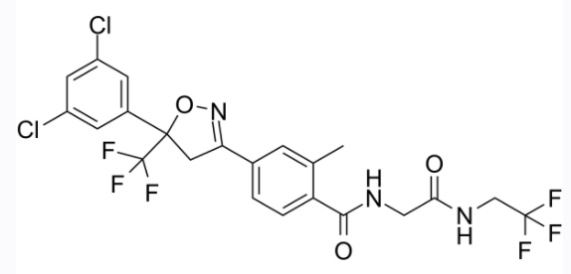 | 32
Asunaprevir | 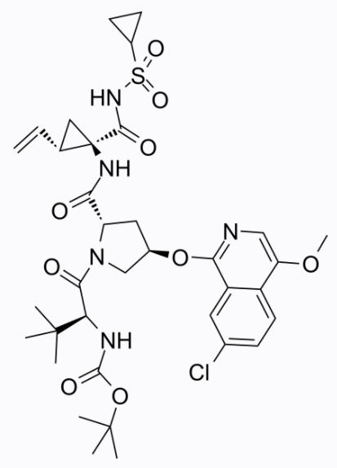 | 32
Voxilaprevir | 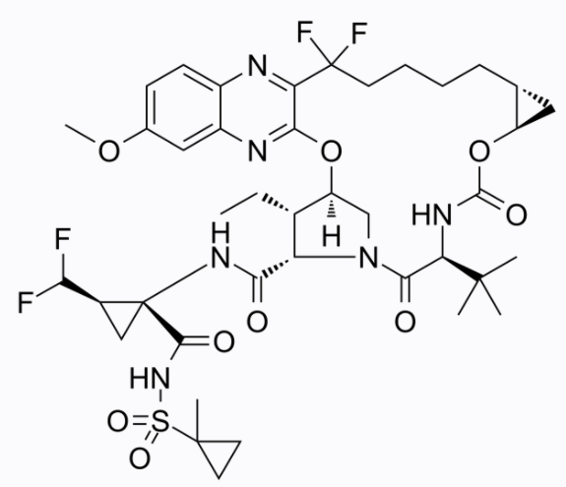 | 64
Daprodustat | 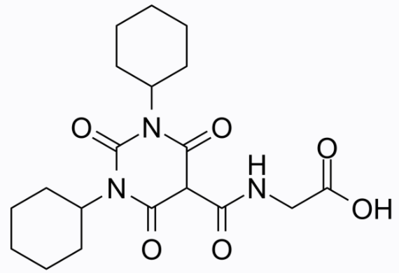 | 32
CERI | 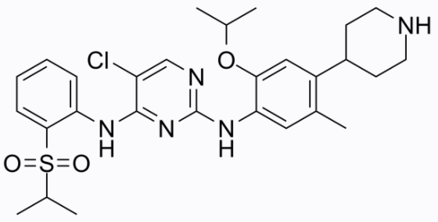 | 16

