JOURNAL: AMB Express
Manuscript title: Enzyme-treated chicory for cosmetics – application assessment and techno-economic analysis
Suvi T. Häkkinen^{1*}, Katarina Cankar², Liisa Nohynek¹, Marjut Suomalainen¹, Jeroen van Arkel², Matti Siika-Aho¹, Anna Twarogowska³, Bart van Droegenbroeck³, Kirsi-Marja Oksman-Caldentey¹
¹ VTT Technical Research Centre of Finland Ltd, Tietotie 2, 02044 Espoo, Finland
² Wageningen University and Research, Wageningen, Netherlands
³ ILVO Institute for agriculture, fisheries and food research, Melle, Belgium
*Corresponding author:
Suvi T. Häkkinen
Senior Scientist, D.Sc.(Tech.)
Industrial Biotechnology and Food Solutions
VTT Technical Research Centre of Finland Ltd
Tietotie 2, P.O.Box 1000, 02044 VTT, Finland
tel.+358 50 561 0720; fax +358 20 722 7001
e-mail: suvi.hakkinen@vtt.fi

Table S1. Composition of the chicory samples.
 |  | Moisture % | Ash g/100g | Protein g/100g | Fat  g/100g | Sugars  g/100g | Fibres  g/100g | Total carbohydrates  g/100g | Dry matter %
#1 | Belgian endive | 87.4 | 0.99 | 0.5 | <0.2 | 5.7 | 4.5 | 6.6 | 12.6
#2 | Industrial chicory root | 76.5 | 0.97 | 1.4 | 0.2 | 3.7 | 4.9 | 16.1 | 23.5
#3 | Industrial chicory root after inulin extraction | 72.1 | 1.58 | 2.4 | 0.8 | <0.2 | 21.3 | 1.9 | 27.9

Table S2. Composition of standard cream formula.
Phase | Compound | INCI name | Amount (%)
A | TEGO CARE 450 | Polyglyceryl-3-methylglucose distearate | 3
A | CITHROL GMS 40 | Glycerol stearate | 3
A | TEGO ARGANOL 1618 | Cetearyl alcohol | 3
A | BERGABEST MCT-OIL 60/40 | Caprylic/capric triglyceride | 6
A | TEGOSOFT OER | Oeyl erucate | 4
B | WATER | Aqua | 78
B | GLYCERIN | Glycerin | 3

Table S3. Scenarios considered.
 | Scenarios | Raw material | Operation period (months per year) | Extract concentration | Solid residue treatment
1 | Baseline | Dried pulp | 11 | Yes | Yes
2 | No extract concentration | Dried pulp | 11 | No | Yes
3 | Fresh pulp | Fresh pulp | 5 | Yes | Yes
4 | Strong integration to inulin plant | Fresh pulp | 5 | Yes | No

Table S4. Applied process parameters for mass and energy calculation based on experimental work and literature.
 | Unit | Bioactive extract | Reference
Enzymatic treatment
Extraction temperature | ºC | 50 | Experimental data
Duration | h | 20 | Assumption based on experimental data
Enzyme inactivation | ºC | 100 | Experimental data
Yield, dry extract/dry biomass (kg/kg) | wt-% | 61 | Experimental data
Enzyme solution input per dry biomass material (kg/kg) | wt-% | 0.5 | Experimental data
pH | - | 5.0 | Experimental data: acetate buffer
Dry biomass input per water input (kg/kg) | % | 5.0 | Experimental data
Mixing electricity consumption | kWh/m³ | 0.6 | Pereira & Leib 2008
Centrifugation
Cake dry matter content | wt-% | 50 | 40-50 % (JRC 2018, EC 2006)
Solids in filtrate | wt-% | 0 | Assumption
Electricity consumption | kWh_{e}/t_{solids in} | 15 | Assumption based on Genck et al. 2008 (10 000 rpm)
Evaporation (MVR)
Product dry matter content | % | 50 | Assumption
Operation temperature | ºC | 40 | Assumption
Evaporated extract | % | 0 | Assumption
Electricity consumption per t of evaporated water | kWh/t_{evaporated water} | 15 | JRC 2018
Rotary dryer
Product dry matter content | % | 90 | JRC 2018 (sugar beet pulp 86-92%)
Extract evaporated | % | 0 | Assumption
Thermal efficiency | % | 55 | Genskow et al. 2008 (Thermal efficiency with steam heated air)
Electricity consumption per kg of feed dry | kWh/kg_{in,dry} | 0.012 | Genskow et al. 2008 (Heat sensitive solid)
Other equipment
Screw conveyor electricity consumption | kWh/t_{solids} | 0.033 | Jansen & Heuning 2021
Thermal efficiency for heating buffer solution/ heating of the mixture to the inactivation temperature |  | 90
Pump efficiency  Pump’s driver efficiency | % | 75  95 | Hannula 2015
Table S5. Applied economic and financial parameters and process operation strategy (location the Netherlands).
Parameter | Unit | Baseline value | Range | Reference/additional information
Dried chicory pulp price (DM 90%) | €/t dry | 370 | 300-440 | Cosucra
Wet chicory pulp price (DM 22%) | €/t dry | 100 |  | Cosucra
Enzyme solution | €/t dry | 100 000 | 40 000 - 150 000 | Estimate
NaOH 100% | €/t dry | 500 |  | Estimate
Acetic acid (glacial 99%) | €/t dry | 500 |  | Estimate
Process water | €/m³_{n} | 1.0 |  | Estimate based on EEA (2013)
Electricity | €/MWh | 70 | 50-100 | Eurostat 2019 (2017: Medium size industry FR 73, BE 81, NL 61)
Heat (low pressure steam) | €/MWh | 40 | 25-55 | Estimate
Waste water | €/m³_{n} | 1.5 |  | Estimate based on EEA (2013)
Product price estimation
Dried solid residue | €/t_{dry} | 145 | 117 - 172 | Estimate based on raw material price and remaining energy content*
Fixed costs
Labour, annual cost of a person to employer | €/a | 70 000 | 60 000 -  80 000 | Estimate (includes overheads)
Number of persons in a shift | - | 2 |  | Estimate
Number of shift (continuous operation) | - | 5
Annual maintenance | % of FCI | 2.0 |  | Peters et al 2004
Operational and financial parameters
Annual operation time | h/a | 7884 | 3592**
 | % | 90 | 41**
Economic lifetime | a | 20
Rate of return | % | 10 | 8-12
* Cost estimation is based on dried chicory pulp price and the decreased energy content left in the solid residue. Based on the extraction process, in which 61% of material is extracted, it is assumed that remaining energy content in the solid residue is 39% and thus the price is 39% of the original chicory pulp price, consequently.
** Scenarios 3 & 4
Mass and energy balances were calculated using spreadsheet software.

Table S6. Amounts of selected carbohydrates, phenolic compounds and sesquiterpene lactones in the three chicory samples. Dry matter was measured by weighing.
 | #1 | #2 | #3
Stachyose (g/100 g DW) | 0.79 | 2.88 | 0.18
Raffinose (g/100 g DW) | 2.29 | 5.59 | 0.23
Saccharose (g/100 g DW) | 25.22 | 8.21 | 0.43
Glucose (g/100 g DW) | 0.07 | 0.11 | 0.01
Fructose (g/100 g DW) | 27.27 | 10.66 | 0.31
4-OH-phenylacetic acid (µg/g DW) | 471.43 | 6.67 | 0.36
Caffeic acid (µg/g DW) | 134.05 | 15.01 | 2.24
Quinic acid (µg/g DW) | 4948.90 | 3902.53 | 47.63
Ferulic acid (µg/g DW) | 0.27 | 0.29 | 0.07
Chlorogenic acid (µg/g DW) | 455.97 | 726.47 | 26.43
Chicoric acid (µg/g DW) | 1.27 | 15.15 | 4.33
Lactucin (µg/g DW) | >120 | 33.18 | 3.24
Dihydrolactucin (µg/g DW) | >120 | >120 | 15.48
Lactucopricin (µg/g DW) | 39.89 | 13.56 | 0.42
Dihydrolactucopicrin (µg/g DW) | 13.01 | 8.09 | 4.68
Dry matter (%) | 91.4 | 90.7 | 93.2

Table S7. Activity profiles and protein content (mg/ml) of used enzymes. Activities are expressed as nkat/ml, except cellulase activity as FPU/ml, and assayed in pH 5, except inulinase in pH 6.
Enzyme | Cellu-lase ª | Endoglucanase ^{b} | β -glucosidase ^{c} | Xylanase ^{d} | Polygalaturonase ^{e} | Inulinase (pH 6,0) ^{f} | Protein content ^{g}
Inulinase (Fructozyme L) |  |  |  |  |  | 19000 | 16.6
Pectinase (Pectinex Smash) |  |  |  |  | 214600 |  | 59
Cellulase  (Cellic CTec2) | 135 |  |  |  |  |  | 257
β-glucosidase (Novozym-188) |  | 736 | 5908 | 2968 | 2079 |  | 104
Xylanase  (Depol 40) | 23 | 21660 | 646 | 21317 | 124500 |  | 105
Esterase  (Depol 740L) | 1 | 1360 | 434 | 15342 |  |  | 29
*Bio Rad Lowry, after acetone precipitation
ª) Ghose (1987)
^{b}) IUPAC (1987)
^{c}) Bailey and Nevalainen (1981)
^{d}) Bailey et al. (1992)
^{e}) Bailey and Pessa (1989)
^{f}) Abu El-souond et al. (2014)
^{g}) Lowry et al. (1951)

Table S8. MSn results per selected peak of LC-Orbitrap-FTMS chromatogram of sample 3A (pectinase + xylanase) (see Figure S1): The retention time, the selected mass for fragmentation, the characteristic mass fragments and the tentative peak identification.
Peak nr. | RT (min.) | Parent ion [M]+(M/Z) | Characteristic MS fragment(s) | Tentative identification
1 | 12.64 | 505.16783 | 475.29132 + 392.28407 + 277.11816 | Sesquiterpene lactone breakdown product
2 | 15.90 | 292.21175 | 264.1805 + 188.12805 + 364.23279 | Sesquiterpene lactone breakdown product
3 | 18.58 | 570.33960 | 528.29279 + 381.24234 + 592.32147 | Not identified
4 | 10.30 | 302.207642 | 344.25424 | Not identified
5 | 9.18 | 556.33369 | 256.32331 + 542.31812 + 539.31875 | Nitrogen containing alkane
6 | 9.88 | 391.28455 | 332.21786 + 207.98514 | Nitrogen containing alkane
7 | 7.53 | 391.28455 | 377.18176 + 328.22292 | Nitrogen containing alkane
8 | 14.31 | 391.28455 | 247.15398 + 292.21179 | Nitrogen containing alkane
9 | 15.09 | 391.28455 | 263.14908 + 308.20685 + 318.19119 | Nitrogen containing alkane
10 | 8.18 | 391.28455 | 304.16547 + 207.98523 + 346.19711 | Nitrogen containing alkane

Table S9. Overall mass balance of the process (baseline, scenario 1).
Stream | Total flow rate (a.r.) | Dry matter content | Dry solid content | Flow rate (dry) | PP+SL
 | kg/h | % | % | kg/h dry | kg/h dry
IN
Chicory pulp | 211 | 90 % | 90 % | 190
Water | 3 785 | 0 % | 0 % | 0
Enzyme | 1.0 | 100 % | 100 % | 1.0
Glacial acetic acid | 23 | 100 % | 100 % | 23
Sodium hydroxide | 11 | 100 % | 100 % | 11
Total | 4 031 |  |  | 225
OUT
Animal feed | 86 | 90 % | 87 % | 77
Extract | 295 | 50 % | 50 % | 148 | 3.9
Evaporated water from rotary dryer | 63 | 0 % | 0 % | 0
Condensed water from evaporation | 3587 | 0 % | 0 % | 0
Total | 4 031 |  |  | 225 | 3.9

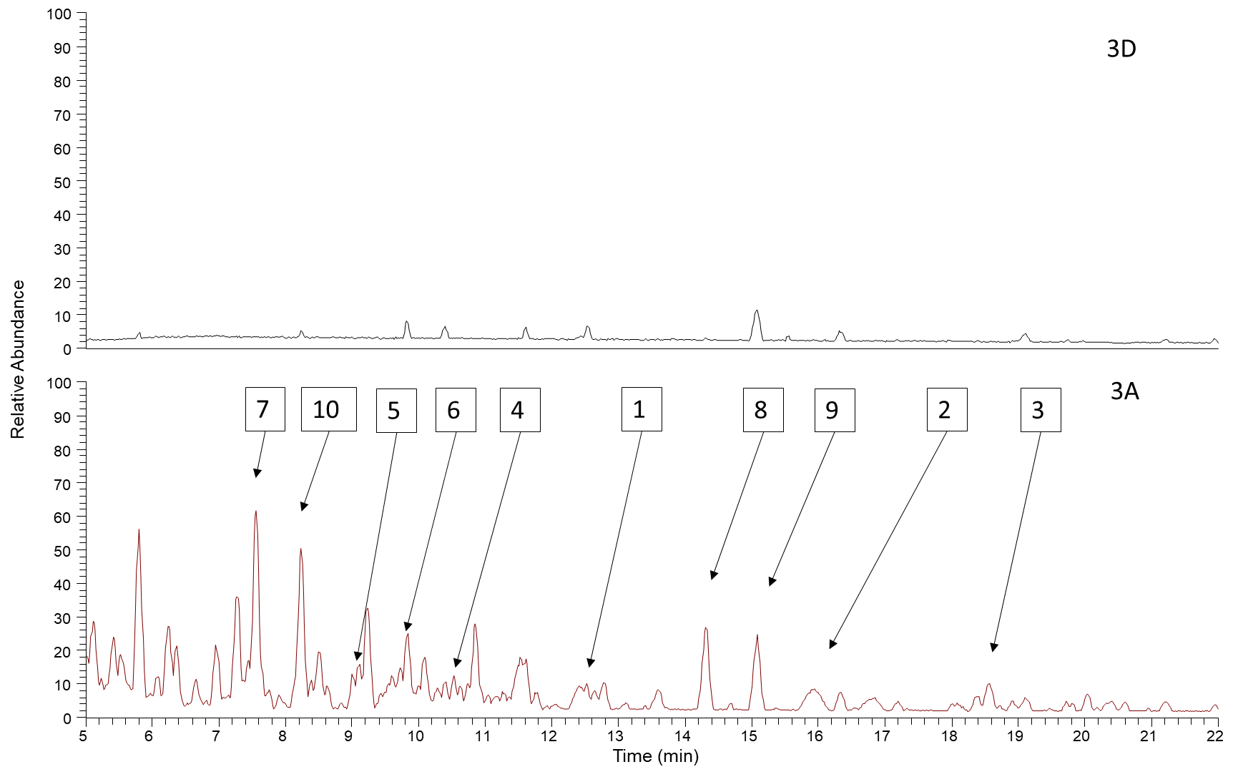

Figure S1 LC-Orbitrap-FTMS chromatogram of samples 3A (pectibase + xylanase) and 3D (no enzyme). Chromatograms are shown to scale. The peaks from the enzyme treated sample 3D that were selected for MSMS analysis are indicated by corresponding numbers.

Figure S2 Electricity demand in different scenarios.

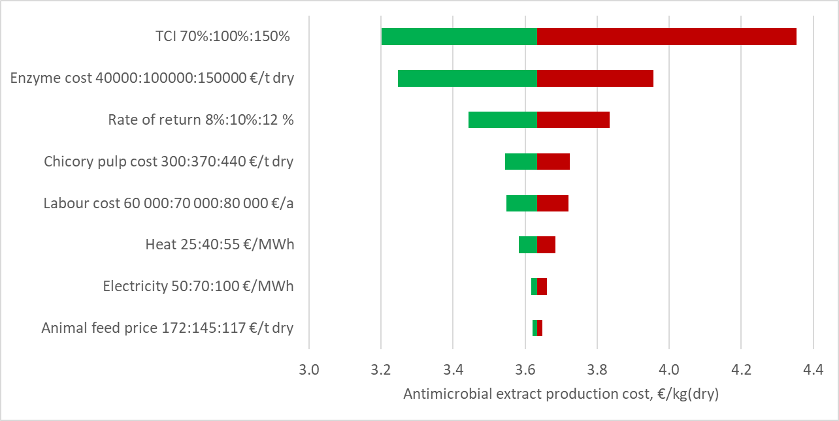
Figure S3. The sensitivity of production cost to the selected parameters in techno-economic scenario 1. The sensitivity assessment shows the effect of one changed parameter to the production cost. The assessment was done to one parameter at a time. The lower and upper bounds of a parameter are presented in the y-axis, left the more competitive, then the base case and the less competitive. The base case is in the figure the point between the green bar and the red bar, while the green bar shows the potential up to the more beneficial value of the parameter, and the red bar the result to the less beneficial value of the parameter.

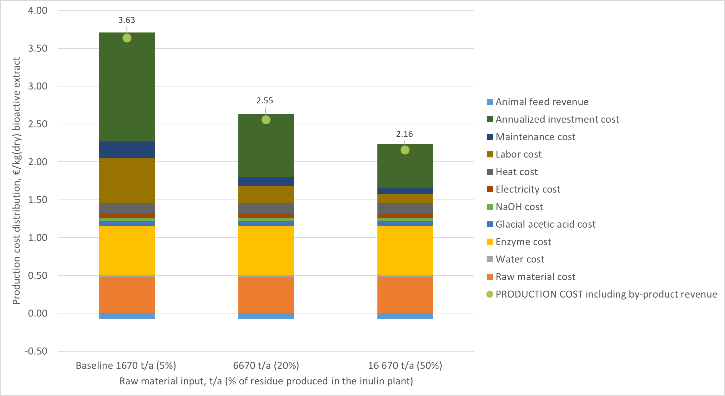
Figure S4. The sensitivity of production cost to capacity (scenario 1). The analysis shows the decrease of the production cost when increasing the production capacity, from the baseline (1670 t/a or 5% of the available raw material at a plant) to either 6670 t/a (20%) or 16670 t/a (50%) of the available raw material.

Bibliography

Abu El-souod, S. M., Mohamed, T. M., Ali, E. M. M., El-badry, M. O. & El-keiy, M. M. Partial purification of extracellular exo-inulinase from Ulocladium atrum. J. Genet. Eng. Biotechnol. 12, 15–20 (2014).
Bailey, M. J. & Nevalainen, K. M. H. Induction, isolation and testing of stable Trichoderma reesei mutants with improved production of solubilizing cellulase. Enzyme Microb. Technol. (1981). doi:10.1016/0141-0229(81)90076-4
Bailey, M. J. & Pessa, E. Strain and process for production of polygalacturonase. Enzyme Microb. Technol. (1990). doi:10.1016/0141-0229(90)90098-B
Bailey, M. J., Biely, P. & Poutanen, K. Interlaboratory testing of methods for assay of xylanase activity. J. Biotechnol. (1992). doi:10.1016/0168-1656(92)90074-J
EC (European Commission). 2006. Best Available Techniques in the Food, Drink and Milk Industries. August 2006. Available in http://eippcb.jrc.ec.europa.eu/reference/BREF/fdm_bref_0806.pdf
EEA (European Environment Agency). 2013. Assessment of cost recovery through water pricing. EEA Technical report No 16/2013.
Eurostat. 2019. Electricity prices by type of user -Medium size industry. Available (16.4.2019) at https://ec.europa.eu/eurostat/tgm/refreshTableAction.do?tab=table&plugin=1&pcode=ten00117&language=en
Genck W.J., McGillicuddy J.K., et al. 2008. Liquid-solid operations and equipment. In Perry’s Chemical Engineers’ Handbook 8th Edition, editor Don W. Green. p. 18-121.
Genskow L.R., Beimesch W.E., Hecht J.P., Kemp I.A., Langrish T., Schwartzbach C., Smith F.L. 2008. Psychometry, evaporative cooling and solids drying. In Perry’s Chemical Engineers’ Handbook 8th Edition, editor Don W. Green. p. 12-77.
Ghose, T. K. Measurement of cellulase activities. Pure Appl. Chem. (1987). doi:10.1351/pac198759020257
Hannula I. 2015. Synthetic fuels and light olefins from biomass residues. carbon dioxide and electricity. VTT Science 107. https://www.vttresearch.com/sites/default/files/pdf/science/2015/S107.pdf
Jansen & Heuning. 2021. Calculation screw conveyor. Available at https://www.jh.nl/en/berekeningsprogramma/
JRC. 2018. Best Available Techniques in the Food, Drink and Milk Industries. Final draft version (October 2018). Available in http://eippcb.jrc.ec.europa.eu/reference/BREF/FDM/FDM_02-10-2018BW.pdf
Lowry, O. H., Rosebrough, N. J., Farr, A. L. & Randall, R. J. Protein measurement with the Folin phenol reagent. J. Biol. Chem. (1951). doi:10.1016/s0021-9258(19)52451-6
Pereira C.J., Leib T.M. 2008. Reactors. In Perry’s Chemical Engineers’ Handbook 8th Edition, editor Don W. Green. p. 19-44.
Union, I., Pure, O. F. & Chemistry, A. International Union of Pure Commission on Biotechnology * Measurement of. Pure Appl. Chem. (1987). doi:10.1351/pac198759020257

