Additional file S1

Title: Bioassay guided isolation and characterization of lead antimicrobial compounds from Acacia hydaspica plant extract.

Tayyaba afsar¹, Suhail Razak^{1*}, Ali Almajwal¹, Maria Shabbir^{2,} Khushbukhat Khan^{2,} Janeen Trembly^{3,4,5}, Nawaf W. Alruwaili¹.
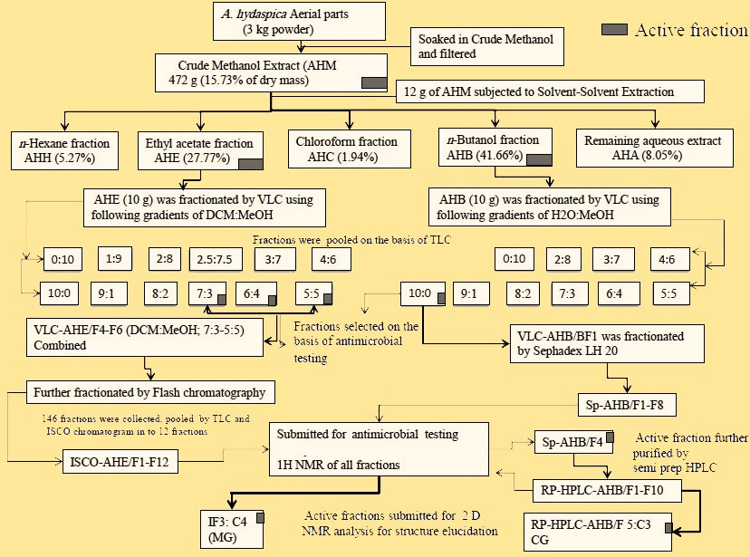
Figure S1: Flowchart summarization of the bioassay guided fractionation and compound isolation.

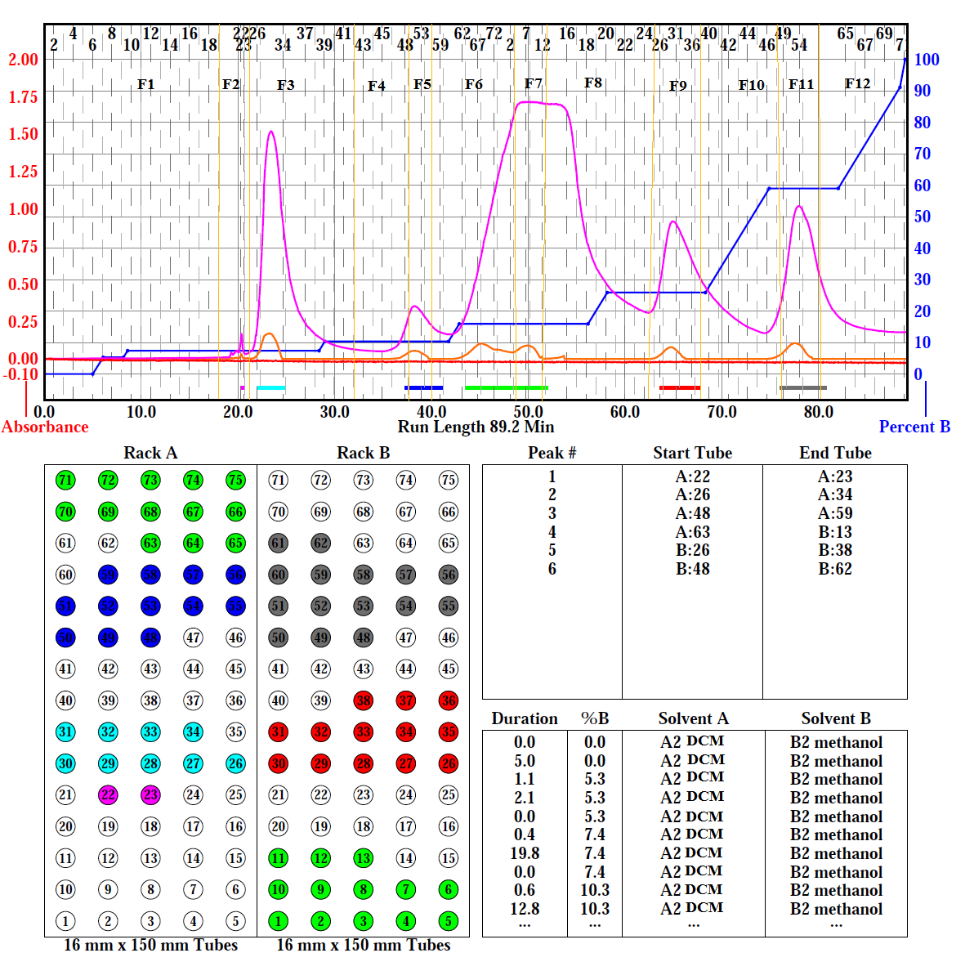
Figure 2: ISCO chromatogram showing the step gradient run and pattern of spectral peaks, yellow lines indicates the pooling arrangement of fractions.

Figure S3: Analytical HPLC Chromatogram of Sp-AHB/F4 at 280nm. Method: 0 min-5min; 15% B in 85% A (isocratic run), 5–25min; up to 50% B in 50% A, 25-30min; upto 100% B, 30.1-35min; 15% B in 85% A (isocratic run).
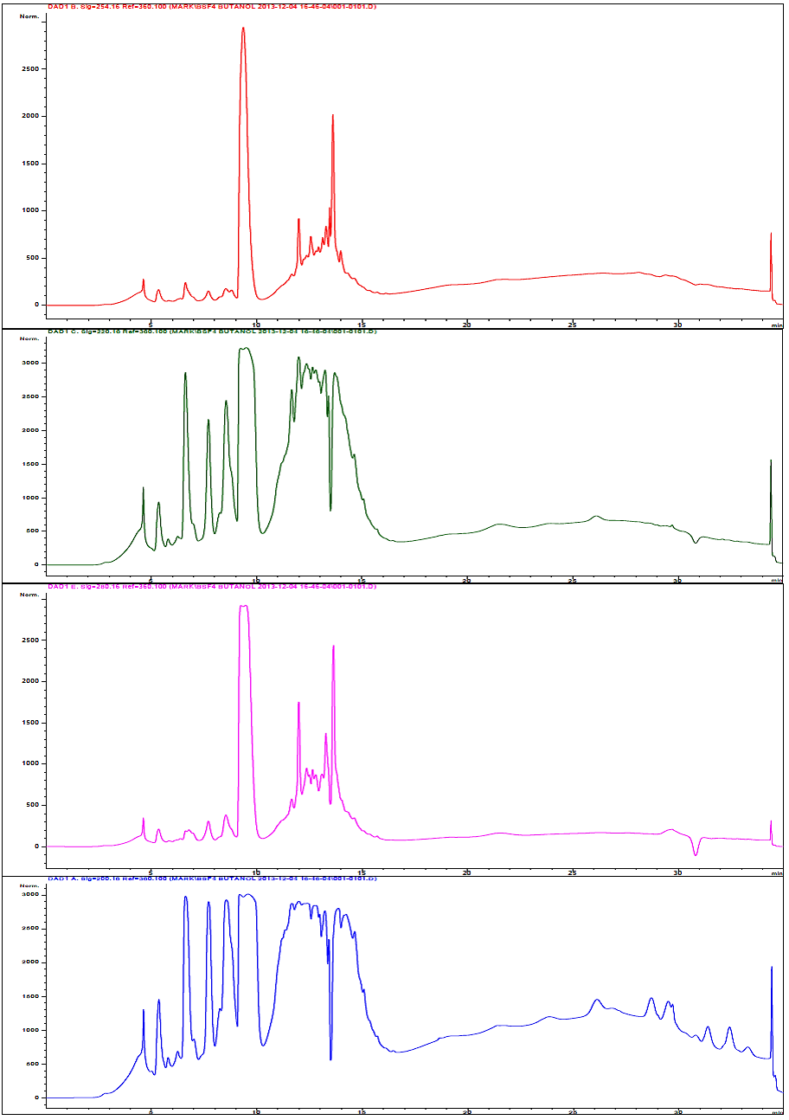
Figure S4: Analytical HPLC Chromatogram of Sp-AHB/F4 at various wavelengths. Method: 0 min-5min; 15% B in 85% A (isocratic run), 5–25min; up to 50% B in 50% A, 25-30min; upto 100% B, 30.1-35min; 15% B in 85% A (isocratic run).
Figure S5: Semi-prep RP-HPLC chromatograph of Sp-AHB/F4 fraction indicating the partitioning of fractions according to the spectral peaks. Method: 0 min - 5min; 15% B in 85% A (isocratic run), 5 - 25 min; up to 70% B in 30% A, 25 - 27min; up to 100% B, 27.1 - 32 min; 15% B in 85% A (isocratic run).
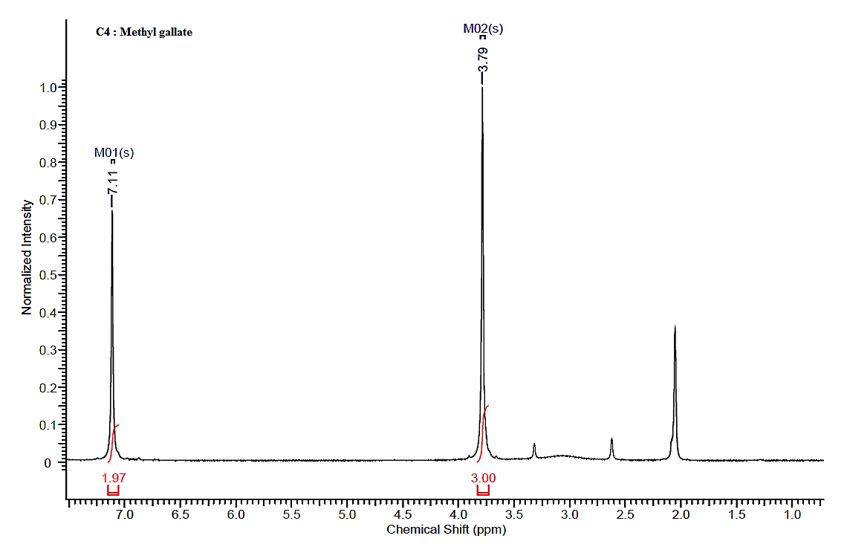Figure S6: 1H NMR spectrum of Methyl gallate (MG). Solvent: acetone-d6, Frequency (MHz):599.67, Nucleus: H, Temperature: 25ºC, Pulse sequence: s2pul, Acquisition time (sec):1.704, Number of transits: 16, Original point count: 16384, Spectrum offsets (Hz): 3598.0154, Spectrum type: Standard, sweep width (Hz):9615.4.

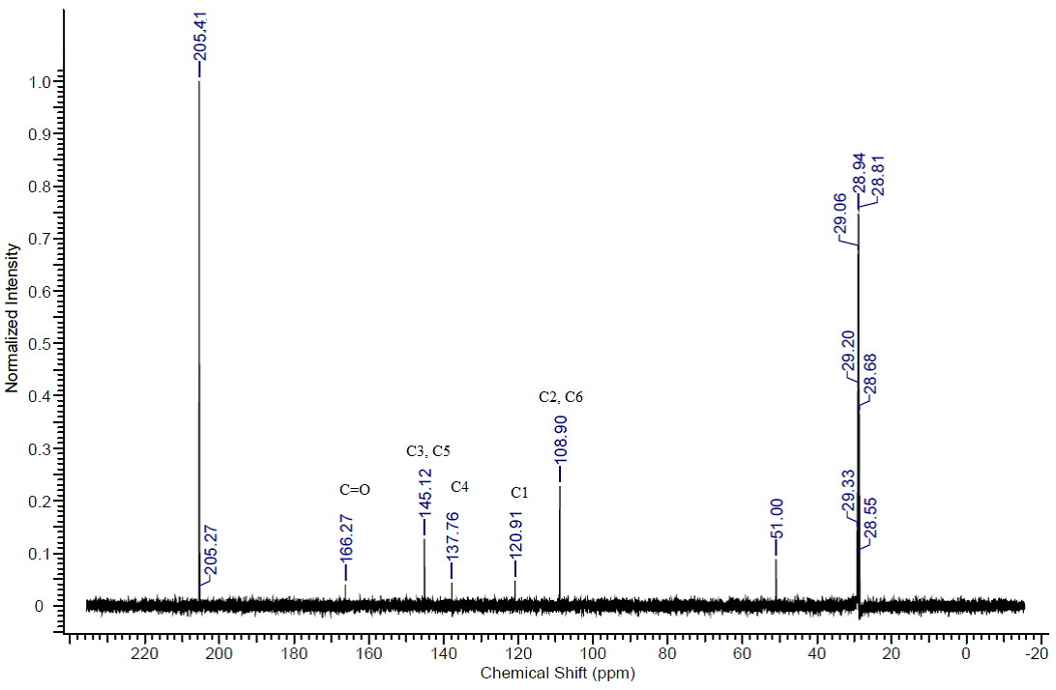
Figure S7: 13C NMR spectrum of Methyl gallate (MG).
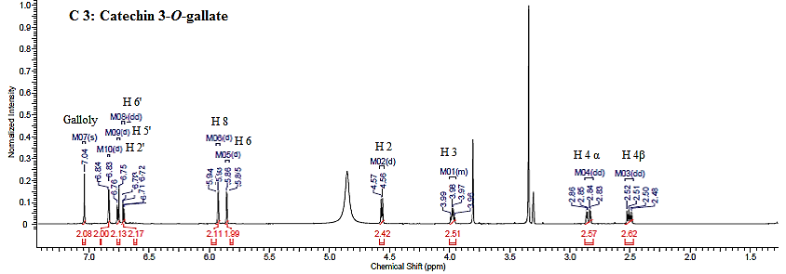
Figure S8: 1H NMR spectrum of Catechin 3-O-gallate (CG). Solvent: methanol-d4, Frequency (MHz):599.67, Nucleus: H, Temperature: 25ºC, Pulse sequence: s2pul, Acquisition time (sec):1.7039, Number of transits: 32, Original point count: 16384, Spectrum offsets (Hz): 3598.0154, Spectrum type: Standard, sweep width (Hz):9615.38.
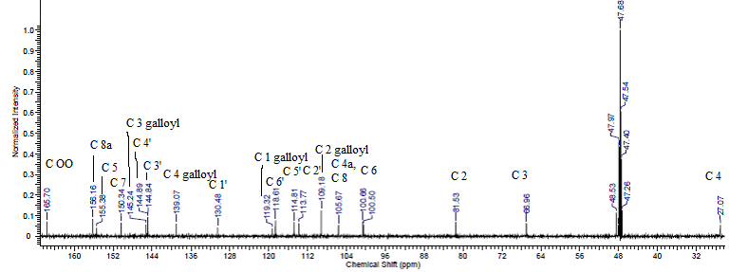
Figure S9: 13C NMR spectrum of Catechin 3-O-gallate (CG).

