Additional file

Journal: AMB Express
TITLE: Antimicrobial, Antiproliferative Activities and Molecular Docking of Metabolites from Alternaria alternata

Authors: Heba T. Khazaalª; Mohamed T. Khazaal^{b}; Ahmed S. Abdel-Razek^{c}; Ahmed A. Hamed^{c}; Hassan Y. Ebrahimª; Reham R. Ibrahimª; Mokhtar Bishr^{d}; Yara E. Mansour^{e}; Rabab A. El Dibª; Hesham S. M. Soliman^{a, f *}

ªDepartment of Pharmacognosy, Faculty of Pharmacy, Helwan University, Ain-Helwan, Cairo 11795, Egypt.
^{b}Botany and Microbiology Department, Faculty of Science, Helwan University, Cairo 11795, Egypt.
^{c}Microbial Chemistry Department, National Research Center, 33 El-Buhouth Street, Giza 12622, Egypt.
^{d}Plant General Manager and Technical Director of the Arab Company for Pharmaceuticals and Medicinal, Plants, Cairo, Egypt.
^{e}Pharmaceutical Organic Chemistry Department, Faculty of Pharmacy, Helwan University, Ain-Helwan, Cairo 11795, Egypt.
^{f}PharmD program, Egypt-Japan University of Science and Technology (E-JUST), New Borg El-Arab City, 21934 Alexandria, Egypt.

* Corresponding Author:
Prof. Hesham Soliman
e-mail: hesham.soliman@ejust.edu.eg
PharmD Program
Egypt-Japan University of Science and Technology (E-JUST),
New Borg El-Arab City, 21934 Alexandria, Egypt.

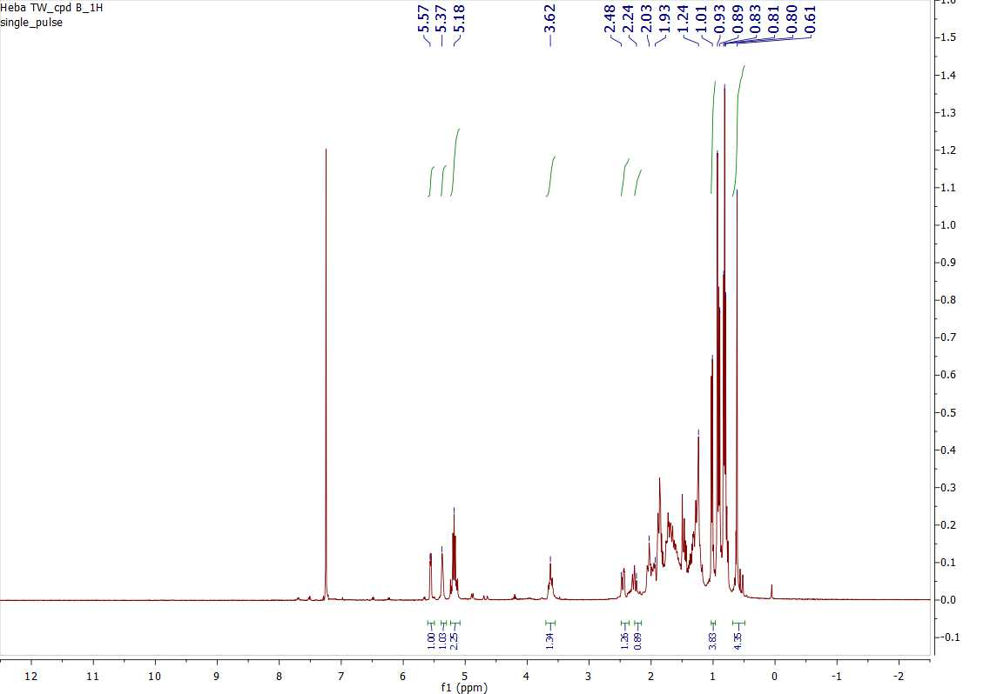
Figure S1. ¹H NMR spectrum (400 MHz, CDCl₃) of compound 1

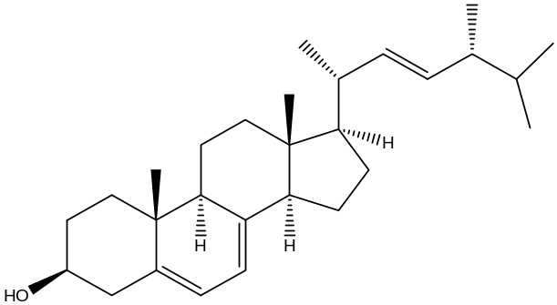

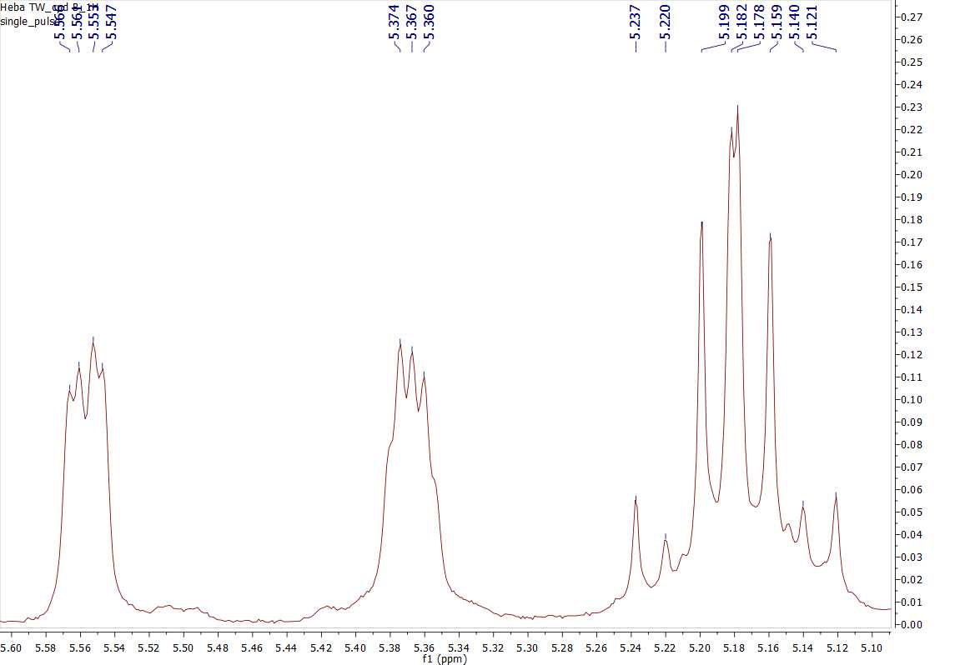

Figure S2. ¹³C NMR spectrum (100 MHz, CDCl3) of compound 1
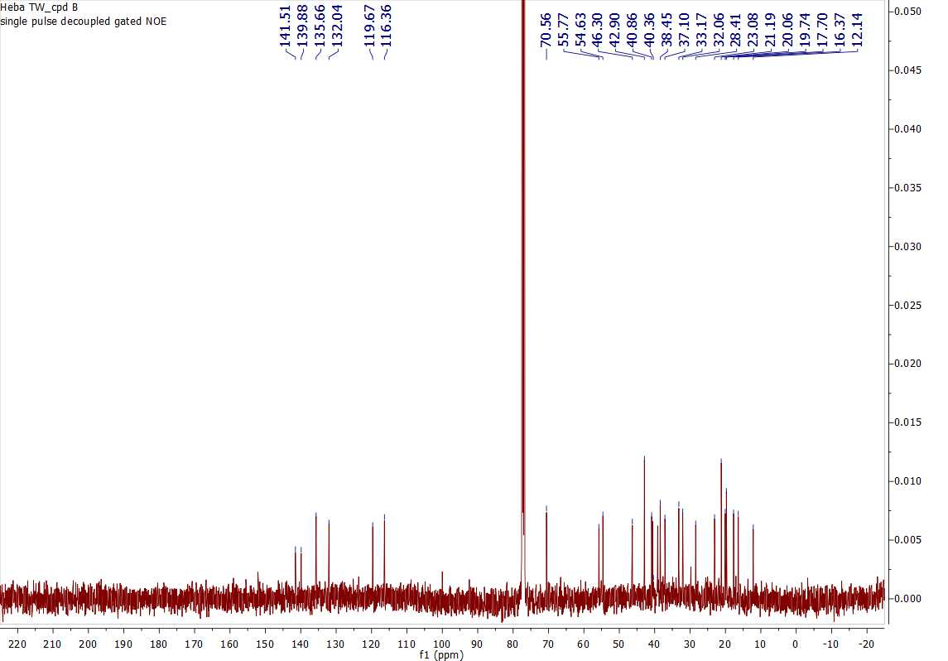

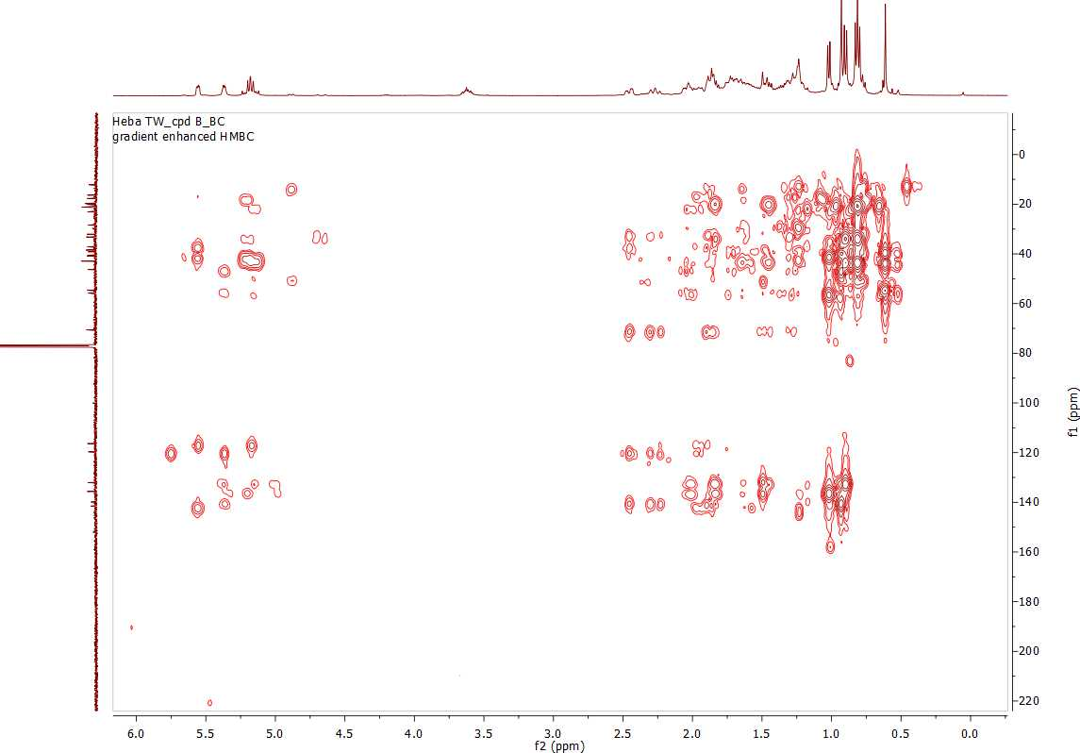
Figure S3. HMBC spectrum of compound 1

Figure S4. ¹H NMR spectrum (400 MHz, CDCl₃) of compound 2
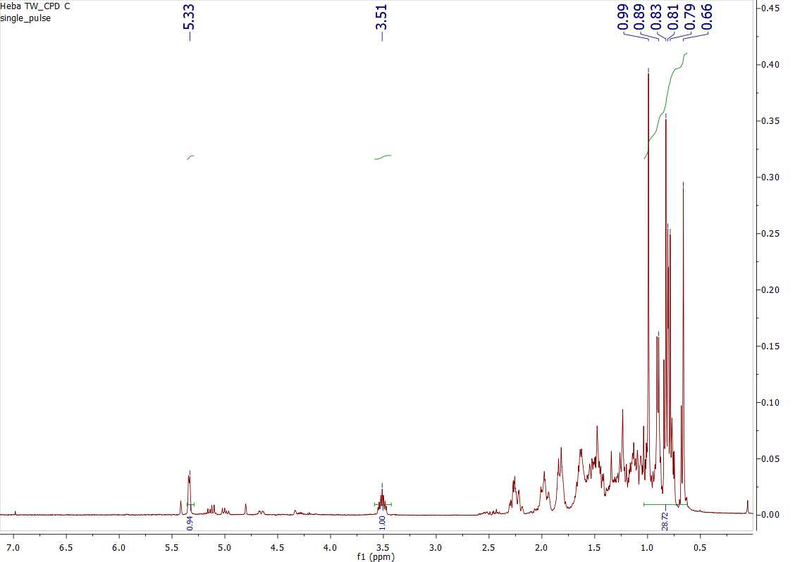
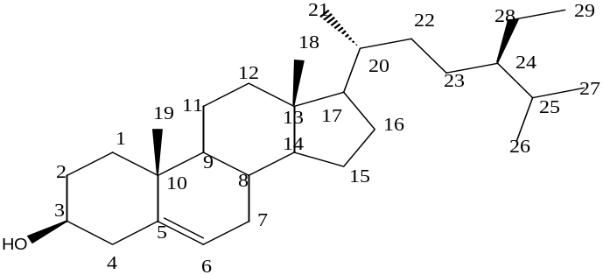

Figure S5. ¹H NMR spectrum (400 MHz, CDCl₃) of compound 2
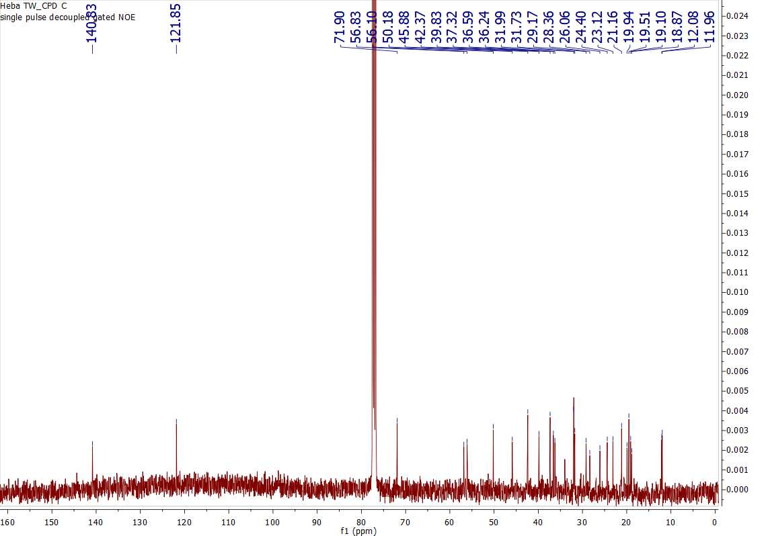

13C NMR spectrum (100 MHz, CDCl3) of compound 2

Figure S6. Positive ESI-MS spectrum of compound 3
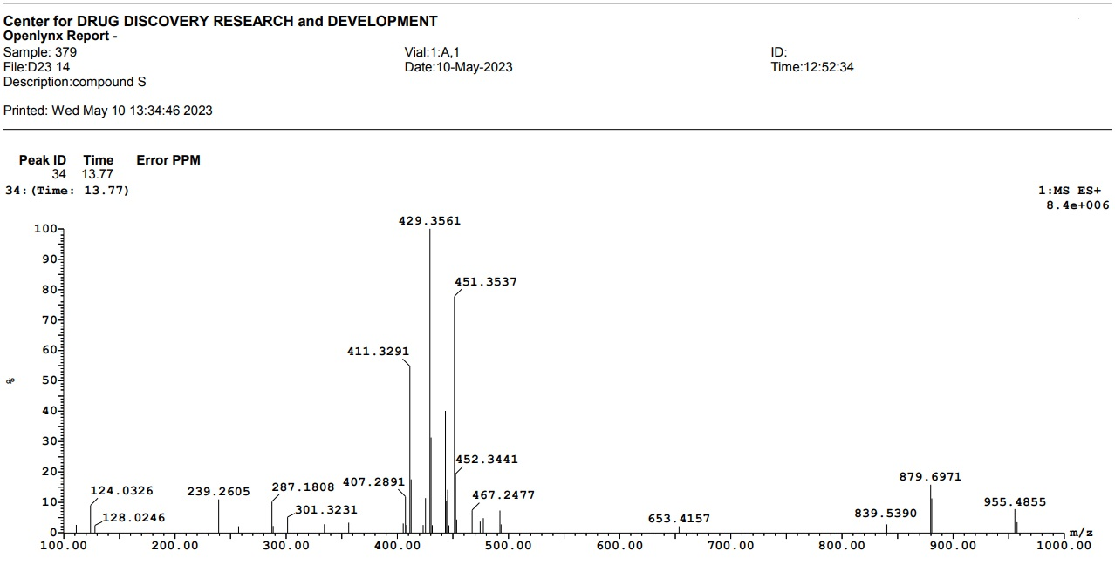

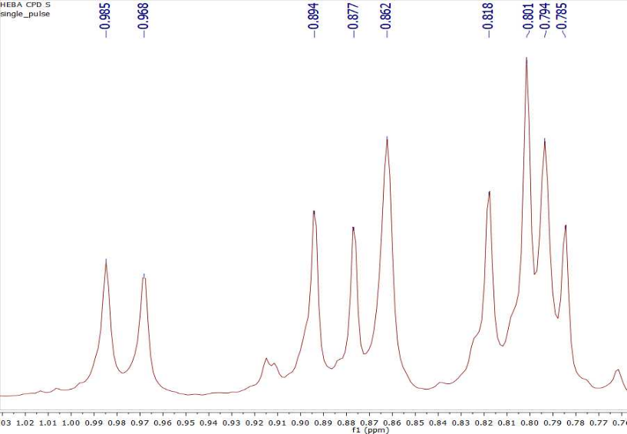
Figure S7. ¹H NMR spectrum (400 MHz, CDCl₃) of compound 3
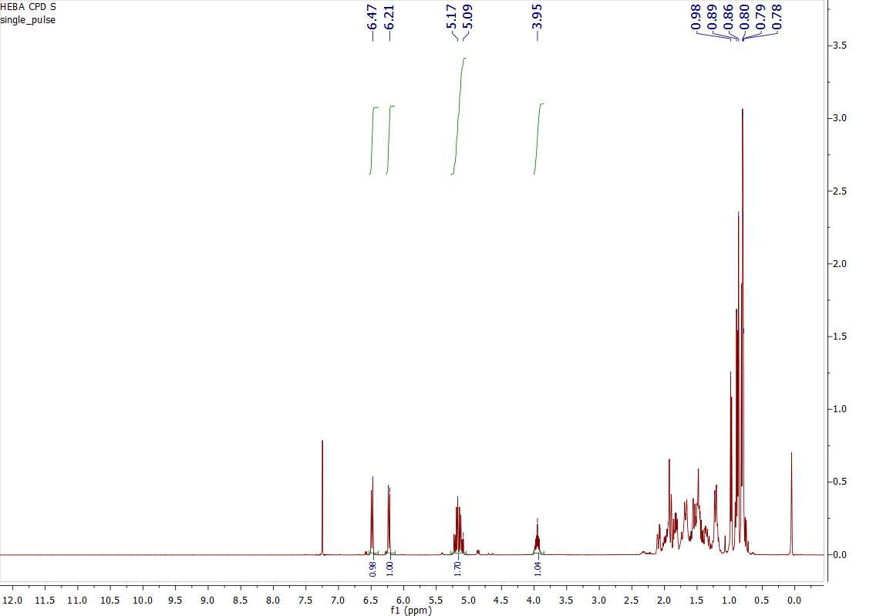
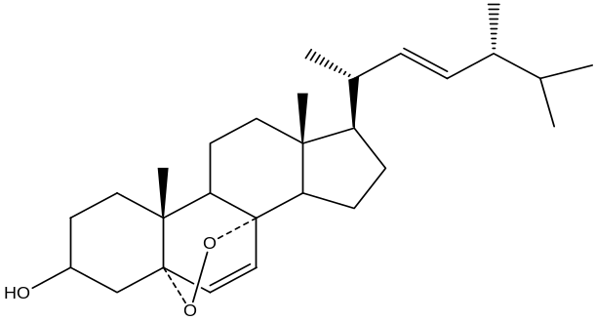

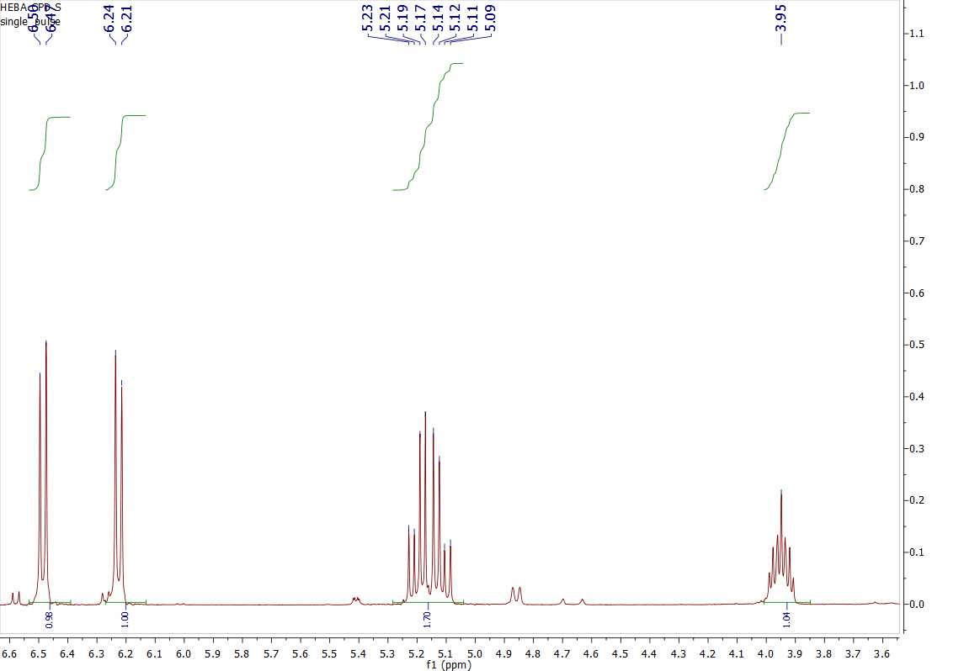

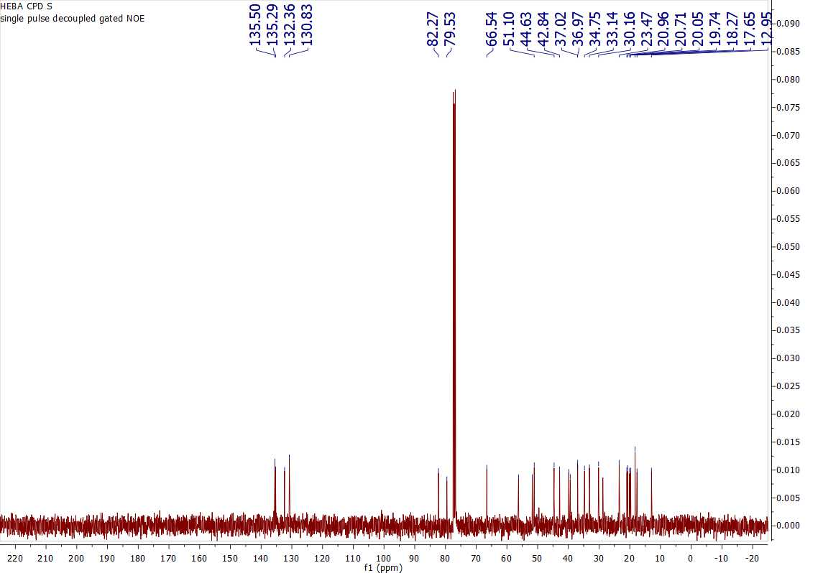
Figure S8. ¹³C NMR spectrum (100 MHz, CDCl3) of compound 3

Figure S9. HMQC spectrum of compound 3
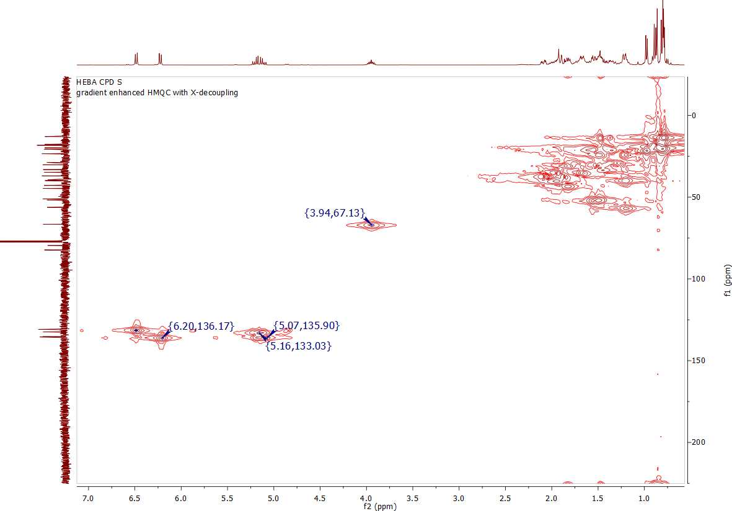

Figure S10. HMBC spectrum of compound 3
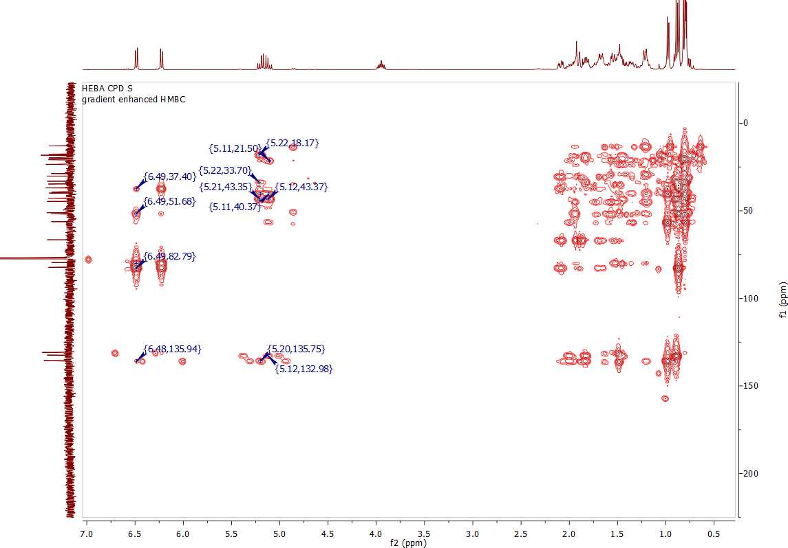

Figure S11. Positive ESI-MS spectrum of compound 4

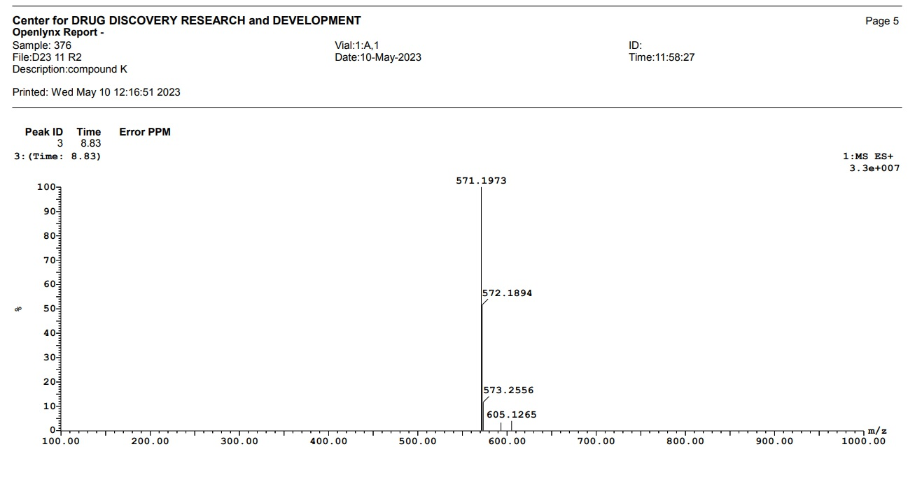

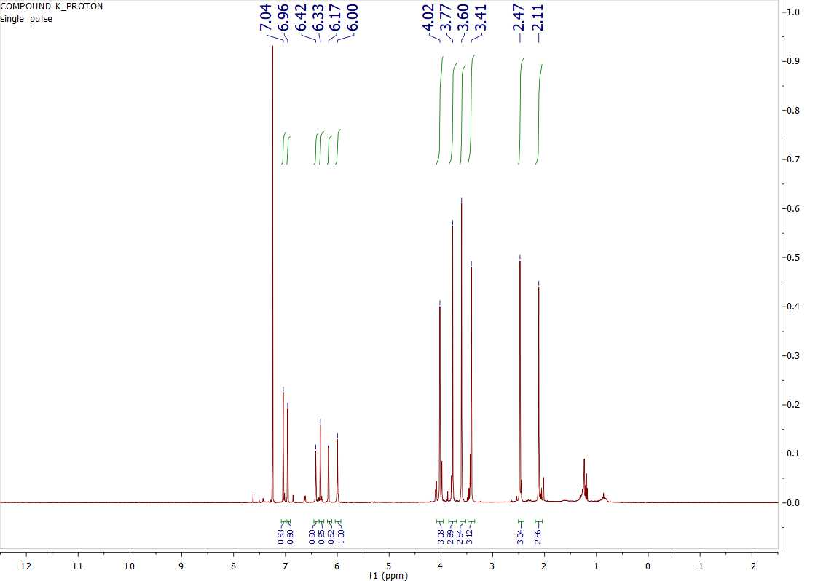
Figure S12. ¹H NMR spectrum (400 MHz, CDCl₃) of compound 4

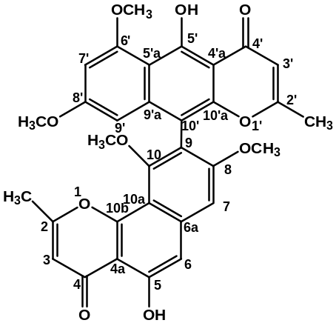

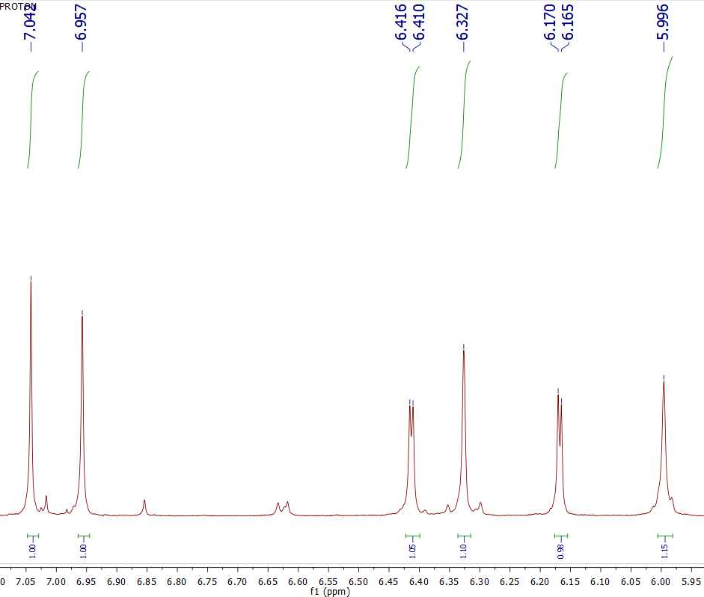

Figure S13. 13C NMR spectrum (100 MHz, CDCl3) of compound 4
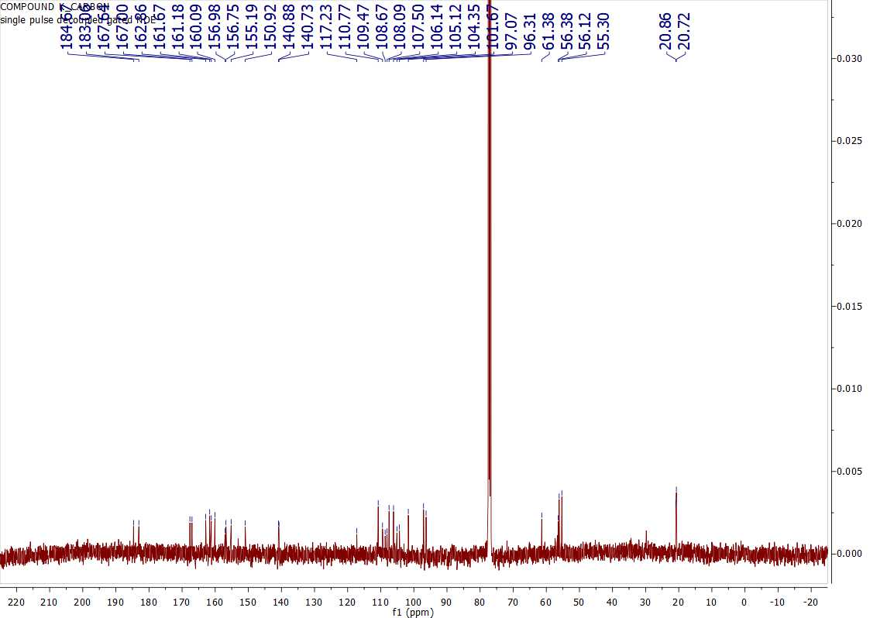

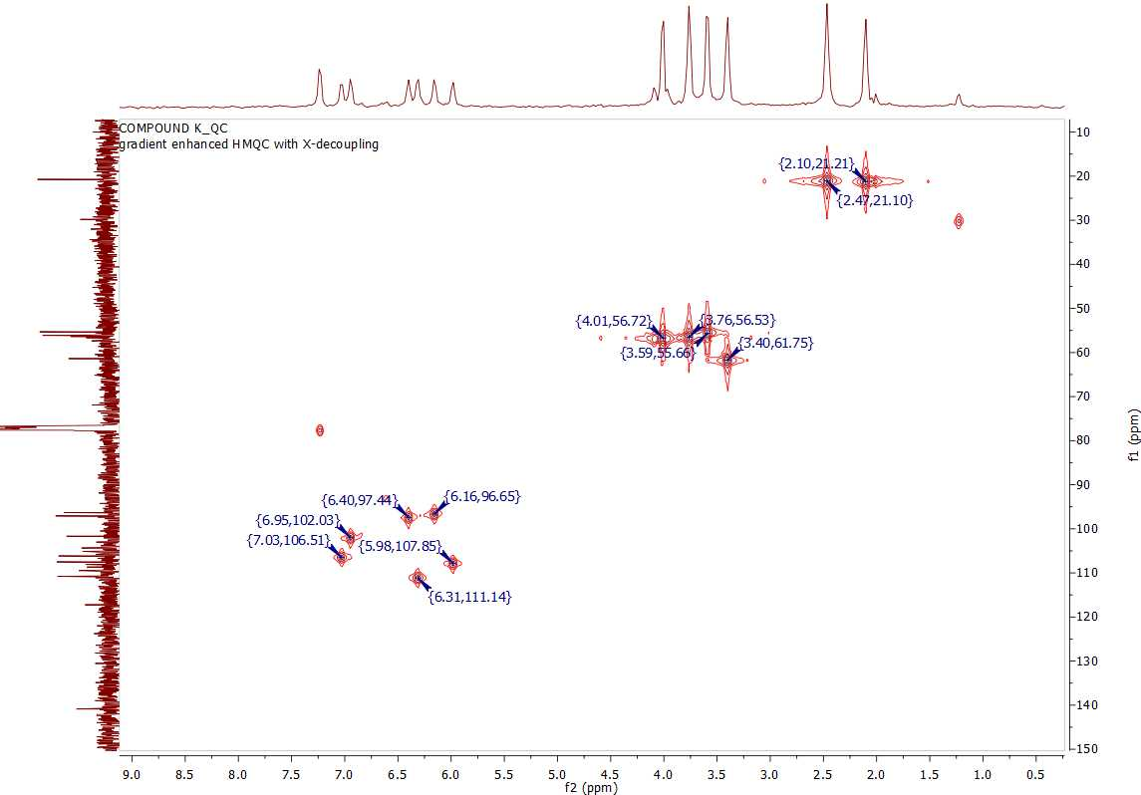
Figure S14. HMQC spectrum of compound 4

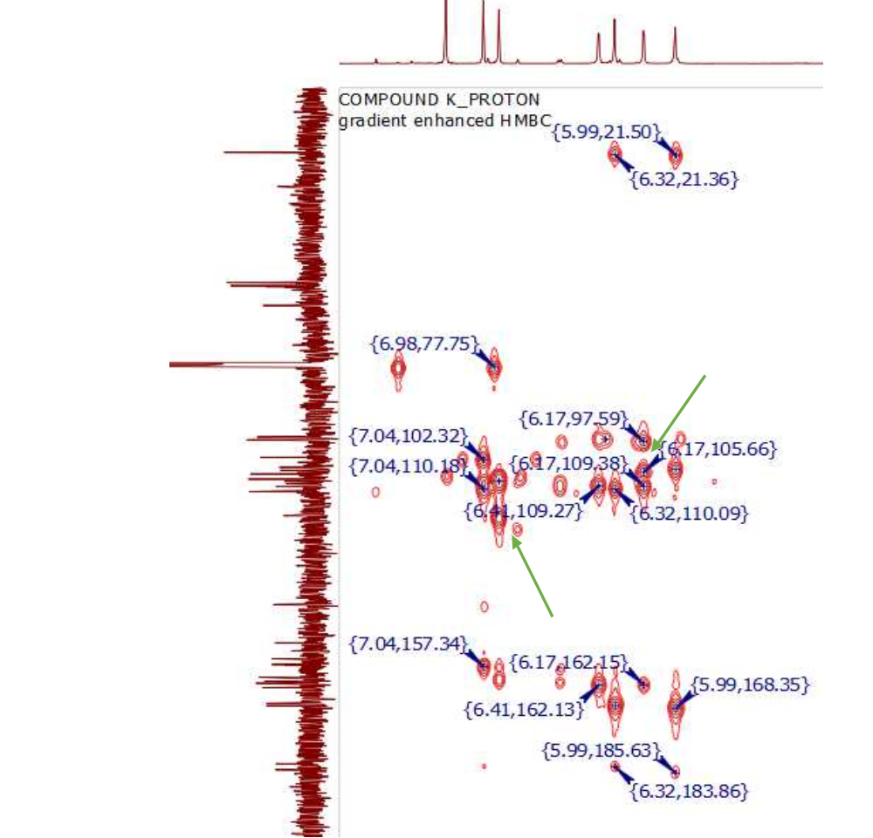
Figure S15. HMBC spectrum of compound 4

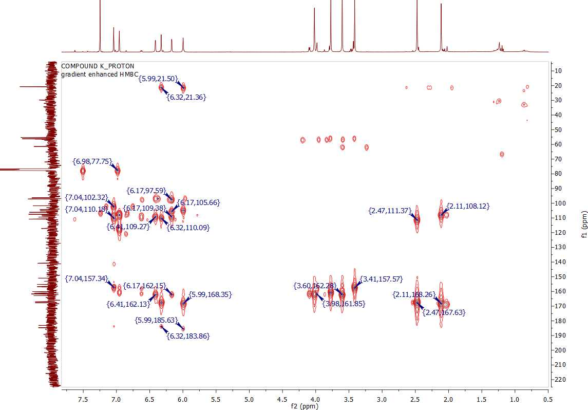
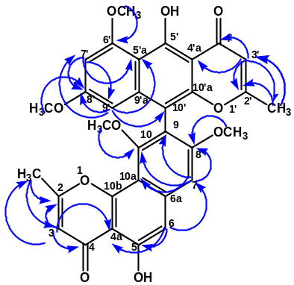

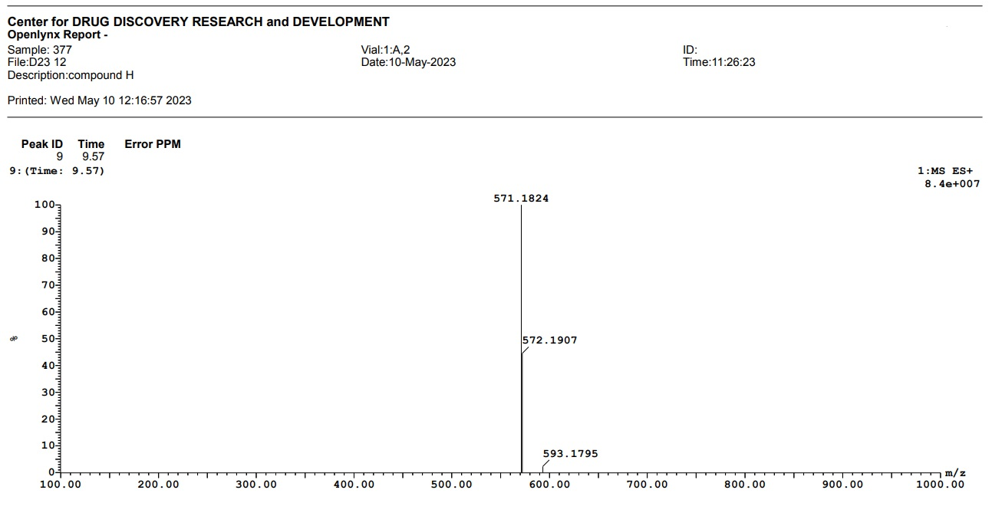
Figure S16. Positive ESI-MS spectrum of compound 5

Figure S17. ¹H NMR spectrum (400 MHz, CDCl₃) of compound 5
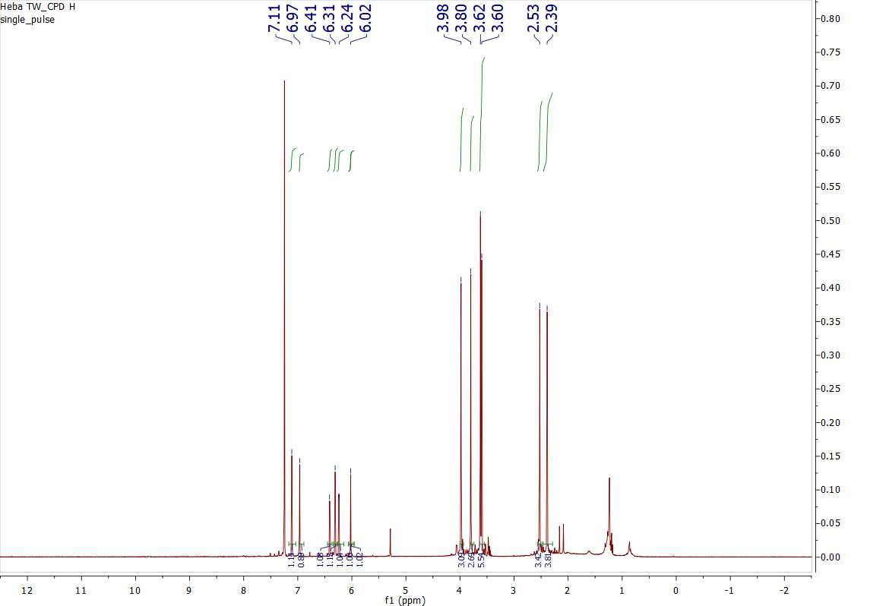
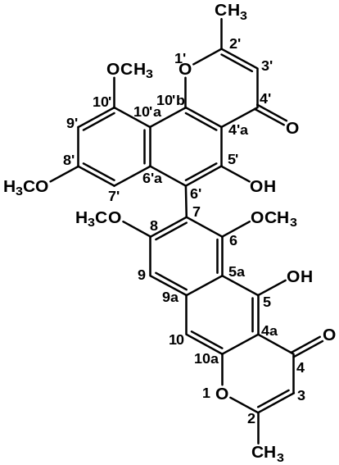
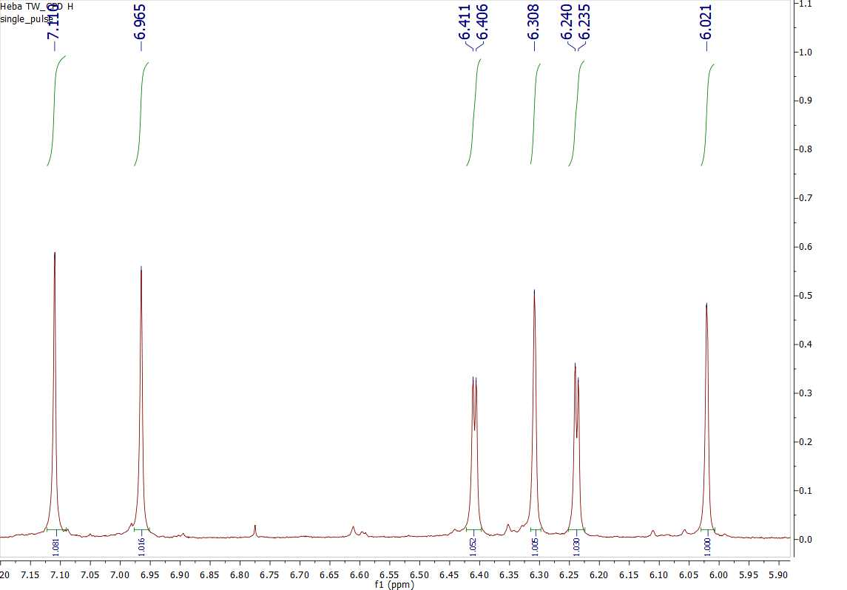

Figure S18. ¹³C NMR spectrum (100 MHz, CDCl₃) of compound 5
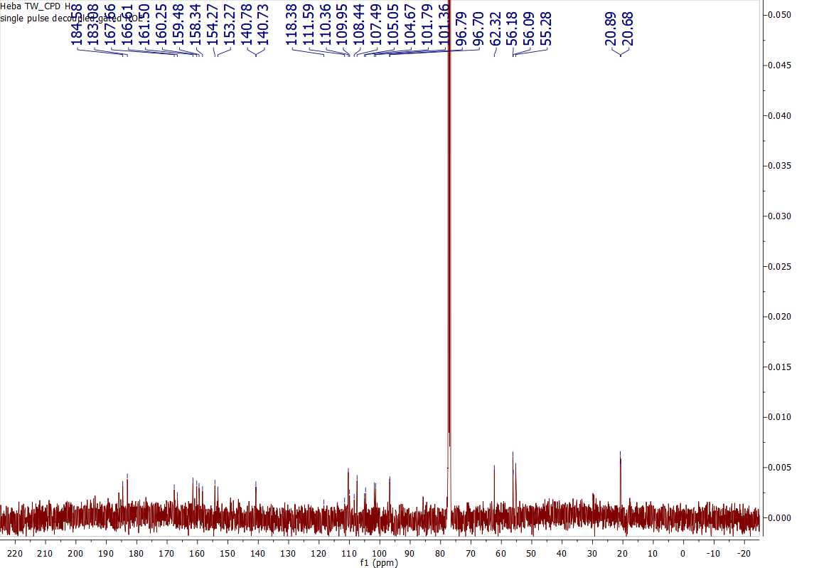

Figure S19. HMQC spectrum of compound 5
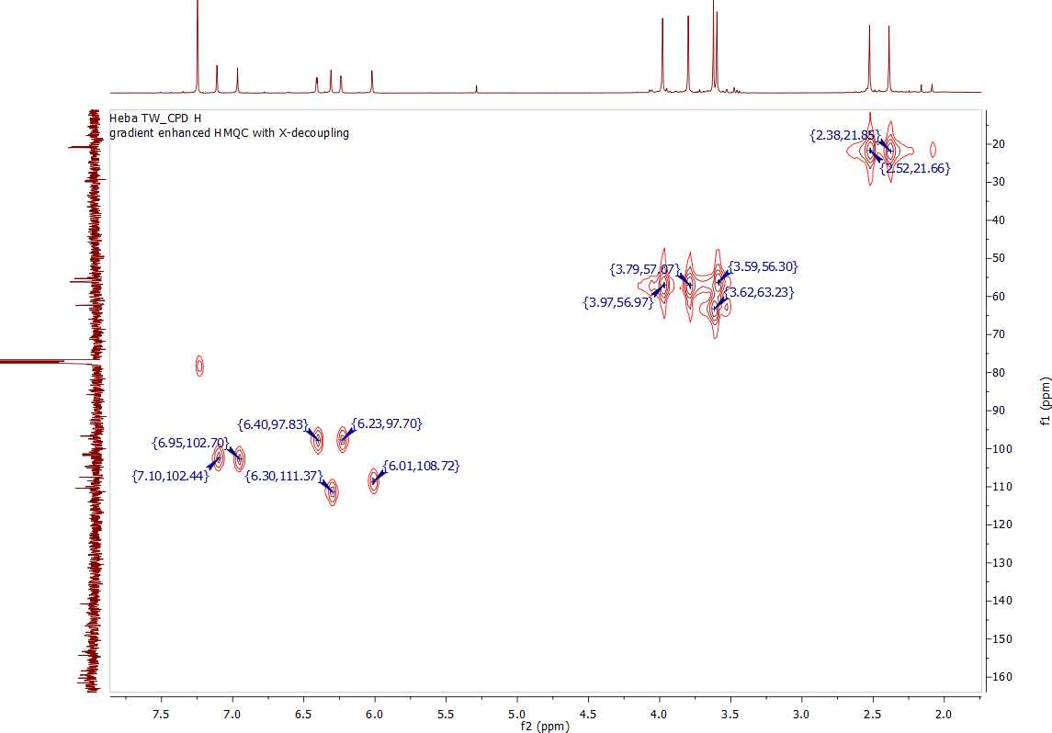

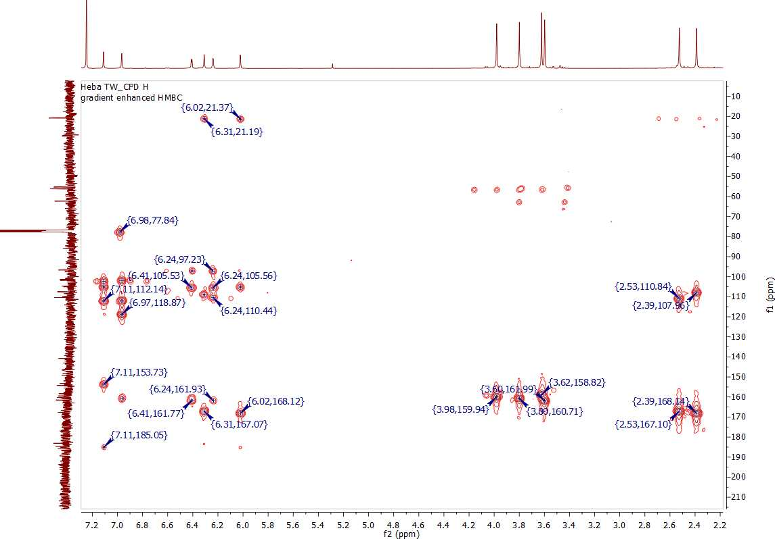
Figure S20. HMBC spectrum of compound 5

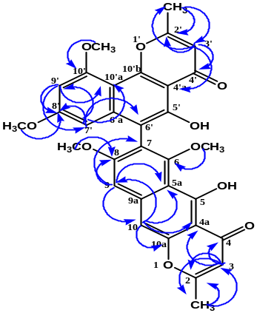

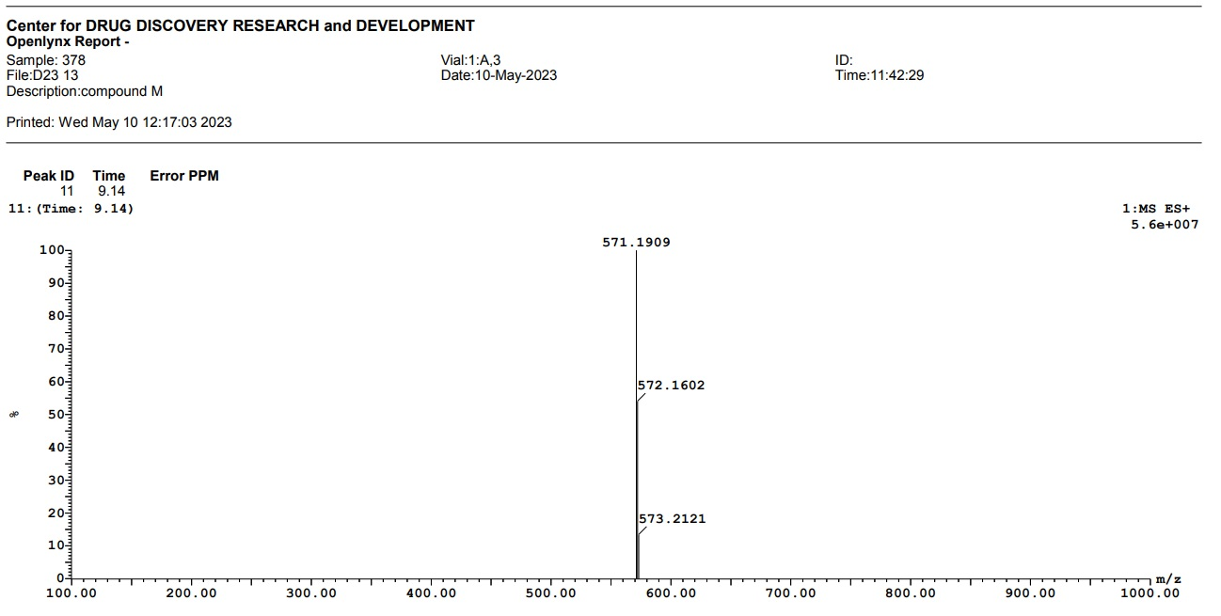
Figure S21. Positive ESI-MS spectrum of compound 6

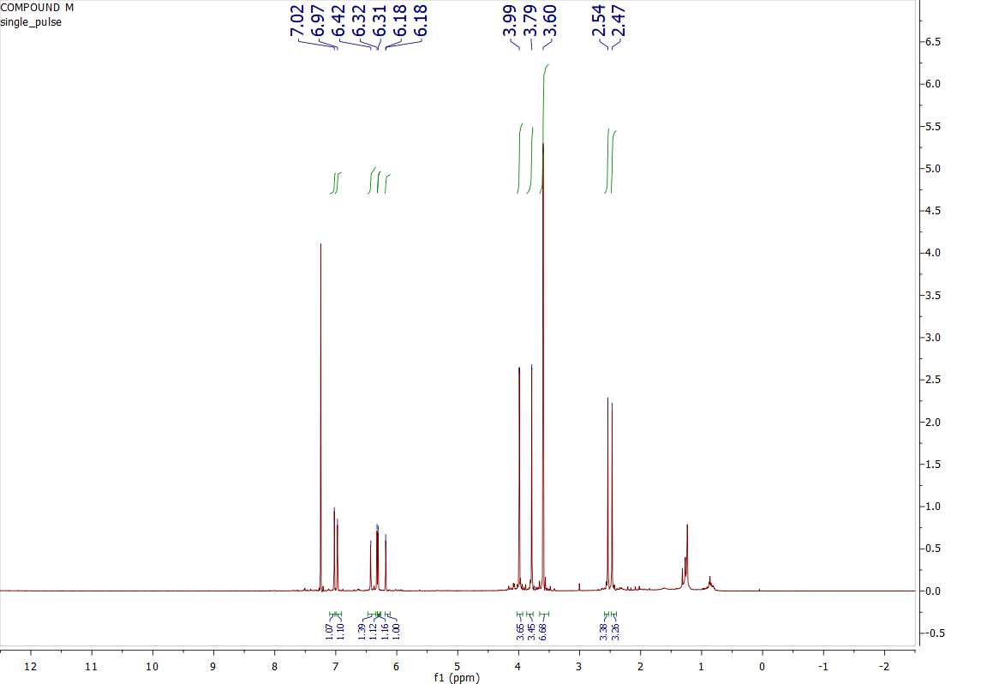
Figure S22. ¹H NMR spectrum (400 MHz, CDCl₃) of compound 6
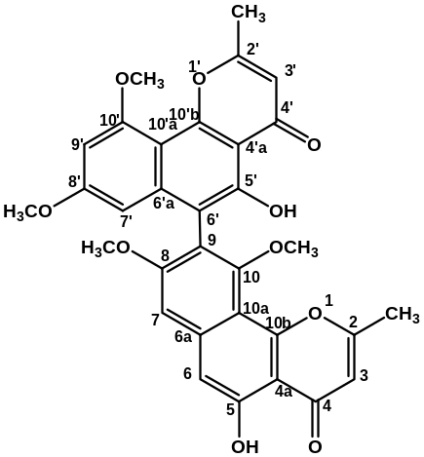
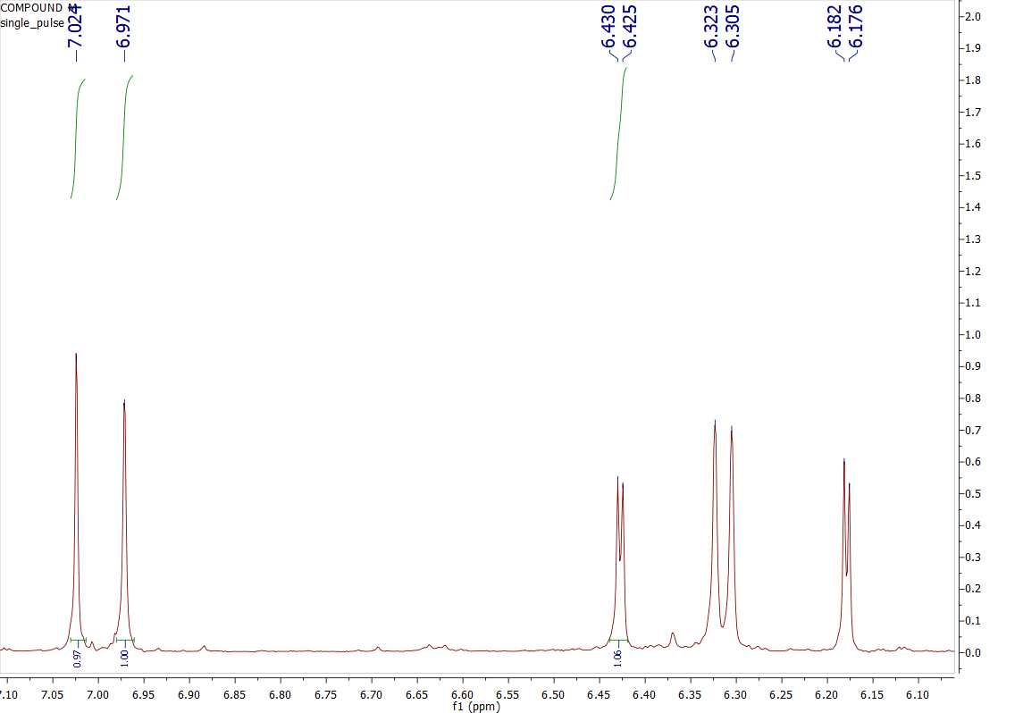

Figure S23. ¹³C NMR spectrum (100 MHz, CDCl₃) of compound 6
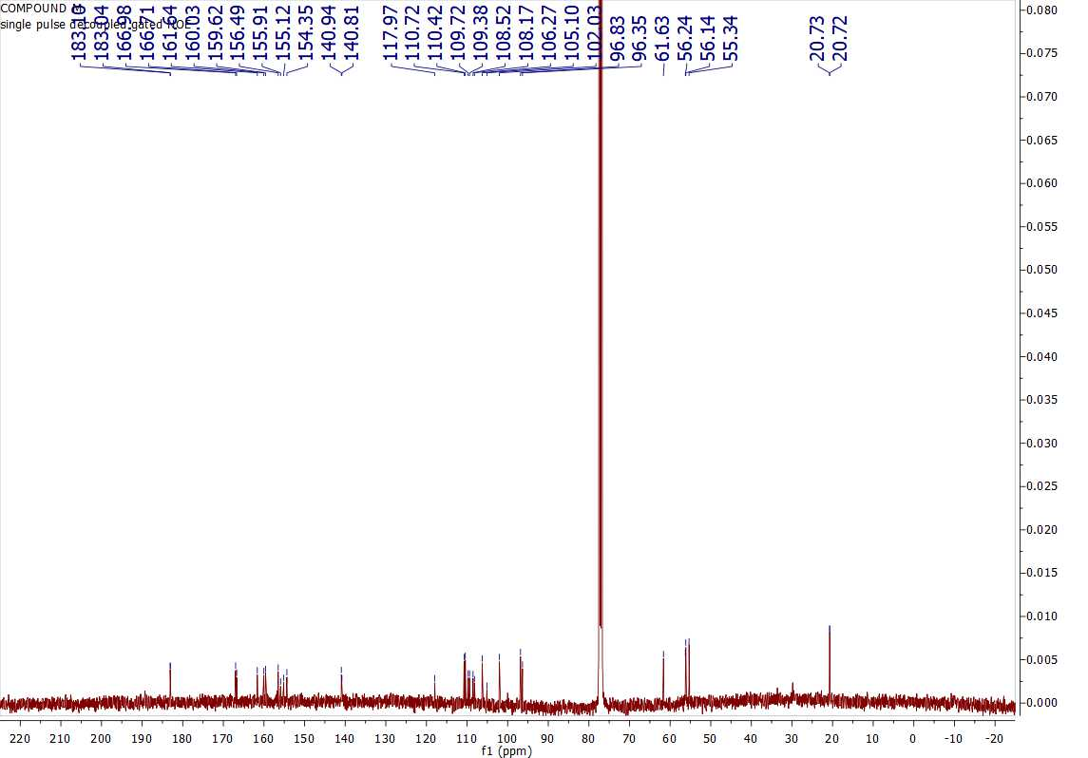

Figure S24. HMBC spectrum of compound 6
.
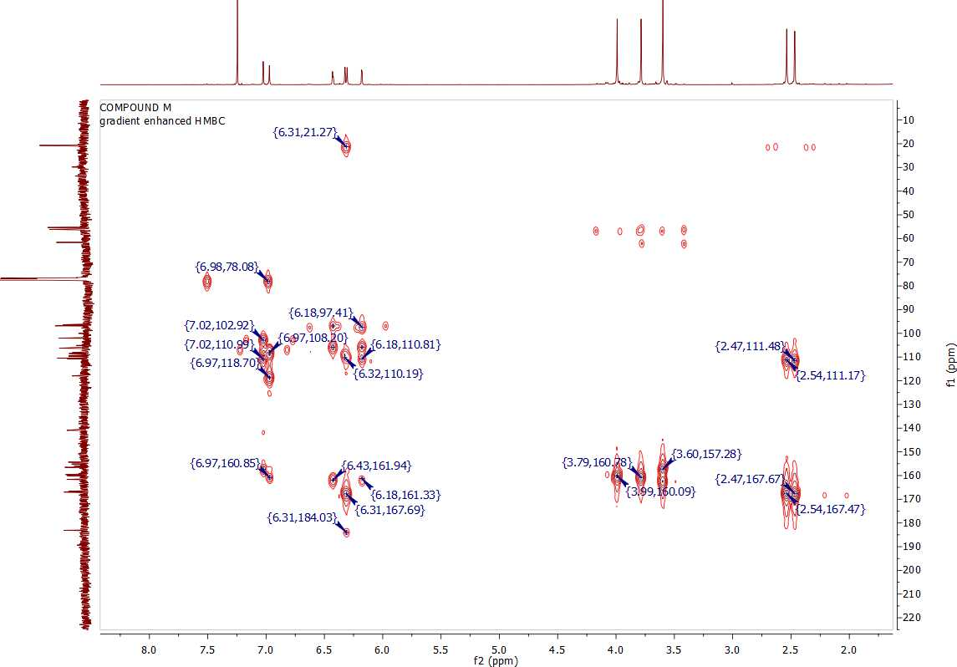

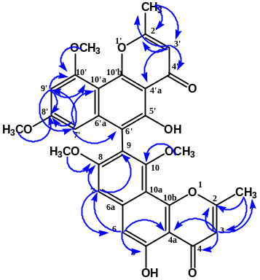

Antimicrobial susceptibility test of tested samples
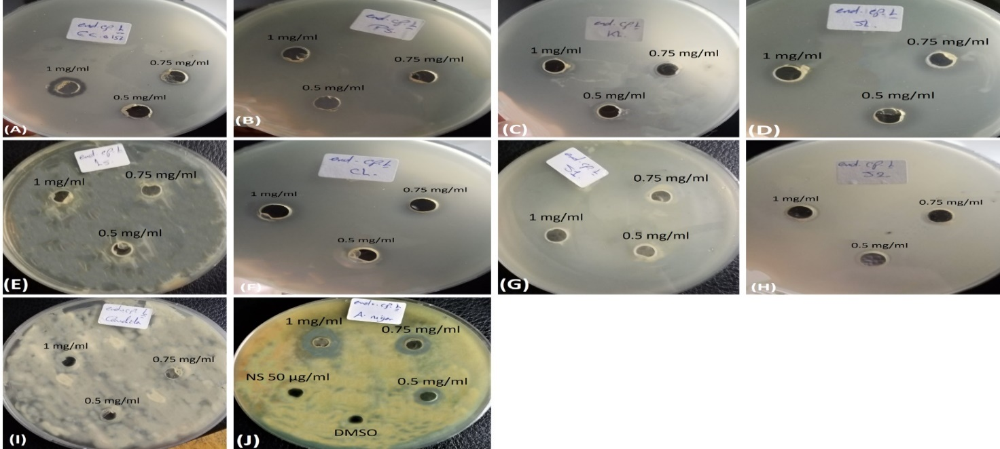
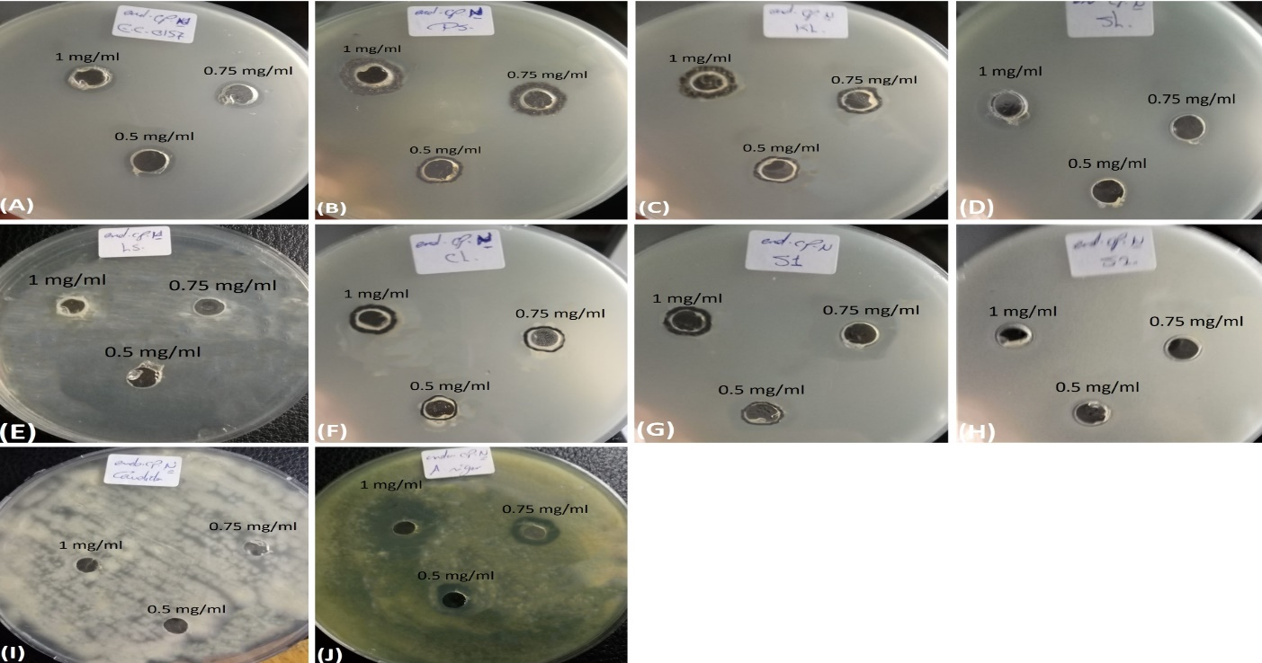
Figure S25. Inhibitory effect of different concentrations (1, 0.75 and 0.5 mg/ml) of ETOAC extract against reference strains. (A) = Escherichia coli ATCC 8739 (E.C), (B) = Pseudomonas aeruginosa ATCC 9027 (Ps.), (C) = Klebsiella pneumonia ATCC 700603 (K), (D) = Salmonella enterica ATCC 14028 (SL.), (E)= Listeria monocytogenes ATCC 7644 (Ls.), (F) = Clostridium perfringens ATCC 13124 (CL.), (G) Staphylococcus aureus ATCC 25923 (S1), (H) = Streptococcus faecalis ATCC 8043 (S2), (I)= Candida albicans ATCC 10231 (C), and (J)= Aspergillus niger ATCC 6275 (Asp.).

Figure S26. Inhibitory effect of different concentrations (1, 0.75 and 0.5 mg/ml) of pure compound 1 against reference strains. (A) = Escherichia coli ATCC 8739 (E.C), (B) = Pseudomonas aeruginosa ATCC 9027 (Ps.), (C) = Klebsiella pneumonia ATCC 700603 (K), (D) = Salmonella enterica ATCC 14028 (SL.), (E)= Listeria monocytogenes ATCC 7644 (Ls.), (F) = Clostridium perfringens ATCC 13124 (CL.), (G) Staphylococcus aureus ATCC 25923 (S1), (H) = Streptococcus faecalis ATCC 8043 (S2), (I)= Candida albicans ATCC 10231 (C), and (J)= Aspergillus niger ATCC 6275 (Asp.).
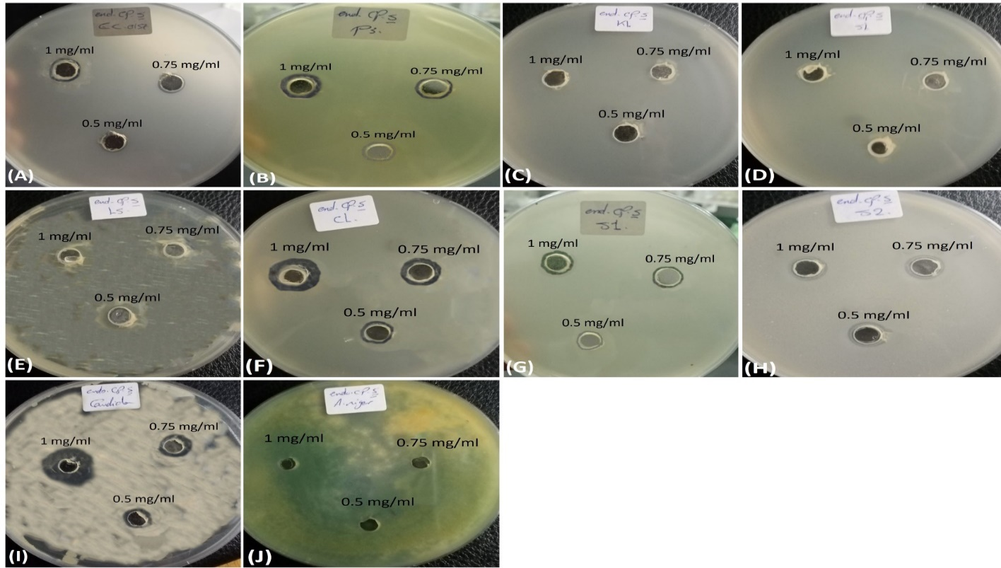
Figure S27. Inhibitory effect of different concentrations (1, 0.75 and 0.5 mg/ml) of pure compound 3 against reference strains. (A) = Escherichia coli ATCC 8739 (E.C), (B) = Pseudomonas aeruginosa ATCC 9027 (Ps.), (C) = Klebsiella pneumonia ATCC 700603 (K), (D) = Salmonella enterica ATCC 14028 (SL.), (E)= Listeria monocytogenes ATCC 7644 (Ls.), (F) = Clostridium perfringens ATCC 13124 (CL.), (G) Staphylococcus aureus ATCC 25923 (S1), (H) = Streptococcus faecalis ATCC 8043 (S2), (I)= Candida albicans ATCC 10231 (C), and (J)= Aspergillus niger ATCC 6275 (Asp.).
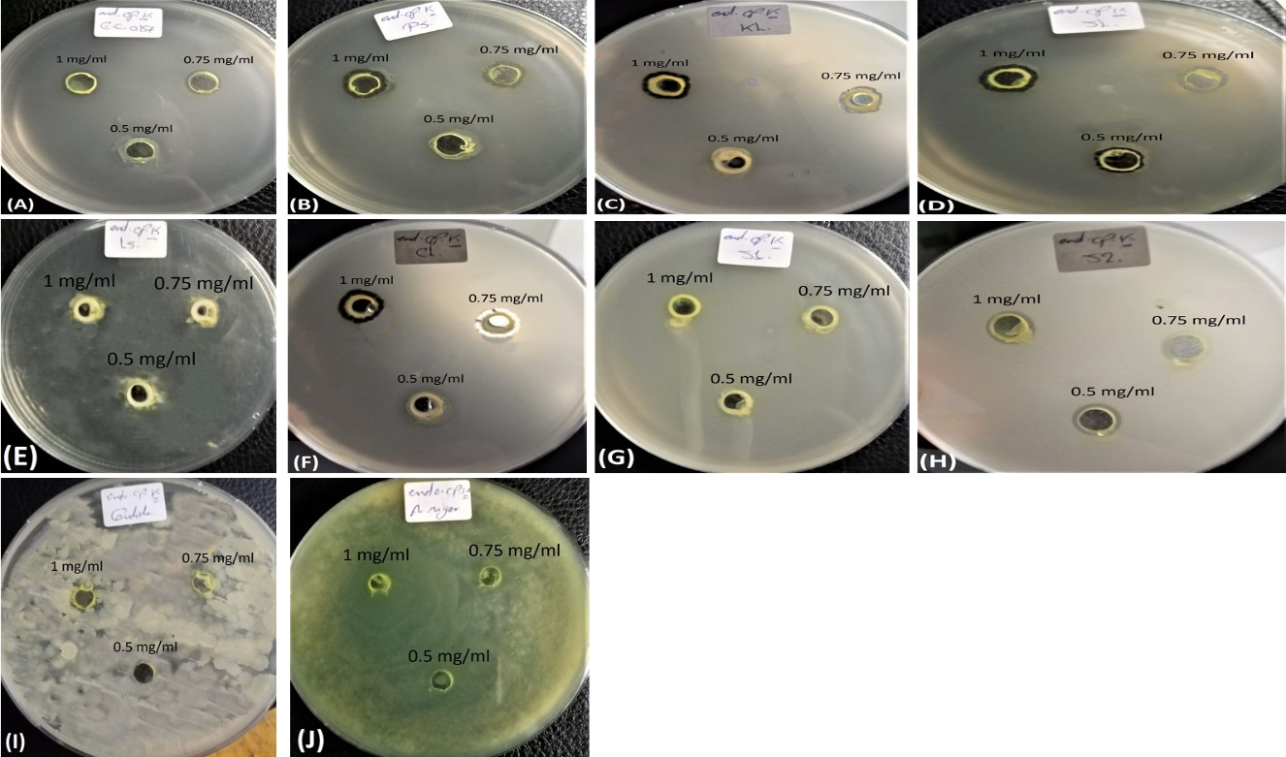
Figure S28. Inhibitory effect of different concentrations (1, 0.75 and 0.5 mg/ml) of pure compound 4 against reference strains. (A) = Escherichia coli ATCC 8739 (E.C), (B) = Pseudomonas aeruginosa ATCC 9027 (Ps.), (C) = Klebsiella pneumonia ATCC 700603 (K), (D) = Salmonella enterica ATCC 14028 (SL.), (E)= Listeria monocytogenes ATCC 7644 (Ls.), (F) = Clostridium perfringens ATCC 13124 (CL.), (G) Staphylococcus aureus ATCC 25923 (S1), (H) = Streptococcus faecalis ATCC 8043 (S2), (I)= Candida albicans ATCC 10231 (C), and (J)= Aspergillus niger ATCC 6275 (Asp.).

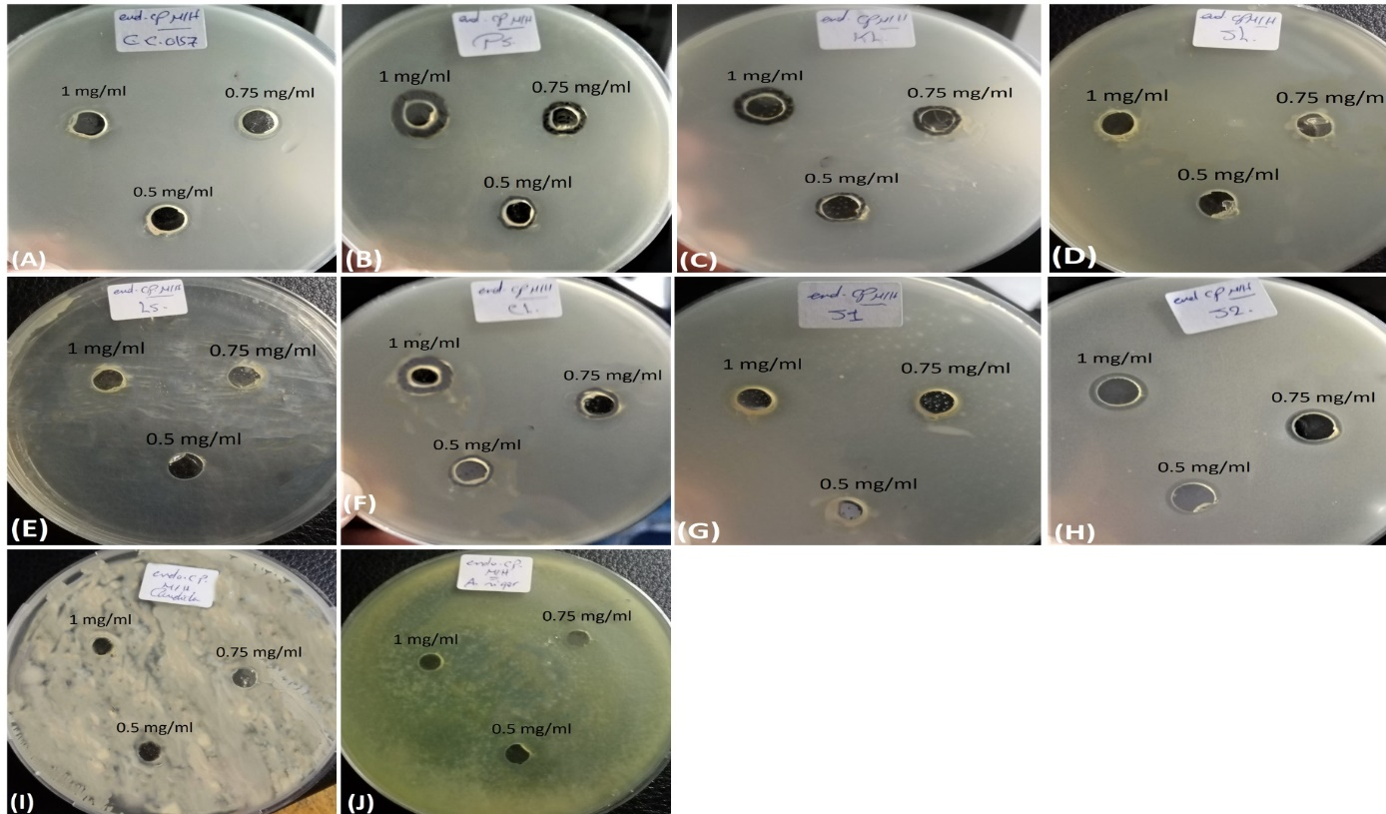
Figure S29. Inhibitory effect of different concentrations (1, 0.75 and 0.5 mg/ml) of pure compound 6 against reference strains. (A) = Escherichia coli ATCC 8739 (E.C), (B) = Pseudomonas aeruginosa ATCC 9027 (Ps.), (C) = Klebsiella pneumonia ATCC 700603 (K), (D) = Salmonella enterica ATCC 14028 (SL.), (E)= Listeria monocytogenes ATCC 7644 (Ls.), (F) = Clostridium perfringens ATCC 13124 (CL.), (G) Staphylococcus aureus ATCC 25923 (S1), (H) = Streptococcus faecalis ATCC 8043 (S2), (I)= Candida albicans ATCC 10231 (C), and (J)= Aspergillus niger ATCC 6275 (Asp.).

Antiproliferative activity

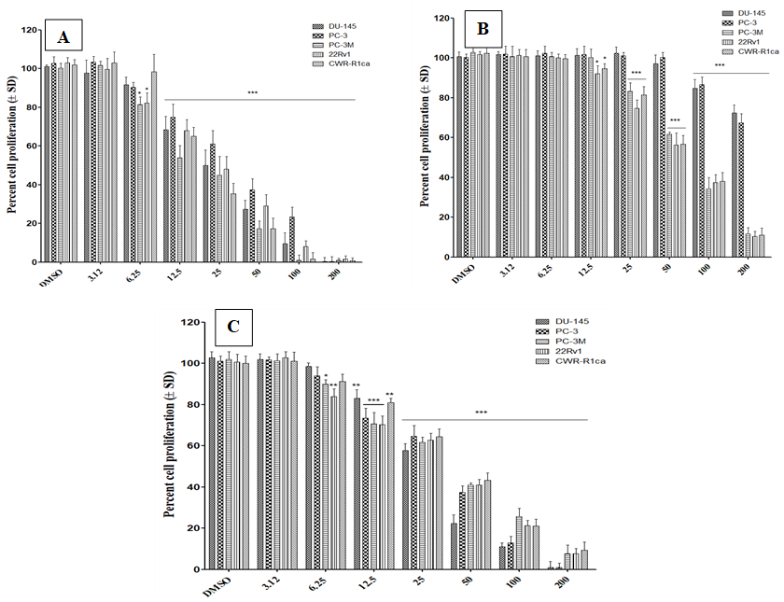

Figure S30. Concentration-response curve of isolated metabolites (1-3) on the proliferation of different prostate cancer cell lines. Bar graphs represent mean cell proliferation (±SD) and indicated concentrations. A) compound 1; B) compound 2; C) compound 3.

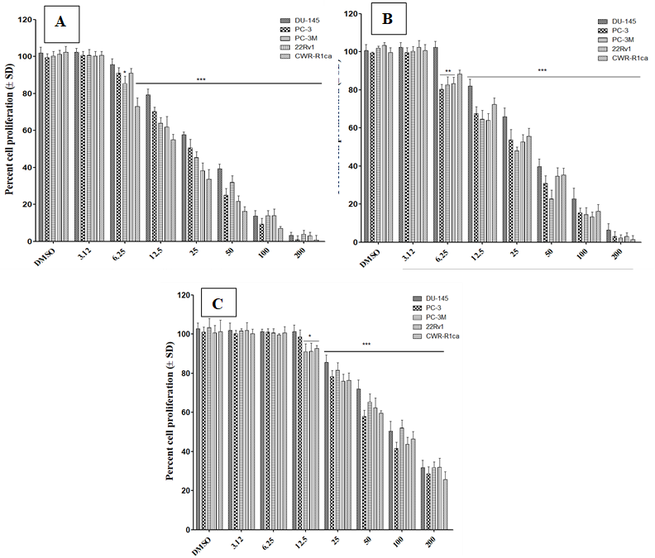

Figure S31. Concentration-response curve of isolated metabolites (4-6) on the proliferation of different prostate cancer cell lines. Bar graphs represent mean cell proliferation (±SD) and indicated concentrations. A) compound 4; B) compound 5; C) compound 6.

