Submitted to: AMB Express
Comparative Analysis of Genome-wide Transcriptional Responses to Continuous Heat Stress in Pleurotus tuoliensis
Long Chen^{a,b,*}, Ying Luoª, Jiazheng Li^{a,b}, Zhijun Zhang^{a,b}, Di Wu^{c,*}
ªTianjin Academy of Agricultural Sciences, Tianjin 300192, China;
^{b}National Engineering Technology Research Center for Preservation of Agricultural Products, Tianjin 300384, China;
^{c}Bionano Genomics, San Diego, CA 92121, USA
Email addresses: lchen6316@gmail.com (L. Chen), luoying201@163.com (Y. Luo), lijzh163@163.com (J. Li), tjzhangzj@sina.cn (Z. Zhang), dwu@bionano.com (D. Wu).
* Correspondence: lchen6316@gmail.com, +86 159-2215-1902 (L. Chen); dwu@bionano.com, +86 13388011318 (D. Wu)

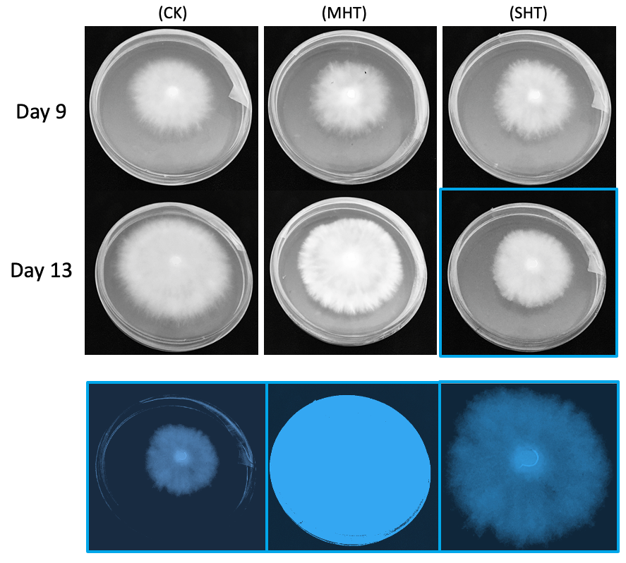
Fig. S1 Images of one replicate in each group on the Day 9 (before HS) and Day 13 (after 96 h HS). The bottom is an illustration of the SHT plate on Day 13 (marked with blue border) showing the captured pixels of plate, dish area, and colony area separately using the NCAR algorithm.
Table S1 Summary statistics of rRNA alignments of sequencing samples
Sample | Total paired reads | Paired mapped reads | Unpaired mapped reads | Unmapped reads | Total mapped
CK1 | 16904798 | 452574(2.68%) | 3940(0.02%) | 16448284(97.30%) | 456514(2.70%)
CK2 | 22009157 | 800154(3.64%) | 4326(0.02%) | 21204676(96.34%) | 804480(3.66%)
CK3 | 21485183 | 765586(3.56%) | 6772(0.03%) | 20712826(96.41%) | 772358(3.59%)
MHT1 | 26032345 | 914316(3.51%) | 4846(0.02%) | 25113184(96.47%) | 919162(3.53%)
MHT2 | 23893148 | 753816(3.15%) | 3980(0.02%) | 23135352(96.83%) | 757796(3.17%)
MHT3 | 23676604 | 740331(3.13%) | 4684(0.02%) | 22931588(96.85%) | 745016(3.15%)
SHT1 | 26241571 | 965670(3.68%) | 8378(0.03%) | 25267523(96.29%) | 974048(3.71%)
SHT2 | 23261438 | 666341(2.86%) | 5490(0.02%) | 22589607(97.11%) | 671831(2.89%)
SHT3 | 23375530 | 1136569(4.86%) | 8999(0.04%) | 22229962(95.10%) | 1145568(4.90%)

Table S2 Summary statistics of reads alignments to the reference genome (Pleurotus tuoliensis strain JKBL130LB)
Sample | Total paired reads | Paired mapped reads | Unpaired mapped reads | Unmapped reads | Total mapped
CK1 | 16445087 | 14447587(87.85%) | 472820(2.88%) | 1524680(9.27%) | 14920406(90.73%)
CK2 | 21201213 | 18750858(88.44%) | 587616(2.77%) | 1862738(8.79%) | 19338474(91.21%)
CK3 | 20707331 | 18173756(87.76%) | 504773(2.44%) | 2028802(9.80%) | 18678529(90.20%)
MHT1 | 25109109 | 22368127(89.08%) | 639400(2.55%) | 2101582(8.37%) | 23007528(91.63%)
MHT2 | 23131998 | 20642175(89.24%) | 569518(2.46%) | 1920305(8.30%) | 21211693(91.70%)
MHT3 | 22927660 | 20409694(89.02%) | 566607(2.47%) | 1951359(8.51%) | 20976301(91.49%)
SHT1 | 25260431 | 22552223(89.28%) | 610835(2.42%) | 2097373(8.30%) | 23163058(91.70%)
SHT2 | 22584926 | 20063695(88.84%) | 541668(2.40%) | 1979564(8.76%) | 20605362(91.24%)
SHT3 | 22222415 | 19848574(89.32%) | 563512(2.54%) | 1810330(8.15%) | 20412086(91.85%)

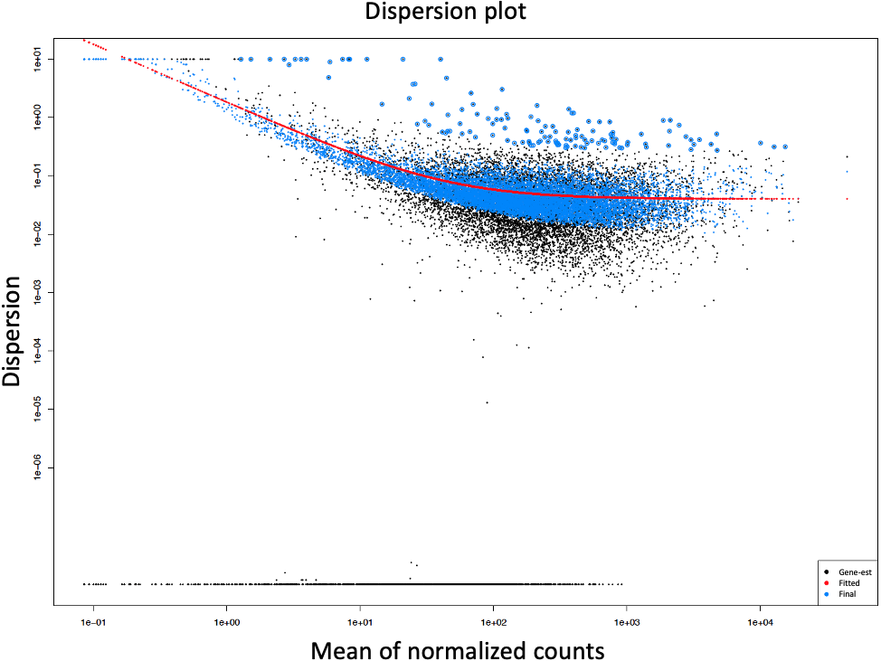
Fig. S2 A dispersion plot of means of normalized counts. Each gene is represented by a black dot, showing its dispersion estimate as a function of its mean normalized count. A curve is fitted to the gene-wise dispersion estimates, indicating the expected dispersion value for genes with a given normalized count. The gene-wise dispersion estimates are then shrunk by an empirical Bayes approach towards the fitted curve, resulting in the final dispersion estimates shown by the blue dots. The genes that have higher variability than expected are not shrunk towards the curve. These outliers are marked by blue circles in the dispersion plot.
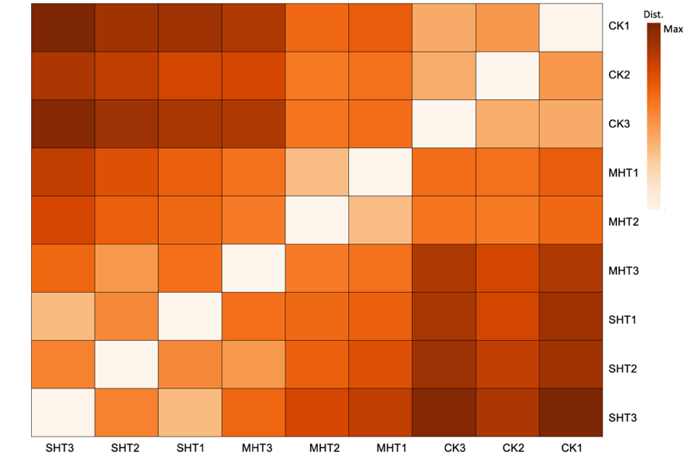
Fig. S3 A heatmap depicts orthogonal distances between nine samples based on the normalized counts of the entire 11,265 unigenes. The darkest color indicates the maximum distance between two individual samples.

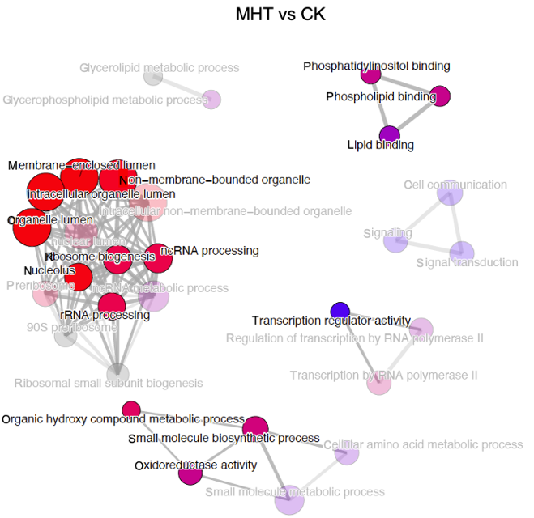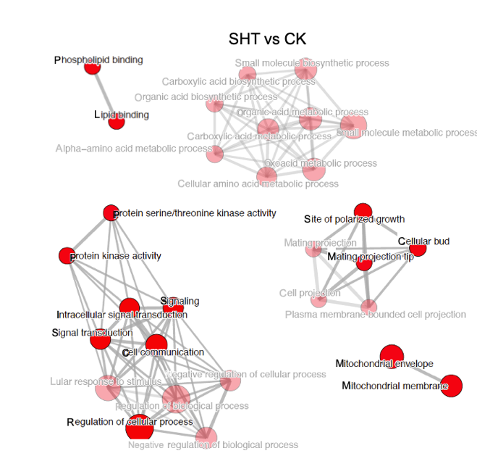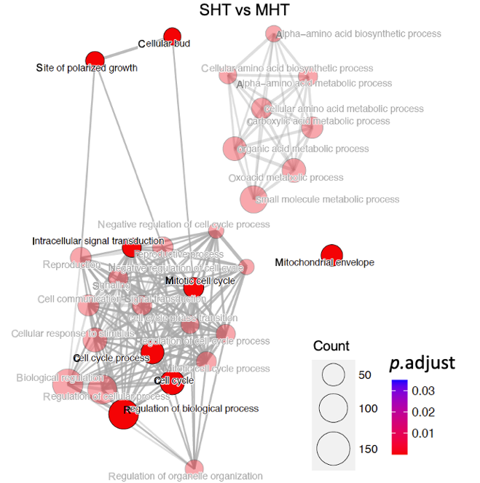
Fig. S4 Enrichment maps of the top 30 GO terms. Each node represents an enriched gene set with its size proportional to the number of the detected genes in that set. Grey lines connecting nodes indicate similarities between the two gene sets: the thicker and shorter the line, the more similar the gene sets. Node color stands for the adjust p-value. Highlighted nodes indicate the top 5 GO terms in each category of BP, CC, and MF shown in Figure 6.
Table S3 Summary table of the DEGs belong to the enriched GO term of oxidoreductase activity.
Enriched GO term | Gene ID | Description | Expression patterns
Cell communication  GO: 0007154 | Gene_25128 | Membrane bound guanine nucleotide exchange factor | Cluster-1
Cell communication  GO: 0007154 | Gene_25129 | Membrane bound guanine nucleotide exchange factor | Cluster-1
Cell communication  GO: 0007154 | Gene_7304 | Essential ATP-binding protein required for DNA replication | Cluster-1
Cell communication  GO: 0007154 | Gene_7303 | Essential ATP-binding protein required for DNA replication | Cluster-1
Cell communication  GO: 0007154 | Gene_6973 | Transcriptional regulator | Cluster-1
Cell communication  GO: 0007154 | Gene_6972 | Transcriptional regulator | Cluster-1
Cell communication  GO: 0007154 | Gene_11731 | Nucleotide binding alpha subunit of the heterotrimeric G protein | Cluster-1
Cell communication  GO: 0007154 | Gene_4499 | Nucleosome spacing factor | Cluster-1
Cell communication  GO: 0007154 | Gene_1628 | GTPase-activating protein | Cluster-1
Cell communication  GO: 0007154 | Gene_25709 | Ser/Thr protein kinase involved in salt tolerance, nutrient response | Cluster-1
Cell communication  GO: 0007154 | Gene_25710 | Ser/Thr protein kinase involved in salt tolerance, nutrient response | Cluster-1
Cell communication  GO: 0007154 | Gene_781 | Guanine nucleotide exchange factor (GEF) for ADP ribosylation factors | Cluster-1
Cell communication  GO: 0007154 | Gene_783 | Guanine nucleotide exchange factor (GEF) for ADP ribosylation factors | Cluster-1
Cell communication  GO: 0007154 | Gene_784 | Guanine nucleotide exchange factor (GEF) for ADP ribosylation factors | Cluster-1
Cell communication  GO: 0007154 | Gene_785 | Guanine nucleotide exchange factor (GEF) for ADP ribosylation factors | Cluster-1
Cell communication  GO: 0007154 | Gene_4896 | Key component of the RAM signaling network | Cluster-1
Cell communication  GO: 0007154 | Gene_4897 | Key component of the RAM signaling network | Cluster-1
Cell communication  GO: 0007154 | Gene_4898 | Key component of the RAM signaling network | Cluster-1
Cell communication  GO: 0007154 | Gene_1194 | Cytoplasmic phosphorelay intermediate osmosensor and regulator | Cluster-1
Cell communication  GO: 0007154 | Gene_1195 | Cytoplasmic phosphorelay intermediate osmosensor and regulator | Cluster-1
Cell communication  GO: 0007154 | Gene_20200 | Phosphatidylinositol-4-kinase | Cluster-1
Cell communication  GO: 0007154 | Gene_20204 | Phosphatidylinositol-4-kinase | Cluster-2

Table S4 Summary table of the DEGs that contribute to the enriched GO term of intracellular signal transduction.
Enriched GO term | Gene ID | Description | Expression patterns
Intracellular signal transduction  GO: 0035556 | Gene_25128 | Membrane bound guanine nucleotide exchange factor | Cluster-1
Intracellular signal transduction  GO: 0035556 | Gene_25129 | Membrane bound guanine nucleotide exchange factor | Cluster-1
Intracellular signal transduction  GO: 0035556 | Gene_7304 | Essential ATP-binding protein required for DNA replication | Cluster-1
Intracellular signal transduction  GO: 0035556 | Gene_7303 | Essential ATP-binding protein required for DNA replication | Cluster-1
Intracellular signal transduction  GO: 0035556 | Gene_11731 | Nucleotide binding alpha subunit of the heterotrimeric G protein | Cluster-1
Intracellular signal transduction  GO: 0035556 | Gene_4499 | Nucleosome spacing factor | Cluster-1
Intracellular signal transduction  GO: 0035556 | Gene_1628 | GTPase-activating protein | Cluster-1
Intracellular signal transduction  GO: 0035556 | Gene_25709 | Ser/Thr protein kinase involved in salt tolerance, nutrient response | Cluster-1
Intracellular signal transduction  GO: 0035556 | Gene_25710 | Ser/Thr protein kinase involved in salt tolerance, nutrient response | Cluster-1
Intracellular signal transduction  GO: 0035556 | Gene_781 | Guanine nucleotide exchange factor (GEF) for ADP ribosylation factors | Cluster-1
Intracellular signal transduction  GO: 0035556 | Gene_783 | Guanine nucleotide exchange factor (GEF) for ADP ribosylation factors | Cluster-1
Intracellular signal transduction  GO: 0035556 | Gene_784 | Guanine nucleotide exchange factor (GEF) for ADP ribosylation factors | Cluster-1
Intracellular signal transduction  GO: 0035556 | Gene_785 | Guanine nucleotide exchange factor (GEF) for ADP ribosylation factors | Cluster-1
Intracellular signal transduction  GO: 0035556 | Gene_1194 | Cytoplasmic phosphorelay intermediate osmosensor and regulator | Cluster-1
Intracellular signal transduction  GO: 0035556 | Gene_1195 | Cytoplasmic phosphorelay intermediate osmosensor and regulator | Cluster-1
Intracellular signal transduction  GO: 0035556 | Gene_20200 | Phosphatidylinositol-4-kinase | Cluster-1
Intracellular signal transduction  GO: 0035556 | Gene_20204 | Phosphatidylinositol-4-kinase | Cluster-2

Table S5 Summary table of the DEGs that contribute to the enriched GO terms of signaling and signal transduction.
Enriched GO term | Gene ID | Description | Expression patterns
Signaling  GO:0023052  Signal transduction  GO:0007165 | Gene_7304 | Essential ATP-binding protein required for DNA replication | Cluster-1
Signaling  GO:0023052  Signal transduction  GO:0007165 | Gene_7303 | Essential ATP-binding protein required for DNA replication | Cluster-1
Signaling  GO:0023052  Signal transduction  GO:0007165 | Gene_25128 | Membrane bound guanine nucleotide exchange factor | Cluster-1
Signaling  GO:0023052  Signal transduction  GO:0007165 | Gene_25129 | Membrane bound guanine nucleotide exchange factor | Cluster-1
Signaling  GO:0023052  Signal transduction  GO:0007165 | Gene_11731 | Nucleotide binding alpha subunit of the heterotrimeric G protein | Cluster-1
Signaling  GO:0023052  Signal transduction  GO:0007165 | Gene_4499 | Nucleosome spacing factor | Cluster-1
Signaling  GO:0023052  Signal transduction  GO:0007165 | Gene_1628 | GTPase-activating protein | Cluster-1
Signaling  GO:0023052  Signal transduction  GO:0007165 | Gene_25709 | Ser/Thr protein kinase involved in salt tolerance, nutrient response | Cluster-1
Signaling  GO:0023052  Signal transduction  GO:0007165 | Gene_25710 | Ser/Thr protein kinase involved in salt tolerance, nutrient response | Cluster-1
Signaling  GO:0023052  Signal transduction  GO:0007165 | Gene_781 | Guanine nucleotide exchange factor (GEF) for ADP ribosylation factors | Cluster-1
Signaling  GO:0023052  Signal transduction  GO:0007165 | Gene_783 | Guanine nucleotide exchange factor (GEF) for ADP ribosylation factors | Cluster-1
Signaling  GO:0023052  Signal transduction  GO:0007165 | Gene_784 | Guanine nucleotide exchange factor (GEF) for ADP ribosylation factors | Cluster-1
Signaling  GO:0023052  Signal transduction  GO:0007165 | Gene_785 | Guanine nucleotide exchange factor (GEF) for ADP ribosylation factors | Cluster-1
Signaling  GO:0023052  Signal transduction  GO:0007165 | Gene_4896 | Key component of the RAM signaling network | Cluster-1
Signaling  GO:0023052  Signal transduction  GO:0007165 | Gene_4897 | Key component of the RAM signaling network | Cluster-1
Signaling  GO:0023052  Signal transduction  GO:0007165 | Gene_4898 | Key component of the RAM signaling network | Cluster-1
Signaling  GO:0023052  Signal transduction  GO:0007165 | Gene_1194 | Cytoplasmic phosphorelay intermediate osmosensor and regulator | Cluster-1
Signaling  GO:0023052  Signal transduction  GO:0007165 | Gene_1195 | Cytoplasmic phosphorelay intermediate osmosensor and regulator | Cluster-1
Signaling  GO:0023052  Signal transduction  GO:0007165 | Gene_20200 | Phosphatidylinositol-4-kinase | Cluster-1
Signaling  GO:0023052  Signal transduction  GO:0007165 | Gene_20204 | Phosphatidylinositol-4-kinase | Cluster-2

Table S6 Summary table of the DEGs that contribute to the enriched GO term of small molecule biosynthetic process.
Enriched GO term | Gene ID | Description | Expression patterns
Small molecule biosynthetic process  GO: 0044283 | Gene_8809 | ATP phosphoribosyltransferase | Cluster-2
Small molecule biosynthetic process  GO: 0044283 | Gene_14686 | Histidinolphosphatase | Cluster-2
Small molecule biosynthetic process  GO: 0044283 | Gene_8226 | Histidinol-phosphate aminotransferase | Cluster-2
Small molecule biosynthetic process  GO: 0044283 | Gene_4773 | Imidazole glycerol phosphate synthase | Cluster-2
Small molecule biosynthetic process  GO: 0044283 | Gene_17859 | Acetohydroxyacid reductoisomerase and mtDNA binding protein | Cluster-2
Small molecule biosynthetic process  GO: 0044283 | Gene_1046 | Isopropylmalate isomerase | Cluster-2
Small molecule biosynthetic process  GO: 0044283 | Gene_1047 | Isopropylmalate isomerase | Cluster-2
Small molecule biosynthetic process  GO: 0044283 | Gene_915 | Homo-isocitrate dehydrogenase | Cluster-2
Small molecule biosynthetic process  GO: 0044283 | Gene_8162 | Alpha aminoadipate reductase | Cluster-2
Small molecule biosynthetic process  GO: 0044283 | Gene_3738 | 5'-methylthioribulose-1-phosphate dehydratase | Cluster-2
Small molecule biosynthetic process  GO: 0044283 | Gene_331 | Methylthioadenosine phosphorylase (MTAP) | Cluster-2
Small molecule biosynthetic process  GO: 0044283 | Gene_330 | Methylthioadenosine phosphorylase (MTAP) | Cluster-2
Small molecule biosynthetic process  GO: 0044283 | Gene_332 | Methylthioadenosine phosphorylase (MTAP) | Cluster-2
Small molecule biosynthetic process  GO: 0044283 | Gene_26510 | Pantothenate synthase | Cluster-2
Small molecule biosynthetic process  GO: 0044283 | Gene_3689 | Thiazole synthase | Cluster-2

Table S7 Summary table of the DEGs that contribute to the enriched GO term of small molecule metabolic process.
Enriched GO term | Gene ID | Description | Expression patterns
Small molecule metabolic process  GO: 0044281 | Gene_4597 | Cytosolic aspartate aminotransferase | Cluster-2
Small molecule metabolic process  GO: 0044281 | Gene_5002 | Adenylate kinase, required for purine metabolism | Cluster-2
Small molecule metabolic process  GO: 0044281 | Gene_5003 | Adenylate kinase, required for purine metabolism | Cluster-2
Small molecule metabolic process  GO: 0044281 | Gene_19876 | Kynurenine 3-monooxygenase | Cluster-2
Small molecule metabolic process  GO: 0044281 | Gene_4600 | Aspartyl-tRNA synthetase, primarily cytoplasmic | Cluster-2
Small molecule metabolic process  GO: 0044281 | Gene_4599 | Aspartyl-tRNA synthetase, primarily cytoplasmic | Cluster-2
Small molecule metabolic process  GO: 0044281 | Gene_17492 | T subunit of the mitochondrial glycine decarboxylase complex | Cluster-2
Small molecule metabolic process  GO: 0044281 | Gene_16967 | GMP synthase | Cluster-2
Small molecule metabolic process  GO: 0044281 | Gene_16966 | GMP synthase | Cluster-2
Small molecule metabolic process  GO: 0044281 | Gene_26362 | Subunit of the trimeric GatFAB AmidoTransferase(AdT) complex | Cluster-2
Small molecule metabolic process  GO: 0044281 | Gene_26363 | Subunit of the trimeric GatFAB AmidoTransferase(AdT) complex | Cluster-2
Small molecule metabolic process  GO: 0044281 | Gene_8809 | ATP phosphoribosyltransferase | Cluster-2
Small molecule metabolic process  GO: 0044281 | Gene_14686 | Histidinolphosphatase | Cluster-2
Small molecule metabolic process  GO: 0044281 | Gene_8226 | Histidinol-phosphate aminotransferase | Cluster-2
Small molecule metabolic process  GO: 0044281 | Gene_4773 | Imidazole glycerol phosphate synthase | Cluster-2
Small molecule metabolic process  GO: 0044281 | Gene_17859 | Acetohydroxyacid reductoisomerase and mtDNA binding protein | Cluster-2
Small molecule metabolic process  GO: 0044281 | Gene_16058 | Lysyl-tRNA synthetase | Cluster-2
Small molecule metabolic process  GO: 0044281 | Gene_1046 | Isopropylmalate isomerase | Cluster-2
Small molecule metabolic process  GO: 0044281 | Gene_1047 | Isopropylmalate isomerase | Cluster-2
Small molecule metabolic process  GO: 0044281 | Gene_915 | Homo-isocitrate dehydrogenase | Cluster-2
Small molecule metabolic process  GO: 0044281 | Gene_8162 | Alpha aminoadipate reductase | Cluster-2
Small molecule metabolic process  GO: 0044281 | Gene_3738 | 5'-methylthioribulose-1-phosphate dehydratase | Cluster-2
Small molecule metabolic process  GO: 0044281 | Gene_331 | Methylthioadenosine phosphorylase (MTAP) | Cluster-2
Small molecule metabolic process  GO: 0044281 | Gene_330 | Methylthioadenosine phosphorylase (MTAP) | Cluster-2
Small molecule metabolic process  GO: 0044281 | Gene_332 | Methylthioadenosine phosphorylase (MTAP) | Cluster-2
Small molecule metabolic process  GO: 0044281 | Gene_7715 | 2-dehydropantoate 2-reductase | Cluster-2
Small molecule metabolic process  GO: 0044281 | Gene_26510 | Pantothenate synthase | Cluster-2
Small molecule metabolic process  GO: 0044281 | Gene_6034 | Alpha subunit of heterooctameric phosphofructokinase | Cluster-2
Small molecule metabolic process  GO: 0044281 | Gene_3689 | Thiazole synthase | Cluster-2
Small molecule metabolic process  GO: 0044281 | Gene_4597 | Cytosolic aspartate aminotransferase | Cluster-2
Small molecule metabolic process  GO: 0044281 | Gene_5002 | Adenylate kinase, required for purine metabolism | Cluster-2
Small molecule metabolic process  GO: 0044281 | Gene_5003 | Adenylate kinase, required for purine metabolism | Cluster-2
Small molecule metabolic process  GO: 0044281 | Gene_19876 | Kynurenine 3-monooxygenase | Cluster-2
Small molecule metabolic process  GO: 0044281 | Gene_4600 | Aspartyl-tRNA synthetase, primarily cytoplasmic | Cluster-2
Small molecule metabolic process  GO: 0044281 | Gene_4599 | Aspartyl-tRNA synthetase, primarily cytoplasmic | Cluster-2
Small molecule metabolic process  GO: 0044281 | Gene_17492 | T subunit of the mitochondrial glycine decarboxylase complex | Cluster-2

Table S8 Summary table of the DEGs that contribute to the enriched GO term of cellular amino acid metabolic process.
Enriched GO term | Gene ID | Description | Expression patterns
Cellular amino acid metabolic process  GO: 0006520 | Gene_4597 | Cytosolic aspartate aminotransferase | Cluster-2
Cellular amino acid metabolic process  GO: 0006520 | Gene_4600 | Aspartyl-tRNA synthetase, primarily cytoplasmic | Cluster-2
Cellular amino acid metabolic process  GO: 0006520 | Gene_4599 | Aspartyl-tRNA synthetase, primarily cytoplasmic | Cluster-2
Cellular amino acid metabolic process  GO: 0006520 | Gene_17492 | T subunit of the mitochondrial glycine decarboxylase complex | Cluster-2
Cellular amino acid metabolic process  GO: 0006520 | Gene_16967 | GMP synthase | Cluster-2
Cellular amino acid metabolic process  GO: 0006520 | Gene_16966 | GMP synthase | Cluster-2
Cellular amino acid metabolic process  GO: 0006520 | Gene_26362 | Subunit of the trimeric GatFAB AmidoTransferase(AdT) complex | Cluster-2
Cellular amino acid metabolic process  GO: 0006520 | Gene_26363 | Subunit of the trimeric GatFAB AmidoTransferase(AdT) complex | Cluster-2
Cellular amino acid metabolic process  GO: 0006520 | Gene_8809 | ATP phosphoribosyltransferase | Cluster-2
Cellular amino acid metabolic process  GO: 0006520 | Gene_14686 | Histidinolphosphatase | Cluster-2
Cellular amino acid metabolic process  GO: 0006520 | Gene_8226 | Histidinol-phosphate aminotransferase | Cluster-2
Cellular amino acid metabolic process  GO: 0006520 | Gene_4773 | Imidazole glycerol phosphate synthase | Cluster-2
Cellular amino acid metabolic process  GO: 0006520 | Gene_17859 | Acetohydroxyacid reductoisomerase and mtDNA binding protein | Cluster-2
Cellular amino acid metabolic process  GO: 0006520 | Gene_16058 | Lysyl-tRNA synthetase | Cluster-2
Cellular amino acid metabolic process  GO: 0006520 | Gene_1046 | Isopropylmalate isomerase | Cluster-2
Cellular amino acid metabolic process  GO: 0006520 | Gene_1047 | Isopropylmalate isomerase | Cluster-2
Cellular amino acid metabolic process  GO: 0006520 | Gene_915 | Homo-isocitrate dehydrogenase | Cluster-2
Cellular amino acid metabolic process  GO: 0006520 | Gene_8162 | Alpha aminoadipate reductase | Cluster-2
Cellular amino acid metabolic process  GO: 0006520 | Gene_3738 | 5'-methylthioribulose-1-phosphate dehydratase | Cluster-2
Cellular amino acid metabolic process  GO: 0006520 | Gene_331 | Methylthioadenosine phosphorylase (MTAP) | Cluster-2
Cellular amino acid metabolic process  GO: 0006520 | Gene_330 | Methylthioadenosine phosphorylase (MTAP) | Cluster-2
Cellular amino acid metabolic process  GO: 0006520 | Gene_332 | Methylthioadenosine phosphorylase (MTAP) | Cluster-2

Table S9 Summary table of the DEGs that contribute to the enriched GO term of regulation of cellular process.
Enriched GO term | Gene ID | Description | Expression patterns
Regulation of cellular process  GO: 0050794 | Gene_4499 | Nucleosome spacing factor | Cluster-1
Regulation of cellular process  GO: 0050794 | Gene_3922 | Transcription factor | Cluster-1
Regulation of cellular process  GO: 0050794 | Gene_3921 | Transcription factor | Cluster-1
Regulation of cellular process  GO: 0050794 | Gene_7304 | Essential ATP-binding protein required for DNA replication | Cluster-1
Regulation of cellular process  GO: 0050794 | Gene_7303 | Essential ATP-binding protein required for DNA replication | Cluster-1
Regulation of cellular process  GO: 0050794 | Gene_25128 | Membrane bound guanine nucleotide exchange factor | Cluster-1
Regulation of cellular process  GO: 0050794 | Gene_25129 | Membrane bound guanine nucleotide exchange factor | Cluster-1
Regulation of cellular process  GO: 0050794 | Gene_781 | Guanine nucleotide exchange factor (GEF) for ADP ribosylation factors | Cluster-1
Regulation of cellular process  GO: 0050794 | Gene_783 | Guanine nucleotide exchange factor (GEF) for ADP ribosylation factors | Cluster-1
Regulation of cellular process  GO: 0050794 | Gene_784 | Guanine nucleotide exchange factor (GEF) for ADP ribosylation factors | Cluster-1
Regulation of cellular process  GO: 0050794 | Gene_785 | Guanine nucleotide exchange factor (GEF) for ADP ribosylation factors | Cluster-1
Regulation of cellular process  GO: 0050794 | Gene_1194 | Cytoplasmic phosphorelay intermediate osmosensor and regulator | Cluster-1
Regulation of cellular process  GO: 0050794 | Gene_1195 | Cytoplasmic phosphorelay intermediate osmosensor and regulator | Cluster-1
Regulation of cellular process  GO: 0050794 | Gene_1655 | Protein phosphatase required for mitotic exit | Cluster-1
Regulation of cellular process  GO: 0050794 | Gene_4698 | Catalytic subunit of Dcp1p-Dcp2p decapping enzyme complex | Cluster-1
Regulation of cellular process  GO: 0050794 | Gene_4699 | Catalytic subunit of Dcp1p-Dcp2p decapping enzyme complex | Cluster-1
Regulation of cellular process  GO: 0050794 | Gene_828 | Subunit of the THO complex | Cluster-1
Regulation of cellular process  GO: 0050794 | Gene_827 | Subunit of the THO complex | Cluster-1
Regulation of cellular process  GO: 0050794 | Gene_20200 | Phosphatidylinositol-4-kinase | Cluster-1
Regulation of cellular process  GO: 0050794 | Gene_20204 | Phosphatidylinositol-4-kinase | Cluster-2
Regulation of cellular process  GO: 0050794 | Gene_6973 | Transcriptional regulator | Cluster-1
Regulation of cellular process  GO: 0050794 | Gene_6972 | Transcriptional regulator | Cluster-1
Regulation of cellular process  GO: 0050794 | Gene_11731 | Nucleotide binding alpha subunit of the heterotrimeric G protein | Cluster-1
Regulation of cellular process  GO: 0050794 | Gene_1628 | GTPase-activating protein | Cluster-1
Regulation of cellular process  GO: 0050794 | Gene_25709 | Ser/Thr protein kinase involved in salt tolerance, nutrient response | Cluster-1
Regulation of cellular process  GO: 0050794 | Gene_25710 | Ser/Thr protein kinase involved in salt tolerance, nutrient response | Cluster-1
Regulation of cellular process  GO: 0050794 | Gene_4896 | Key component of the RAM signaling network | Cluster-1
Regulation of cellular process  GO: 0050794 | Gene_4897 | Key component of the RAM signaling network | Cluster-1
Regulation of cellular process  GO: 0050794 | Gene_4898 | Key component of the RAM signaling network | Cluster-1
Regulation of cellular process  GO: 0050794 | Gene_26374 | Ubiquitin hydrolase | Cluster-1
Regulation of cellular process  GO: 0050794 | Gene_26375 | Ubiquitin hydrolase | Cluster-1
Regulation of cellular process  GO: 0050794 | Gene_19938 | Subunit of the SAGA transcriptional regulatory complex; | Cluster-1
Regulation of cellular process  GO: 0050794 | Gene_19939 | Subunit of the SAGA transcriptional regulatory complex; | Cluster-1

Table S10 Summary table of the DEGs that contribute to the enriched GO term of mitochondrial matrix.
Enriched GO term | Gene ID | Description | Expression patterns
Mitochondrial matrix  GO:0044283 | Gene_4597 | Cytosolic aspartate aminotransferase | Cluster-2
Mitochondrial matrix  GO:0044283 | Gene_7345 | Mitochondrial cytochrome-c peroxidase | Cluster-2
Mitochondrial matrix  GO:0044283 | Gene_17118 | Mitochondrial matrix co-chaperonin | Cluster-2
Mitochondrial matrix  GO:0044283 | Gene_19698 | Tetradecameric mitochondrial chaperonin | Cluster-2
Mitochondrial matrix  GO:0044283 | Gene_17859 | Acetohydroxyacid reductoisomerase and mtDNA binding protein | Cluster-2
Mitochondrial matrix  GO:0044283 | Gene_23494 | Mitochondrial ribosomal protein of the large subunit | Cluster-2
Mitochondrial matrix  GO:0044283 | Gene_22257 | Mitochondrial ribosomal protein of the large subunit | Cluster-2
Mitochondrial matrix  GO:0044283 | Gene_3658 | Mitochondrial ribosomal protein of the large subunit | Cluster-2
Mitochondrial matrix  GO:0044283 | Gene_22018 | Mitochondrial ribosomal protein of the small subunit | Cluster-2
Mitochondrial matrix  GO:0044283 | Gene_7687 | Mitochondrial intermediate peptidase | Cluster-2
Mitochondrial matrix  GO:0044283 | Gene_3172 | Subunit of the import motor (PAM complex) | Cluster-2
Mitochondrial matrix  GO:0044283 | Gene_18208 | Subunit of the import motor (PAM complex) | Cluster-2

