Supplementary information

- Supplementary Tables
Table 1. Strains and plasmids used in this work
Strains and plasmids | Description | Source or reference
Nonomuraea gerenzanensis | Wild-type, glycopeptide substance A40926 producer | ATCC 39727
N. gerenzanensis EE | The genome DNA of ATCC 39727 with the exogenous ermE promoter and eGFP gene | This study
E.coli DH5α | Routine subcloning host | [1]
E.coli ET12567 (pUZ8002) | Cloning host (methylation defective), used for conjugative transfer of DNA and for demethylating plasmid DNA | [2]
ET-pIJ-eGFP | Strain ET12567 that contains pIJ8660 plasmid with promoter ermE and eGFP gene. Am^{R}, Km^{R}, Cm^{R} | This study
pIJ8660 | A pSET152 derivative. Am^{R} | [3]
pIJ8660-ermEp-eGFP | pIJ8660 plasmid with ermE promoter and eGFP gene | This study
*Apramycin resistance (Am^{R}), kanamycin resistance (Km^{R}), chloramphenicol resistance (Cm^{R}).

- Supplementary Figures

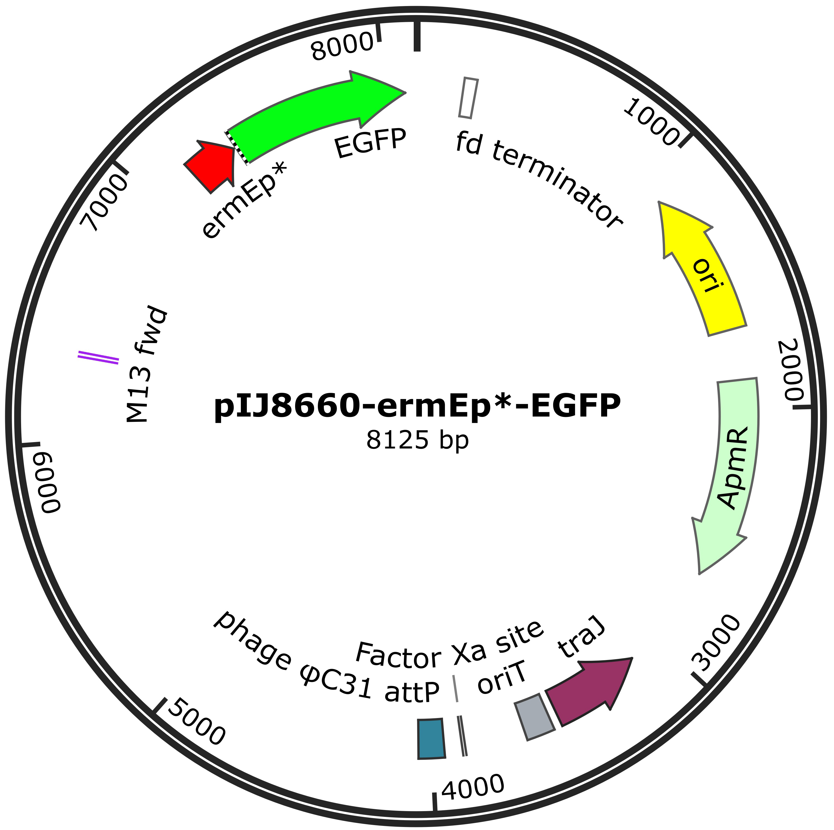
Figure 1. Diagram of the recombinant plasmid.

Figure 2. Sporulation examination of N. gerenzanensis on different agar medium.

Figure 3. Sensitivity of N. gerenzanensis to different concentrations of different antibiotics.

Figure 4. Sensitivity of E. coli ET12567 to different concentrations of teicoplanin.

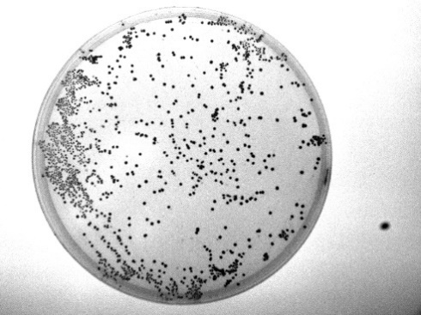
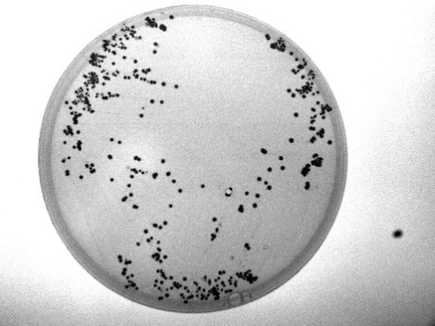
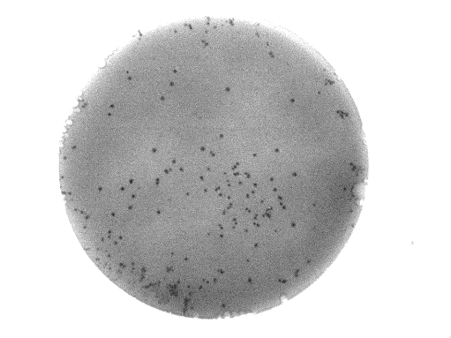
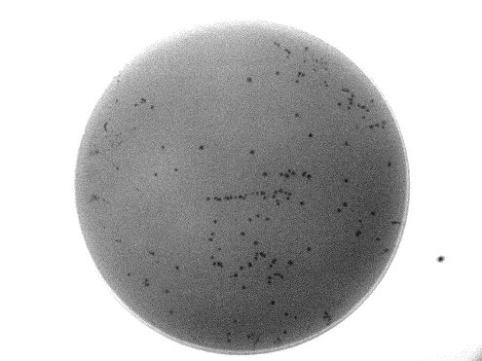
MS+30 mM MgCl₂
MS+20 mM MgCl₂
V0.1+20 mM MgCl₂
V0.1+30 mM MgCl₂

Figure 5. Comparison of conjugator regeneration on MS and V0.1 agar medium containing different concentrations of magnesium ions. The pictures are presented in black and white.

Figure 6. Growth curves and microscopic check of N. gerenzanensis cultivated in different liquid media. A, growth curves; B, microscopic observation. Each point represents the mean (n=3) ± standard deviation

Figure 7. Exconjugant confirmation through the methods of antibiotic resistance, fluorescence observation and PCR. A, exconjugants grown on apramycin resistant plate. B, fluorescence observation of exconjugant mycelium. C, gel electrophoresis of amplified products of EGFP in exconjugants, M: DNA ladder, WT: wild-type strain, 1-7: seven random exconjugants.

Reference
1. Hanahan D (1983) Studies on transformation of Escherichia coli with plasmids. J Mol Biol 166 (4):557-580. doi:10.1016/s0022-2836(83)80284-8
2. MacNeil DJ, Gewain KM, Ruby CL, Dezeny G, Gibbons PH, MacNeil T (1992) Analysis of Streptomyces avermitilis genes required for avermectin biosynthesis utilizing a novel integration vector. Gene 111 (1):61-68. doi:10.1016/0378-1119(92)90603-m
3. Santos-Beneit F, Errington J (2017) Green fluorescent protein as a reporter for the spatial and temporal expression of actIII in Streptomyces coelicolor. Arch Microbiol 199 (6):875-880. doi:10.1007/s00203-017-1358-1

