Supplementary data

Table S1. Primers used for amplifying SeHAS and the variants in this study.
Primer Sequence  5' 3' | Deleted domains | Construct name
F: ggaattcCATATGagaacattaaaaaacctcataactg  R: cccgCTCGAGtaataattttttacgtgttcc | None | SeHAS
F: acgCATATGagaacattaaaaaacctc  R: cgaCTCGAGatcaaattctctgacattgc | TMD5 TMD4 | HAS₁₂₃
F: gatCATATGgctaaaggaagcttgtcaatttatgg  R: cgaCTCGAGatcaaattctctgacattgc | TMD1  TMD4 TMD5 | HAS₂₃
F: tacCATATGaagccatttaagggaagg  R: ataCTCGAGaggattgttcatgattttcttaacag | TMD1 TMD2  TMD3  TMD4  TMD5 | HAS_{Intra}

Table S2. The characteristics of SeHAS and variants.
Enzyme | Transmembrane membrane domain | Start | End | Length (AA) | MW (kDa)
SeHAS | 1, 2, 3, 4, 5 | 1 | 417 | 417 | 42.0
HAS₁₂₃ | 1, 2, 3 | 1 | 341 | 341 | 39.1
HAS₂₃ | 2, 3 | 33 | 341 | 308 | 35.9
HAS_{Intra} | None | 55 | 319 | 264 | 30.0

Table S3. Solubilization and activity (HA titer) of variants after purification by different detergents.
HA Titer (µg/mL) |  |  | Protein Concentration (µg/mL) |  |  | Detergent
HAS₂₃ | HAS₁₂₃ | SeHAS | HAS₂₃ | HAS₁₂₃ | SeHAS | Detergent
104.70 ± 3.4 | 160.09 ± 0.8 | 225.24 ± 1.4 | 997.96 ± 5.7 | 886.11 ± 1.7 | 1378.70 ± 8.2 | DDM
12.25 ± 4.1 | 18.36 ± 3.6 | 67.22 ± 8.7 | 301.45 ± 1.6 | 206.44 ± 2.5 | 774.86 ± 4.4 | Triton X-100
6.05 ± 2.3 | 10.75 ± 2.0 | 56.32 ± 8.1 | 108.22 ± 2.3 | 150.62 ± 1.2 | 644.64 ± 3.4 | Tween 20

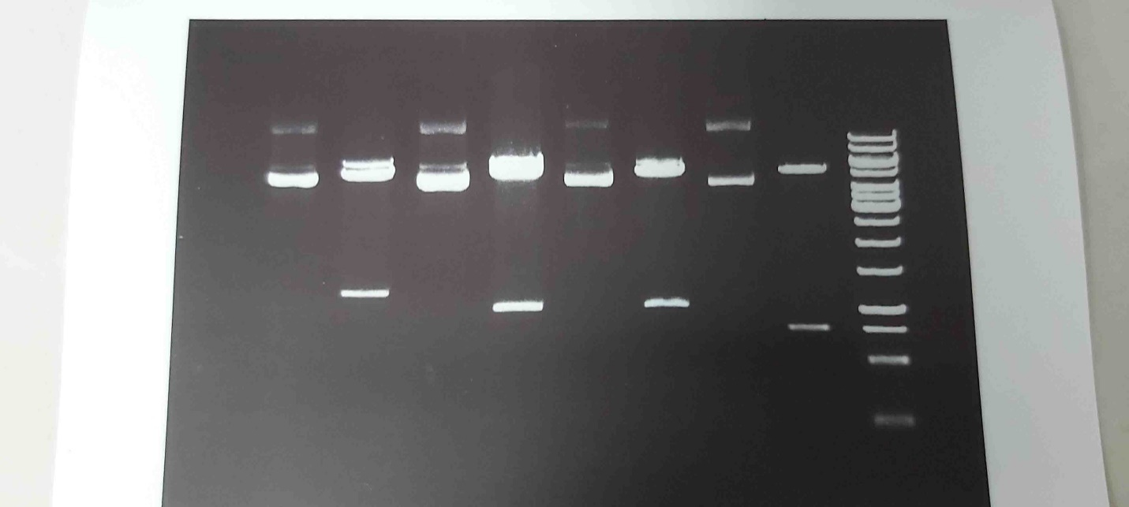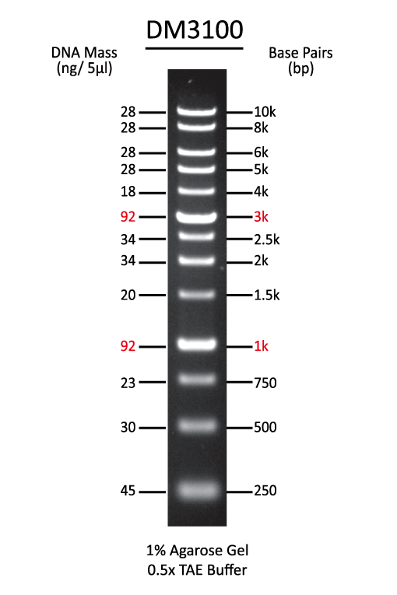
1271 bp
807 bp
1065 bp
981 bp
1 2 3 4 5 6 7 8 M
Fig. S1. Restriction map analysis of recombinant plasmids using XbaI and NdeI restriction enzymes [Lane 1: undigested pET-28a(+)-SeHAS plasmid, Lane 2: digested pET-28a(+)-SeHAS, Lane 3: undigested pET-28a(+)-HAS₂₃ plasmid, Lane 4: digested pET-28a(+)-HAS₂₃ plasmid, Lane 5: undigested pET-28a(+)-HAS₁₂₃ plasmid, Lane 6: digested pET-28a(+)-HAS₁₂₃ plasmid, Lane 7: undigested pET-28a(+)-HAS_{Intra} plasmid, Lane 8: digested pET-28a(+)-HAS_{Intra} plasmid, and M: DNA marker.]

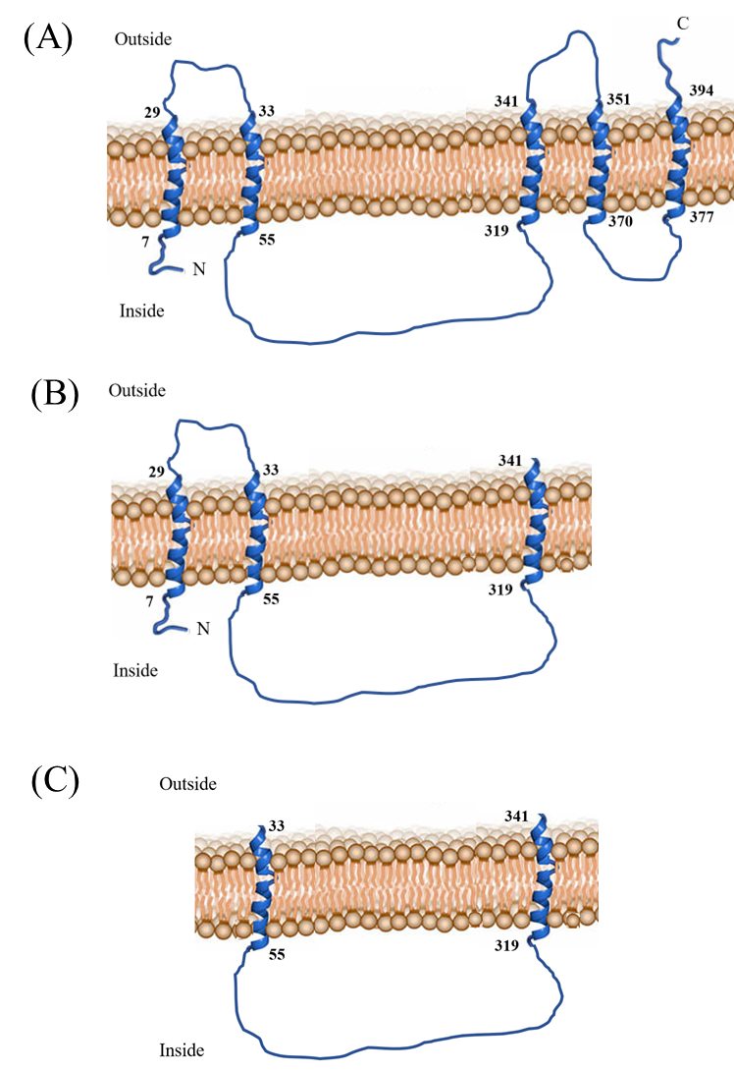
Fig. S2. Membrane-topology models for (A) seHAS, (B) HAS₁₂₃, and (C) HAS₁₂. The numbers within each TMD indicate the starting and ending residues.
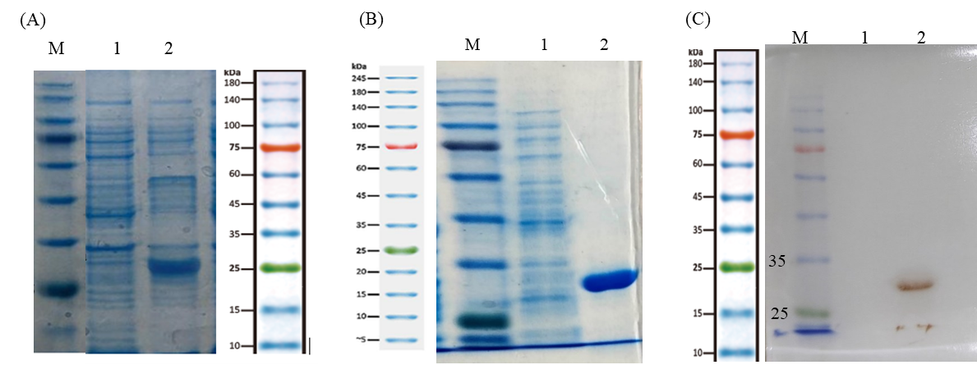

Fig. S3. 12% SDS-PAGE and western blot analysis of recombinant HAS_{Intra}. [(A) Lane 1: uninduced cell lysate; Lane 2: induced cell lysate. (B) Lane 1: uninduced cell lysate; Lane 2: eluted fraction, (C) Lane 1: uninduced cell lysate; Lane2: eluted fraction, and Lane M; protein marker].

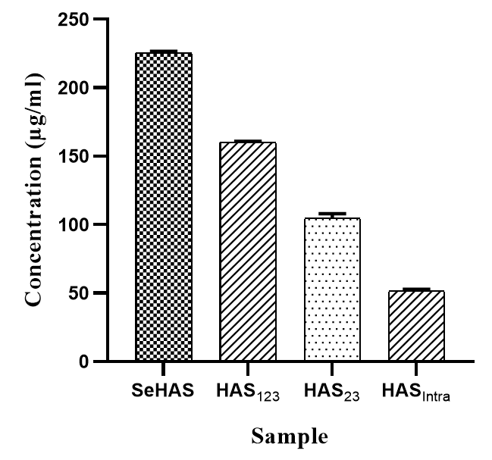
Fig. S4. Quantitative measurement of HA synthesized in the enzymatic reactions after purification. Data are represented as Mean ± SD from three independent measurements.

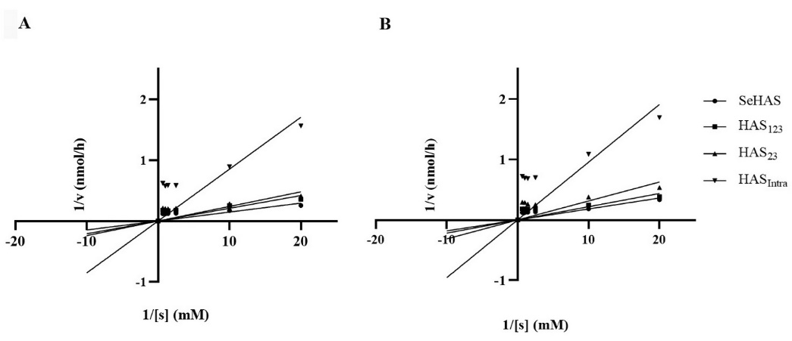

Fig. S5. The Lineweaver-Burk plots show the effect of substrate concentration on the activity of SeHAS variants at various concentrations of (A) UDP-GlcUA and (B) UDP-GLcNAc. The Vmax values were determined by varying the concentration of one substrate from 0.05 to 1.5 mM while keeping the other at 1.5 mM.

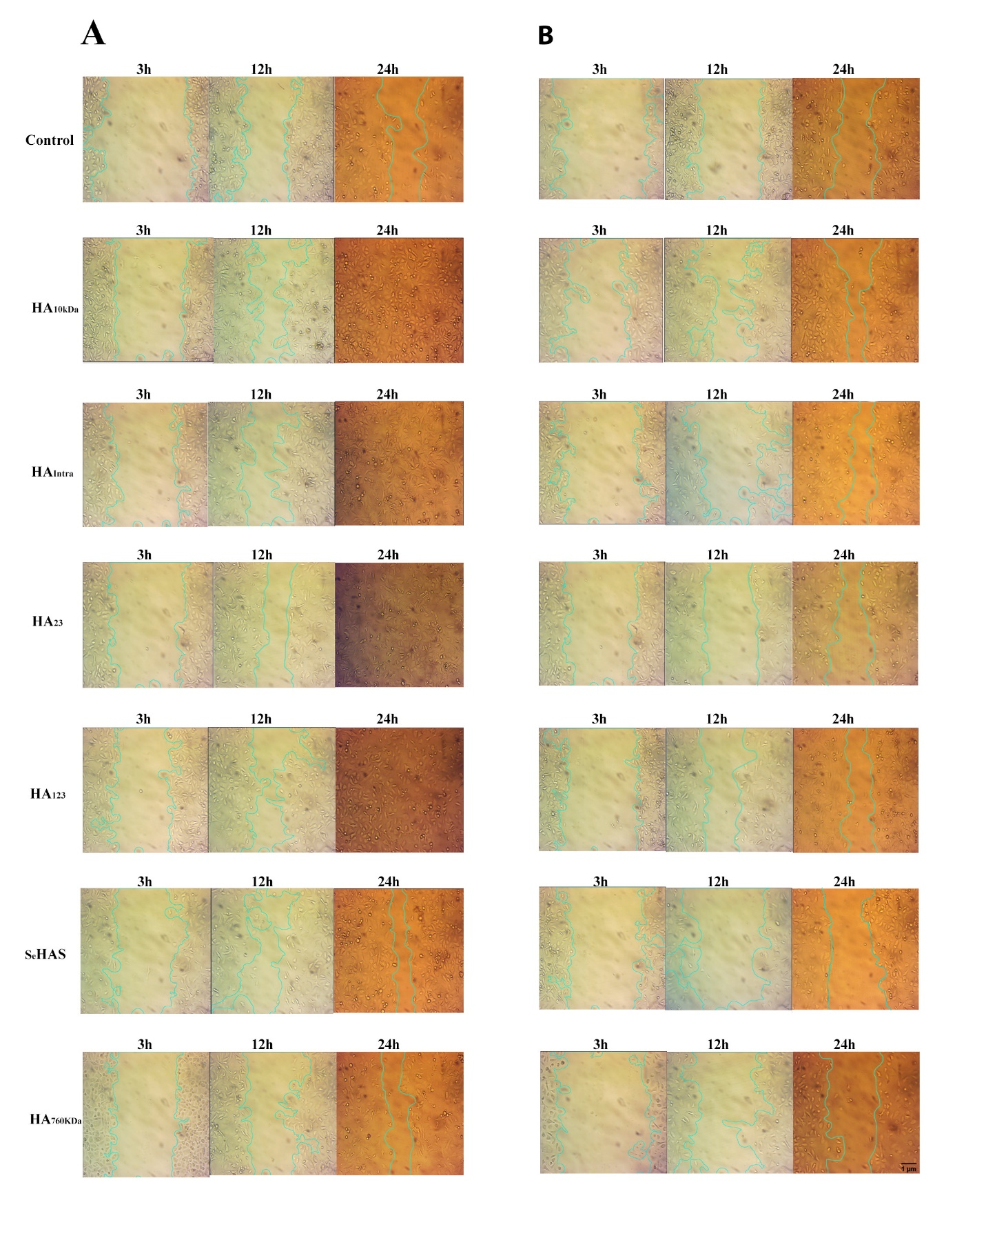
Fig. S6. Cell imaging of cell migration assay. The images show the influence of LMW-HAs and HMW-HAs at a concentration of 10 μg/mL (A) and 200 μg/mL (B) on ECs proliferation to recover the lesion after 3, 12, and 24 h in comparison to untreated control (518*545 pixels).

