Supplementary Figure 1. Modeled ribbon structure (a.) and surface view (b.) of Ace and Esp proteins.

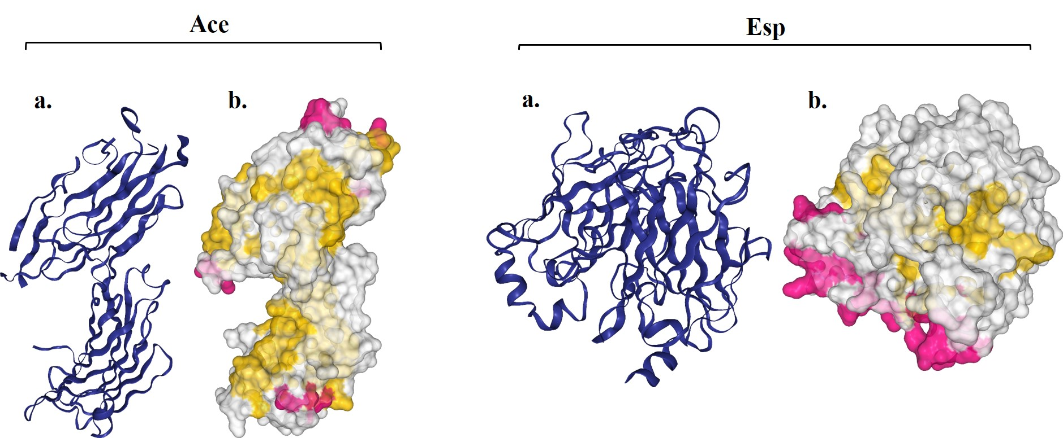

Supplementary Figure 2. Kyte and Doolittle hydropathy plot in: a. Ace, b. Esp.

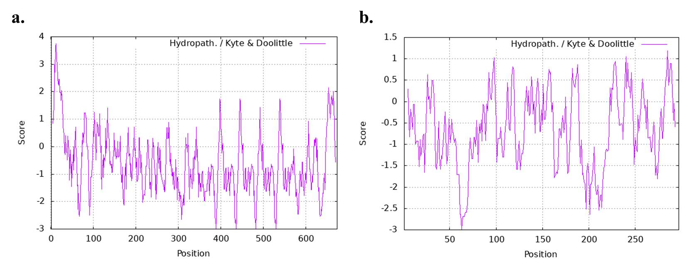

Supplementary Figure 3. Average antigenic propensity in: a. Ace, b. Esp.

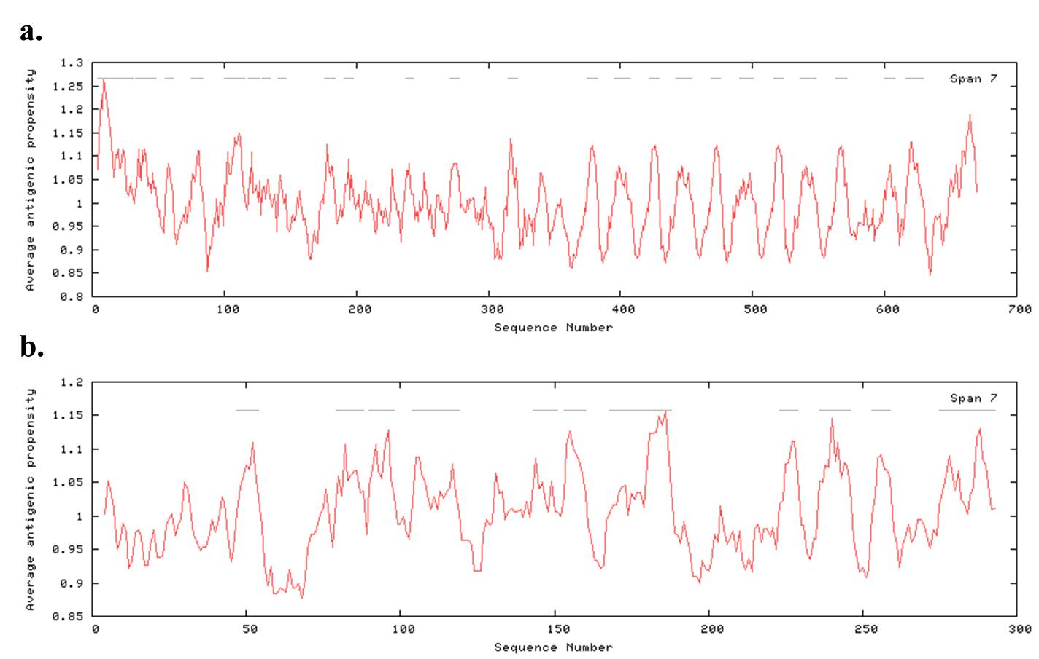

Supplementary Figure 4. Signal peptide of: a. Ace, b. Esp.

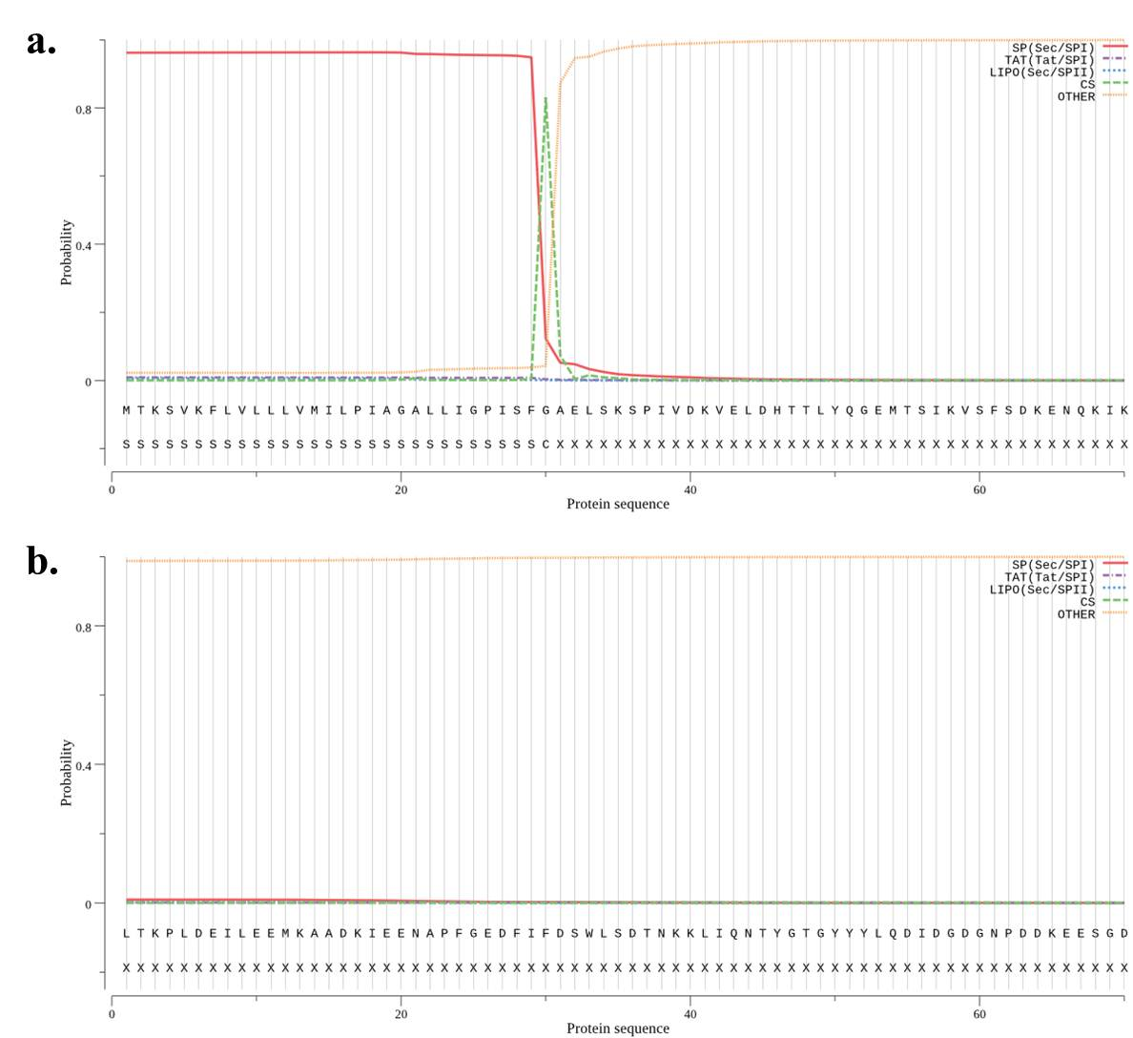

Supplementary Figure 5. Protein-protein interaction network: a. Ace, b. Esp.

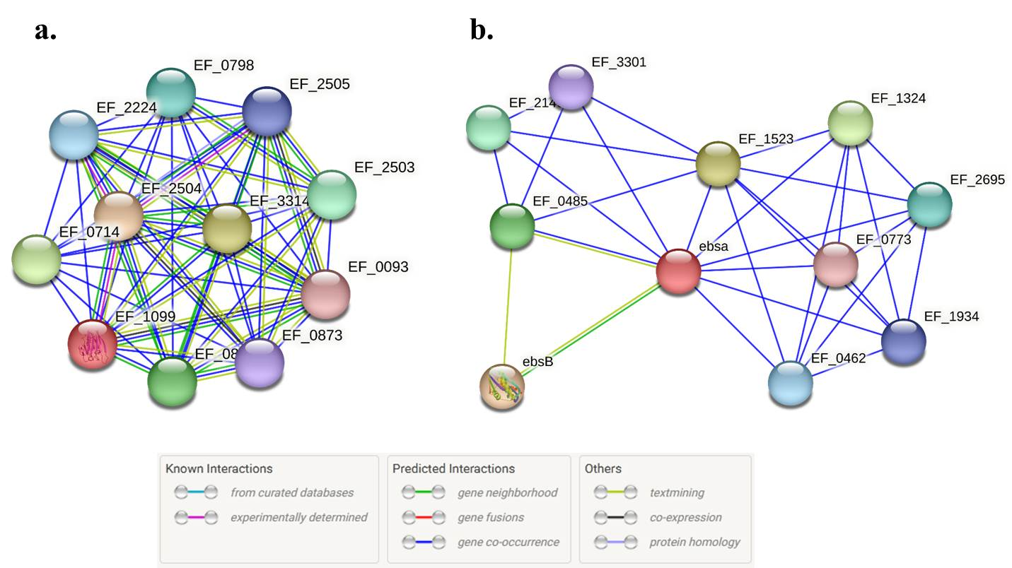

Supplementary Figure 6. Predicted Boiled-Egg plot: a. Kojic acid, b. Parietin. The plot is divided into yellow, white, and gray areas. These areas represent the BBB, HIA, and not showing both, respectively.

