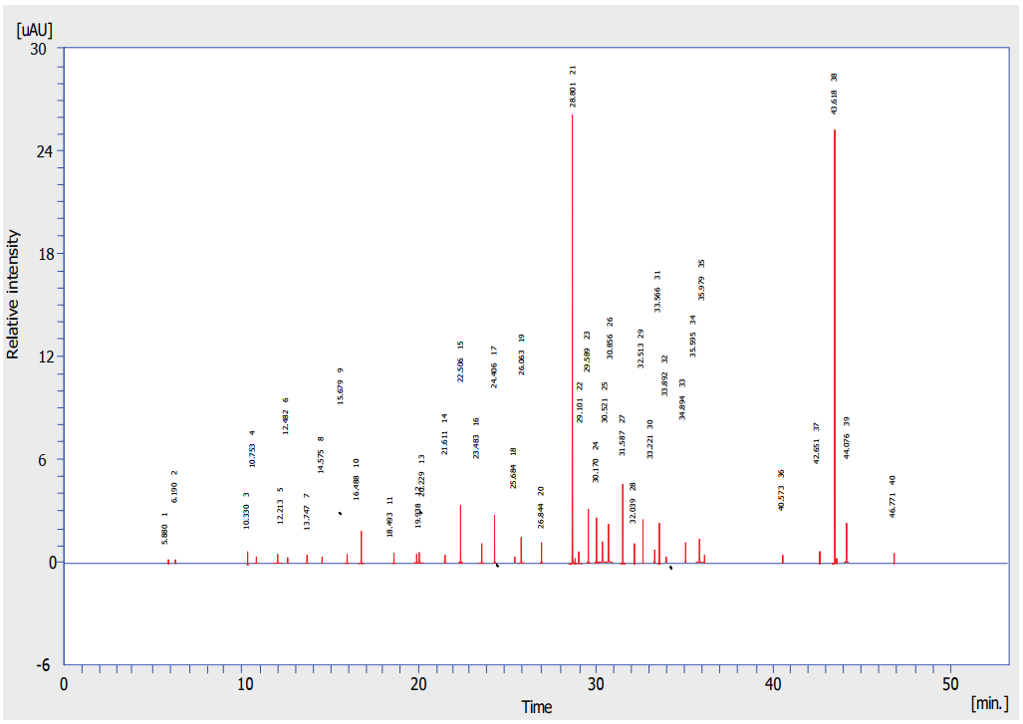

Fig. 1S The GC Mass chromatogram of sumac extracted

