Supplementary Files

Title: Leveraging Lactobacillus plantarum Probiotics to Mitigate Diarrhea and Salmonella Infections in Broiler Chickens

Seyed Mehrdad Mirsalami ^{a,∗}, Mahsa Mirsalami ^{b}
ª Department of Chemical Engineering, Faculty of Engineering, Islamic Azad University Central Tehran Branch, Tehran, Iran
^{b} Faculty of Engineering and Technical Sciences, Qazvin Islamic Azad University, Qazvin, Iran

Table S1 Content of probiotic compounds in three samples of existing medium
Compound | Concentrations (μg/L)
 | LP0 | LP6 | LP12 | LP18 | LP24 | LP30 | LP36 | LP42 | LP48
Butanal | 9.61±45 | 5.25±58 | 2.99±32 | 8.92±02 | 6.98±28 | 3.68±1 | 2.89±93 | 4.02±11 | 1.89±41
Tween 80 | 5.29±91 | 6.39±22 | 3.11±44 | 7.54±15 | 2.97±32 | 6.78 | 8.92±75 | 6.34±81 | 2.45±8
3-Octanol | 10.3±88 | 2.48 | 5.98±2 | 3.49 | 5.63±89 | 7.56±7 | 6.63 | 31.9±74 | 11.3±86
Lithium chloride | 36.1±23 | 5.23±39 | 6.31±39 | 9.48±82 | 12.3±9 | 5.98±19 | 7.29±99 | 5.34 | 14.5±79
2-Ethyl-1-hexanol | 2.95 | 4.32±94 | 7.81 | 6.95±16 | 3.77±16 | 1.39±22 | 8.62±5 | 4.02±18 | 5.77
Sodium chloride | 6.78±19 | 1.04±71 | 4.89±85 | 9.89±73 | 5.65±83 | 5.01±43 | 2.97 | 7.56±97 | 2.78±43
Pentanal | 5.02±83 | 4.06±58 | 5.76±28 | 2.65±17 | 4.89±97 | 3.77 | 6.45±76 | 1.79 | 3.36±86
Isopropanol | 2.98±77 | 9.69±11 | 5.68±19 | 7.15 | 7.18±12 | 5.22±03 | 8.18±18 | 9.37±08 | 6.73±79
Isoamyl alcohol | 8.71±28 | 5.15±2 | 7.36±37 | 5.43±83 | 8.19±93 | 4.56±11 | 6.17±46 | 4.38 | 9.67±13
2-Pentanone | - | 7.27±87 | 15.48±4 | 2.03±03 | 5.46±78 | 3.07±08 | 8.91±28 | 3.08±78 | 18.9±48
Hexanol | 3.56±94 | 4.09±69 | 42.01±8 | 8.34±98 | 1.12±88 | 5.72±2 | 3.19±69 | 7.11±44 | 40.6
Oetane, 3,6-dimethyl | 61.9±28 | 25.3±47 | 4.02±89 | 7.15±71 | 3.08±93 | 47.2 | 56.2 | 4.71±52 | 5.3±77
Propane, 1-2-methyl | 5.88±32 | 5.42±51 | 8.82±14 | 3.46±07 | 2.01 | 7.84±37 | 4.28±88 | 12.42±1 | 6.32±23
Decane | 5.57±17 | 8.49±96 | 9.63±08 | 4.41 | - | 9.53 | 5.26±13 | 68.01±9 | 32.5±98
Tridecane, 6-methyl | 1.91±22 | 3.09±61 | 4.48±15 | 5.67±96 | 7.15 | 2.64±96 | 3.09±76 | 12.41±2 | 2.06±03
Nonane | 2.28±78 | 6.69±37 | 5.12 | 2.08±15 | 4.88±33 | 5.19±4 | 7.45±49 | 5.19±76 | 8.91±88
Butanoic acid,methyl ester | 3.17±63 | 7.25±46 | 5.68±97 | 2.99±75 | 5.67±79 | 4.31 | 2.07±53 | 5.48±89 | 11.49±6
Nonane, 3-methyl | 9.19±49 | 5.58±33 | 7.91±26 | 5.48±28 | 2.24±83 | 5.06±79 | 7.91±72 | 4.62±23 | 2.08±8
1,1,3,3-Tetramethylbutyl | 5.06±15 | 6.81±97 | 8.56±3 | 4.93±66 | 2.76±12 | 1.01±56 | 5.28±96 | 4.93±79 | 7.82
Manganese sulfate | 15.7±28 | 4.32±29 | 5.07±73 | 6.49±49 | 3.744 | 1.49±75 | 6.33 | 5.79±82 | 2.93±3
Vanillin, derivative | 2.34 | 1.09±09 | 7.94±99 | 5.58±42 | 2.82 | 3.93±48 | 17.1 | 9.39±53 | 3.13±06
Methyl nonyl ether | 5.02±88 | 4.82±48 | 4.38±45 | 7.91±87 | 2.43±78 | 3.86±84 | 4.02±02 | 1.78±70 | 9.42±49
Pentanedione | 7.86±37 | 6.64±07 | - | 11.48±2 | 1.78±82 | 5.69±6 | 6.79 | 8.72±96 | 3.44±56
2-Nonanone | 33.7±45 | 1.59±70 | 14.71±8 | 24.3±12 | 5.69±14 | 4.78±5 | 5.46±8 | 6.37±13 | 1.09
Oxime-, methoxy-phenyl | 19.28±1 | 4.78±59 | 9.18±16 | 6.75±92 | 3.14±73 | 2.07 | 5.49±3 | 4.78±75 | 8.18±75
2-Heptanol | 5.3±89 | 18.8±46 | 5.73±43 | 2.48 | 9.48±22 | 5.17±73 | 9.66 | 3.08±94 | 4.17±34
Phenethyl acetate | 6.42±67 | 5.78±37 | 9.41±95 | 5.72 | 4.14±03 | 9.43±49 | 2.83±4 | 7.04±1 | 3.49±83
4-Heptanol, ethyl dimethyl | 4.5±49 | 17.58±9 | 8.33±86 | 7.98±19 | 6.11±93 | 8.94±62 | 11.41±7 | 6.78 | 5.33±12
Di-Amoniumhydrogen | 11.8±23 | 9.52±23 | 2.05±17 | 3.72±33 | 8.91±74 | 4.1 | 6.81±98 | 9.77±2 | 8.14±29
Octyl butyrate | 8.7±91 | 5.93 | 5.81±46 | 6.09±59 | 5.82±94 | 3.9±06 | 4.89 | 6.03±07 | 4.79±45
D-Limonene | 9.13±77 | 8.22±83 | 9.37 | 5.01±85 | 6.16±38 | 7.48±8 | 5.73±34 | 6.89±6 | 2.12±34
Benzoic acid | 1.82±52 | 2.09±59 | 31.2±36 | 5.78±18 | 5.49±85 | 3.82±92 | 3.07±59 | 9.19 | 8.71±39
Pentanoic acid | 5.15±41 | 18.75 | 2.98±18 | 4.98±77 | 3.16±82 | 4.55±47 | 7.09±6 | 8.14±72 | 9.86±78
Hexanoic acid | 20.9±93 | 81.9±2 | 5.8±78 | 91.8 | 4.68±77 | 3.05±3 | 4.79 | 5.15±15 | 7.17±66
Isooctanoic acid | 5.07±28 | 6.7±12 | 4.14 | 5.89±56 | 19.58±9 | 5.67±07 | 3.18±41 | 6.56±42 | 1.09±94
Butyric acid | 7.59±71 | 8.15±94 | 2.19±28 | 6.47±34 | 5.52±72 | 7.17±76 | 8.19±08 | - | 9.02±46
Acetic acid | 81.2 | 2.1±58 | 7.38 | 5.35±93 | 7.48 | 12.89 | 24.3 | 14.9±8 | 7.58±27
Propanoic acid | 3.13±29 | 5.68±43 | 5.76±49 | 13.6±46 | 4.14±1 | 5.18±04 | 29.8±9 | 36.6±7 | 4.17
2-5Hexanedione | 19.77±7 | 9.08±77 | 13.13±6 | 5.86±29 | 3.1827 | 4.87±2 | 5.69±4 | 2.22 | 8.7±67
2-Hexen-1-ol | 2.89±51 | 15.83±2 | 63.9±79 | 8.17±85 | 3.09 | 2.99±7 | 3.41±52 | 16.8±5 | 7.91±48
Data are expressed as the mean ± standard deflection from iterates analyses (n = 3) of three repeat samples. The different lowercase letters in each row illustrate significant differences between samples (P < 0.05). The symbol “-” means not found.

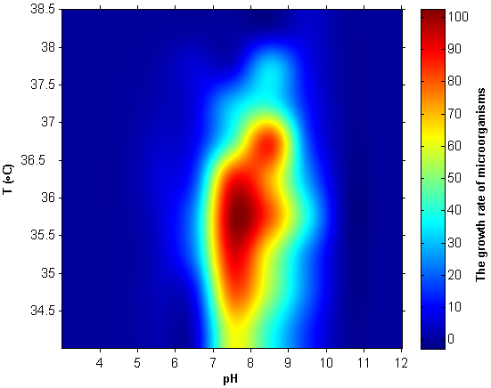

Fig. S1. Growth rate of L. plantarum at room temperature and neutral pH, acidic and basic

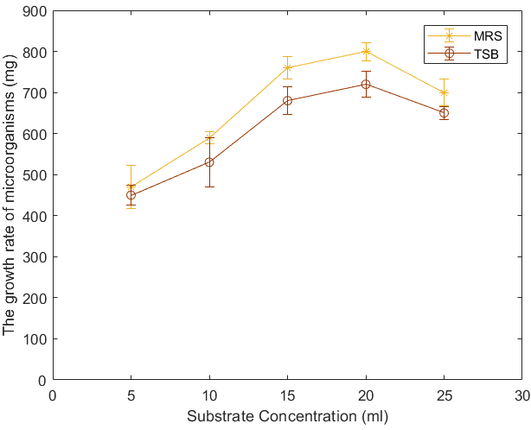

Fig. S2. The effect of changing the concentration of substrate (ml) in MRS, TSB medium on the growth rate of microorganisms (t = constant)

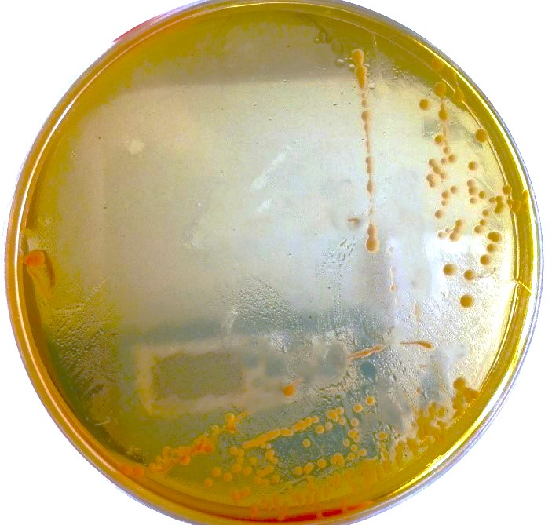
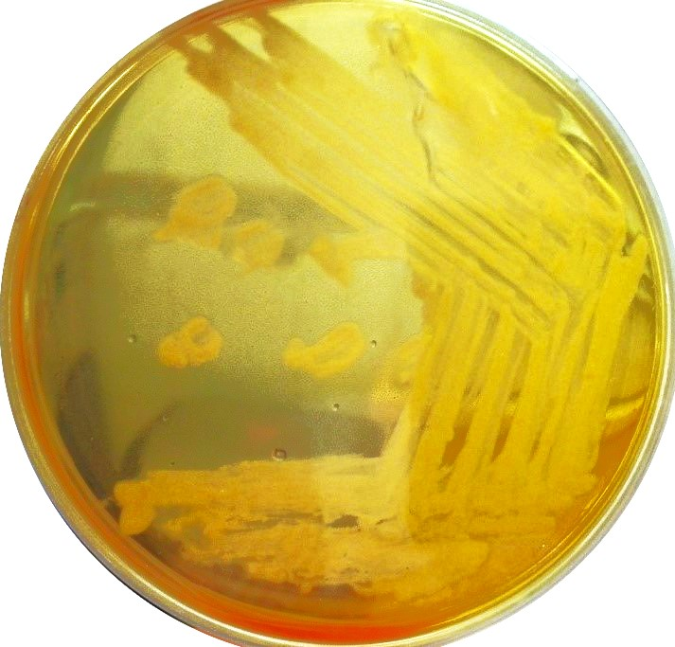

A (NotActive)
B (MRS)

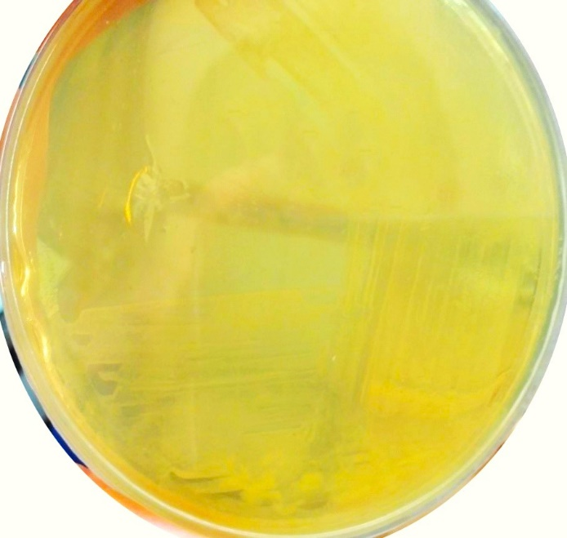

C (TSB)

Fig. S3. A. Lactobacillus plantarum strain in MRS medium at 30°C (inactivity of microorganism growth at 30°C and below). (B),(C) Bacterial growth on MRS and TSB medium, 37°C, pH = 6.5-7 respectively

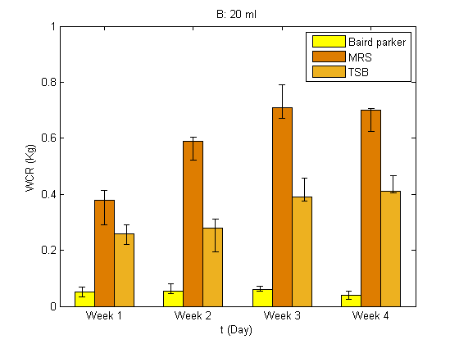
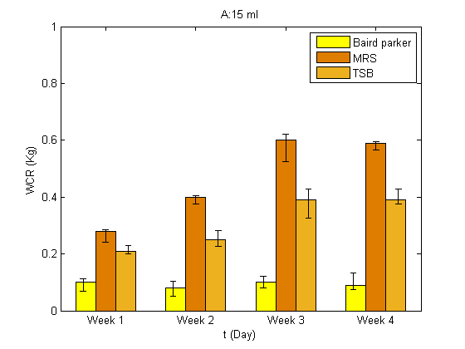

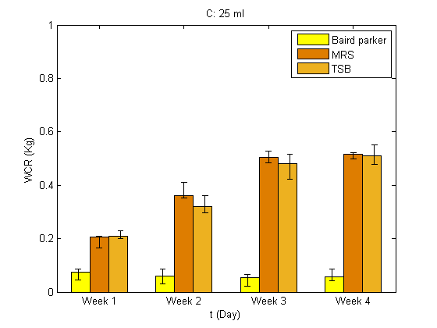

Fig. S4. Weight change of adult chickens after receiving 15, 20 and 25 ml within 4 weeks. A: Weight of chickens before probiotic injection respectively (2.061 Kg: Baird parker, 2.111 Kg: MRS, 2.203 Kg: TSB) -- 15 ml recipient of LPS-115 (bacteria cultured in solution), B: (1.947 Kg: Baird parker, 1979 Kg: MRS, 2.301 Kg: TSB) -- 20 ml C: (1.989 Kg: Baird parker, 2.027 Kg: MRS, 2.185 Kg: TSB) -- 25 ml (*Weight change rate: WCR)

∗ Corresponding author: Email: m.mirsalami.eng@iauctb.ac.ir (SM.M.)

