Construction of a Multienzyme Cascade Reaction System and its Application in D-tagatose Biosynthesis
Xiaoxiao Zhang¹, Jie Chu^{1 *}, Yuanqiang lv¹, Xuan Li¹, Aijiao Yin¹, and Yanhua Huang^{1*}
¹ Biology Institute, Qilu University of Technology (Shandong Academy of Sciences), Jinan 250103, China
*Corresponding author:
Jie Chu (chujie6532@163.com)
Yanhua Huang (hyhua0827@126.com).

Figure. S1 Identification of recombinant strains on kanamycin plates.
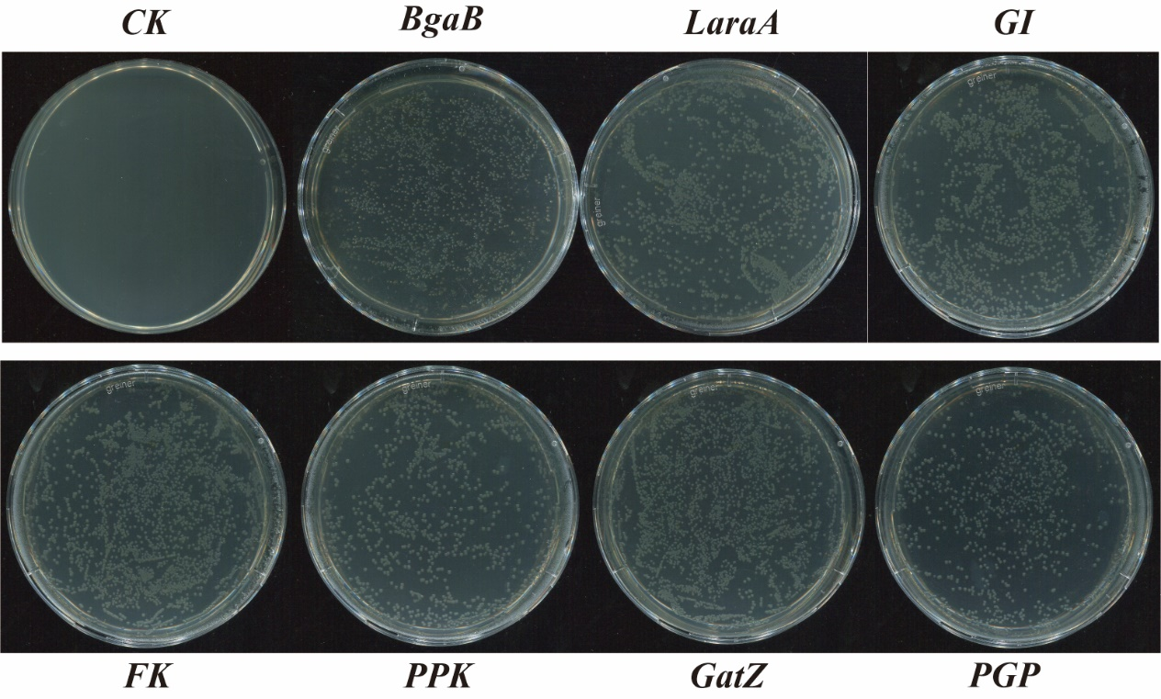

Figure. S2 HPLC analysis of the standards lactose, D-galactose, D-glucose, and D-tagatose.

Figure. S3 Standard Curve of D-tagatose.

