Table S1. Antibiotic susceptibility test results of Enterococcus sp isolates (n=65).
Antibiotic | Number of resistant isolates | Percentage %
Vancomycin | 26 | 40
Teicoplanin | 6 | 9.23
Linezolid | 4 | 6.15
Erythromycin | 59 | 90.7
Ampicillin/sulbactam | 63 | 96.9
Chloramphenicol | 11 | 16.92
Doxycycline | 53 | 81.53
Ciprofloxacin | 57 | 87.69

Table S2. Biofilm formation test results (n=65)
Isolate code | No biofilm | Week biofilm | Intermediate biofilm | Strong biofilm
E1 |  |  | +
E2 |  |  |  | +
E3 |  | +
E4 |  | +
E5 |  |  |  | +
E6 |  |  | +
E7 |  |  | +
E8 |  | +
E9 |  | +
E10 |  |  | +
E11 |  |  |  | +
E12 |  |  | +
E13 |  |  | +
E14 |  |  |  | +
E15 |  | +
E16 |  |  | +
E17 |  |  | +
E18 |  |  | +
E19 |  |  | +
E20 |  |  |  | +
E21 |  |  | +
E22 |  | +
E23 | +
E24 |  |  |  | +
E25 |  |  | +
E26 |  |  |  | +
E27 |  | +
E28 |  | +
E29 |  |  | +
E30 |  | +
E31 |  | +
E32 |  |  | +
E33 |  | +
E34 |  |  |  | +
E35 |  | +
E36 |  |  | +
E37 |  | +
E38 |  |  | +
E39 |  | +
E40 |  |  | +
E41 |  |  | +
E42 |  |  |  | +
E43 |  |  | +
E44 |  |  | +
E45 |  |  | +
E46 |  |  |  | +
E47 |  |  | +
E48 | +
E49 | +
E50 | +
E51 |  | +
E52 |  | +
E53 | +
E54 | +
E55 |  | +
E56 |  | +
E57 | +
E58 | +
E59 | +
E60 |  | +
E61 |  | +
E62 |  | +
E63 | +
E64 | +
E65 |  | +

Table S3. Thermal stability test of Enterococcus phage vB_EF_Enf3_CCASU-2024-3
Temperature | Spot test
30°C | +
40°C | +
50°C | +
60°C | +
70°C | -
80°C | -

Table S4. pH stability test for Enterococcus phage vB_EF_Enf3_CCASU-2024-3
pH value | Spot test
1 | -
2 | -
3 | +
4 | +
5 | +
6 | +
7 | +
8 | +
9 | -
10 | -
11 | -
12 | -

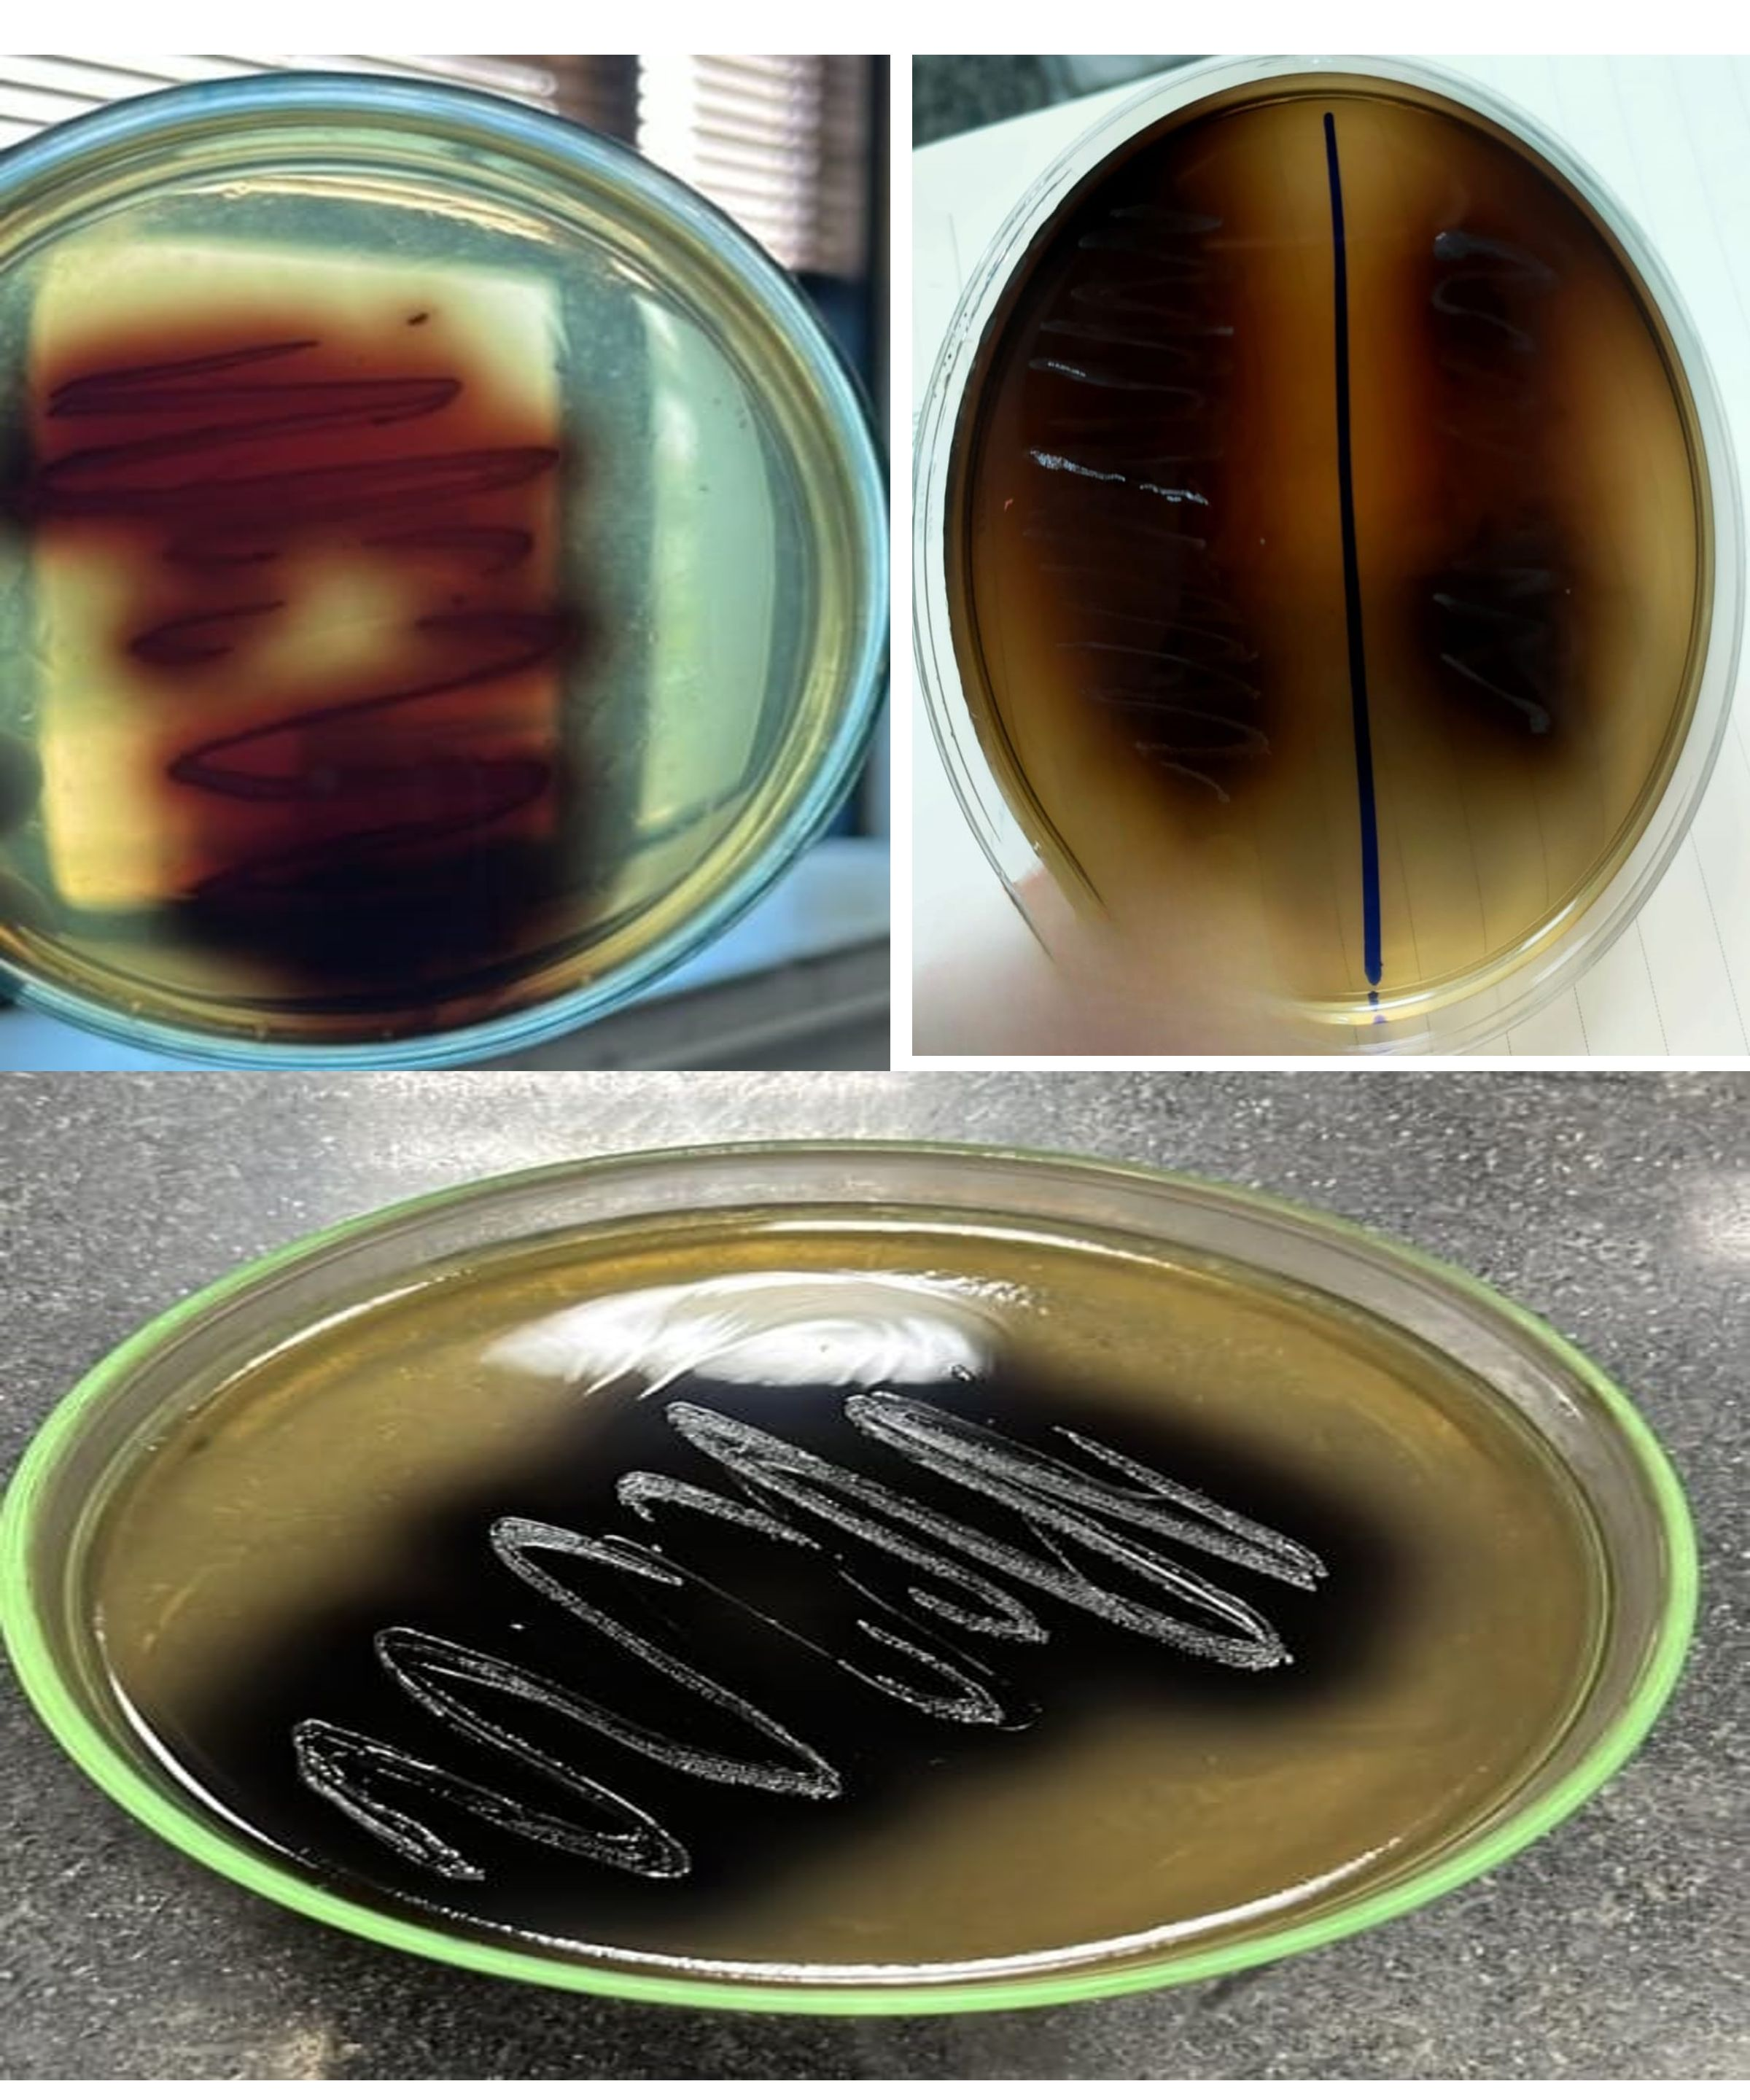
Fig. S1. Phenotypic growth of Enterococcus sp. showing brown, black colonies on Bile Esculin Agar (BEA) plates

