supplementary Information

Study of anti-Toxoplasma gondii effect of mPEG - PCL copolymeric loaded with pyrimethamine, in vitro
Mobina Gholami ¹, Hossein Danafer ^{1,} ², Mitra Sadeghi ^{3, 4}, Ahmad Daryani ^{4, 5}, Seyed Abdullah Hosseini ^{4, 5}, Shirzad Gholami ^{4, 5, *}
¹ Zanjan Pharmaceutical Nanotechnology Research Center, Zanjan University of Medical Sciences, Zanjan, Iran.
² Department of Medicinal Chemistry, School of Pharmacy, Zanjan University of Medical Sciences, Zanjan, Iran.
³ Student Research Committee, Mazandaran University of Medical Sciences, Sari, Iran
⁴ Toxoplasmosis Research Center, Communicable Disease Institute, Mazandaran University of Medical Sciences, Sari, Mazandaran, Iran
⁵ Department of Parasitology and Mycology, School of Medicine, Mazandaran University of Medical Science, Sari, Iran

*Corresponding authors: Dr. Shirzad Gholami
Department of Medical Parasitology and Mycology 18 Km of Khazar Abad Road, School of Medicine, Mazandaran University of Medical Sciences, Sari, Iran
Email: sgholami200@gmail.com

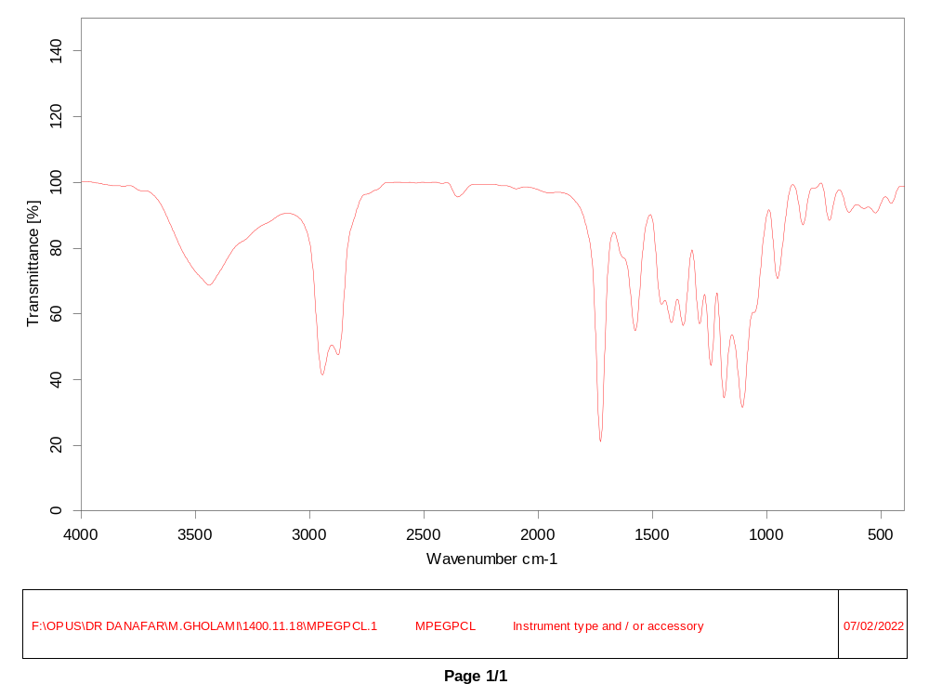
Figure S1 FT-IR spectrum of mPEG-PCL copolymer.

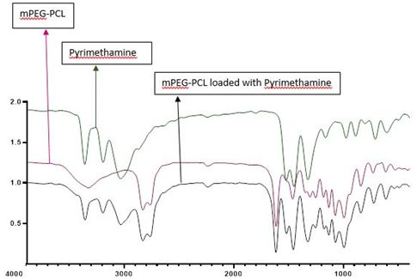

Figure S2 FT-IR spectrum of mPEG-PCL copolymer, pyrimethamine drug and mPEG-PCL copolymer nanoparticle loaded with pyrimethamine.

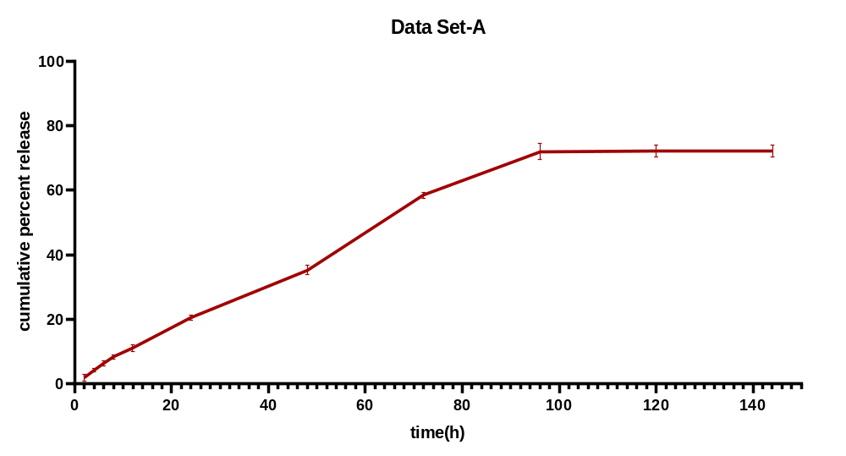
Figure S3 Release of pyrimethamine in buffer medium with pH= 7.4 in vitro

Table S1 Mortality and Viability of Toxoplasma gondii tachyzoites treated with drugs using Trypan blue exclusion assay
Treatment | Tachyzoites Viability (%) 30 min | Tachyzoites Mortality (%) 24 h
Negative Control | 100 | 2
mPEG-PCL | 99 | 50
Nano medicine | 99 | 68
Pyrimethamine | 97 | 80

