Autonomous Microfluidic Influenza A/B Subtyping System Using On-Chip Multiplex Isothermal Amplification for Field-Deployable Surveillance
Si-Ming Lu^{1,2#}, Jia-Long Wang^{4,5#}, Yang Li^{4,5#}, Ling Zhang ^{1,2}, Hang-Ping Yao^{4,5}*, Li-Guo Liang^{3,4,5}*

- Department of Laboratory Medicine, the First Affiliated Hospital, Zhejiang University School of Medicine, Hangzhou, China
- Institute of Laboratory Medicine, Zhejiang University, Hangzhou, China
- Centre for Clinical Laboratory, The First Affiliated Hospital of Zhejiang Chinese Medical University, Hangzhou, China
- State Key Laboratory for Diagnosis and Treatment of Infectious Diseases, the First Affiliated Hospital, Zhejiang University School of Medicine, Hangzhou, China
- National Clinical Research Center for Infectious Diseases, the First Affiliated Hospital, Zhejiang University School of Medicine, Hangzhou, China

Authorship: # These authors contributed equally to the study presented in this article.
*Correspondences: Hang-Ping Yao (Email: yaohangping@zju.edu.cn), Li-Guo Liang (Email: lianglg@zju.edu.cn )

Page 6, line 115-119
Specifically, the microfluidic detection chip we have developed has 24 detection wells, with each area consisting of 8 wells. These wells correspond to the detection of six types of viral nucleic acids mentioned earlier. Additionally, there are two other detection wells: one for the positive control and one for the negative control.

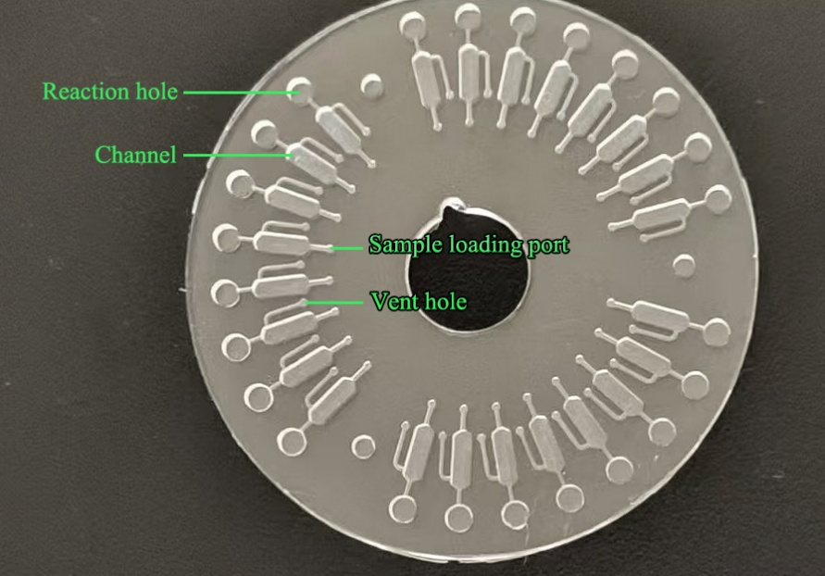
Figure S1: Structural diagram of the microfluidic detection chip

Page 8, line 193 to page 9, line 194-199
First, add viral nucleic acid through six sample wells into the microfluidic chip channel cavity. Then, add amplification reagents one by one independently and seal the sample and vent holes with transparent tape. At the same time, place the amplification chip in our self-developed centrifugal drive real-time fluorescence constant temperature amplification instrument. Under centrifugal force, the reagents are distributed into the circular reaction chambers of the chip, where amplification and real-time detection occur simultaneously.

page 5, line 86-90
RNA integrity was validated via RIN (RNA Integrity Number) >7.0 (Agilent Bioanalyzer 2100), A260/A280 ratio 1.8-2.0 (NanoDrop™), Concentration ≥20 ng/μL (Qubit® 4.0 Fluorometer). RNA Integrity Metrics see in table S1. Samples failing any criterion (n=3) were excluded prior to analysis.
Table S1: RNA Integrity Metrics
Sample Group | n | RIN (Mean ± SD) | A260/A280 (Mean ± SD) | Qubit® Yield (ng/μL)
Patients | 150 | 8.2 ± 0.7 | 1.92 ± 0.08 | 35.4 ± 12.1
Controls | 30 | 8.5 ± 0.5 | 1.94 ± 0.06 | 38.1 ± 10.8

page 5, line 94-98
We confirm that all 10 clinical RNA samples were rigorously selected to represent a broad spectrum of viral loads (Ct range: 26.8-37.9), classified according to WHO standards. As shown in the Table above, every sample met predefined eligibility criteria: (1) symptomatic confirmation, (2) early collection (<5 days post-symptom onset), and (3) validation by reference RT-PCR. Critically, our rapid diagnostic system detected all samples as positive, including the very low viral load specimen (P06, Ct=37.9), demonstrating high sensitivity across clinically relevant ranges. Full methodological details are provided in Supplementary Table 2.

Table 2: Viral Load Distribution and Sample Eligibility Criteria
Sample ID | RNA Source | RT-PCR Ct Value | Viral Load Levelª | Eligibility Criteria Met^{b} | Detection Result (By Chip)
P01 | Nasopharyngeal | 28.1 | High (≥10⁶ copies/mL) | ① ② ③ | Positive
P02 | Sputum | 32.5 | Medium (10⁴-10⁵ copies/mL) | ① ② ③ | Positive
P03 | Throat Swab | 35.2 | Low (10³-10⁴ copies/mL) | ① ② ③ | Positive
P04 | Nasopharyngeal | 26.8 | High | ① ② ③ | Positive
P05 | Sputum | 30.1 | Medium | ① ② ③ | Positive
P06 | Throat Swab | 37.9 | Very Low (<10³ copies/mL) | ① ② ③ | Positive
P07 | Nasopharyngeal | 29.3 | High | ① ② ③ | Positive
P08 | Sputum | 33.7 | Medium | ① ② ③ | Positive
P09 | Throat Swab | 36.4 | Low | ① ② ③ | Positive
P10 | Nasopharyngeal | 31.0 | Medium | ① ② ③ | Positive
ª Viral Load Classification (WHO Guidelines ^{[1]}):
High: Ct ≤30 (≥10⁶ copies/mL); Medium: Ct 30–35 (10⁴-10⁵ copies/mL)
Low: Ct 35–38 (10³-10⁴ copies/mL); Very Low: Ct >38 (<10³ copies/mL)
^{b} Eligibility Criteria: ① Clinically confirmed symptomatic cases② Collection within 5 days of symptom onset③ Validated by reference RT-PCR (Ct <40)
Reference
[1] WHO/2019-nCoV/Sci_Brief/LOD detection/2022.1

