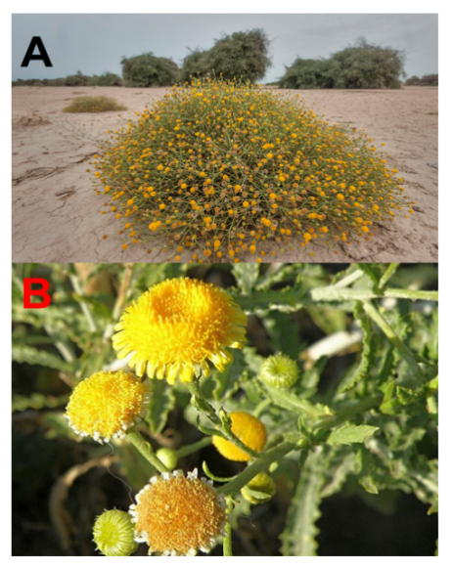
Supp 1. Pulicaria undulata (L.) plant form. A) Whole plant in the arid environment. B) Yellow flower that are being used in the extraction.

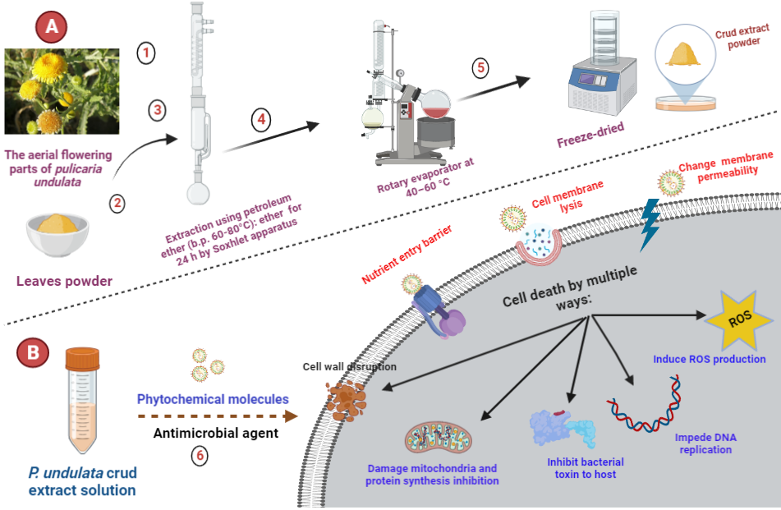
Supp 2. (A) Illustration of the preparation of the aerial flowering parts of pulicaria undulate extract; and (B) phytochemical molecules p. undulate bactericidal mechanism agent

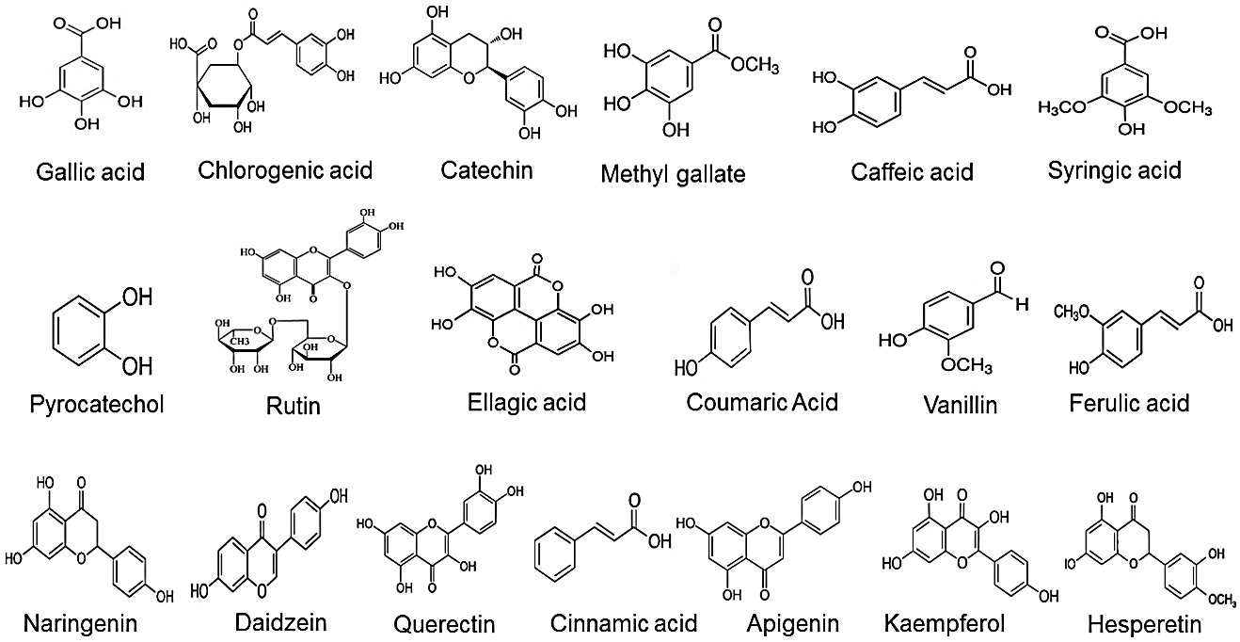

Supp 3. Structures of the 19 natural compounds isolated from P. undulate extract.

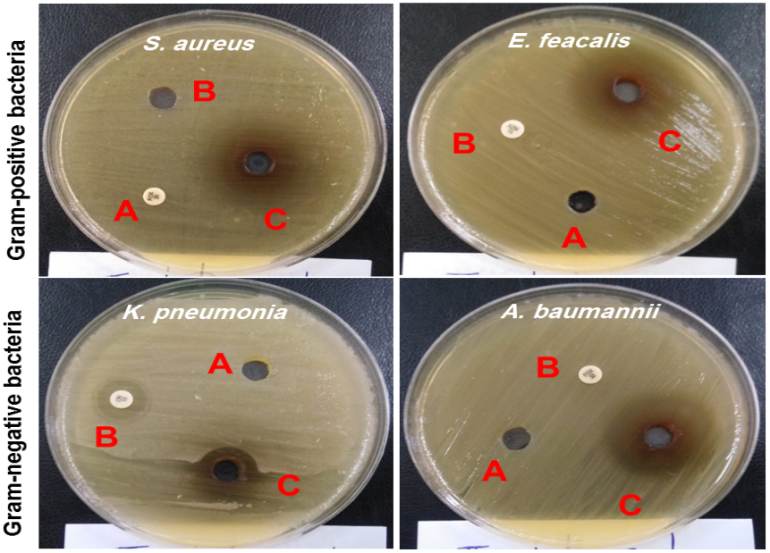
Supp 4. Antimicrobial screenings of P. undulata petroleum ether of the flowering parts extract against isolated bacteria. (A) Negative control (distilled water); (B) Positive control Levoﬂoxacin, and (C) P. undulata extract (6 mg/disc).

