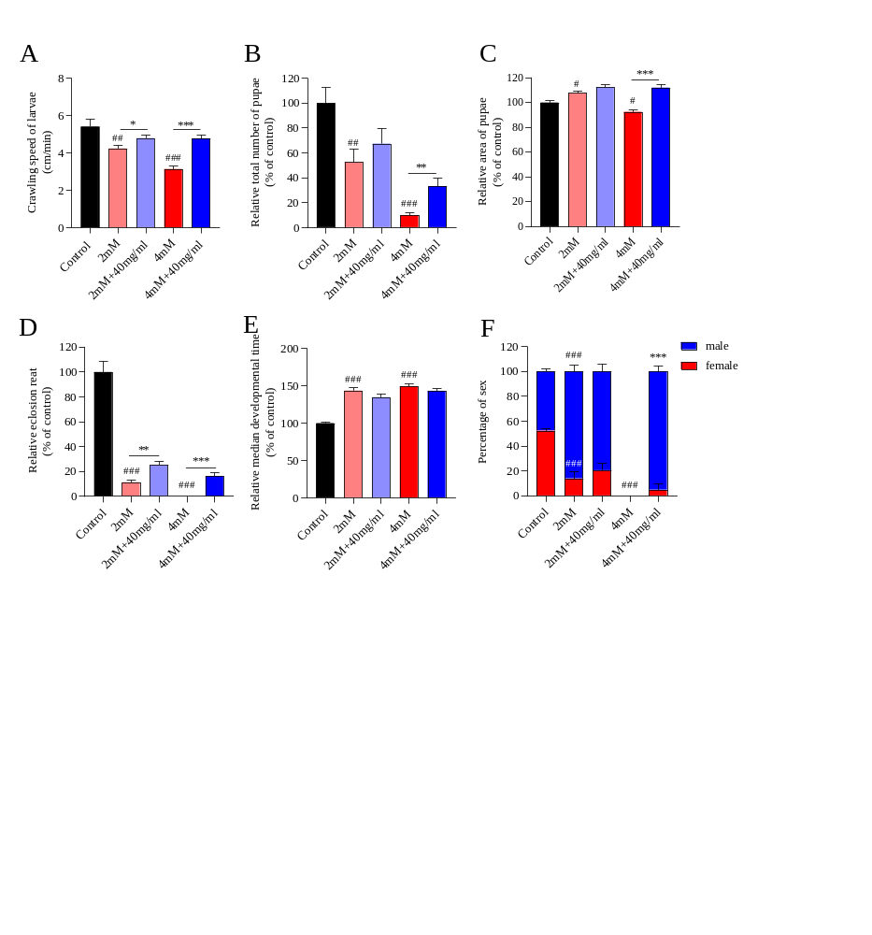
Figure S1. HQBHG ameliorates the development and eclosion in CPT-11 treated flies. (A) HQBHG alleviates the crawling ability of larvae after CPT-11 treatment (n=15-18). It alleviates the decrease of total pupa number (B) and increases the area of pupa (C) in CPT-11 treated flies (n=30-35). HQBHG increases the eclosion rate (D) and restores the eclosion time from pupae to adult after administration of CPT (E) (n=7-9). (F) HQBHG recovers the decrease of female to male ratio in offspring caused by CPT-11 (n=7-9). *p< 0.05, **p< 0.01 and ***p< 0.001 indicate significant difference between CPT-11 and HQBHG. ##p< 0.01 and ###p< 0.001 indicate significant difference between CPT-11 and control.
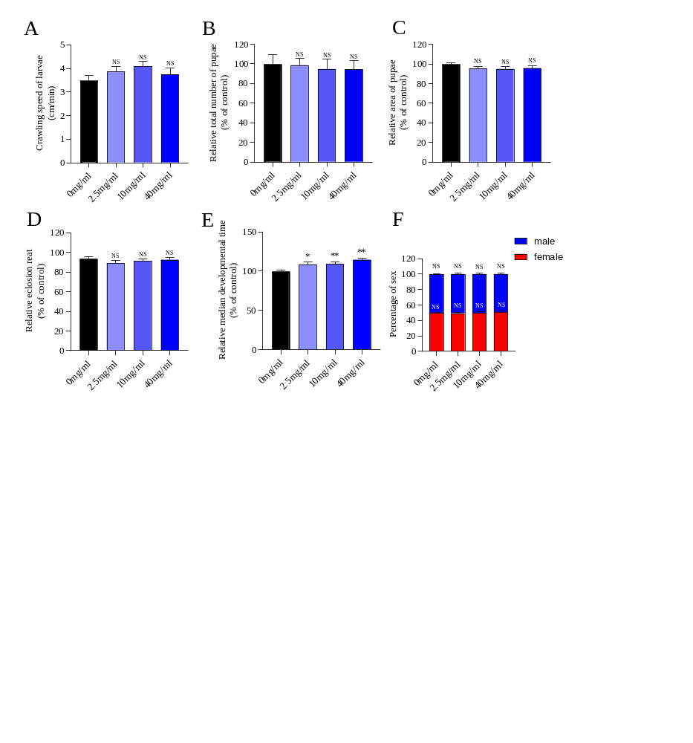
Figure S2. HQBHG is harmless to Drosophila larvae development. (A) HQBHG has no effect on the crawling speed of larvae (n=6). (B) The total number of pupae was not affected by HQBHG (n=10). (C) HQBHG has no effect on pupa area of pupa (n=35). (D) HQBHG don’t demonstrate any impact on the rate of eclosion (n=10). (E) HQBHG doesn’t have any impact on the median developmental time of larvae (n=10). (F) HQBHG has no effect on the female to male ratio in offspring (n=10). One-way ANOVA followed by Tukey’s multiple comparisons test. *p < 0.05 and **p < 0.01 for comparisons between the control and HQBHG groups.
Figure S3. Network analysis on the mechanism of HQBHG against CPT-11-induced gastrointestinal toxicity. (A) Intersection of HQBHG compound-putative targets and Chemotherapy bowel injury-putative targets. HQBHG shares 185 putative targets with known Chemotherapy bowel injury targets. (B) Protein–protein interaction network of the target genes of HQBHG in Chemotherapy bowel injury. (C) KEGG pathway enrichment analysis of potential targets. The pathways related to inflammation and gastrointestinal diseases with p-values less than 0.05 are shown. (D) GO enrichment analysis of potential targets: cellular components, molecular functions, and biological processes associated with the detoxification effect of HQBHG on CPT-11.

Figure S4. Ethics approval and consent to participate

Table S1. List of forward and reverse primers used in this study
Model organisms | Gene | Forward (5'-3') | Reverse (5'-3')
flies | Rp49 | CTTCATCCGCCACCAGTC | GCACCAGGAACTTCTTGAATC
flies | Myd88 | GGCTCGTTCCCTACACGATC | GAATGCTGGGAGTGGTCACC
flies | Relish | ACAGCTACAGGAACTGCATCAGGAA | TCATCCTCCTCGAAGAACCTCACT
flies | Dif | ATGTTTGAGGAGGCTTTCGG | GAACCGGCGGTGCGACCCTCGC
flies | reaper | ACAGAGCCACAACACCCACC | TAGCCAACTTCGACTCATCTTC
flies | Upd2 | CGGAACATCACGATGAGCGAAT | TCGGCAGGAACTTGTACTCG
flies | Upd3 | ACTGGGAGAACACCTGCAAT | GCCCGTTTGGTTCTGTAGAT
mice | β-actin | GTGACGTTGACATCCGTAAAGA | GTAACAGTCCGCCTAGAAGCAC
mice | TLR4 | TGAGGACTGGGTGAGAAATGAGC | CTGCCATGTTTGAGCAATCTCAT
mice | NFκB-P65 | AGGCTTCTGGGCCTTATGTG | TGCTTCTCTCGCCAGGAATAC
mice | IL-6 | CCCCAATTTCCAATGCTCTCC | CGCACTAGGTTTGCCGAGTA
mice | IL-1β | GCAACTGTTCCTGAACTCAACT | ATCTTTTGGGGTCCGTCAACT
mice | NRF2 | TGTCTTAATACCGAAAACAAGCAGC | GACCACAGTTGCCCACTTCTTTT
mice | Keap1 | CAGATTGACAGCGTGGTTCG | TGCGGGCAGTCGTATTTGA
mice | NQO-1 | AGGATGGGAGGTACTCGAATC | AGGCGTCCTTCCTTATATGCTA
mice | SOD1 | GTGAACCAGTTGTGTTGTC | ATCACACGATCTTCAATGGA

Table S2. The Effect of HQBHG on the Survival Rate of Flies (Fig. 1A and Fig. 1B)
Group |  | 9-day cumulative survival rate (%) | Median survival time (d)
Female fly | Control | 99.44±0.96 | -
Female fly | Model | 35.25±28.29# | 8.68±1.53
Female fly | 2.5 mg/mL | 38.99±26.34 | 9.00±2.00
Female fly | 10 mg/mL | 78.38±8.78 | 12.33±2.52
Female fly | 40 mg/mL | 92.86±5.08* | 22.33±5.77*
Male fly | Control | 98.89±1.93 | -
Male fly | Model | 20.33±19.55## | 7.67±0.58
Male fly | 2.5 mg/mL | 34.80±36.47 | 9.00±1.73
Male fly | 10 mg/mL | 58.92±24.11 | 9.67±1.53
Male fly | 40 mg/mL | 85.58±8.78** | 14.67±1.53**
Note: Table S2 presents the 9-day cumulative survival rate and median survival time (n=180-200) for female or male flies exposed to varying concentrations of HQBHG under 4 mM CPT-11. Compared with the Control group: #P<0.05, ##P<0.01; Compared with the Model group: *P<0.05, **P<0.01.
Table S3. Changes in climbing ability, food intake, and ovarian morphology across fruit fly groups (Fig. 1C-1F)
Group | climbing ability | food intake | ovarian morphology
Control | 1.10±0.13** | 1.58±0.70*** | 2.11±0.69****
Model | 0.83±0.24 | 2.94±0.24 | 0.98±0.19
40 mg/mL | 1.06±0.16* | 2.46±0.72*** | 1.33±0.46**
Note: Climbing ability (n=180-200), food intake (n=9), and ovary size (n=15-20) in each group of female flies. Compared with the Model group: *P<0.05, **P<0.01, ***P<0.001, ****P<0.0001.
Table S4. Effects of HQBHG on Drosophila excretion levels, intestinal length, crop size, and intestinal acid-base homeostasis (Fig. 2)
Group | Excretion levels (%) |  | intestinal length（mm） | crop size（%） |  | intestinal acid-base homeostasis（%）
 |  |  |  |  |  | Homestasis |  | Perturbed A | Perturbed B
Control | 0.65±0.07*** | 7.52±0.69*** |  |  | 0.33±0.13*** |  | 76.33±13.65*** | 22.33±15.95*** | 1.33±2.31
Model | 1.00±0.13 | 6.12±0.64 |  |  | 1.00±0.24 |  | 9.90±8.59 | 87.90±11.17 | 2.60±4.50
40 mg/mL | 0.67±0.15*** | 7.01±0.82*** |  |  | 0.78±0.16** |  | 52.67±15.63*** | 44.00±17.35*** | 3.33±5.77
Note: Effects on excretion volume (n=9), intestinal length (n=24), crop changes (n=15), and intestinal acid-base homeostasis score changes (n=3) in each group of female flies. Compared with the Model group, **P<0.01, ***P<0.001.
Table S5. Changes in the extent of intestinal cell death in fruit flies across different groups (Fig. 3A-3D)
Group | trypan blue staining score | 7-AAD Fluorescence Intensity（%）
Control | 0.44±0.73*** | 38.14±15.94***
Model | 1.37±0.76 | 94.97±21.99
40 mg/mL | 0.53±0.62** | 70.31±9.67***
Note: Trypan blue staining scores in female fly intestines (n=17-20), 7-AAD fluorescence intensity (n=16-17). Compared with the Model group, **P<0.01, ***P<0.001.
Table S6: Day 11-Mouse body weight changes and diarrhoea scoring (Fig. 4A-4B)
Group | body weight changes（%） | diarrhoea scoring
Control | 9.65±4.19 | 0.00
Model | -29.77±4.69### | 3.36±0.75##
LPM | -17.02±10.34*** | 0.55±0.69**
HQBHG/H | -23.440±9.23 | 1.85±082**
HQBHG/M | -18.25±11.96*** | 1.30±0.75**
HQBHG/L | -20.28±10.83*** | 1.64±1.01**
Note: Compared with the Control group: ##P<0.01, ###P<0.001; Compared with the Model group: **P<0.01, ***P<0.001.
Table S7: Changes in intestinal length and tight junction proteins across mouse groups (Fig. 4C-4D and Fig. 4F-4G)
Group | intestinal length (cm) | Occludin | ZO-1
Control | 8.70±1.05 | 1.65±0.14 | 1.49±0.12
Model | 7.29±0.48## | 0.64±0.07# | 0.58±0.18#
LPM | 8.69±0.31*** | 1.70±0.09* | 1.58±0.23*
HQBHG/H | 8.58±0.65** | 1.31±0.48 | 1.04±0.52
HQBHG/M | 8.25±0.47** | 1.46±0.34* | 1.69±0.32*
HQBHG/L | 8.33±0.68* | 1.39±0.13* | 0.76±0.25
Note: Intestinal length in mice (n=10), Occludin and ZO-1 expression in the intestine (n=3). Compared with the Control group: #P<0.05, ##P<0.01; Compared with the Model group: *P<0.05, **P<0.01, ***P<0.001.
Table S8 (Fig. 5A): Gene expression of the NF-κB signalling pathway in Drosophila intestinal tissue
Group | Myd88 | Relish | Dif | reaper | Upd2 | Upd3
Control | 0.56±0.17** | 0.75±0.17* | 0.74±0.25* | 0.86±0.13 | 0.35±0.18** | 0.30±0.19**
Model | 1.02±0.19 | 1.01±0.16 | 1.00±0.08 | 0.97±0.06 | 1.01±0.11 | 1.01±0.13
40 mg/mL | 0.62±0.094** | 0.60±0.08** | 0.54±0.13** | 0.69±0.29* | 0.56±0.45** | 0.34±0.03**
Note: Expression levels of Myd88, Relish, Dif, reaper, Upd2 and Upd3 in the gut of each group of fruit flies (n=3). Compared with the Model group, *P<0.05, **P<0.01.
Table S9: Changes in IL-1β, TNF-α and IL-10 levels in intestinal tissue across mouse groups (Fig. 5B-5D)
Group | IL-1β (pg/mL) | TNF-α (pg/mL) | IL-10 (pg/mL)
Control | 208.19±4.25** | 163.13±20.27** | 257.92±23.63**
Model | 472.13±23.37 | 315.56±22.47 | 106.93±17.33
HQBHG/M | 293.87±24.17** | 242.34±14.91** | 193.81±5.11**
Note: Levels of IL-1β, TNF-α and IL-10 in colon tissue from each group of mice (n=3). Compared with the Model group, **P<0.01.
Table S10: Changes in NF-κB signalling pathway genes in intestinal tissue across mouse groups (Fig. 5E)
Group | TLR4 | NF-κB p65 | IL-6 | IL-1β
Control | 0.12±0.05** | 0.29±0.07** | 0.16±0.19** | 0.38±0.40**
Model | 1.00±0.06 | 1.01±0.15 | 1.00±0.08 | 1.00±0.10
HQBHG/M | 0.17±0.08** | 0.6±0.1** | 0.34±0.53** | 0.29±0.27**
Note: Expression levels of TLR4, NF-κB p65, IL-6, and IL-1β in the colon of each mouse group (n=3). Compared with the Model group, **P<0.01.
Table S11: Changes in NF-κB signalling pathway proteins in intestinal tissue across mouse groups (Fig. 5F-5G)
Group | P-NF-κB/NF-κB | IL-6
Control | 0.87±0.46* | 0.89±0.09*
Model | 1.39±0.28 | 1.16±0.03
HQBHG/M | 0.82±0.23* | 0.73±0.09*
Note: Expression levels of P-NF-κB/NF-κB and IL-6 in the colons of each group of mice (n=3). Compared with the Model group, *P<0.05.
Table S12 (Fig. 6A-6D): Changes in ROS content in the midgut and hindgut of fruit flies across different groups
Group | Relative DHE content (%) | Relative expression levels of gstD1 (%)
Control | 67.79±19.58*** | 53.19±14.28***
Model | 98.31±11.70 | 100.00±29.90
40 mg/mL | 83.79±11.59*** | 77.02±18.55*
Note: Relative ROS fluorescence expression levels in each group (n=15–17), relative gstD1 expression levels in each group (n=13–14). Compared with the Model group, *P<0.05, ***P<0.001.
Table S13 (Fig. 6E-6F): Changes in ROS levels in the colons of mice across different groups
Group | Relative expression levels of ROS (%)
Control | 74.81±23.34**
Model | 100.00±18.26
HQBHG/M | 84.86±24.04*
Note: Relative fluorescence expression levels of ROS in each group (n=3). Compared with the Model group, *P<0.05, **P<0.01.
Table S14: Changes in SOD, GSH and MDA levels in intestinal tissue across mouse groups (Fig. 6G-6I)
Group | SOD (U/mgprot) | GSH (µmol/mgprot) | MDA (nmol/mgprot)
Control | 223.77±21.88** | 320.46±20.33** | 1.18±0.05**
Model | 113.20±7.88 | 117.81±1.73 | 1.82±0.02
HQBHG/M | 160.31±7.86** | 128.70±3.56** | 1.52±0.05**
Note: SOD, GSH and MDA levels in colon tissue from each group of mice (n=3). Compared with the Model group, **P<0.01.
Table S15: Changes in Keap1/Nrf2 signalling pathway genes in intestinal tissue across mouse groups (Fig. 6J)
Group | Keap1 | Nrf2 | SOD1 | NQO-1
Control | 0.79±0.17* | 1.51±0.32** | 1.40±0.13** | 1.10±0.24
Model | 1.01±0.13 | 1.00±0.07 | 1.03±0.09 | 1.01±0.11
HQBHG/M | 0.79±0.12* | 1.65±0.24** | 1.28±0.29* | 1.17±0.11
Note: Expression levels of Keap1, Nrf2, SOD1 and NQO-1 in the colon of each mouse group (n=3). Compared with the Model group, *P<0.05, **P<0.01.
Table S16: Significant intergroup differences in gut microbiota (Fig. 7)
Serial number | gut microbiota | kruskal.test.p_value | q_value | Model vs Coltrol | HQBHG/M vs Model
1 | g__Clostridium_sensu_stricto_1 | 0.00 | 0.02 | ↑ | ↓
2 | g__Candidatus_Saccharimonas | 0.00 | 0.02 | ↓ | ↑
3 | g__Enterorhabdus | 0.00 | 0.02 | ↓ | ↑
4 | g__Enterobacter | 0.00 | 0.02 | ↓ | ↑
5 | g__Gastranaerophilales_unclassified | 0.00 | 0.02 | ↓ | ↑
6 | g__Absiella | 0.00 | 0.02 | ↓ | ↑
7 | g__DNF00809 | 0.00 | 0.02 | ↓ | ↑
8 | g__Clostridia_UCG-014_unclassified | 0.00 | 0.02 | ↓ | ↑
9 | g__Erysipelotrichaceae_unclassified | 0.00 | 0.02 | ↓ | ↑
10 | g__RF39_unclassified | 0.00 | 0.02 | ↓ | ↑
11 | g__Parvibacter | 0.00 | 0.02 | ↓ | ↑
12 | g__Lachnospiraceae_NK4A136_group | 0.00 | 0.02 | ↓ | ↑
13 | g__Anaerotignum | 0.00 | 0.02 | ↓ | ↑
14 | g__Monoglobus | 0.00 | 0.03 | ↓ | ↑
15 | g__Clostridia_vadinBB60_group_unclassified | 0.00 | 0.03 | ↓ | ↑
16 | g__Lachnospiraceae_unclassified | 0.00 | 0.03 | ↓ | ↑
17 | g__Peptococcaceae_unclassified | 0.00 | 0.03 | ↓ | ↑
18 | g__Catenibacterium | 0.00 | 0.03 | - | ↑
19 | g__Lawsonella | 0.00 | 0.03 | - | ↑
20 | g__Clostridiales_unclassified | 0.00 | 0.03 | ↓ | ↑
21 | g__Escherichia-Shigella | 0.00 | 0.03 | ↑ | ↓
22 | g__Desulfovibrio | 0.00 | 0.03 | ↓ | ↑
23 | g__Rodentibacter | 0.00 | 0.03 | ↑ | ↑
24 | g__Firmicutes_unclassified | 0.00 | 0.03 | ↓ | ↑
25 | g__Acidovorax | 0.00 | 0.03 | ↓ | ↓
26 | g__Eubacterium]_siraeum_group | 0.00 | 0.04 | ↓ | ↑
27 | g__Eubacterium]_xylanophilum_group | 0.00 | 0.04 | ↓ | ↑
28 | g__Candidatus_Arthromitus | 0.00 | 0.04 | ↑ | ↓
29 | g__Lachnospiraceae_UCG-006 | 0.00 | 0.04 | ↓ | ↑
30 | g__Alistipes | 0.00 | 0.04 | ↓ | ↑
31 | g__Muribaculaceae_unclassified | 0.00 | 0.04 | ↓ | ↑
32 | g__Muribaculum | 0.00 | 0.04 | ↓ | ↑
33 | g__Clostridium | 0.00 | 0.04 | ↓ | ↓
34 | g__Acetatifactor | 0.00 | 0.04 | ↓ | ↑
35 | g__Subgroup_7_unclassified | 0.00 | 0.04 | ↓ | ↓
36 | g__Pantoea | 0.00 | 0.04 | ↑ | ↓
37 | g__Klebsiella | 0.00 | 0.04 | ↓ | ↑
38 | g__Ileibacterium | 0.00 | 0.04 | ↓ | ↓
39 | g__Odoribacter | 0.00 | 0.05 | ↓ | ↓
40 | g__Ruminococcaceae_unclassified | 0.00 | 0.05 | ↓ | ↑
41 | g__UCG-010_unclassified | 0.00 | 0.05 | ↓ | ↑
42 | g__Pseudoflavonifractor | 0.01 | 0.05 | ↓ | ↑
43 | g__Rikenella | 0.01 | 0.05 | ↓ | ↑
44 | g__Lysobacter | 0.01 | 0.05 | ↓ | -
45 | g__Lachnoclostridium | 0.01 | 0.05 | ↓ | ↑
46 | g__Clostridioides | 0.01 | 0.05 | ↑ | ↓
47 | g__Subdoligranulum | 0.01 | 0.05 | ↑ | ↓
48 | g__Eubacterium]_ruminantium_group | 0.01 | 0.06 | ↓ | ↑
49 | g__Prevotella | 0.01 | 0.06 | ↑ | ↑
50 | g__Streptococcus | 0.01 | 0.06 | ↓ | ↓
51 | g__Marvinbryantia | 0.01 | 0.06 | ↓ | ↑
52 | g__UBA1819 | 0.01 | 0.06 | ↓ | ↑
53 | g__Anaerotruncus | 0.01 | 0.06 | ↓ | ↓
54 | g__Incertae_Sedis | 0.01 | 0.06 | ↓ | ↑
55 | g__SBR1031_unclassified | 0.01 | 0.06 | ↑ | ↑
56 | g__UCG-002 | 0.01 | 0.06 | ↑ | ↑
57 | g__Rikenellaceae_RC9_gut_group | 0.01 | 0.06 | ↓ | ↑
58 | g__Hydrogenophilus | 0.01 | 0.06 | - | ↑
59 | g__Bryobacter | 0.01 | 0.06 | - | ↑
60 | g__Christensenellaceae_R-7_group | 0.01 | 0.07 | ↓ | ↑
61 | g__Tyzzerella | 0.01 | 0.07 | ↓ | ↑
62 | g__Tannerellaceae_unclassified | 0.01 | 0.07 | ↑ | ↓
63 | g__Fusobacterium | 0.01 | 0.07 | ↑ | ↑
64 | g__unclassified | 0.01 | 0.07 | ↓ | ↑
65 | g__UCG-005 | 0.01 | 0.08 | ↓ | ↑
66 | g__Romboutsia | 0.01 | 0.08 | ↑ | ↓
67 | g__Coprococcus | 0.01 | 0.08 | ↓ | ↑
68 | g__Ruminococcus | 0.01 | 0.08 | ↓ | ↑
69 | g__Actinobacteriota_unclassified | 0.01 | 0.08 | ↓ | ↑
70 | g__Anaerofustis | 0.01 | 0.08 | ↓ | ↑
71 | g__Lachnospiraceae_UCG-001 | 0.01 | 0.08 | ↓ | ↑
72 | g__Clostridium]_innocuum_group | 0.02 | 0.08 | ↑ | ↓
73 | g__Extibacter | 0.02 | 0.08 | ↓ | ↓
74 | g__Dialister | 0.02 | 0.09 | ↑ | ↓
75 | g__Prevotella_9 | 0.02 | 0.09 | ↑ | ↑
76 | g__Vibrio | 0.02 | 0.10 | ↑ | ↓
77 | g__Acinetobacter | 0.02 | 0.10 | ↓ | ↑
78 | g__Collinsella | 0.02 | 0.10 | ↑ | ↓
79 | g__Anaeroplasma | 0.02 | 0.10 | ↓ | ↑
80 | g__Megamonas | 0.02 | 0.10 | ↑ | ↑
81 | g__Chryseolinea | 0.02 | 0.11 | ↑ | ↑
82 | g__Ferrovibrionales_unclassified | 0.02 | 0.11 | ↓ | ↓
83 | g__Desulfotomaculum | 0.02 | 0.11 | ↓ | -
84 | g__Duncaniella | 0.02 | 0.11 | ↓ | -
85 | g__Peptococcus | 0.02 | 0.11 | ↓ | -
86 | g__Pseudonocardia | 0.02 | 0.11 | ↓ | -
87 | g__Clostridiales_Family_IV._Incertae_Sedis_unclassified | 0.02 | 0.11 | ↓ | -
88 | g__Caulobacter | 0.02 | 0.11 | ↓ | ↑
89 | g__Ruminococcus]_gnavus_group | 0.03 | 0.12 | ↑ | ↑
90 | g__NS9_marine_group_unclassified | 0.03 | 0.12 | ↑ | ↑
91 | g__Paramuribaculum | 0.03 | 0.13 | ↓ | ↑
92 | g__Roseburia | 0.03 | 0.13 | ↓ | ↑
93 | g__Prevotella_7 | 0.03 | 0.13 | ↓ | ↑
94 | g__Bacillus | 0.03 | 0.13 | ↓ | ↑
95 | g__Gaiellales_unclassified | 0.03 | 0.13 | ↓ | ↓
96 | g__Citrobacter | 0.03 | 0.13 | ↓ | ↓
97 | g__Intestinimonas | 0.04 | 0.14 | ↓ | ↑
98 | g__Limosilactobacillus | 0.04 | 0.14 | ↑ | ↓
99 | g__Flavonifractor | 0.04 | 0.15 | ↓ | ↑
100 | g__Agathobacter | 0.04 | 0.15 | ↓ | ↑
101 | g__Colidextribacter | 0.04 | 0.15 | ↓ | ↑
102 | g__S0134_terrestrial_group_unclassified | 0.04 | 0.15 | ↑ | ↑
103 | g__Faecalibacterium | 0.04 | 0.15 | ↓ | ↑
104 | g__Rhodospirillales_unclassified | 0.04 | 0.15 | ↓ | ↑
105 | g__Bilophila | 0.04 | 0.15 | ↓ | ↑
106 | g__Family_XIII_UCG-001 | 0.04 | 0.16 | ↓ | ↓
107 | g__Desulfuromonadaceae_unclassified | 0.04 | 0.16 | ↓ | ↓
Note: Upward adjustment: ↑; Downward adjustment: ↓
Table S17: Differential metabolites modulated by HQBHG (Fig. 8)
Serial number | Metabolite | Model vs Control | HQBHG/M vs Model | KEGG COMPOUND ID
1 | 1-Pyrroline | ↑ | ↓ | C15668
2 | L-Threonine | ↑ | ↓ | C00188
3 | N-Acetyl-L-alanine | ↑ | ↓
4 | Phosphorylcholine | ↓ | ↑ | C00588
5 | N-[(Ethoxycarbonyl)methyl)-p-menthane-3-carboxamide | ↓ | ↑
6 | Taurine | ↓ | ↑ | C00245
7 | 5-Methylcytosine | ↑ | ↓ | C02376
8 | D-Pantothenic Acid | ↑ | ↓
9 | L-Methionine | ↑ | ↓ | C00073
10 | L-Valine | ↑ | ↓ | C00183
11 | Phenylpyruvic acid | ↑ | ↓ | C00166
12 | Hypotaurine | ↓ | ↑ | C00519
13 | L-Malic acid | ↓ | ↑ | C00149
14 | L-Arginine | ↑ | ↓ | C00062
15 | Prolyl-Alanine | ↑ | ↓
16 | Cytarabine | ↑ | ↓ | C02961
17 | L-Tyrosine | ↑ | ↓ | C00082
18 | Prolyl-Threonine | ↑ | ↓
19 | Pyrrolidine | ↑ | ↓
20 | SM(d18:1/14:0) | ↓ | ↑
21 | Oxoglutaric acid | ↑ | ↓
22 | PC(24:1(15Z)/18:4(6Z,9Z,12Z,15Z)) | ↓ | ↑ | C00157
23 | Phytosphingosine | ↑ | ↓ | C12144
24 | 4-Pyridoxic Acid | ↑ | ↓
25 | L-Carnitine | ↓ | ↑ | C00318
26 | Uric acid | ↑ | ↓ | C00366
27 | Methionyl-Isoleucine | ↑ | ↓
28 | L-Phenylalanine | ↑ | ↓ | C00079
29 | 2,6-diaminohexanoic acid | ↑ | ↓
30 | 3-Indoleacrylic Acid | ↑ | ↓
31 | D-Phenylalanine | ↑ | ↓
32 | D-Ribose 5-phosphate | ↓ | ↑ | C00117
33 | Cytidine | ↑ | ↓ | C00475
34 | Hydroxypropionic acid | ↓ | ↑ | C01013
35 | L-Kynurenine | ↑ | ↓ | C00328
36 | Calycosin | ↑ | ↓
37 | Apigenin 7-sulfate | ↑ | ↓
38 | (2R)-3-(((2-Aminoethoxy)(hydroxy)phosphoryl)oxy)propane-1,2-diyl ditetradecanoate | ↑ | ↓
39 | L-Tryptophan | ↑ | ↓ | C00078
40 | myo-Inositol | ↓ | ↑ | C00137
41 | phenethanolamine | ↑ | ↓
42 | N-Acetyl-D-glucosamine | ↑ | ↓ | C00140
43 | 3-Hydorxy-3-methylglutaric acid | ↓ | ↑
44 | PC(18:3(6Z,9Z,12Z)/22:4(7Z,10Z,13Z,16Z)) | ↑ | ↓ | C00157
45 | N-Acetyl-D-Galactosamine | ↑ | ↓
46 | D-Lyxose | ↑ | ↓
47 | L-Azetidine-2-carboxylic acid | ↑ | ↓
48 | 1-Aminocyclopropanecarboxylic acid | ↑ | ↓
49 | Tyrosyl-Glycine | ↑ | ↓
50 | 4-Aminobutyric Acid | ↑ | ↓
51 | Asparaginyl-Proline | ↑ | ↓
52 | Glutamylglutamic acid | ↑ | ↓
53 | Cytosine | ↑ | ↓ | C00380
54 | 2-Pyrrolidineacetic acid | ↑ | ↓
55 | N-Lactoyl-Phenylalanine | ↑ | ↓
56 | Docosahexaenoic acid | ↑ | ↓ | C06429
57 | Pyruvic acid | ↑ | ↓ | C00022
58 | 3-Dehydroxycarnitine | ↓ | ↑ | C05543
59 | N-Acetylgalactosamine 6-sulfate | ↑ | ↓
60 | Flavin Adenine Dinucleotide | ↓ | ↑
61 | Glyceric acid | ↑ | ↓ | C00258
62 | Alpha-ketoisovaleric acid | ↑ | ↓
63 | TWS119 | ↑ | ↓
64 | PC(22:5(4Z,7Z,10Z,13Z,16Z)/20:5(5Z,8Z,11Z,14Z,17Z)) | ↑ | ↓ | C00157
65 | Genistein | ↑ | ↓ | C06563
66 | Ethiofencarb | ↓ | ↑ | C18649
67 | 4-Acetylbutyrate | ↑ | ↓
68 | N1,N10-Dicoumaroylspermidine | ↑ | ↓
69 | Prolyl-Glutamine | ↑ | ↓
70 | 5-Aminopentanal | ↑ | ↓ | C12455
71 | 2-Phenylacetamide | ↑ | ↓ | C02505
72 | 3,4-Dihydro-2H-1-benzopyran-2-one | ↑ | ↓
73 | Glutamyllysine | ↑ | ↓
74 | Palmitoleoyl Ethanolamide | ↑ | ↓
75 | Verimol D | ↑ | ↓
76 | PC(22:5(4Z,7Z,10Z,13Z,16Z)/14:0) | ↓ | ↑ | C00157
77 | PC(18:3(9Z,12Z,15Z)/18:0) | ↓ | ↑ | C00157
78 | Betaine | ↑ | ↓ | C00719
79 | 2-Acetylthiazole | ↓ | ↑
80 | Galactosylhydroxylysine | ↑ | ↓ | C05547
81 | Soyasaponin I | ↑ | ↓ | C08983
82 | Caryophyllene alpha-oxide | ↑ | ↓
83 | Aristeromycin | ↑ | ↓
84 | N-Carbamoylsarcosine | ↓ | ↑ | C01043
85 | Tokinolide A | ↑ | ↓
86 | L-allo-isoleucine | ↑ | ↓
87 | Androsterone sulfate | ↑ | ↓
88 | Oxolan-3-one | ↑ | ↓
89 | Pyrazin-2-carboxylic acid | ↓ | ↑
90 | 2,4,6-Octatriynoic acid | ↑ | ↓
91 | 1-Hexanethiol | ↑ | ↓
92 | Piceatannol 4'-galloylglucoside | ↓ | ↑
93 | 2-Pyrrolidinone | ↑ | ↓ | C11118
94 | Epsilon-(gamma-Glutamyl)-lysine | ↑ | ↓
95 | 8,11,14-Eicosatrienoic acid | ↑ | ↓ | C03242
96 | PC(P-18:1(11Z)/22:5(4Z,7Z,10Z,13Z,16Z)) | ↑ | ↓
97 | 6-Hydroxynicotinic acid | ↓ | ↑ | C01020
98 | 5-Hydroxyindoleacetic acid | ↑ | ↓ | C05635
99 | PC(20:1(11Z)/15:0) | ↓ | ↑ | C00157
100 | Monomethyl phthalate | ↑ | ↓
101 | Methyl Beta-D-Galactopyranoside | ↓ | ↑
102 | Galanthamine N-Oxide | ↑ | ↓
103 | Leucyl-Glycine | ↓ | ↑
104 | DL-Methionine sulfoxide | ↑ | ↓
105 | 3-Methyluridine | ↓ | ↑
106 | 1,4-Dideoxy-1,4-imino-D-ribitol | ↓ | ↑
107 | alpha-Hydroxytamoxifen | ↑ | ↓
108 | 3-Hydroxyisovalerylcarnitine | ↓ | ↑
109 | O-Phosphotyrosine | ↓ | ↑ | C06501
110 | L-4-Hydroxyglutamate semialdehyde | ↑ | ↓ | C05938
111 | Arginyl-Valine | ↑ | ↓
112 | L-2-Amino-5-hydroxypentanoic acid | ↓ | ↑
113 | Isopentenyladenine-9-N-glucoside | ↑ | ↓
114 | Procurcumenol | ↑ | ↓
115 | PE(15:0/15:0) | ↑ | ↓ | C00350
116 | Lysyl-Valine | ↑ | ↓
117 | Aflatoxin G | ↓ | ↑ | C16755
118 | 12-Ketodeoxycholic acid | ↓ | ↑
119 | 2-Hydroxypropyl glucosinolate | ↓ | ↑
120 | Ouabain (Octahydrate) | ↑ | ↓
121 | 2,4-Diamino-6-nitrotoluene | ↑ | ↓
122 | Purine | ↑ | ↓ | C15587
123 | 1-Hydroxy-3-methoxy-10-methylacridone | ↓ | ↑
Note: Upward adjustment: ↑; Downward adjustment: ↓

