Investigation of the antimicrobial, antibiofilm, and immunomodulatory activities of cranberry (Vaccinium macrocarpon L.) proanthocyanidins against multidrug-resistant pathogens
Mai Zafer¹*, Omar Zayan², Rawan Nasser², Nadeen Hatem², Mohamed Al Tamawi², Dalia Hamdy², Sayed E. El-Sayed¹
¹Department of Microbiology and Immunology, Faculty of Pharmacy, Ahram Canadian University, Sixth of October City, Giza 12451, Egypt
²Faculty of Pharmacy, Ahram Canadian University, Sixth of October City, Giza 12451, Egypt
* Corresponding Author: Mai Zafer
Address: Department of Microbiology and Immunology, Faculty of Pharmacy, Ahram Canadian University, Sixth of October City, Giza 12451, Egypt
E-mail: maizafer@acu.edu.eg
Mobile: +201-1111-12472
Authors’ e-mails
Mai Zafer: maizafer@acu.edu.eg
Omar Zayan: Omarzayan2001@gmail.com
Rawan Nasser: Rn491368@gmail.com
Nadeen Hatem: Nadeenhatem41@icloud.com
Mohamed Al Tamawi: Mohamedaltamawi@gmail.com
Dalia Hamdy: 11910585.dalia@acu.edu.eg
Sayed E. El-Sayed: sayed.emad@acu.edu.eg

Supplementary Methods
S1. Antimicrobial testing
For Pseudomonas aeruginosa, the tested antimicrobial agents included piperacillin/tazobactam (P/T), ceftazidime (CAZ), cefepime (FEP), aztreonam (ATM), meropenem (MEM), ciprofloxacin (CIP), amikacin (AMK), and gentamicin (GEN).
Acinetobacter baumannii isolates were tested against amikacin (30 μg), amoxicillin/clavulanic acid (20/10 μg), ampicillin (10 μg), cefepime (30 μg), cefotaxime (30 μg), cefoxitin (30 μg), ceftriaxone (30 μg), imipenem (10 μg), levofloxacin (5 μg), meropenem (10 μg), piperacillin/tazobactam (100/10 μg), tetracycline (30 μg), tigecycline (15 μg), and trimethoprim/sulfamethoxazole (1.25/23.75 μg).
For coagulase-negative staphylococci (CONS), susceptibility testing was performed using ampicillin, amoxicillin/clavulanic acid, cefoxitin, gentamicin, tobramycin, neomycin, chloramphenicol, clindamycin, erythromycin, ciprofloxacin, moxifloxacin, tetracycline, and trimethoprim/sulfamethoxazole.
Methicillin-resistant Staphylococcus aureus (MRSA) isolates were evaluated using cefoxitin (FOX, 30 μg), penicillin (P, 10 μg), gentamicin (GN, 10 μg), ciprofloxacin (CIP, 5 μg), norfloxacin (NOR, 10 μg), azithromycin (AZM, 15 μg), erythromycin (E, 15 μg), clindamycin (DA, 2 μg), linezolid (LZD, 30 μg), doxycycline (DO, 30 μg), rifampicin (RD), tetracycline (TE, 30 μg), levofloxacin (LEV, 5 μg), vancomycin (VA, 30 μg) (vancomycin disks were included for preliminary screening purposes only and were not used for definitive susceptibility interpretation), and trimethoprim/sulfamethoxazole (SXT, 25 μg).
Streptococcus viridans isolates were tested against penicillin (P, 10 μg), erythromycin (E, 15 μg), clindamycin (DA, 2 μg), tetracycline (TE, 30 μg), levofloxacin (LEV, 5 μg), cefoxitin (FOX, 30 μg), linezolid (LZD, 30 μg), and vancomycin (VA, 30 μg).
Escherichia coli isolates were screened using amikacin, colistin, aztreonam, tobramycin, gentamicin, imipenem/cilastatin (Tinam), piperacillin/tazobactam (Tazocin), trimethoprim/sulfamethoxazole (Septrin), cefepime (Maxipime), meropenem, cefoxitin, amoxicillin/clavulanic acid (Augmentin), cefotaxime, tigecycline, levofloxacin, ceftazidime, and ciprofloxacin.
Similarly, Klebsiella pneumoniae isolates were tested against colistin, imipenem/cilastatin (Tinam), ampicillin/sulbactam (Unasyn), trimethoprim/sulfamethoxazole (Septrin), piperacillin/tazobactam (Tazocin), amikacin, aztreonam, cefepime (Maxipime), ertapenem, cefazolin, amoxicillin/clavulanic acid (Augmentin), cefoxitin, meropenem, cefotaxime, ampicillin, gentamicin, tobramycin, ceftriaxone, tigecycline, ceftazidime, levofloxacin, and ciprofloxacin.
Fungal susceptibility testing was carried out using a disk diffusion method adapted for yeasts and filamentous fungi according to CLSI recommendations. The antifungal agents tested included fluconazole (FLC), amphotericin B (AMB), and voriconazole (VRC).

Table S1. ANOVA table for PAC content
Source | Sum of Squares | df | Mean Square | F-value | p-value
Model | 69.22 | 14 | 4.94 | 5336.26 | < 0.0001 | significant
A-Acetone | 31.42 | 1 | 31.42 | 33908.96 | < 0.0001
B-Time | 2.07 | 1 | 2.07 | 2231.26 | < 0.0001
C-Temperature | 2.02 | 1 | 2.02 | 2180.35 | < 0.0001
D-Formic acid | 17.4 | 1 | 17.4 | 18786.13 | < 0.0001
AB | 0.5476 | 1 | 0.5476 | 591.05 | < 0.0001
AC | 0.0756 | 1 | 0.0756 | 81.63 | < 0.0001
AD | 1.77 | 1 | 1.77 | 1909.27 | < 0.0001
BC | 0.1056 | 1 | 0.1056 | 114.01 | < 0.0001
BD | 0.4761 | 1 | 0.4761 | 513.88 | < 0.0001
CD | 0.2756 | 1 | 0.2756 | 297.5 | < 0.0001
A² | 0.8369 | 1 | 0.8369 | 903.28 | < 0.0001
B² | 0.0363 | 1 | 0.0363 | 39.16 | < 0.0001
C² | 0.2229 | 1 | 0.2229 | 240.62 | < 0.0001
D² | 0.6961 | 1 | 0.6961 | 751.34 | < 0.0001
Residual | 0.0139 | 15 | 0.0009
Lack of Fit | 0.0038 | 10 | 0.0004 | 0.1891 | 0.9876
Pure Error | 0.0101 | 5 | 0.002
Cor Total | 69.23 | 29

Table S3. Ferric reducing antioxidant power (FRAP) of Vaccinium macrocarpon extract at different concentrations. Values are expressed as absorbance at 700 nm (mean ± SD, n = 3).

Concentration (mg/mL) | Absorbance at 700 nm
60 | 0.32 ± 0.02
100 | 0.58 ± 0.03
140 | 0.87 ± 0.04
180 | 1.19 ± 0.05
220 | 1.54 ± 0.06

Table S3. Inhibition zone diameters of Vaccinium macrocarpon extract and antimicrobial controls determined by agar well diffusion assay

Microorganism | Cranberry extract (mm) | Positive control (mm) | Control agent
Gram-positive bacteria
Streptococcus viridans | 14.8 ± 0.5 | 11.5 ± 0.5 | Penicillin
CoNS | 10.8 ± 0.4 | 10.8 ± 0.3 | Penicillin
MRSA (Staphylococcus aureus) | 12.4 ± 0.6 | 10.0 ± 0.0 | Penicillin
Enterococcus faecalis | 13.5 ± 0.7 | 11.5 ± 0.5 | Penicillin
Bacillus spizizenii ATCC 6633 | 15.5 ± 1.5 | 11.8 ± 0.7 | Penicillin
Bacillus subtilis ATCC 6633 | 18.0 ± 0.6 | 12.0 ± 0.4 | Penicillin
Gram-negative bacteria
Escherichia coli | 12.2 ± 0.8 | 11.0 ± 0.2 | Gentamicin
Acinetobacter baumannii | 11.3 ± 0.6 | 10.0 ± 0.0 | Gentamicin
Klebsiella pneumoniae | 11.8 ± 0.8 | 11.0 ± 0.4 | Gentamicin
Salmonella enterica serovar Typhimurium ATCC 14028 | 14.8 ± 1.2 | 12.0 ± 0.4 | Gentamicin
Pseudomonas aeruginosa | 10.8 ± 0.4 | 10.0 ± 0.0 | Gentamicin
Fungi
Candida albicans | 13.5 ± 0.5 | 12.8 ± 0.5 | Fluconazole
Aspergillus niger | 12.2 ± 0.6 | 11.2 ± 0.4 | Fluconazole
Aspergillus Brasiliense ATCC 16404 | 13.0 ± 0.8 | 12.0 ± 0.8 | Fluconazole
Negative control | 0 | — | 3% DMSO

Figure S1. Model adequacy diagnostics for the response surface model of PAC content.(a) Normal probability plot of residuals. (b) Box–Cox plot for power transformation, suggesting no significant transformation is required (recommended λ = 1). (c) Predicted versus actual PAC content values demonstrating strong agreement and high model accuracy. (d) Residuals versus run order plot illustrating random distribution of externally studentized residuals within control limits, indicating independence of errors and absence of systematic trends.

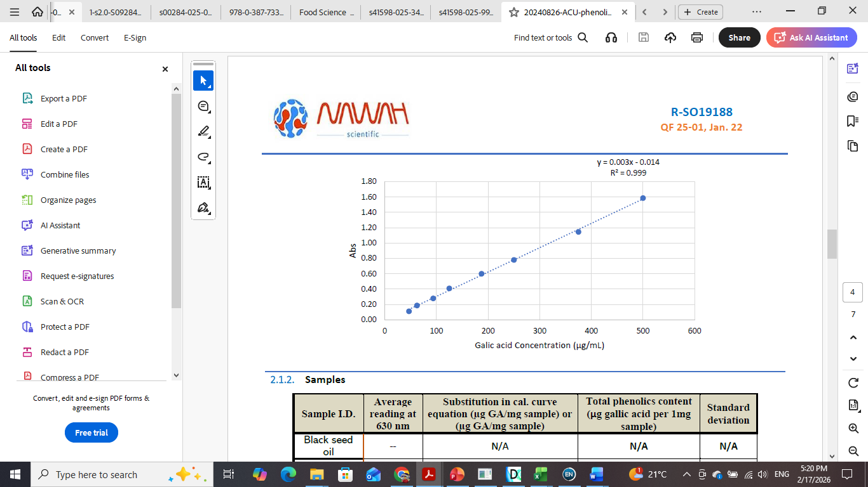

Figure S2. Calibration curve for gallic acid used for total phenolic content determination.

Figure S3. DPPH radical scavenging activity of Vaccinium macrocarpon fruit extracts prepared with different solvents.

Figure S4. Radar plot showing the antimicrobial resistance profiles of multidrug-resistant (MDR) Gram-negative bacterial isolates against different tested antibiotics.

Figure S5. Antimicrobial activity of Vaccinium macrocarpon fruit extract against (a) Gram-positive bacteria, (b) Gram-negative bacteria, and (c) fungi.

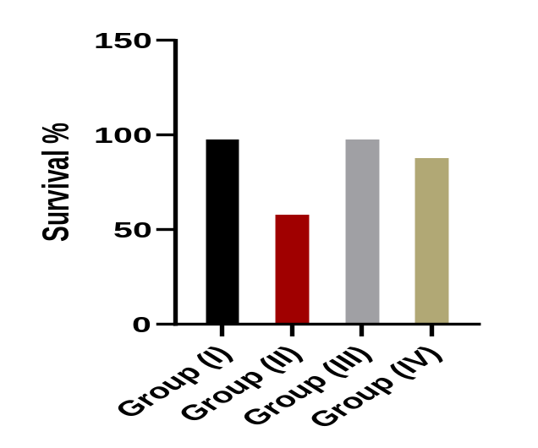

Figure S6. Survival analysis of experimental animal groups following infection and treatment.

