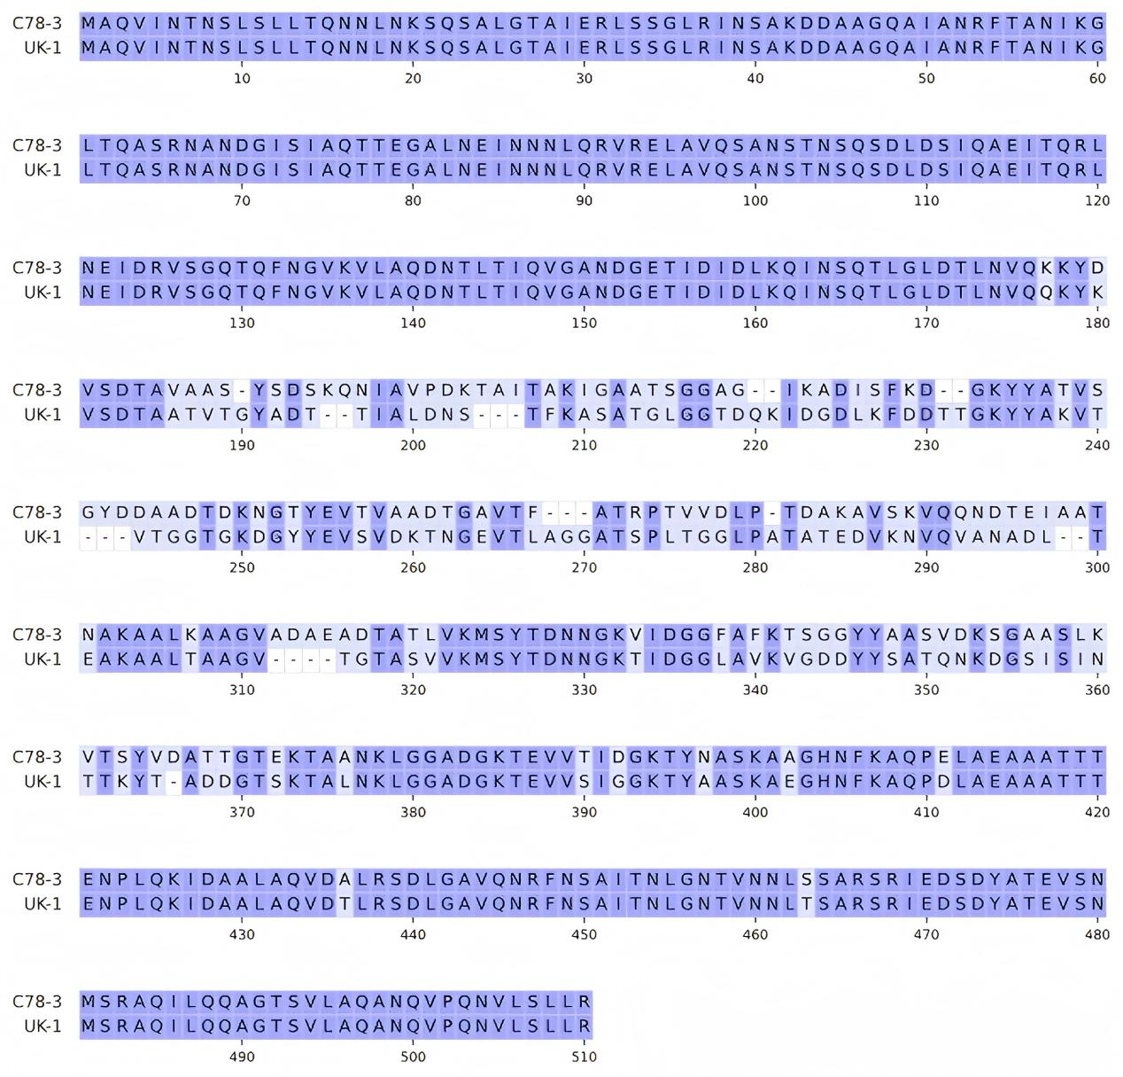
Figure S1. Sequence alignment and homology analysis of FliC proteins from S. Typhimurium UK-1 and S. Choleraesuis C78-3. The full-length amino acid sequences of FliC from S. Typhimurium UK-1 (495 aa) and S. Choleraesuis C78-3 (501 aa) were aligned. The two serovars share approximately 77% amino acid identity in their flagellin FliC sequences.

