Annex A: Relationship between grazing intensity, plant height and distance at the waterholes and protected kraals piospheres
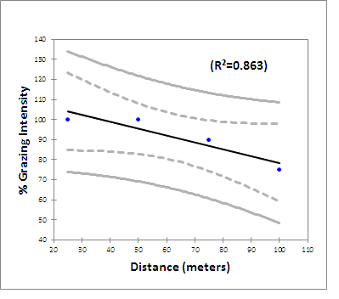  A1: Relationship between grazing intensity and distance at the waterholes piospheres | 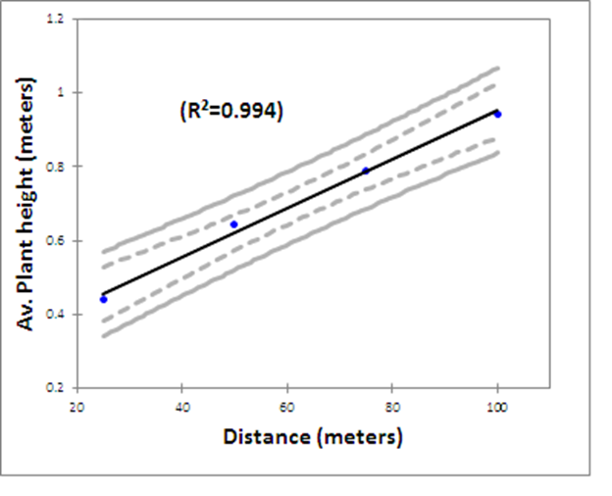  A2: Relationship between plant height and distance at the waterholes piospheres
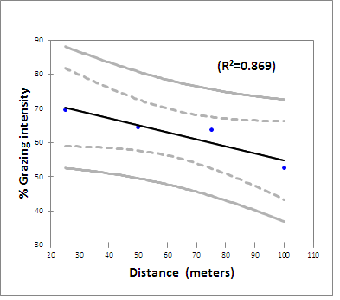  A3: Relationship between grazing intensity and distance at the protected kraals piospheres | 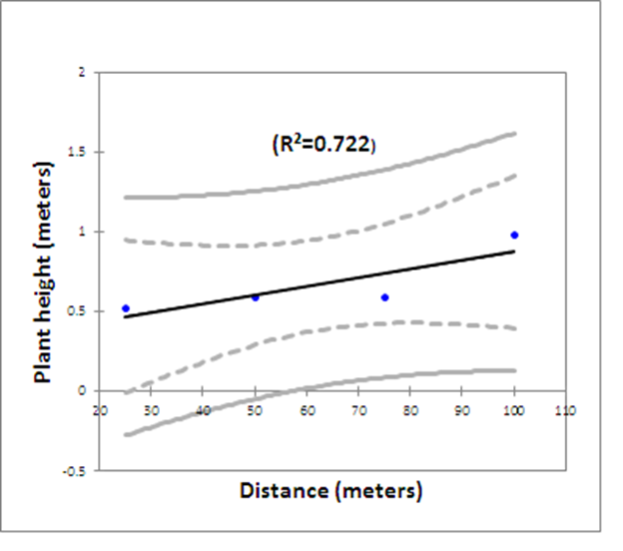  A4: Relationship between plant height and distance at the protected kraals piospheres

