Supplementary Material 2 – Results of the One-way ANOVA

- Difference in mean overall endoparasite levels
Anova: Single Factor
SUMMARY
Groups | Count | Sum | Average | Variance
Migratory | 65 | 4250 | 65.38461538 | 5697.115385
Ibex | 74 | 825 | 11.14864865 | 596.2652721
Sedentary | 86 | 1770 | 20.58139535 | 2200.246238
ANOVA
Source of Variation | SS | df | MS | F | P-value | F crit
Between Groups | 115271.2092 | 2 | 57635.60459 | 21.49846278 | 2.92043E-09 | 3.036523693
Within Groups | 595163.6797 | 222 | 2680.917476
Total | 710434.8889 | 224
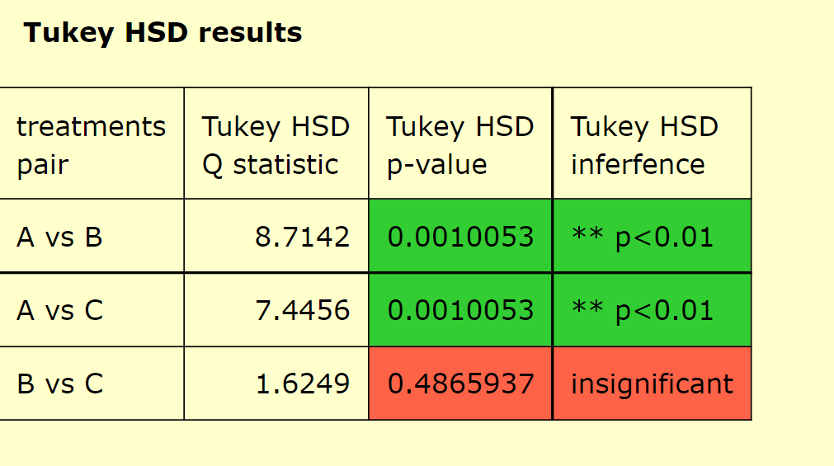
A = Migratory livestock
B= Asiatic Ibex
C = Sedentary livestock

- Difference in mean Strongyle levels
Anova: Single Factor
SUMMARY
Groups | Count | Sum | Average | Variance
Mig.Strongyle | 65 | 1665 | 25.61538 | 1229.303
Ibex.strongyle | 74 | 305 | 4.121622 | 32.43706
Seden.strongyle | 86 | 405 | 4.709302 | 34.32627
ANOVA
Source of Variation | SS | df | MS | F | P-value | F crit
Between Groups | 20744.53 | 2 | 10372.27 | 27.42514 | 2.27E-11 | 3.036524
Within Groups | 83961.02 | 222 | 378.2028
Total | 104705.6 | 224

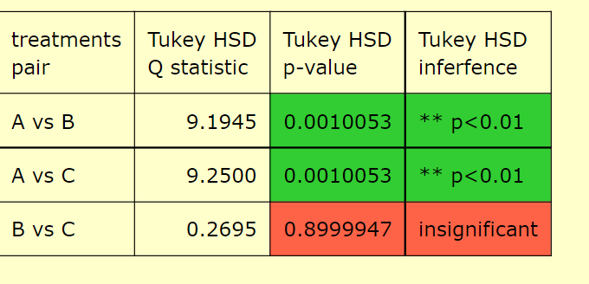
A = Migratory livestock
B= Asiatic Ibex
C = Sedentary livestock

