Comparative Transcriptome Analysis Revealed Differential Gene Expression in Multiple Signaling Pathways at Flowering in polyploid Brassica rapa

Janeen Braynen^{1, 2}, Yan Yang¹, Jiachen Yuan¹, Zhengqing Xie², Gangqiang Cao², Xiaochun Wei^{3,} Gongyao Shi^{1,2}, Xiaowei Zhang³, FangWei^{1,2*}, Baoming Tian^{2*}

1. School of Life Sciences, Zhengzhou University, Zhengzhou, Henan 450001, China
2. Henan International Joint Laboratory of Crop Gene Resources and Improvements, School of Agricultural Sciences, Zhengzhou University, Zhengzhou, Henan 450001, China.
3. Institute of Horticultural Research, Henan Academy of Agricultural Sciences, Zhengzhou, Henan 450002, China
* Corresponding authors: Fang Wei, E-mail address: fangwei@zzu.edu.cn; and Baoming Tian, E-mail address: tianbm@zzu.edu.cn.

Supplementary Figures:

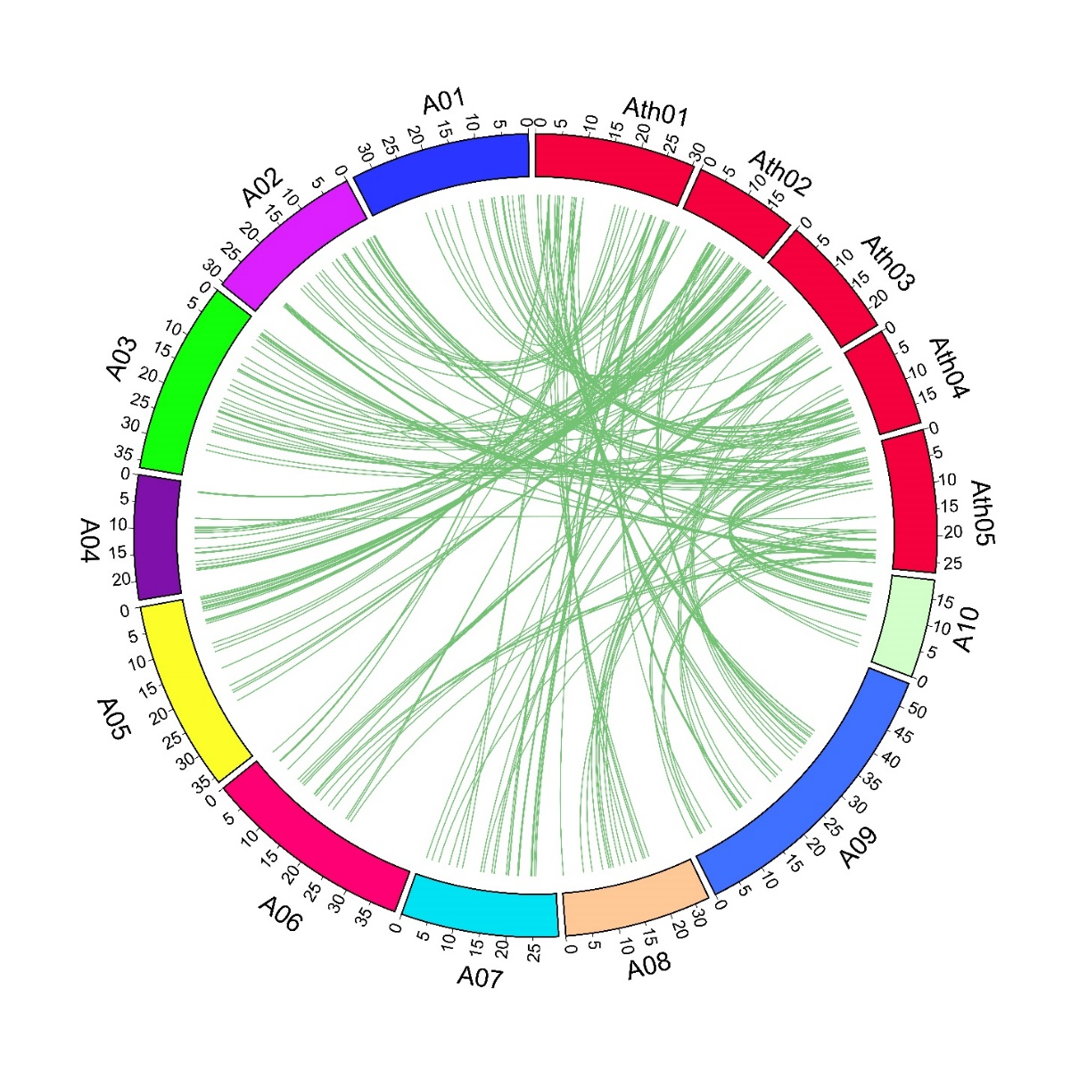

Figure S1. Gene duplication and collinearity analysis among Flower time genes from including B.rapa and A.thaliana. Lines connecting genes depict ortholog pairs diverged from the same ancestor. A1-A10 indicated B.rapa chromosomes, and Ath01-Ath05 displayed A.thaliana chromosomes.

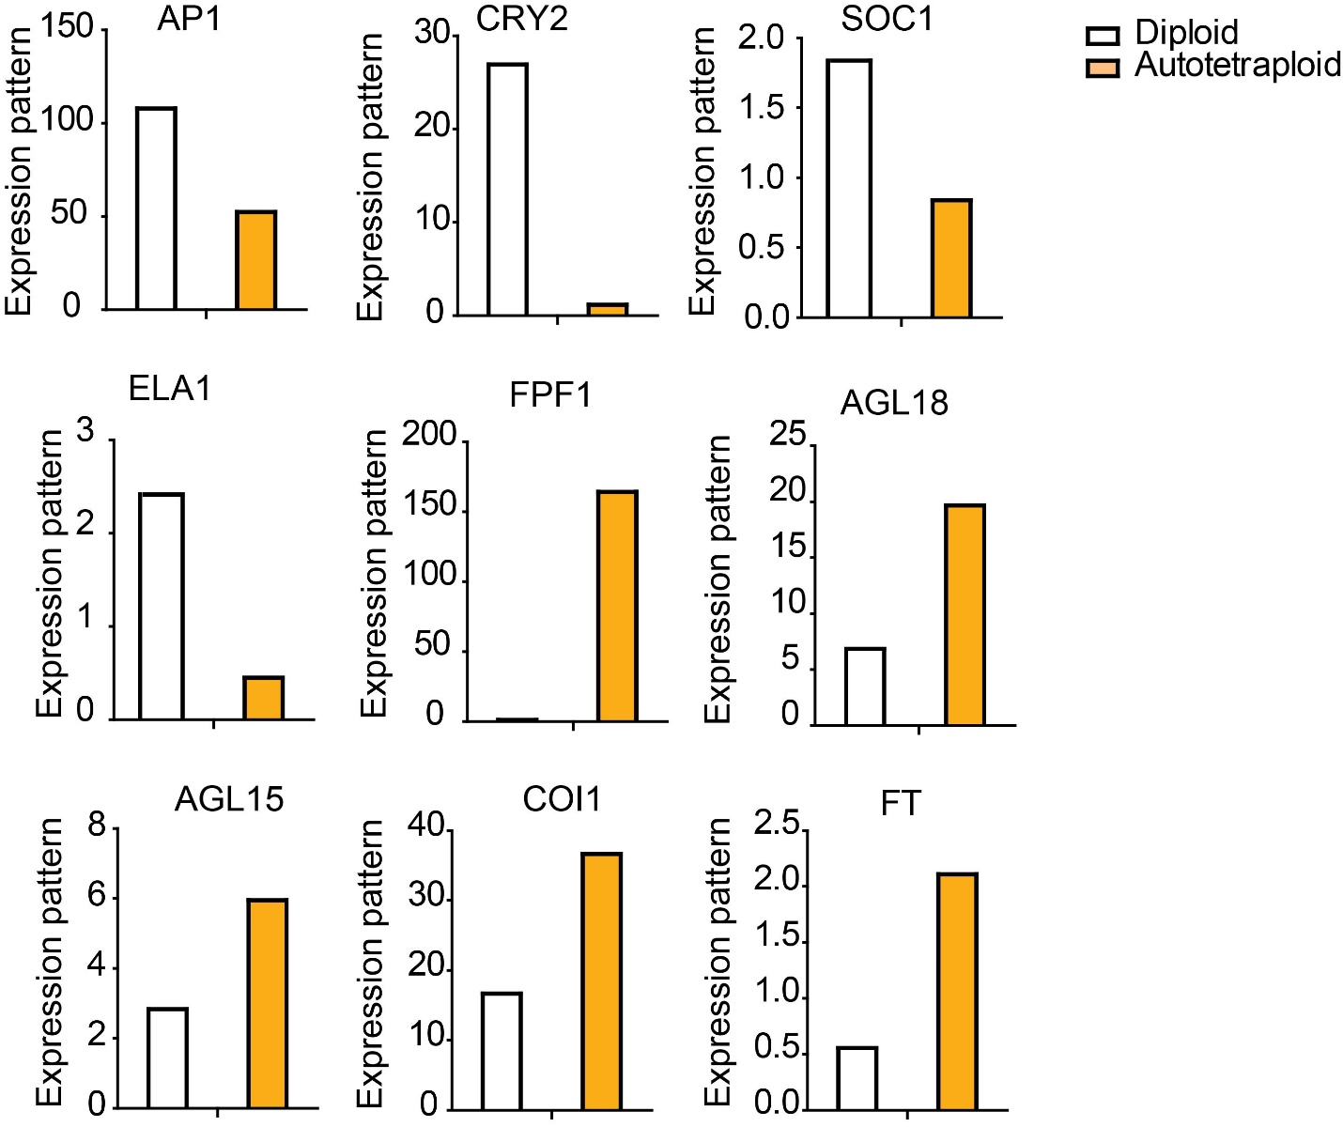
Figure S2. RNA-seq results of key genes in the flowering time pathway.

