Supplementary Information
Table S1 CI values for propranolol and T1012G cotreatment for AGS and MFC gastric cancer cell lines
MFC |  | AGS
Combination dose | CI¹ | Combination dose | CI¹
60 μM+0.01 MOI | 0.712 ± 0.055 | 40 μM+0.01 MOI | 1.091 ± 0.171
60 μM+0.05 MOI | 0.643 ± 0.024 | 40 μM+0.05 MOI | 0.796 ± 0.103
60 μM+0.1 MOI | 0.843 ± 0.044 | 40 μM+0.1 MOI | 0.726 ± 0.057
60 μM+1 MOI | 1.365 ± 0.069 | 40 μM+1 MOI | 0.707 ± 0.050
60 μM+2 MOI | 1.378 ± 0.054 | 40 μM+2 MOI | 0.747 ± 0.162
60 μM+5 MOI | 2.385 ± 0.360 | 40 μM+5 MOI | 1.010 ± 0.280
80 μM+0.01 MOI | 0.692 ± 0.032 | 60 μM+0.01 MOI | 0.657 ± 0.039
80 μM+0.05 MOI | 0.607 ± 0.075 | 60 μM+0.05 MOI | 0.703 ± 0.037
80 μM+0.1 MOI | 0.694 ± 0.002 | 60 μM+0.1 MOI | 0.769 ± 0.064
80 μM+1 MOI | 0.782 ± 0.167 | 60 μM+1 MOI | 0.919 ± 0.005
80 μM+2 MOI | 0.956 ± 0.278 | 60 μM+2 MOI | 0.918 ± 0.099
80 μM+5 MOI | 1.524 ± 0.484 | 60 μM+5 MOI | 1.187 ± 0.091
The CI value of combination models were measured by Chou-Talalay method (19).
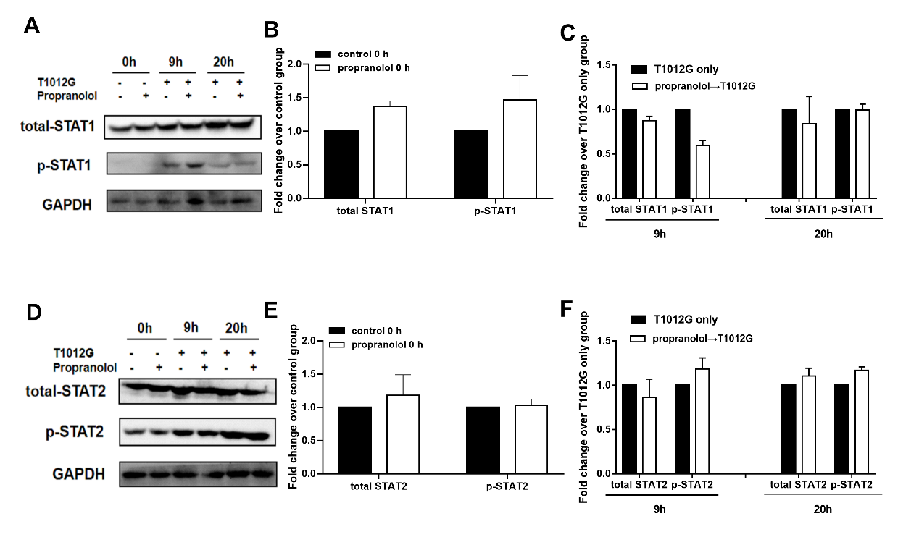
Supplementary Figure S1. Propranolol pretreatment possessed no effect on the expression and activation of interferon responsive genes-STAT1, STAT2. (A, D) The expression and phosphorylation of interferon responsive genes (STAT1 and STAT2 ) were measured at 0, 9 and 20 hours after T1012G treatment by western blotting. (B-C, E-F) Quantification of A, D. Data are presented as mean±SEM.

