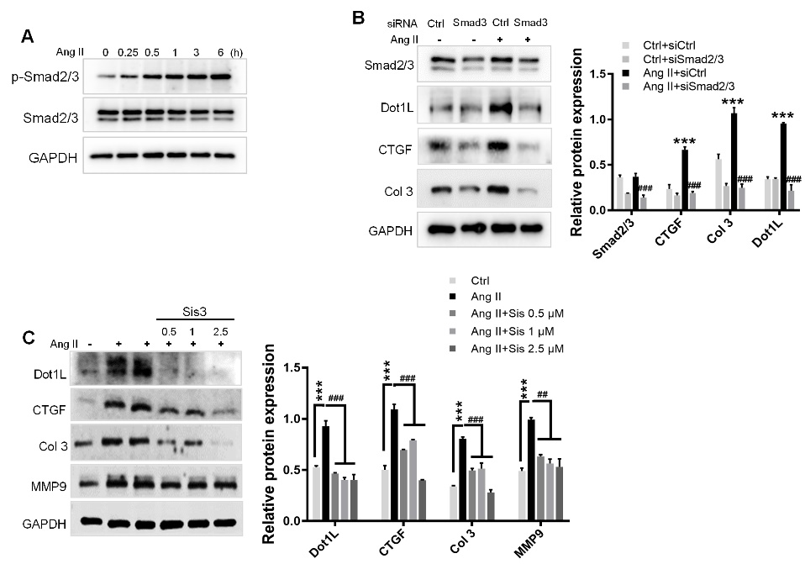
Fig. S1 Dot1L expression is mediated by p-Smad3 in Ang II-induced CFs. (A) p-Smad3 is upregulated in NRCFs treated with 2 μmol/L Ang II for different times. Smad3 and its phosphorylation form were analyzed by western blot. (B) Smad2/3 knockdown attenuates Dot1L expression in Ang II treated NRCFs. Smad2/3 siRNA and control siRNA were transfected into NRCFs, followed by Ang II stimulation for 48 h. The protein expressions of Smad2/3, Dot1L, CTGF and Col 3 were analyzed by western blot. (C) Smad2/3 inhibition attenuates Dot1L expression in Ang II treated NRCFs. NRCFs were pretreated with Sis (0.5, 1, and 2.5 μmol/L) for 4 h and then co-incubated with 2 μmol/L Ang II for 48 h. Dot1L, Col 3, CTGF and MMP9 were analyzed by western blot. All data are presented as mean ± SD. ANOVA, ***p < 0.001 versus Ctrl or Ctrl+siCtrl, ##p < 0.01, ###p < 0.001 versus Ang II or Ang II+ siCtrl, each acquired from three individual experiments.

