- (B)

(C) (D)

Supplementary Figure 1. Results of differential protein analysis of population serum proteomics.
- The ACR-exposed and non-exposed groups were completely distinguished in the PCA plot.
- GO enrichment analysis diagram of differential proteins. P<0.05，P just =1，Fold change≥1.2.
- KEGG pathway analysis diagram of differential proteins. P<0.05，P just =1，Fold change≥1.2.
- Differential protein interaction network diagram.

(A)

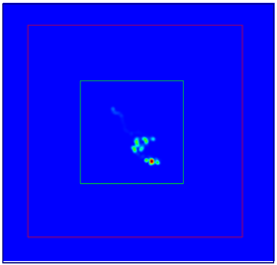
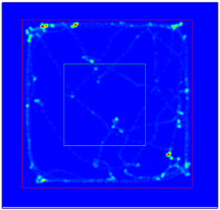
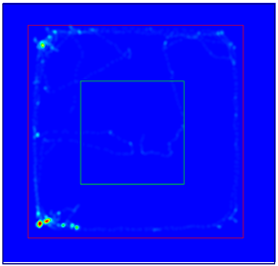
(B)

Control
6mg/kg ACR
18mg/kg ACR
(C) (D)

Supplementary Figure 2. Body weight recording and behavioral experiments of SD rats.
- Body weight changes in ACR-exposed SD rats within 28 days.
- Heat map of open field test after ACR exposure in SD rats.
- Periphery grid movement time in the open field test. Data are expressed as means ± SD, n=4. **P<0.01.
- Centre grid resting time in the open field test. Data are expressed as means ± SD, n=4. **P<0.01.

Supplementary Figure 3. CCK-8 assay measures cell survival after ACR exposure of PC12 cells.****P<0.0001 compared with the control group; ####P<0.0001 compared with the experimental group exposed to the same ACR concentration.

Supplementary Figure 4. eEF2K-KO mouse gene knockout strategy. The eEF2K gene was modified using CRISPR/Cas9 technology.

Supplementary Figure 5. Pearson correlation analysis between samples from each group of eEF2K-KO mice.

