Supplemental Figures and Tables for
PINK1 functions in mitophagy and mitochondrial homeostasis during mice oocyte maturation
Shiwei Wang^{1,2,3}, Xuan Wu¹, Mengmeng Zhang¹, Yixiao Zhu¹, Yajun Guo¹, Shuang Song¹, Shenming Zeng¹*
- State Key Laboratory of Animal Biotech Breeding, National Engineering Laboratory for Animal Breeding, Key Laboratory of Animal Genetics, Breeding and Reproduction of the Ministry of Agriculture, College of Animal Science and Technology, China Agricultural University, Beijing, China.
- State Key Laboratory of Female Fertility Promotion, Center for Reproductive Medicine, Department of Obstetrics and Gynecology, Peking University Third Hospital, Beijing, China, 100191.
- National Clinical Research Center for Obstetrics and Gynecology, Peking University Third Hospital.
*Corresponding author: zengsm@cau.edu.cn
This file includes:
Figs. S1 to S2
Tables. S1 to S2

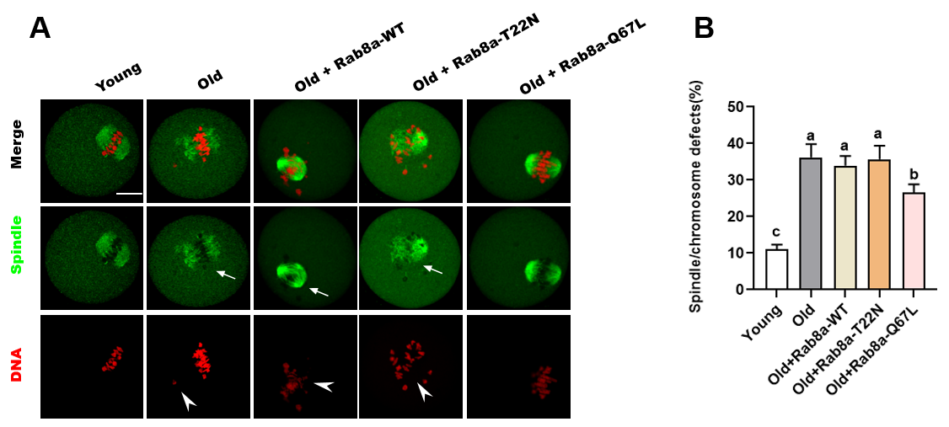
Figure S1. RAB8A activity is essential for spindle assembly and chromosome alignment in mice oocytes. (A) Representative examples of meiotic spindle and chromosomes, and chromosomes at MI stage in young, old, old + Rab8a-WT, old + Rab8a-T22N, and old + Rab8a-Q67L oocytes with spindle/chromosome defects. (B) Quantification of Young, Old, Old + Rab8a-WT, Old + Rab8a - T22N, and Old + Rab8a - Q67L oocytes with spindle/chromosome defects [11.0 ± 1.10 % (Young), n = 37; 36.2 ± 2.94% (Old), n = 42; 33.9 ± 2.17%(Rab8a-WT), n = 39; 35.6 ± 3.06% (Rab8a-T22N), n=46; 26.6 ± 1.82% (Rab8a-Q67L), n = 49]. Different lowercase letters represent significant (p < 0.05).

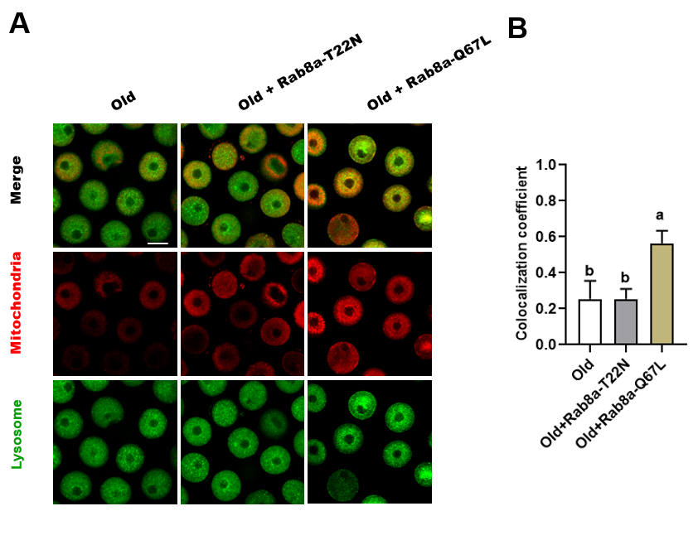
Figure S2. Mitophagy monitoring in Pink1-OE oocytes by LSCM. (A) Fluorescence colocalization of mitochondria and lysosomes under LSCM (laser scanning cconfocal) (scale bar: 80 μm). (B) Colocalization coefficient of mitochondria and lysosomes. Highly fused distribution of mitochondrial and lysosomes were detected in Old + Rab8a-Q67L oocytes rather than in Old or Old + Rab8a-T22N oocytes [0.25 ± 0.08 (WT), n =35; 0.26 ± 0.04 (Rab8a-T22N), n = 32, 0.56 ± 0.06 (Rab8a-Q67L), n=38]. *Significantly different (the bars labeled with completely different letters indicate significant difference at p < 0.05).

Supplementary Table 1. Primer sequences used for cDNA amplification and site-directed mutagenesis.

Gene | Primer sequence
Rab8a-WT-F | 5’- CCGGAATTCAGAGTGTAATATGGCGAA -3’
Rab8a-WT-R | 5’-TGCTCTAGACAAACATCAGAGGTGGAGG -3’
Rab8a-Q67L-F | 5’- GGGACACGGCCGGCCTGGAGCGGTTTCGAACAAT -3’
Rab8a-Q67L-R | 5’- ATTGTTCGAAACCGCTCCAGGCCGGCCGTGTCCC -3’
Rab8a-T22N-F | 5’- CGGGGGTAGGGAAGAACTGTGTCCTGTTCCGCTT -3’
Rab8a-T22N-R | 5’- AAGCGGAACAGGACACAGTTCTTCCCTACCCCCG -3’

Supplementary Table 2. Mouse mitochondrial DNA specific primer for mtDNA copy number assay

Gene | Prime sequence
ND5-F | 5’-CATCCTTCTCAACTTTACTGGGGT-3’
ND5-R | 5’- GTTTGTGTGAAGAGTTGAGGTGG-3’
Actin-F | 5’- ATGACGATATCGCTGCGCTG -3’
Actin-R | 5’- TCACTTACCTGGTGCCTAGGGC-3’

