Supplementary material
Supplementary methods
Reagents and antibodies
Mannitol and D-glucose were obtained from Sigma-Aldrich (St. Louis, MO, USA). Cell culture reagents were obtained from HyClone (Logan, UT, USA) unless stated otherwise. All other reagents were sourced from Sigma unless otherwise stated.
Cell transfection
The siRNAs targeting SETD7 and A2BR were designed and synthesized by Genepharma (Shanghai, China). The specific siRNA sequences used for transfection in this study are provided in Table S1. To silence SETD7 and A2BR, SV40-MES-13 cells were infected with specific siRNA targeting Setd7 (siSetd7) or Adora2b (siAdora2b) or negative control siRNA (siScr). To inhibit SETD7 or STAT3, SV40-MES-13 cells were pretreated with 20 μM sinefungin or 5 μM stattic for 4 hours before exposure to high glucose.
Full-length and truncated mutant plasmids of A2BR were generated based on the pcDNA3.1-His plasmid. SV40-MES-13 cells were seeded onto cell culture plates or dishes at approximate 50% confluence and then transfected with siRNA using Lipofectamine™ RNAiMAX (Invitrogen Biotechnology, CA, USA) or plasmids using Lipofectamine 2000 (Invitrogen Biotechnology, CA, USA). Transfections of plasmids or siRNA were performed at the recommended working concentrations according to the manufacturer's protocol. Cells were collected for further experiments after 48-72 hours post-transfection.
Western blot analysis
The total proteins were extracted by incubating the cell pellet or kidney in RIPA lysis buffer (Beyotime, Shanghai, China), supplemented with 1% PMSF and 1% phosphatase inhibitors (APExBIO, Houston, USA). The protein concentration of the extracted samples was measured with the BCA method (ThermoFisher, MA, USA). Equal amounts of protein samples were separated through sodium dodecyl sulfate-polyacrylamide gel electrophoresis (SDS-PAGE) and transferred onto an Immune-Blot nitrocellulose membrane (Millipore, MA, USA). Following blocking with 5% non-fat dry milk in 0.05% Tween-20 Tris-buffered saline (TBST), the membrane was incubated overnight at 4°C with primary antibodies from Table S2. After washing with TBST, the membrane was further incubated with horseradish peroxidase (HRP)-labeled secondary antibodies (1:5000; Jackson ImmunoResearch, Pennsylvania, USA), and exposed to ECL reagent.
RNA isolation and RT-qPCR
The total RNA was extracted from renal cortical tissue or cultured cells using TRIzol (Takara, Dalian, China). Subsequently, it was reverse transcribed into cDNA utilizing the Prime RT Master Mix kit (Takara, Dalian, China) following the manufacturer's instructions. Real-time PCR analysis was performed using SYBR Premix EX Taq II (Yeasen, Shanghai, China) on Bio-Rad CFX Connect™ Real-time qPCR Detection System (Bio-Rad, Carlsbad, CA, USA). The specific primers listed in Table S3 were employed to amplify the cDNA template. The fold changes of genes were determined using the 2^{-ΔΔCt} method.
Immunohistochemical staining
The paraffin-embedded tissues sections (4-μm-thick) were subjected to dewaxed, rehydrated, antigen retrieved and detection using the HRP/DAB detection kit (Abcam, Cambridge, UK). Briefly, the sections blocked endogenous nonspecific antigen and peroxidase activity with goat serum and 3% H₂O₂. Subsequently, the sections were incubated overnight at 4°C with primary antibodies (Table S2). After three times washes with PBS, the sections were incubated with an HRP-conjugated secondary antibody and visualized using DAB substrate. Nuclei were counterstained with hematoxylin.
Immunofluorescence analysis
Cell slides or tissues sections were fixed, blocked with 30% goat serum, and incubated with primary antibodies in PBS at 4°C overnight. Following three washes with PBS, tissues or cells were then incubated with Alexa Fluor-conjugated secondary antibody (Invitrogen Biotechnology, CA, USA), and nuclei were counterstained using DAPI.

Supplemental figures
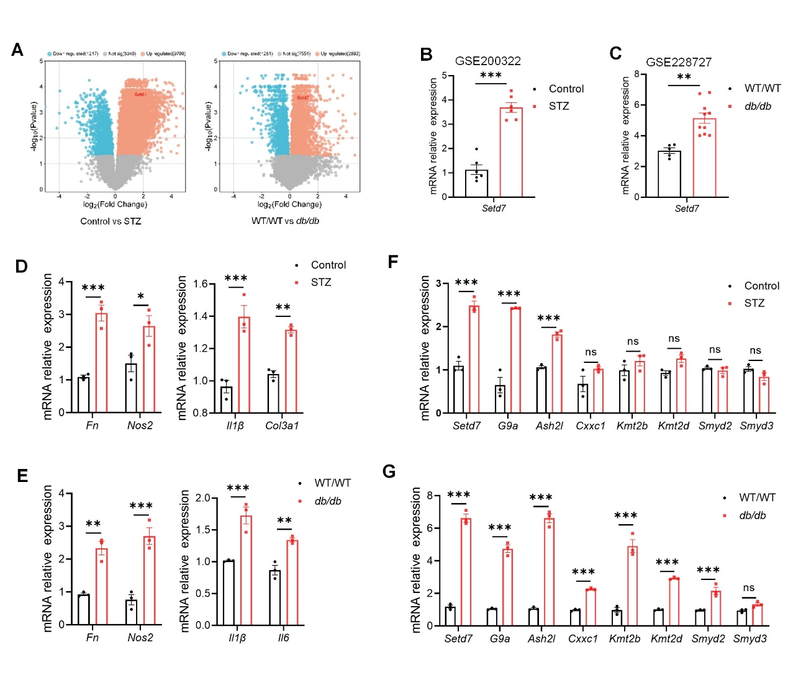
Figure S1. SETD7 expression is up-regulated in diabetic kidney. (A-C) Setd7 mRNA levels in STZ-induced mice and db/db mice. Data from GSE200322 and GSE228727. (D) RT-qPCR evaluation of Fn, Nos2, Il1β, and Col3a1 expressions in kidney samples of Control and STZ-induced mice (n = 3). (E) RT-qPCR evaluation of Fn, Nos2, Il1β, and Il6 mRNA expressions in kidney samples of wild-type (WT/WT) and db/db mice (n = 3). (F-G) RT-qPCR evaluation of Setd7, G9a, Ash2l, Cxxc1, Kmt2b, Kmt2b, Smyd2, and Smyd3 mRNA expressions in kidney samples from Control and STZ-induced mice or wild-type (WT/WT) and db/db mice (n = 3). The data are presented as the mean ± SEM, statistical analysis revealed a significant difference with *p < 0.05, **p < 0.01, ***p < 0.001, and ns = no significance vs Control or WT/WT group.

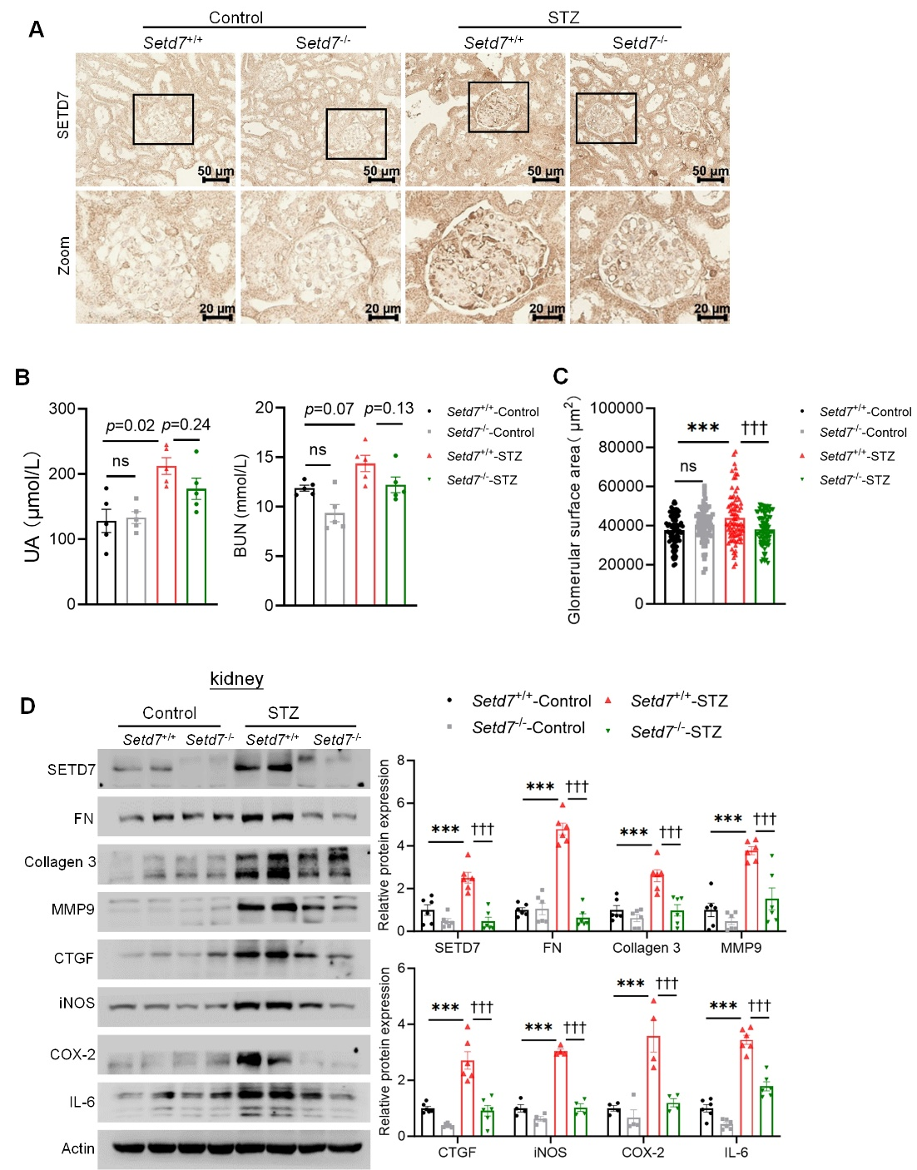
Figure S2. SETD7 deficiency alleviates fibrosis and inflammation in DN. (A) Representative images of immunohistochemical staining of SETD7 in renal sections from Setd7^{-/-} and Setd7^{+/+} mice untreated or treated with STZ. Scale bars, 50 μm, zoomed scale bars, 20 μm. (B) Uric acid (UA) and Urea nitrogen (BUN) were evaluated in Setd7^{-/-} and Setd7^{+/+} mice untreated or treated with STZ (n = 5). (C) Statistical quantified of glomerular area of the kidney sections from Setd7^{-/-} and Setd7^{+/+} mice untreated or treated with STZ (n = 4). (D) Western blot analysis of SETD7, fibrosis and inflammation markers (FN, Collagen 3, MMP9, CTGF, iNOS, COX-2, and IL-6) in whole kidney samples from Setd7^{-/-} and Setd7^{+/+} mice untreated or treated with STZ (n = 6). The data are presented as the mean ± SEM, statistical analysis revealed a significant difference with ***p < 0.001, †††p < 0.001.

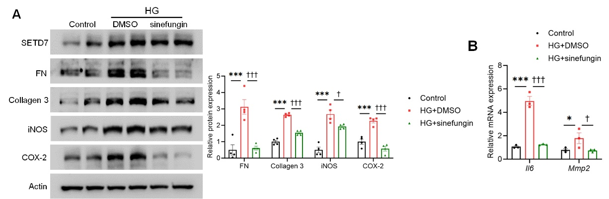
Figure S3. SETD7 inhibition alleviates fibrosis and inflammation in mesangial cells. (A) Western blot analysis of SETD7, fibrosis markers (FN and Collagen 3) and inflammatory markers (iNOS and COX-2) in MCs treated with or without HG after preincubated with DMSO or SETD7 inhibitor sinefungin. (B) RT-qPCR evaluation of Il6 and Mmp2 mRNA expressions in MCs treated with or without HG after preincubated with DMSO or SETD7 inhibitor sinefungin (20 μM). All experiments were performed at least three times independently. The data are presented as the mean ± SEM, statistical analysis revealed a significant difference with *p < 0.05, ***p < 0.001, †p < 0.05, †††p < 0.001.

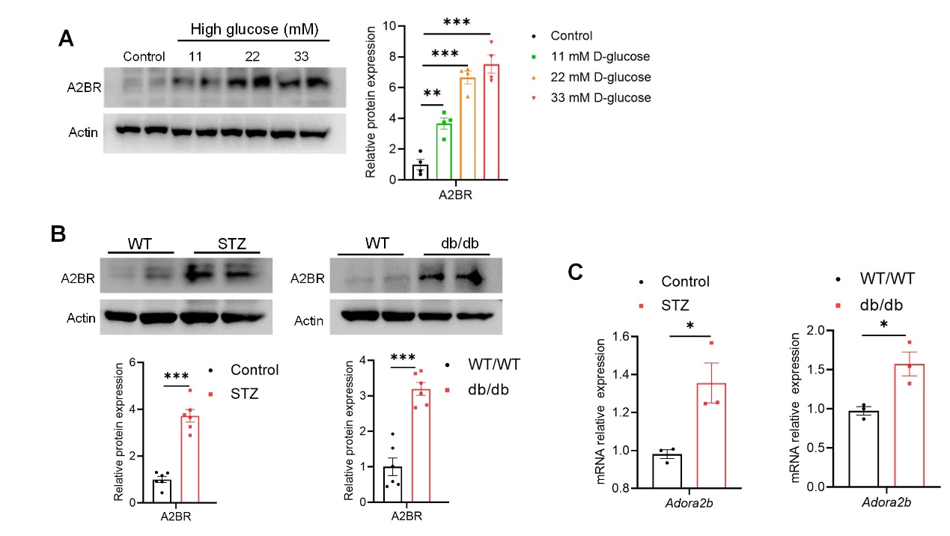
Figure S4. SETD7 promotes A2BR transcription in high glucose induced mesangial cells. (A) Western blot analysis of A2BR expression in MCs treated with or without 11 mM, 22 mM, 33 mM high glucose for 24 hours. (B) Western blot analysis of A2BR in kidney samples from STZ-induced mice and db/db mice (n = 6). (C) RT-qPCR analysis of Adora2b in STZ-induced mouse and db/db mouse (n = 3). The data are presented as the mean ± SEM, statistical analysis revealed a significant difference with *p < 0.05, ***p < 0.001

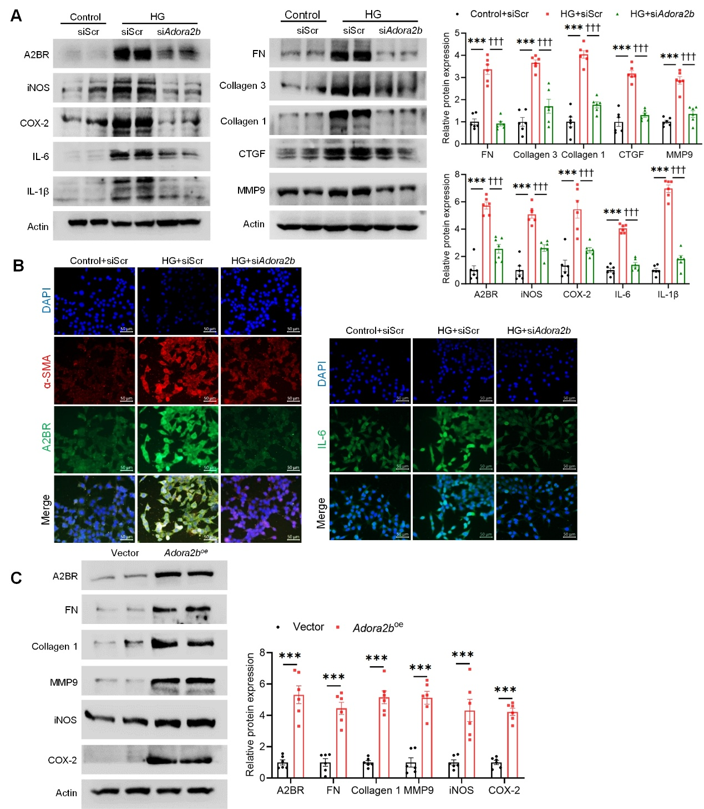
Figure S5. A2BR deficiency alleviates fibrosis and inflammation in mesangial cells. (A) Western blot analysis of A2BR, inflammatory markers (iNOS, COX-2, IL-6, and IL-1β) and fibrosis markers (FN, Collagen 1, Collagen 3, CTGF, and MMP9) in MCs treated with or without HG after transfected with negative control (siScr) or A2BR small interfering RNA (siAdora2b). (B) Representative images of immunofluorescence staining of A2BR, α-SMA, and IL-6 in MCs treated with or without HG after transfected with siScr or siAdora2b. Scale bars, 50 μm. (C) Western blot analysis of A2BR, fibrosis (FN, Collagen 1, and MMP9) and inflammatory markers (iNOS and COX-2) in MCs transfected with vector control (Vector) or A2BR overexpression lenti-virus (Adora2b^{oe}). All experiments were performed at least three times independently. All data are presented as the mean ± SEM, statistical analysis revealed a significant difference with ***p < 0.001, †††p < 0.001.

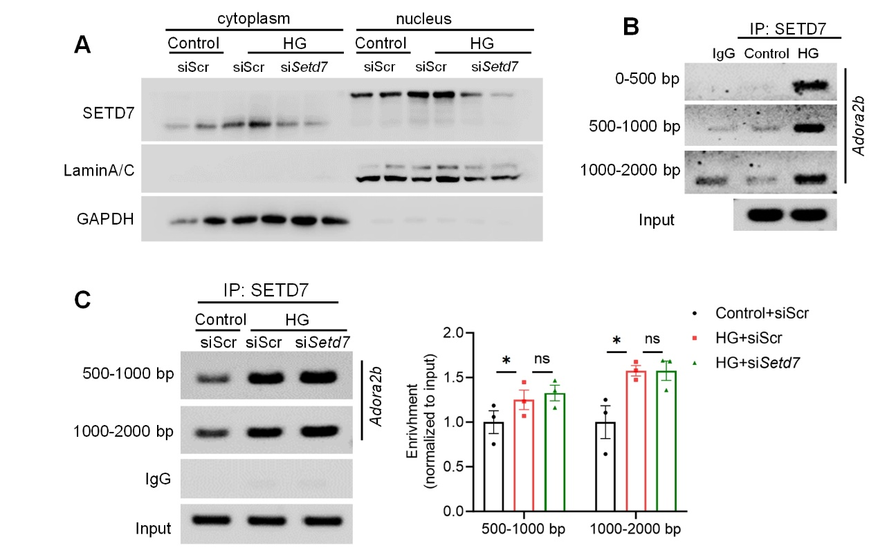
Figure S6. SETD7 mediates A2BR transcription to promote fibrosis and inflammation in high glucose induced mesangial cells. (A) Western blot analysis of SETD7 expression in separated cytoplasm and nucleus from mesangial cells (MCs) treated with or without HG after being transfected with siScr or siSetd7. (B-C) ChIP-PCR analysis of SETD7 enrichment on Adora2b gene promoter in HG-treated MCs. All experiments were performed at least three times independently. The data are presented as the mean ± SEM, statistical analysis revealed a significant difference with *p < 0.05, †p < 0.05, and no = no significance.

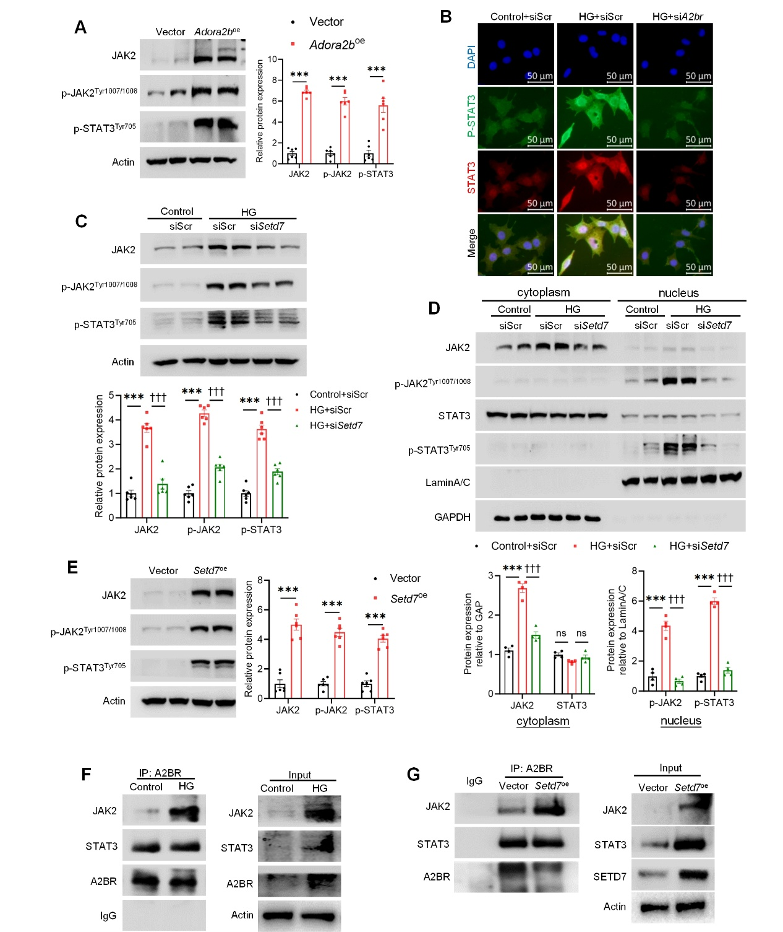
Figure S7. A2BR interacts with JAK2 and promotes JAK2/STAT3 pathway activation to involve in high glucose induced mesangial cells. (A) Western blot analysis of JAK2, p-JAK2 and p-STAT3 in MCs transfected with Vector or Adora2b^{oe}. (B) Representative images of immunofluorescence staining of STAT3 and p-STAT3 in mesangial cells (MCs) treated with or without HG after being transfected with siScr or siSetd7. Scale bars, 50 μm. (C) Western blot analysis of JAK2, p-JAK2 and p-STAT3 in MCs treated with or without HG after being transfected with siScr or siSetd7. (D) Western blot analysis of JAK2, p-JAK2, STAT3, and p-STAT3 expression in separated cytoplasm and nucleus from MCs treated with or without HG after transfected with siScr or si Setd7. (E) Western blot analysis of JAK2, p-JAK2 and p-STAT3 in MCs transfected with Vector or Setd7^{oe}. (F) Immunoprecipitation of the JAK2 protein by an anti-A2BR antibody in MCs treated with or without HG. IgG was used as a negative control. (G) Immunoprecipitation of the JAK2 protein by an anti- A2BR antibody in MCs transfected with Vector or Setd7^{oe}. IgG was used as a negative control. All experiments were performed at least three times independently. The data are presented as the mean ± SEM, statistical analysis revealed a significant difference with ***p < 0.001, †††p < 0.001, and no = no significance.

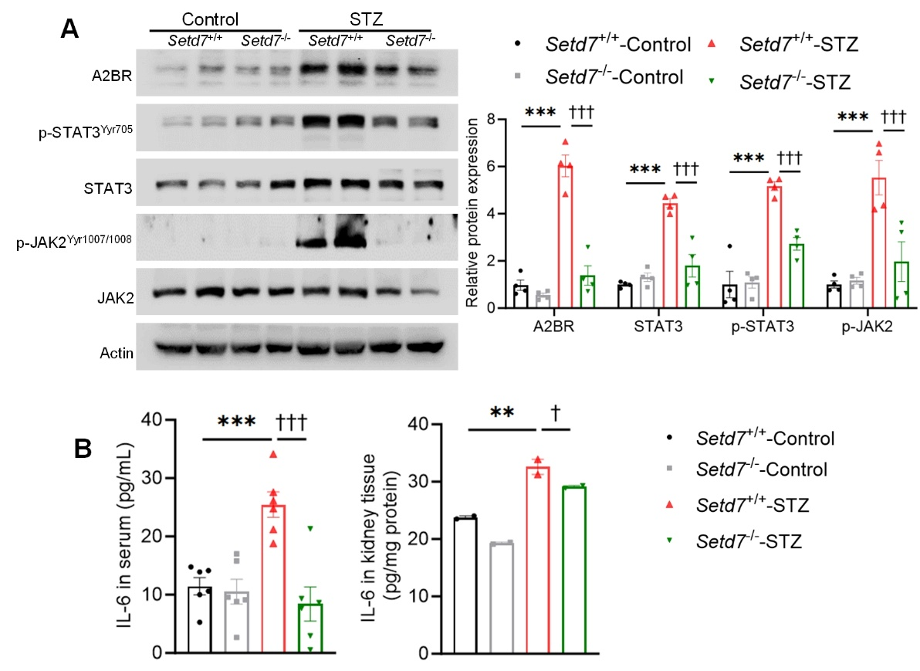
Figure S8. Loss of SETD7 suppressed A2BR and JAK2-STAT3 pathway in DN mice. (A) Western blot analysis of A2BR, p-STAT3, STZT3, p-JAK2, and JAK2 in whole kidney samples from Setd7^{-/-} and Setd7^{+/+} mice untreated or treated with STZ (n = 4). (B) Elisa analysis of IL-6 concentration in serum (n = 6) and kidney tissues from Setd7^{-/-} and Setd7^{+/+} mice untreated or treated with STZ (n = 2). The data are presented as the mean ± SEM, statistical analysis revealed a significant difference with **p < 0.01, ***p < 0.001 and #p < 0.05, ###p < 0.001.

Supplemental table
Table S1 siRNA used for transfection.
siRNA | Sequence (5´ to 3´)
siSetd7 | GCAGCACCCUGGAGGGAUATT
 | UAUCCCUCCAGGGUGCUGCTT
siAdora2b | GCUACAGUUUCCACAAGAUTT
 | AUCUUGUGGAAACUGUAGCTT
siScr | UUCUCCGAACGUGUCACGUTT
 | ACGUGACACGUUCGGAGAATT
Table S2 primary antibodies used for western blot analysis.
Antibodies | Source | Catalog Number
FN | Servicebio | GB114491
MMP9 | Servicebio | GB12132
MMP2 | Servicebio | GB11130
α-SMA | Servicebio | GB111364
CTGF | Proteintech | 25474-1-AP
Collagen 1 | Proteintech | 14695-1-AP
Collagen 3 | Proteintech | 22734-1-AP
COX-2 | Proteintech | 27308-1-AP
IL-6 | Proteintech | 21865-1-AP
IL-1β | Proteintech | 16806-1-AP
iNOS | Cell Signal Technology | 39898S
Nerphrin | Santa | sc-377246
SETD7 | Bioworld | BS71399
A2BR | Abconal | A1953
JAK2 | Cell Signal Technology | 3230S
p-JAK2 | Cell Signal Technology | 3771S
STAT3 | Cell Signal Technology | 4904S
p-STAT3 | Cell Signal Technology | 9131S
GST | Proteintech | 10000-2-Ig
Flag | Proteintech | 66008-4-Ig
His | Proteintech | 66005-1-Ig
β-actin | Proteintech | 66009-1-Ig
β-tubulin | Proteintech | 10094-1-AP
Lamin A/C | Santa | sc-376248
GAP | Proteintech | 60004-1-Ig
Table S3 Primers used for RT-qPCR validation.
Gene name | Primer name | Primer sequence (5´ to 3´)
Setd7 | mouse-SETD7-Forward | GCGGAGGAATTGAAAGGACTGT
 | mouse-SETD7-Reverse | ACCACCTCATCGTCGCTATC
Adora2b | mouse-A2BR-Forward | TCTTTAGCCTCTTGGCGGTG
 | mouse-A2BR-Reverse | CTCGTGTCCCAGTGACCAAA
G9a | mouse-G9A-Forward | GAGTGAGGAGACCCTTCCCA
 | mouse-G9A-Reverse | CACTCCTCTTGGCTCCTTGG
Ash2l | mouse-ASH2L-Forward | AGAAGGGAGGTCAACTGGAG
 | mouse-ASH2L-Reverse | CGCCTGGGTATCCATCACTT
Kmt2b | mouse-KMT2B-Forward | CAGTCCGTGGAGTTCTGGAC
 | mouse-KMT2B-Reverse | GCCTCGCCTGCTGAATAGTG
Kmt2d | mouse-KMT2D-Forward | ATCAAACAGGGTCGGAGCAG
 | mouse-KMT2D-Reverse | TCAGCCACCAGTGTCTCAAC
Cxxc1 | mouse-CXXC1-Forward | GATGCAGAAGAGTCCCCGTT
 | mouse-CXXC1-Reverse | TCCTCCTTCTTCTTCTCGGACT
Smyd2 | mouse-Smyd2-Forward | GGAGACGAGGTGTTCACCAG
 | mouse-Smyd2-Reverse | ATTGCGTGCGTATCTGACCA
Smyd3 | mouse-Smyd3-Forward | CACTATCTGCAACGCGGAGA
 | mouse-Smyd3-Reverse | GGCCCGTTGAATACGATGGA
Col3a1 | mouse-Collagen 3-Forward | ACGTAAGCACTGGTGGACAG
 | mouse-Collagen 3-Reverse | CAGGAGGGCCATAGCTGAAC
Col1a1 | mouse-Collagen 1-Forward | CTGACGCATGGCCAAGAAGA
 | mouse-Collagen 1-Reverse | CGTGCCATTGTGGCAGATAC
Mmp9 | mouse-MMP9- Forward | CAGACGTGGGTCGATTCCAA
 | mouse-MMP9-Reverse | TCATCGATCATGTCTCGCGG
Mmp2 | mouse-MMP2- Forward | AGCTGTACAGACACTGGTCG
 | mouse-MMP2-Reverse | GCTGGTGCAGCTCTCATACT
Nos2 | mouse-iNOS-Forward | AAGATGGCCTGGAGGAATGC
 | mouse-iNOS-Reverse | TGCTGTGCTACAGTTCCGAG
Cox2 | mouse-COX-2-Forward | GATGACTGCCCAACTCCCAT
 | mouse-COX-2-Reverse | CCATCCTTGAAAAGGCGCAG
Il6 | mouse-IL-6-Forward | AGAGACTTCCATCCAGTTGCC
 | mouse-IL-6-Reverse | CCGGACTTGTGAAGTAGGGAA
Il1β | mouse-IL-1β-Forward | TGCCACCTTTTGACAGTGATG
 | mouse-IL-1β-Reverse | AAGGTCCACGGGAAAGACAC
βactin | mouse-β-actin-Forward | TAGGCGGACTGTTACTGAGC
 | mouse-β-actin-Reverse | CTGCGCAAGTTAGGTTTTGTC
Gapdh | mouse-GAP-Forward | GTTTCCTCGTCCCGTAGACA
 | mouse-GAP-Reverse | GATGGGCTTCCCGTTGATGA

