Cell & Bioscience
PRSS55 Regulates BCAA Metabolism and Interacts with BCKDK and BCKDHA in Mouse Testes and Sperm
Supporting materials (original images of immunoblotting assays)

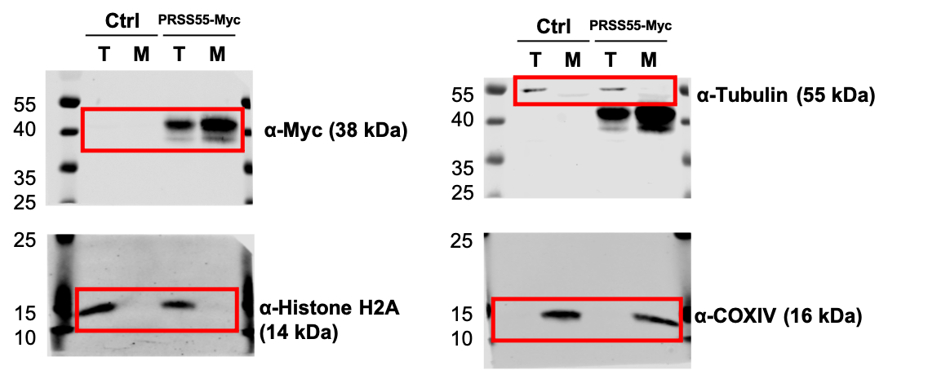
Figure 2B

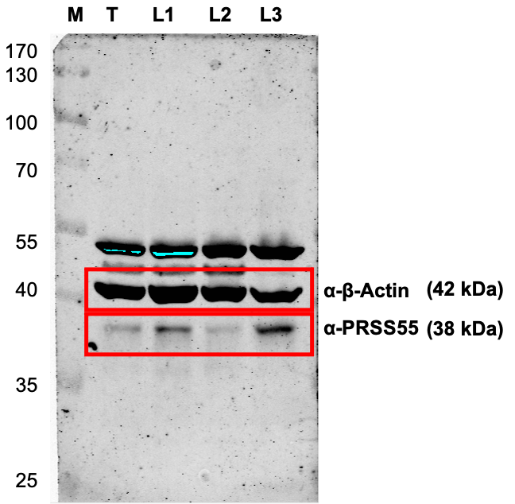
Figure 3D

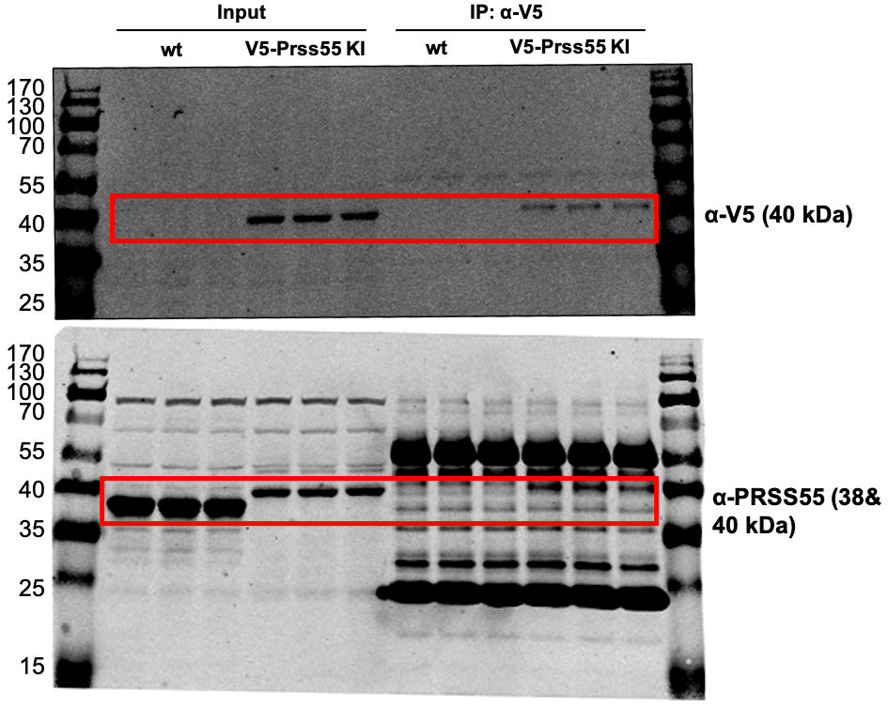
Figure 6A

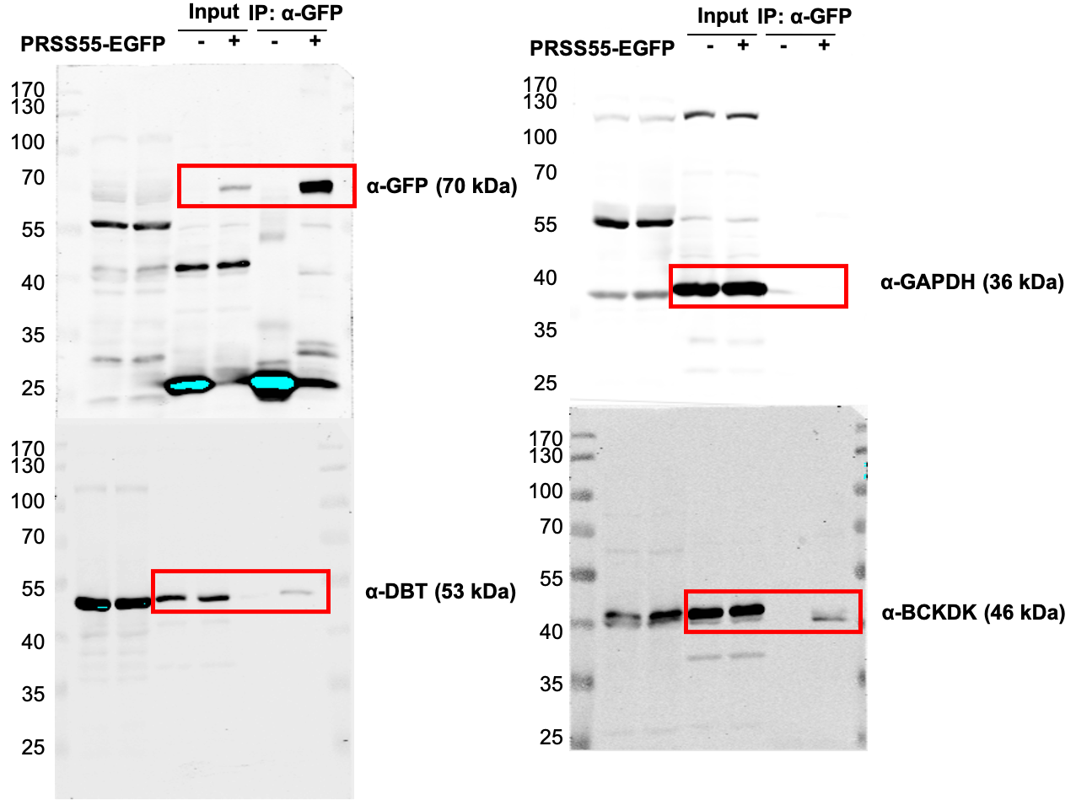
Figure 6C

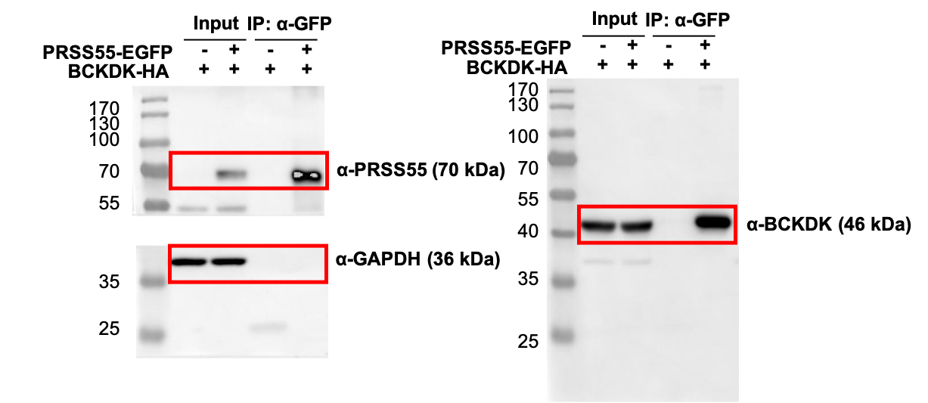
Figure 6D

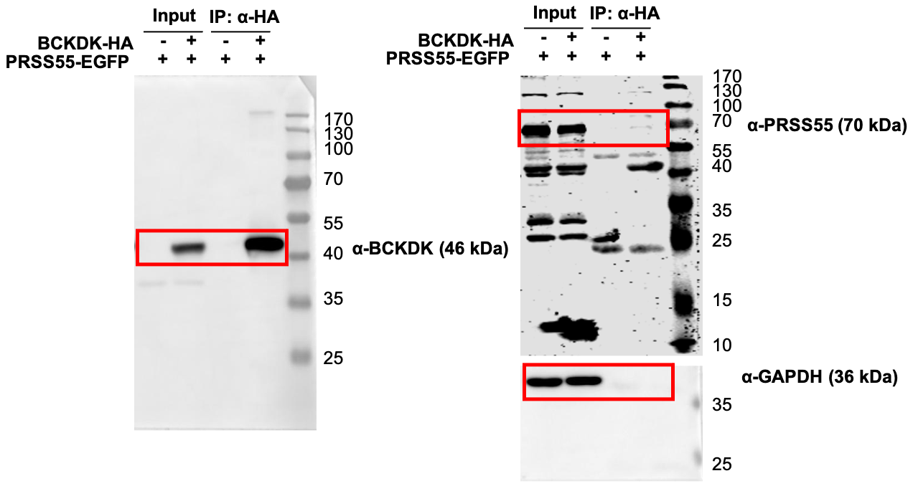
Figure 6E
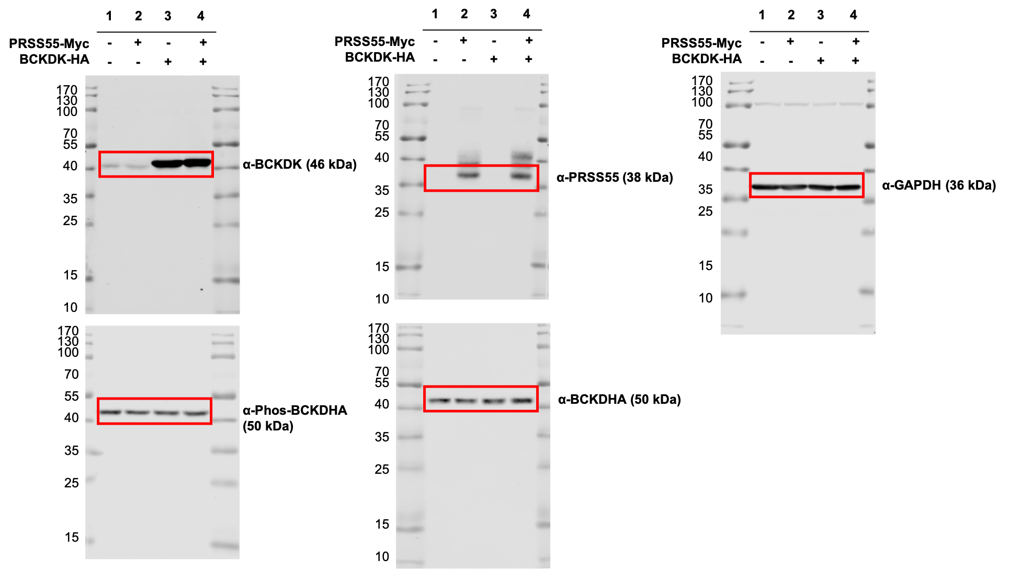
Figure 6F (LEFT)
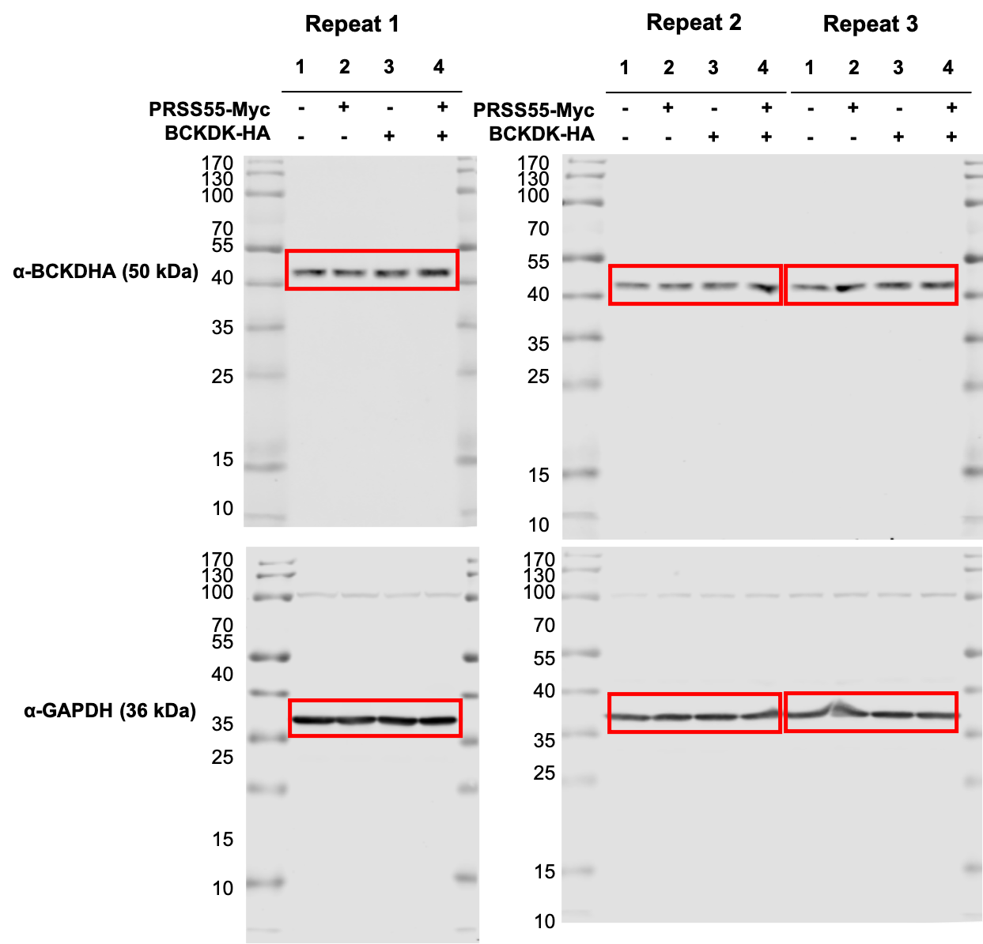
Figure 6F (RIGHT) Three repeats for quantitative analysis

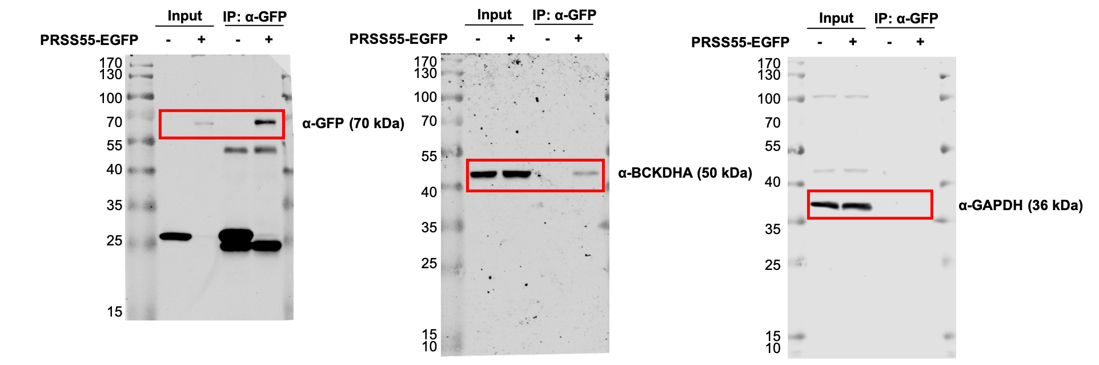Figure 6G
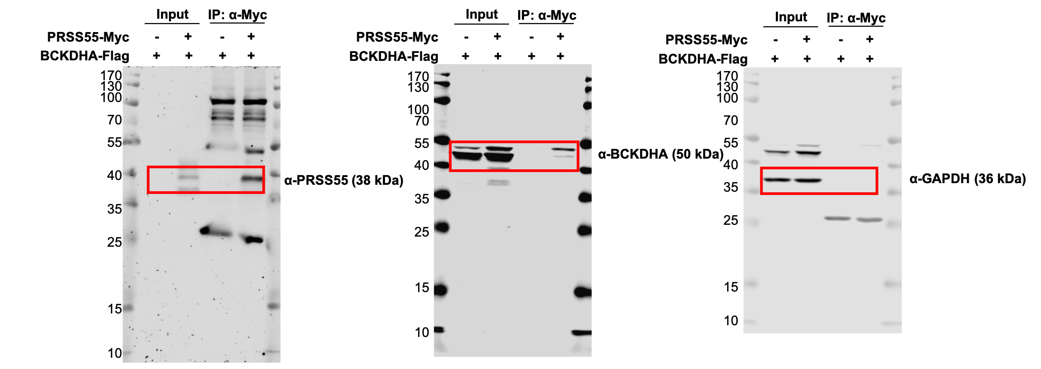
Figure 6H
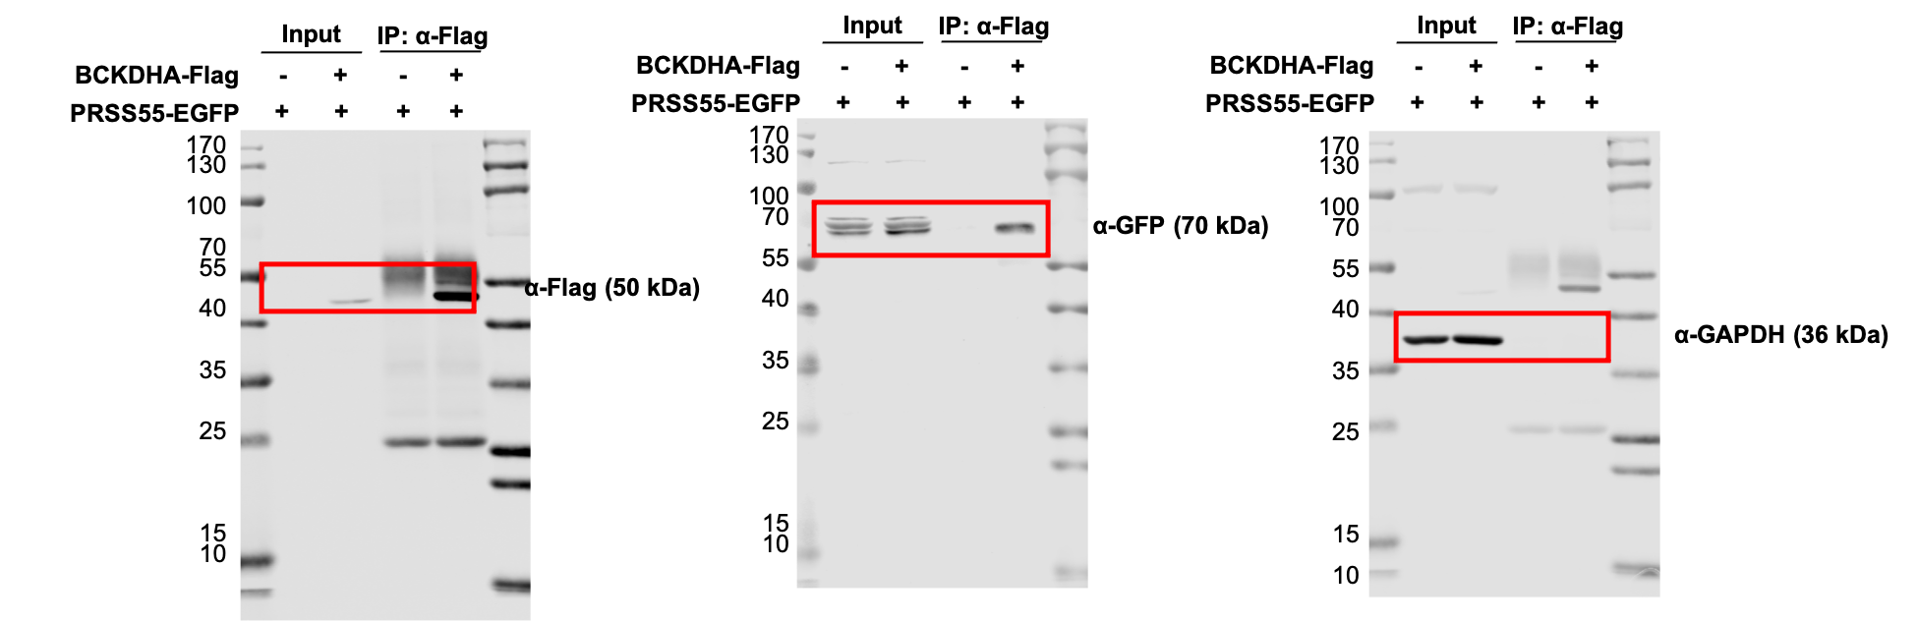
Figure 6I
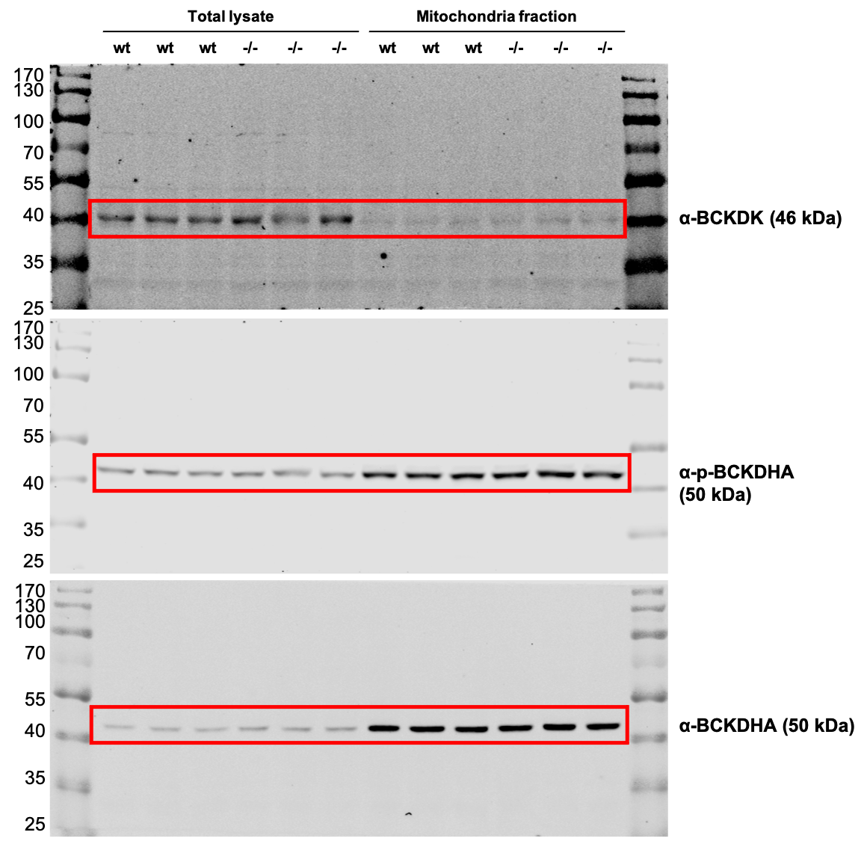
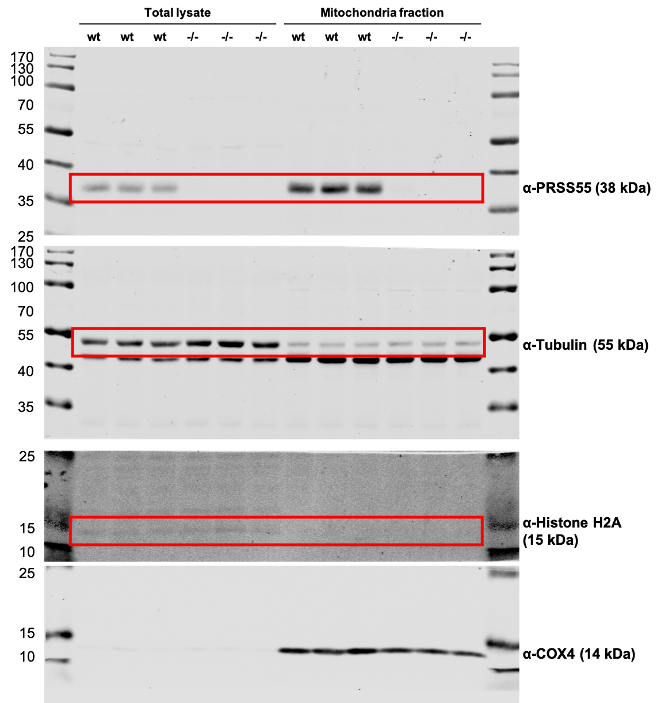
Figure 6J

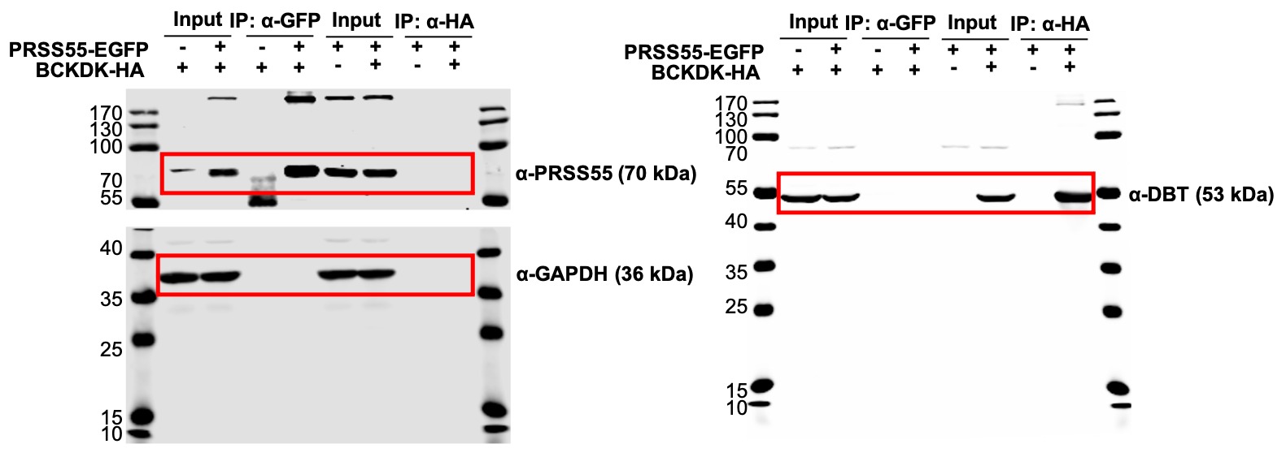
Supplementary Figure 3A & B

