Repeat 1
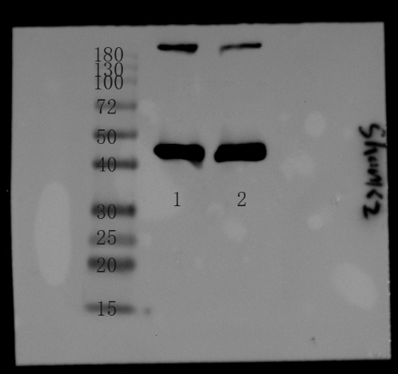
Repeat 2
Repeat 3
The above is Shank2 protein expression in hippocampus. 1 indicates the NC group, and 2 indicates the HFB group. The molecular weight of shank2 protein is 201KDA.

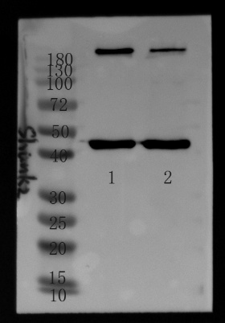
Repeat 1
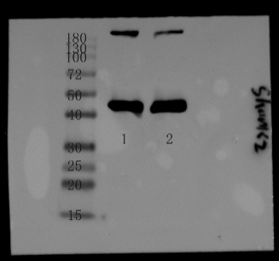
Repeat 1
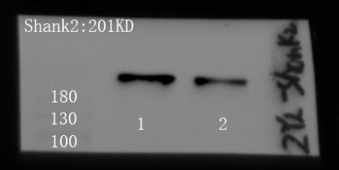
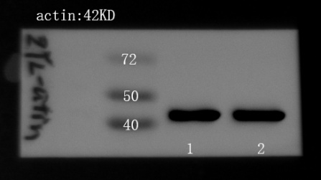
Repeat 3
The above is Shank2 protein expression in Prefrontal cortex. 1 indicates the NC group, and 2 indicates the HFB group. The molecular weight of shank2 protein is 201KDA.

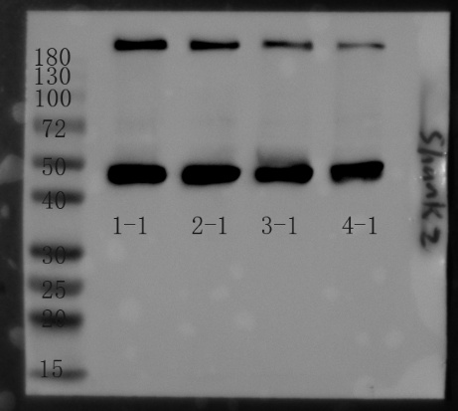
Repeat 1
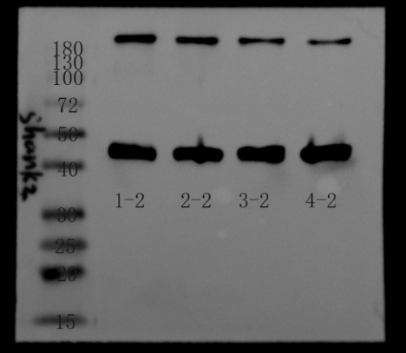
Repeat 2
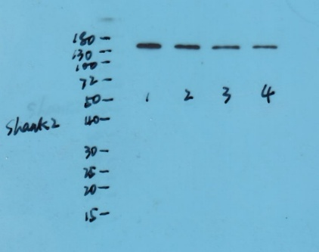
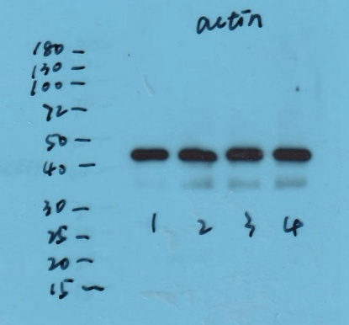
Repeat 3
The above is Shank2 protein expression in HT22 cells. From left to right, control group, IL-1βL group, IL-1βM group, IL-1βH group. The molecular weight of shank2 protein is 201KDA.

