Supplementary Figure 1. CIT knockdown inhibits chondrocyte cell cycle progression and reduces cell cycle regulatory protein expression, while HOXC-AS3 overexpression reverses these effects
(A&B) Flow cytometry analysis of cell cycle distribution after CIT knockdown and quantification of cell cycle phases; (C&D) Western blot analysis of cell cycle-related proteins CDK4 and CCND1 and corresponding quantification. Values represent mean ± SEM of 3 samples per group. **p<0.01, ***p<0.001, compared with control group; ##p<0.01, ###p<0.001, compared with IL-1β+si-CIT group.

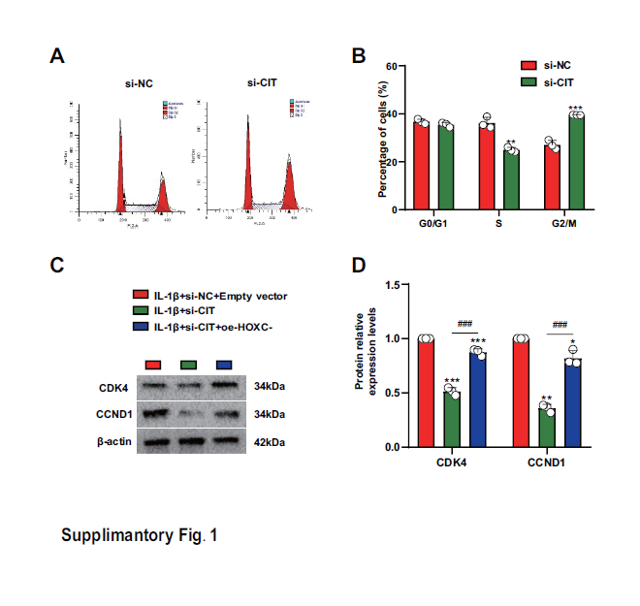

Supplementary Table S1
Name | F primer (5’-3’) | R primer (5’-3’) | Species |  | Tm(℃)
HOXC-AS3 | CTTTAACACCCCGTTCCTGA | CTTCCAGTGGAGGTCATGGT |  | human | 60
ACTB | TCATGAAGTGTGACGTGGACAT | CTCAGGAGGAGCAATGATCTTG |  | human | 60
U1 | GGGAGATACCATGATCACGAAGGT | CCACAAATTATGCAGTCGAGTTTCCC |  | human | 65
RRBP1 | AGTTCGGACCAGGTGAGGGAGCAC | GCGTCTTCAGCTGAACGGGGTCCT |  | human | 70
CIT | CAGGCAAGATTGAGAACG | GCACGATTGAGACAGGGA |  | human | 60

