Supplementary Figure.1 Gating strategy of different precursor cells in bone marrow. (A-C) Representative flow cytometry images show the gating strategy of different lineage precursor cells and hematopoietic progenitor cells in bone marrow. (D) Representative flow cytometry images show the gating strategy of B cells at different differentiation stages in bone marrow.
Supplementary Figure.2 CXCR4 transcription level in different cell clusters of BM.
Supplementary Fig. 3. Gating strategy of CXCR2⁻/CXCR2⁺ monocytes. Representative flow cytometry plots illustrate the gating strategy for CD11b⁺Ly6C^{high}Ly6G^{low}CXCR2⁺ and CD11b⁺Ly6C^{high}Ly6G^{low}CXCR2⁻ monocytes cells, along with their MFI of TNF-α and IL-1β.
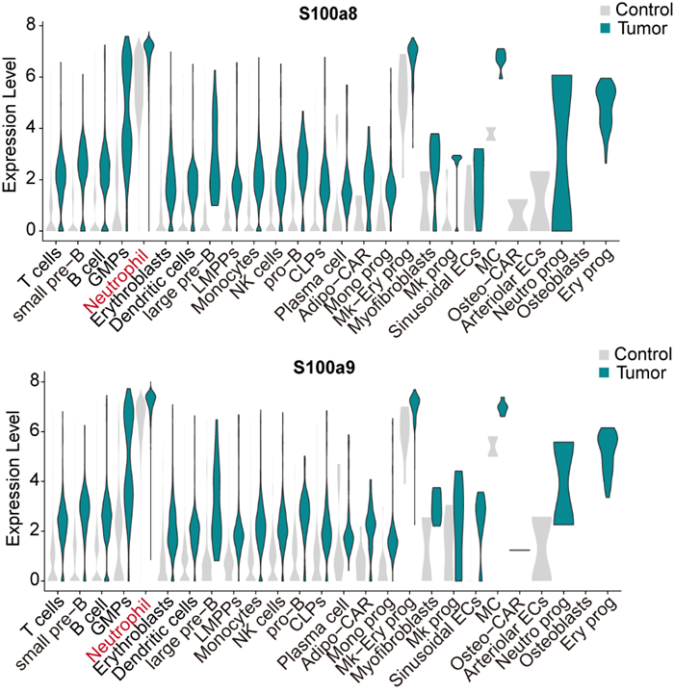
Supplementary Fig. 4. S100A8 and S100A9 transcription level in different cell clusters of BM.

