Figure 1 Full-length blots of Figure 1F.
Whole membrane
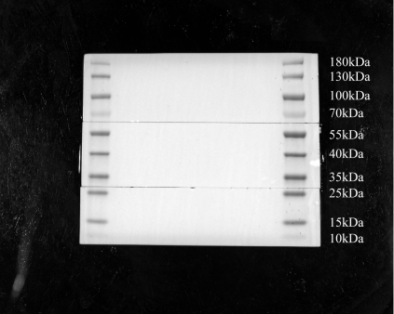
Calnexin: 100 kDa
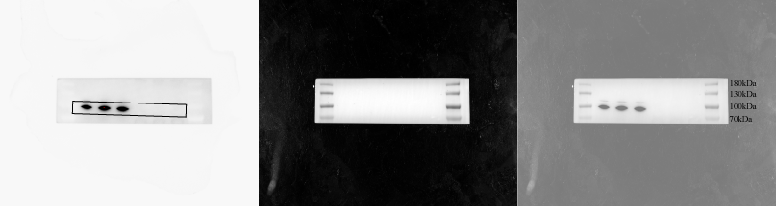
ALIX: 110 kDa
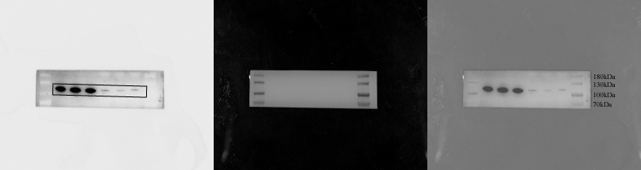
CD63: 35-55kDa
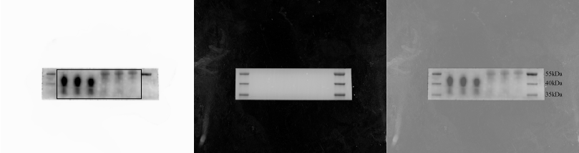
CD9: 23kDa
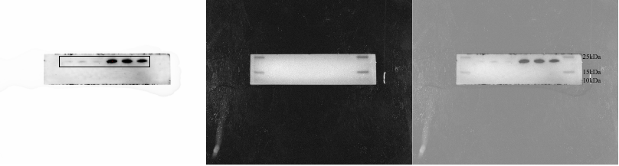

Figure 2 Full-length blots and biological repeats of Figure 4B.
Whole membrane
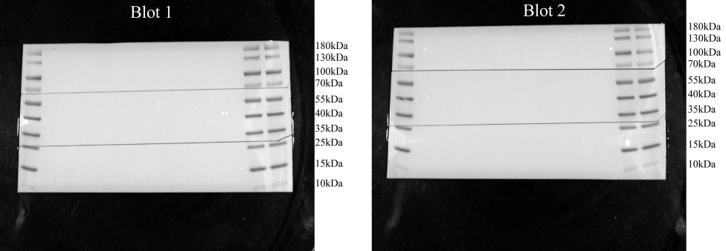
NLRP3: 118kDa, 78kDa
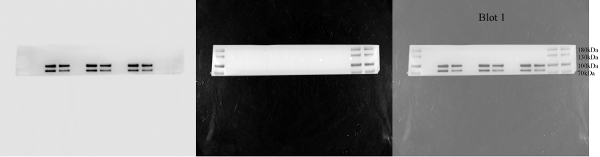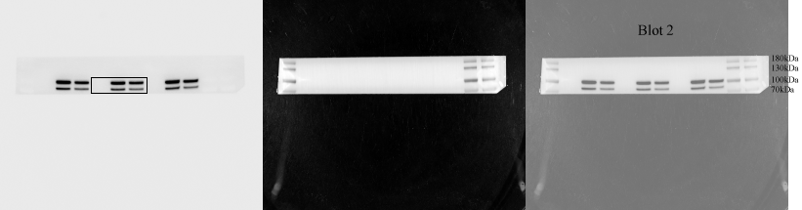
Cleaved caspase-1: 20kDa
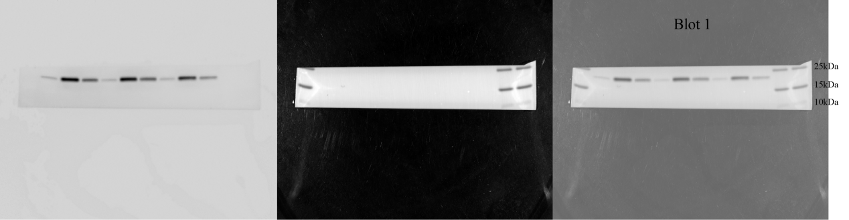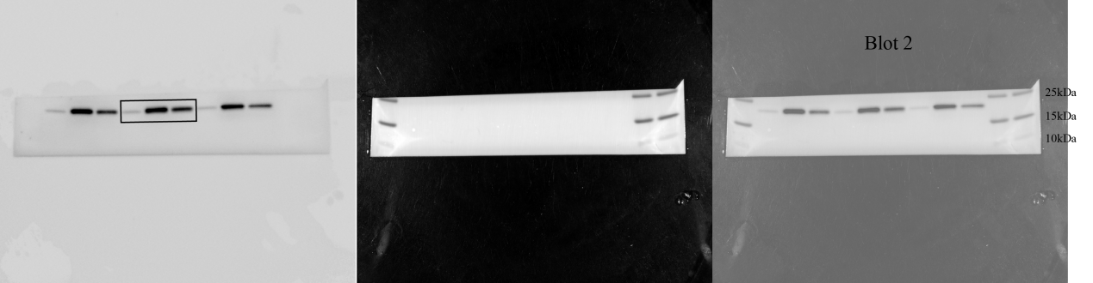
GSDMD: 55kDa GSDMD-NT: 35kDa
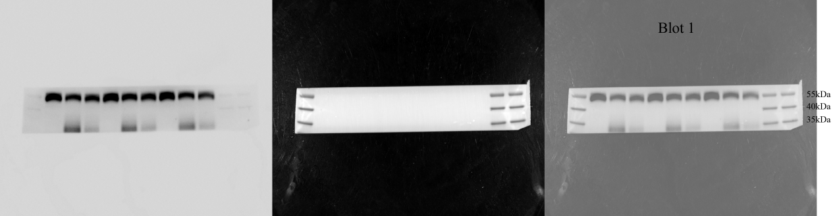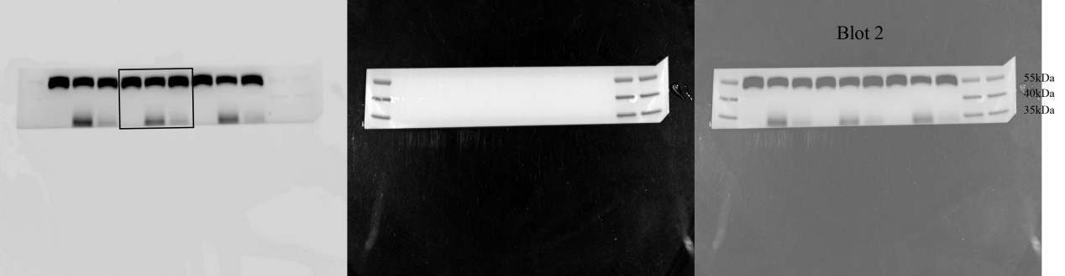
β-actin: 42kDa
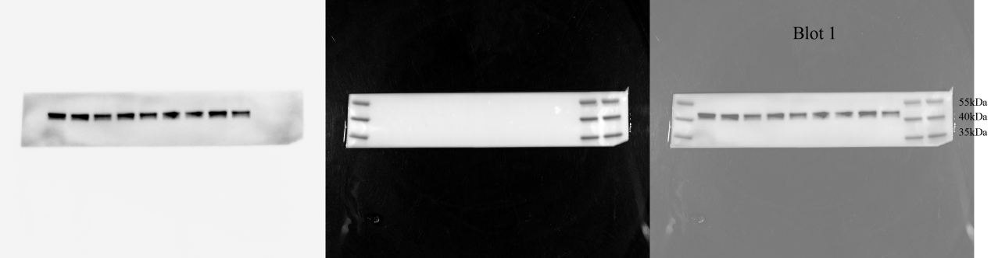
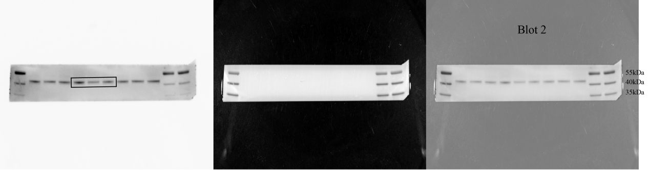

Figure 3 Full-length blots and biological repeats of Figure 4M.
Whole membrane
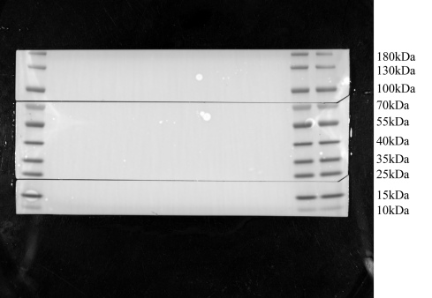
NLRP3: 118kDa
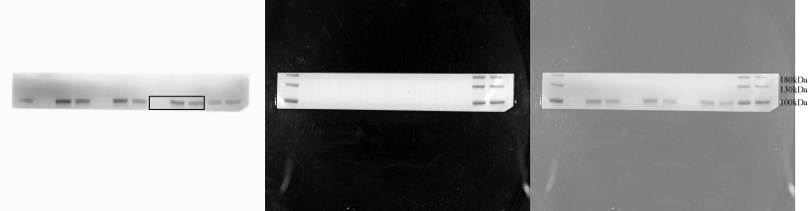
GSDMD: 55kDa GSDMD-NT: 35kDa
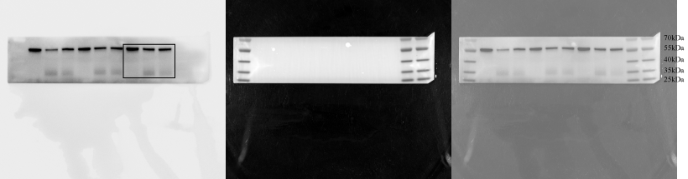
β-actin: 42kDa
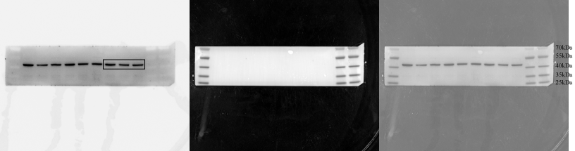

Figure 4 Full-length blots and biological repeats of Figure 5A.
Whole membrane
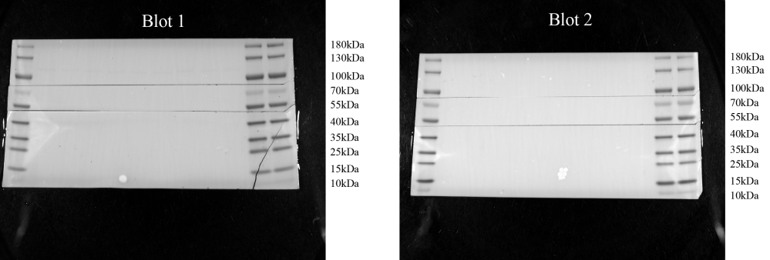
cGAS: 62kDa
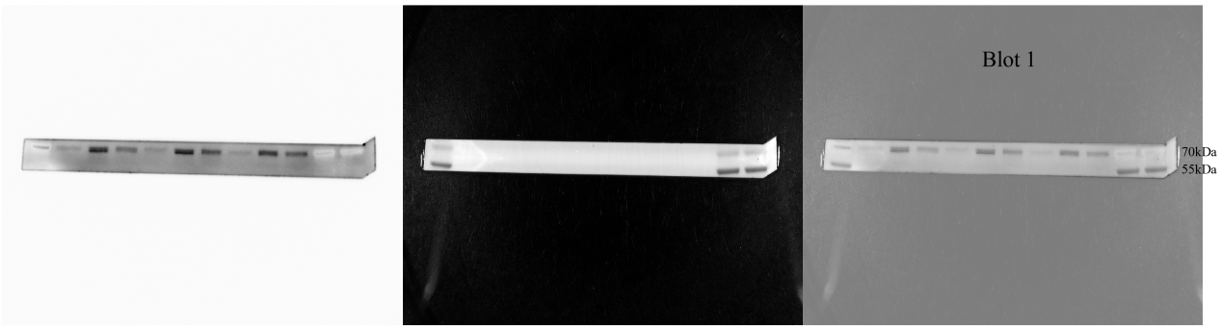
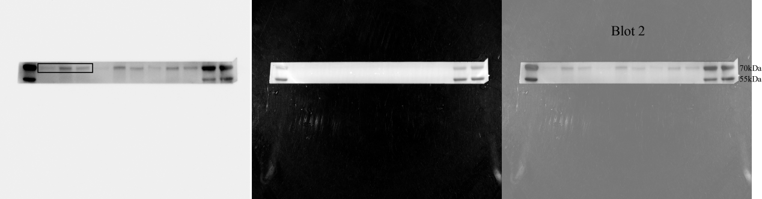
STING: 35-40kDa
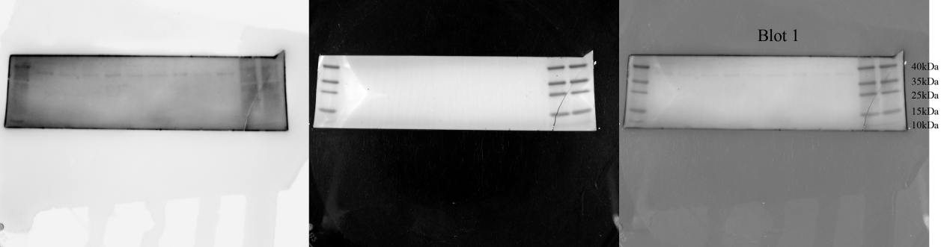
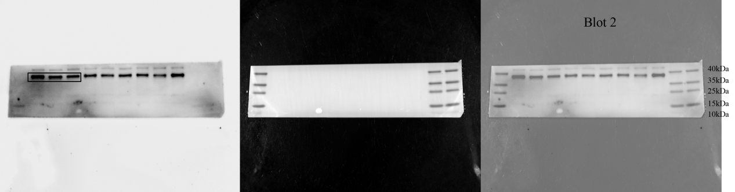
TBK1: 84kDa
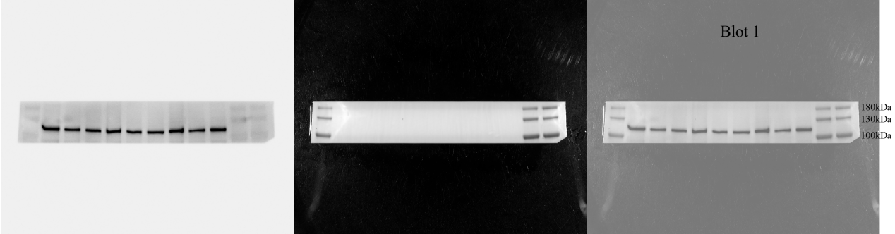
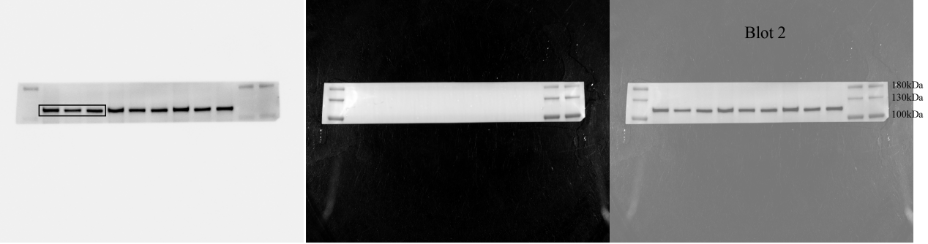
p-TBK1: 84kDa
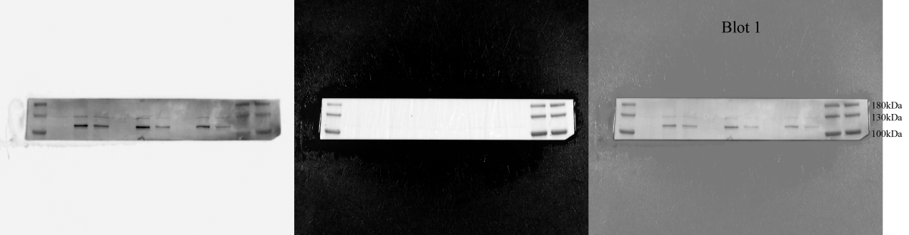
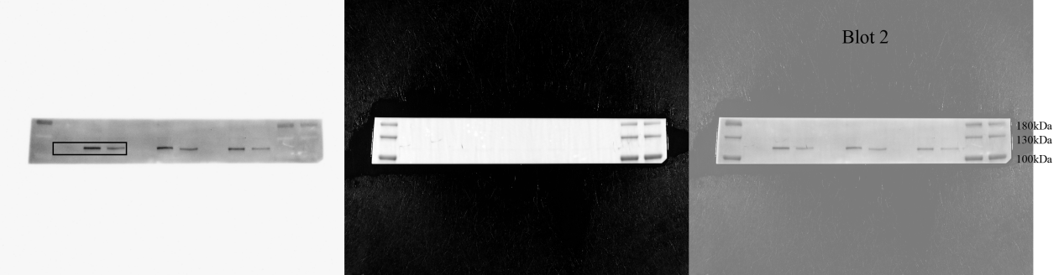
β-actin: 42kDa
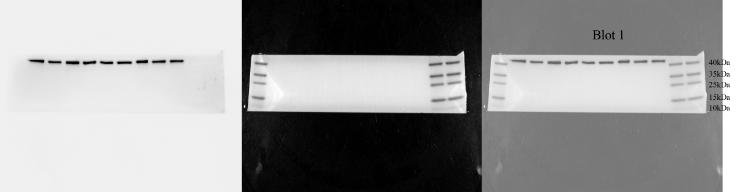
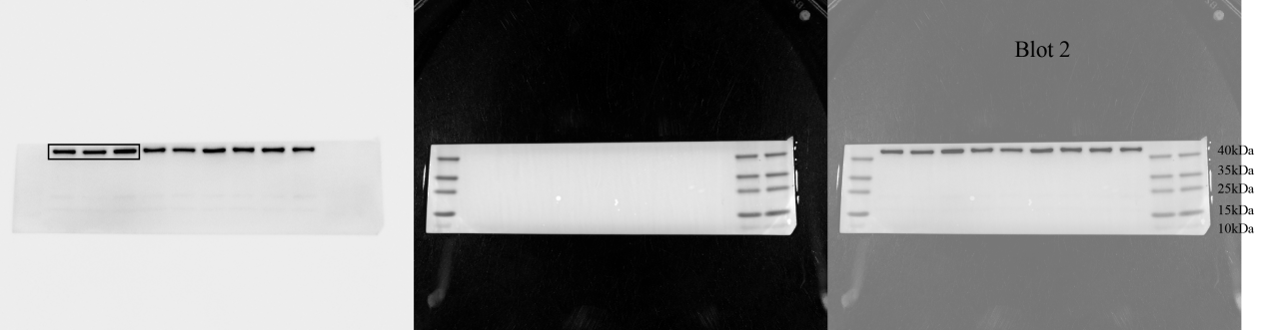
Whole membrane
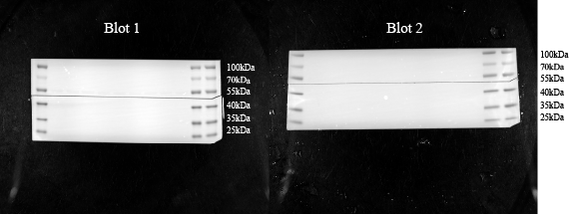
p-STING: 35-40kDa
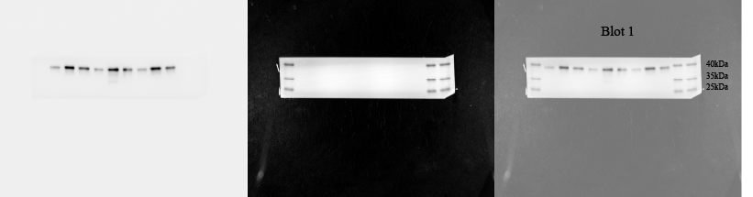
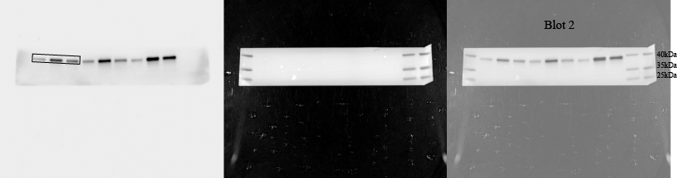
β-tubulin: 55kDa
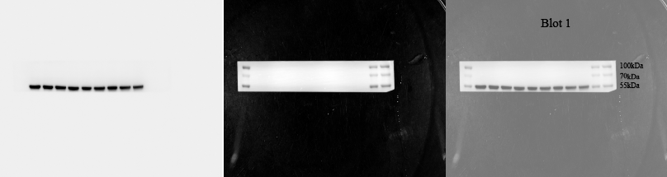
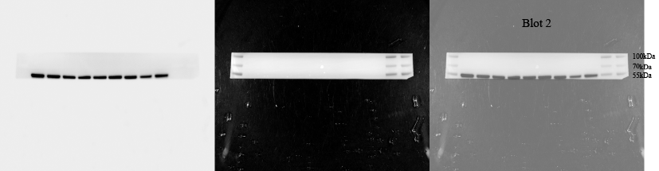

Figure 5 Full-length blots and biological repeats of Figure 5E.
Whole membrane
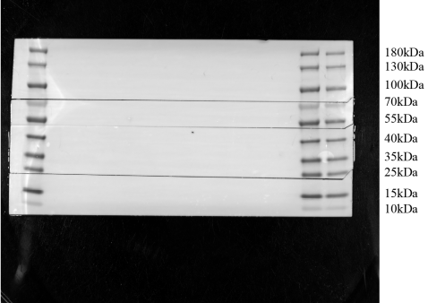
cGAS: 62kDa
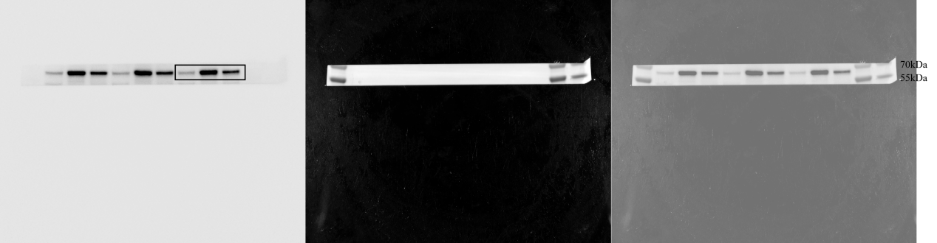
STING: 35-40kDa
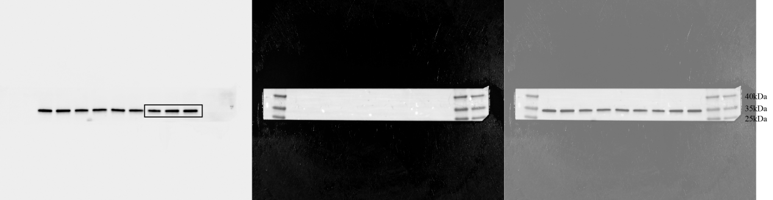
TBK1: 84kDa
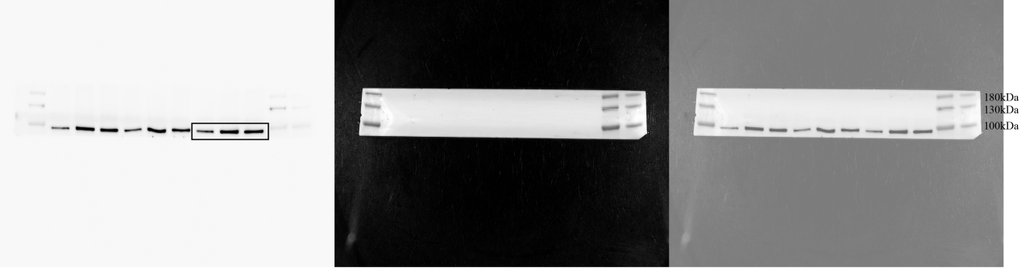
p-TBK1: 84kDa
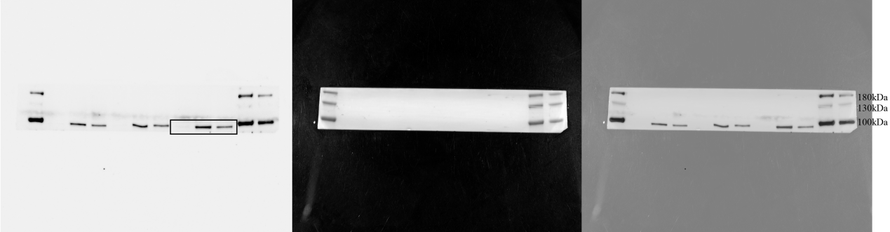
β-actin: 42kDa
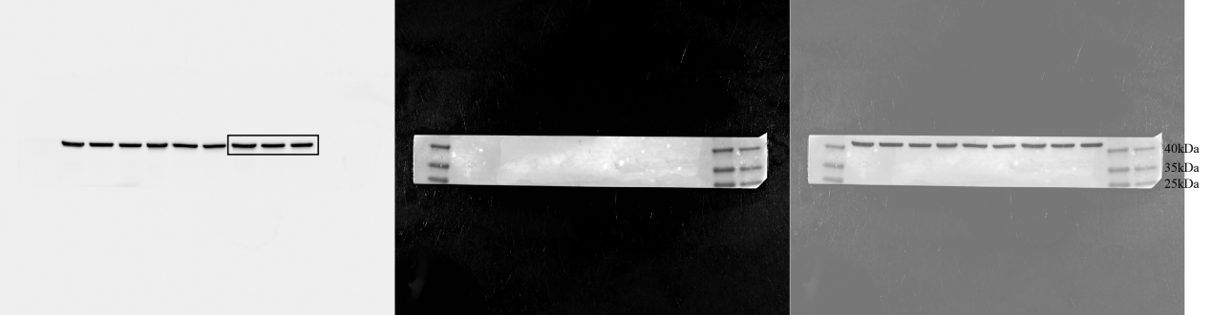
Whole membrane
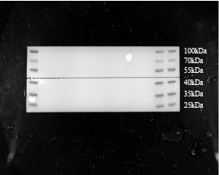
p-STING: 35-40kDa
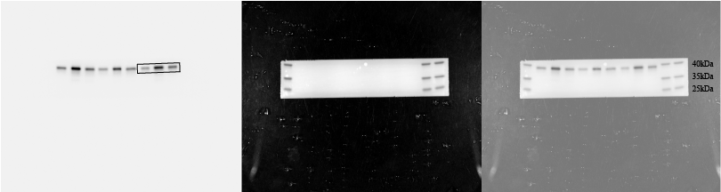
β-tubulin: 55kDa
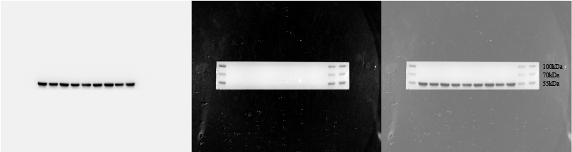

Figure 6 Full-length blots and biological repeats of Figure 6A.
Whole membrane
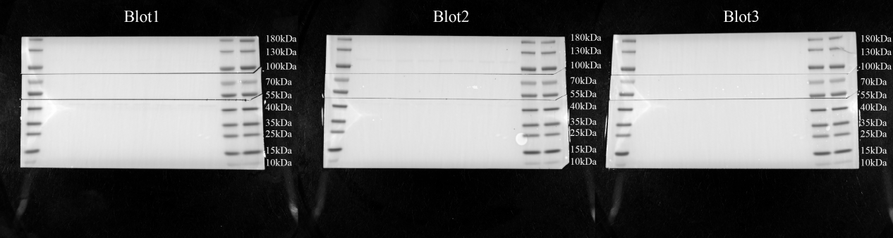
cGAS: 62kDa
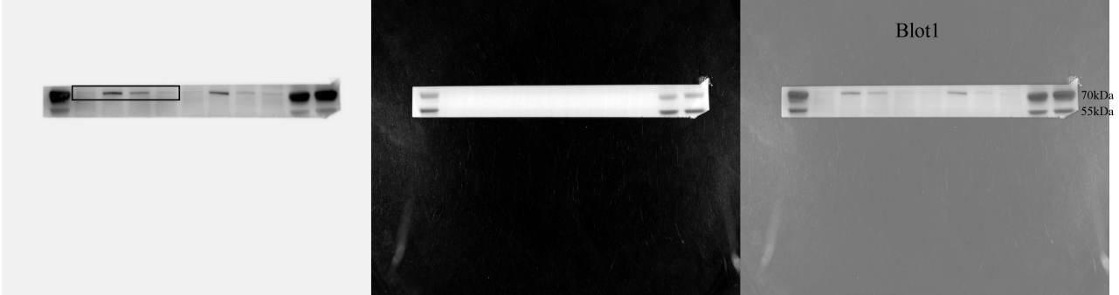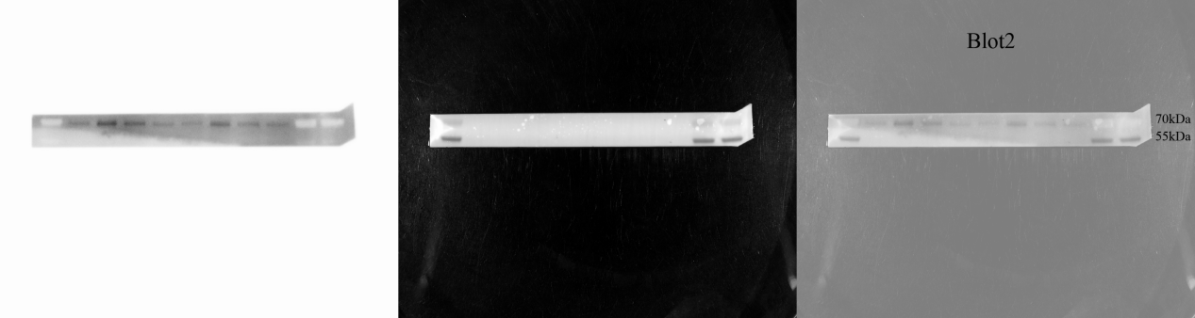
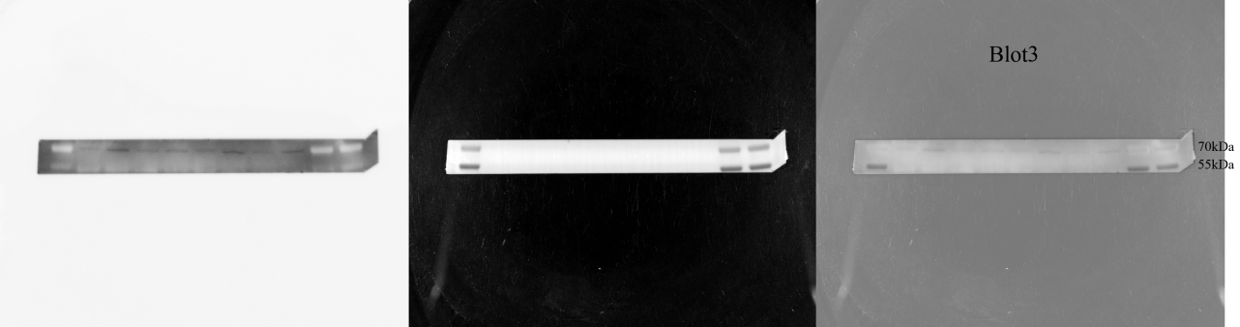
STING: 35-40kDa
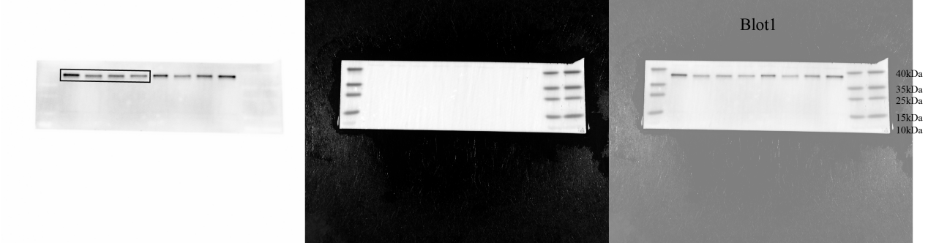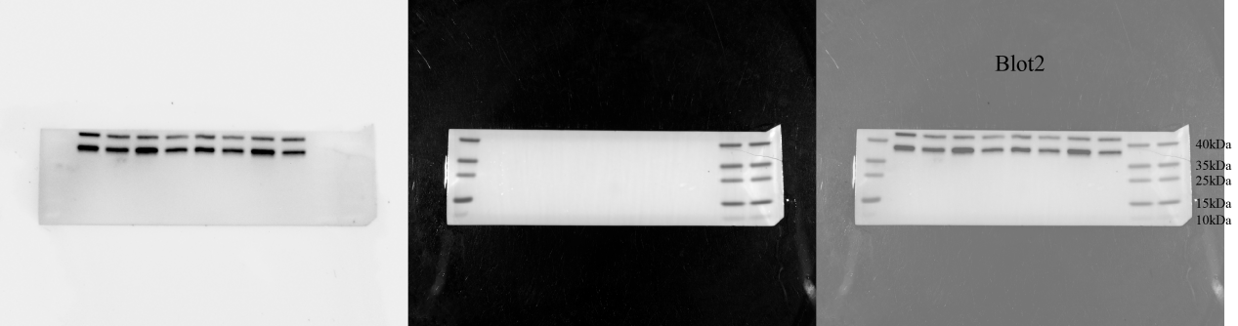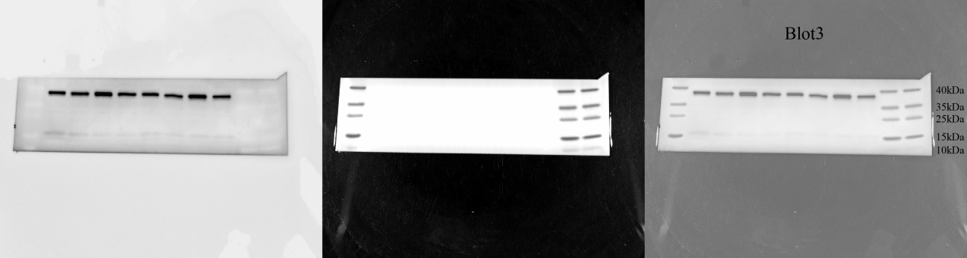
TBK1: 84kDa
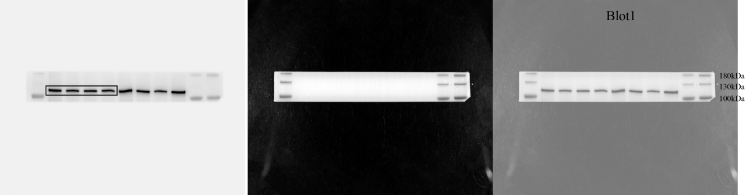
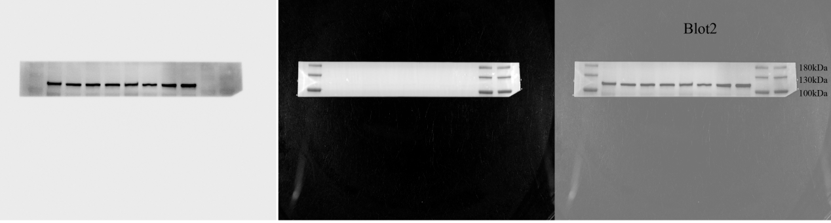
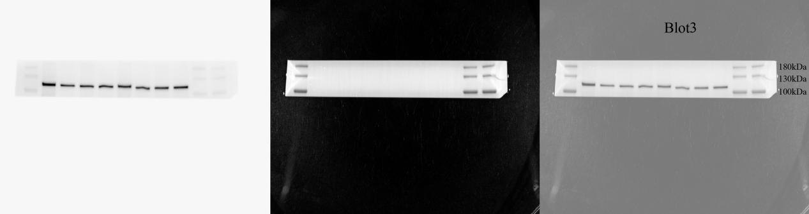
p-TBK1: 84kDa
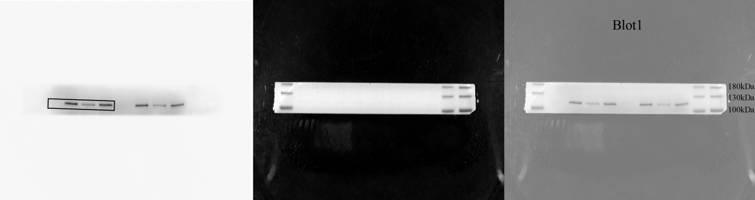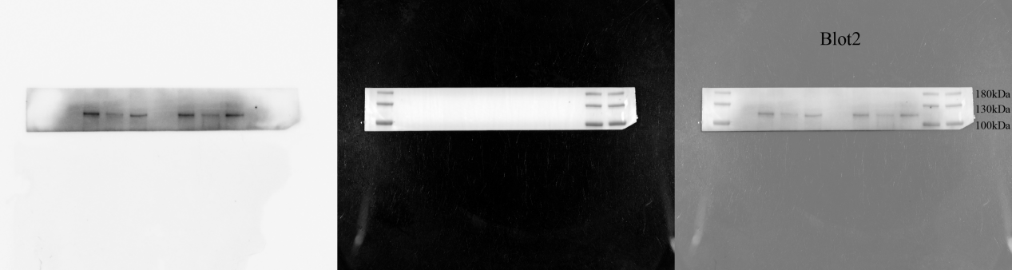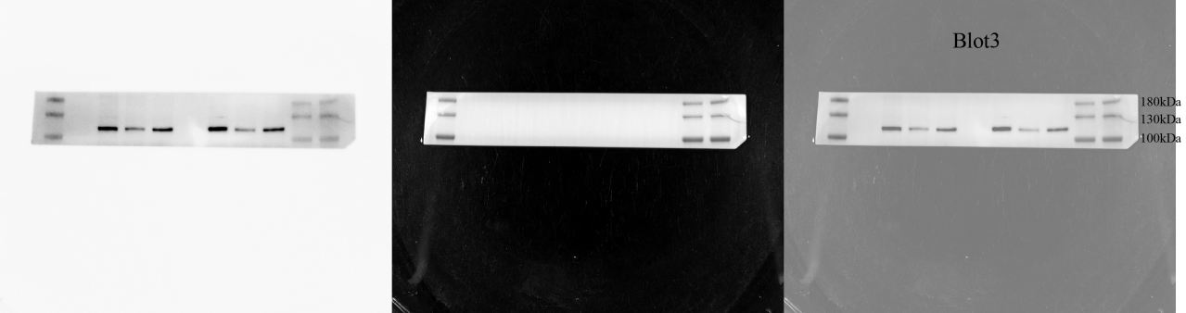
β-actin: 42kDa
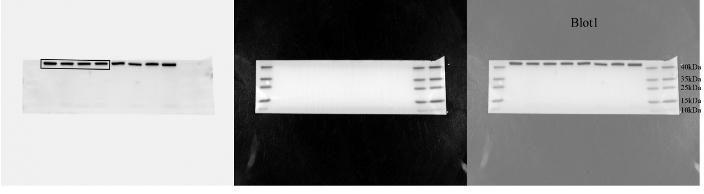
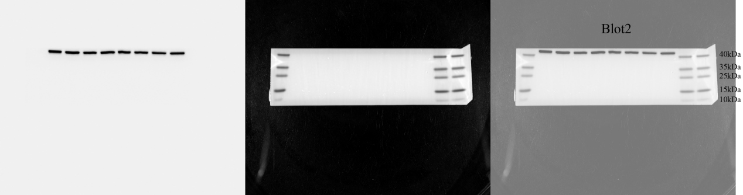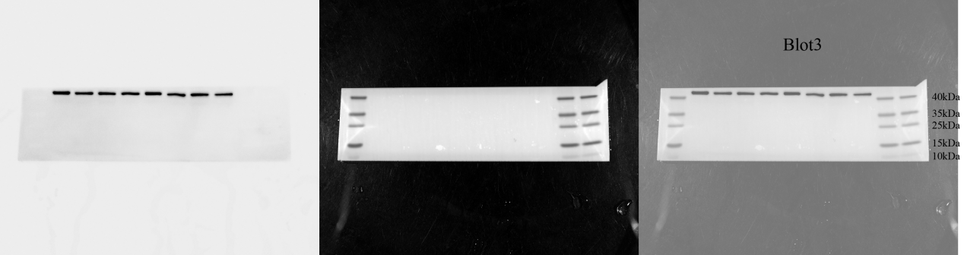
Whole membrane
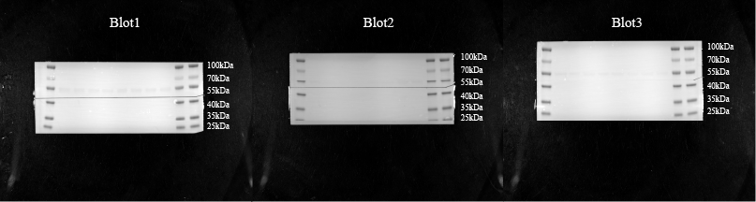
p-STING: 35-40kDa
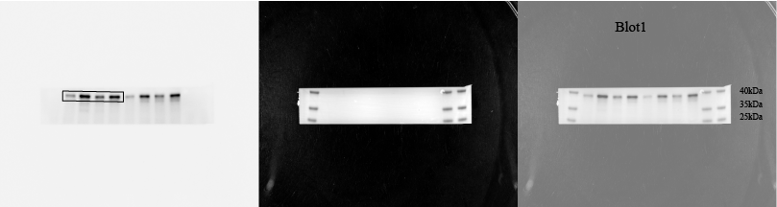
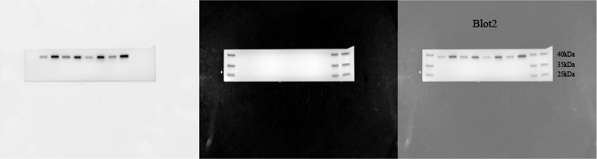
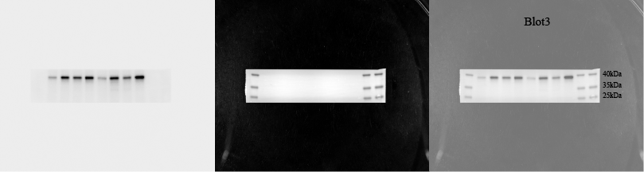
β-tubulin: 55kDa
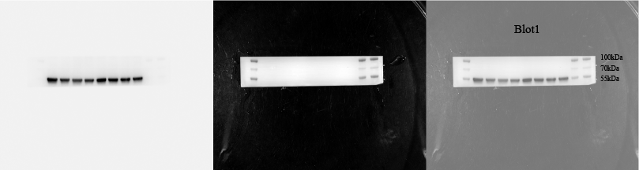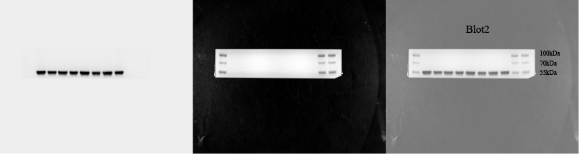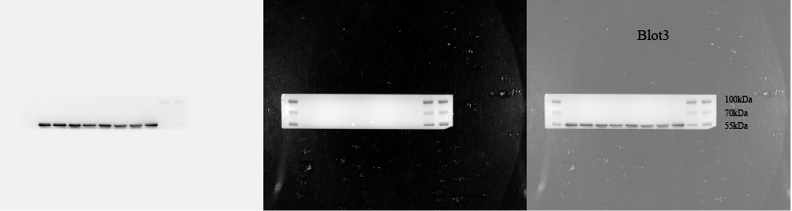

Figure 7 Full-length blots and biological repeats of Figure 6O.
Whole membrane
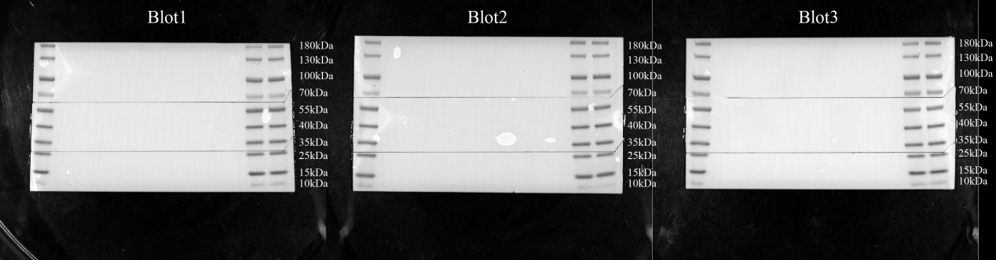
NLRP3: 118kDa, 78kDa
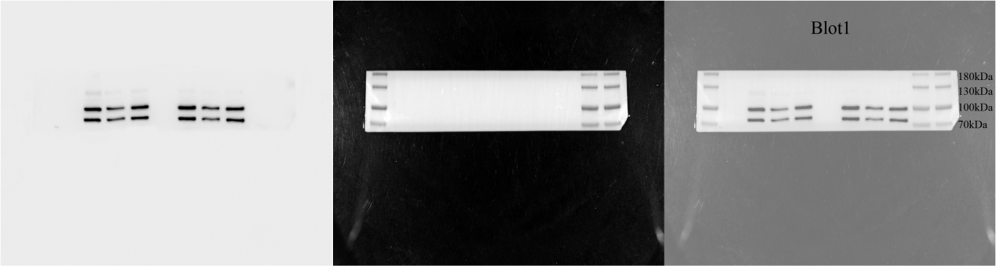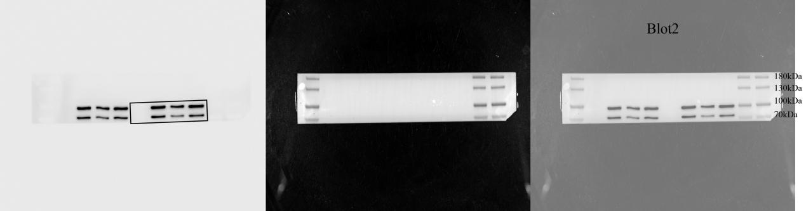
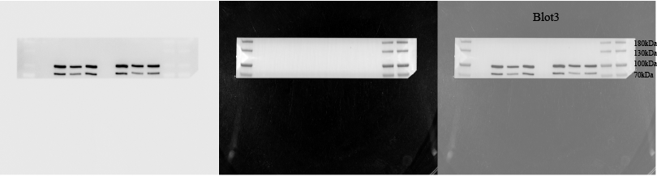
Cleaved caspase-1: 20kDa
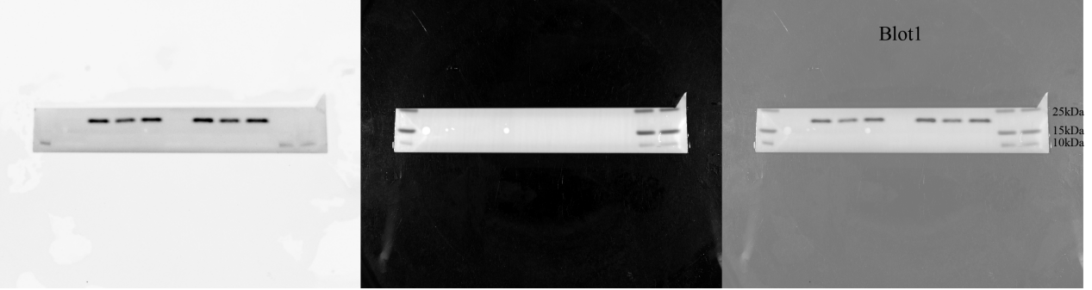
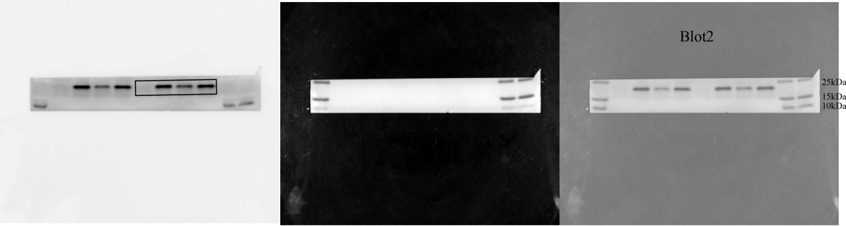
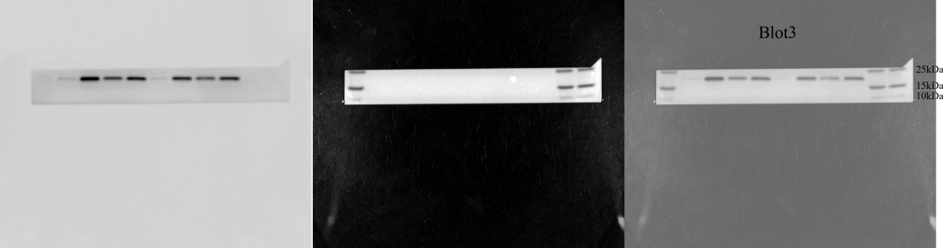
GSDMD: 55kDa GSDMD-NT: 35kDa
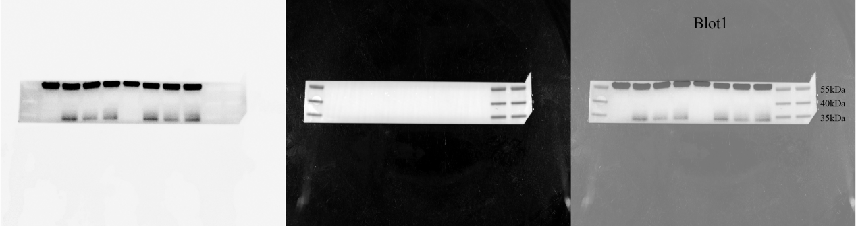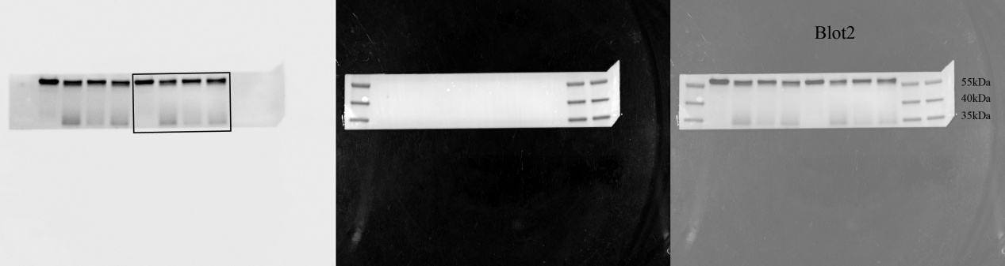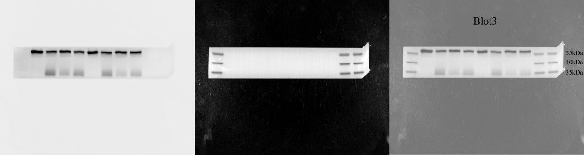
β-actin: 42kDa
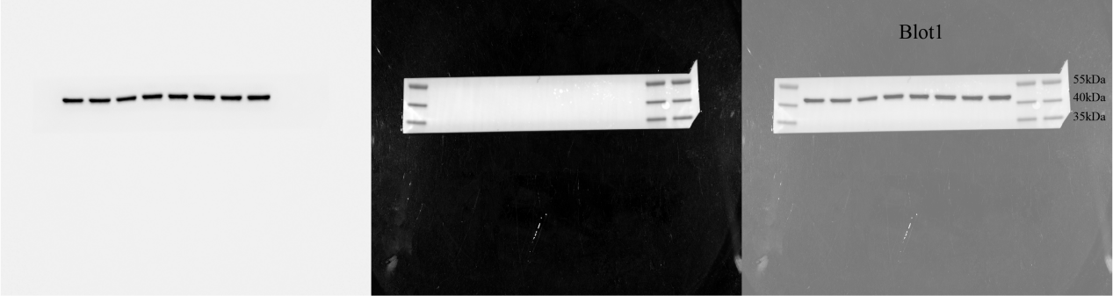
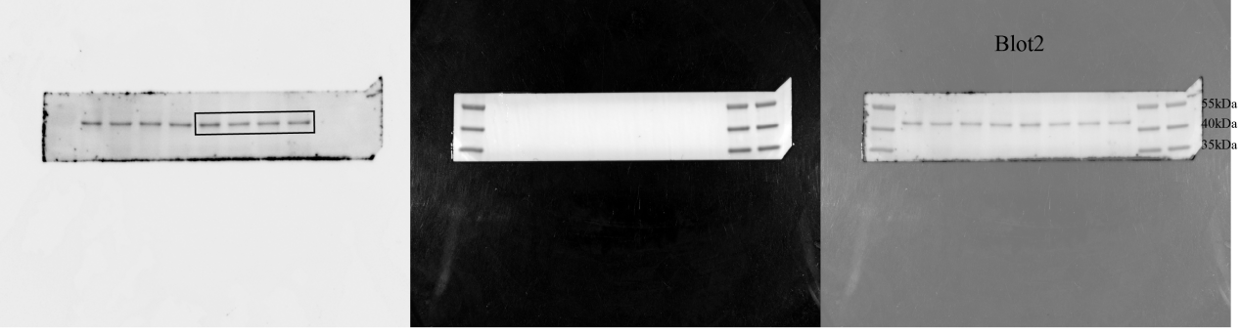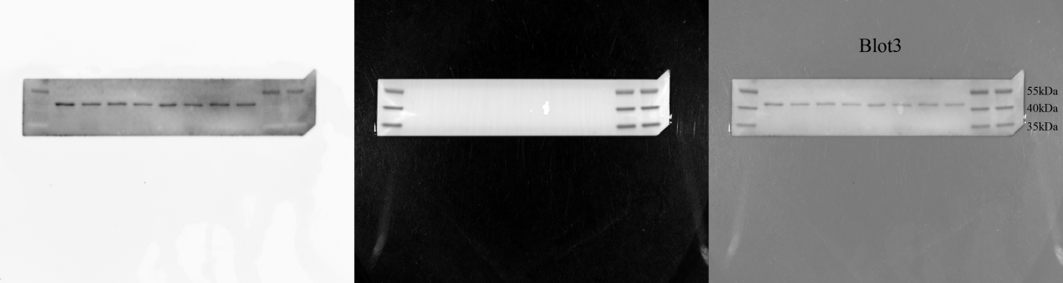

Figure 8 Full-length blots and biological repeats of Figure 7A.
Whole membrane
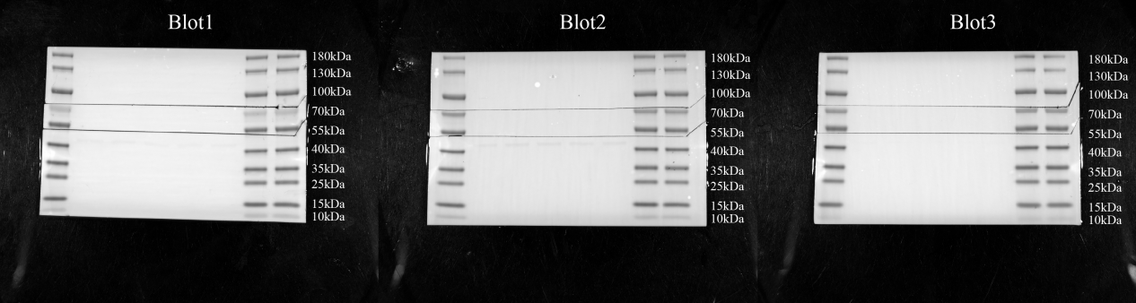cGAS: 62kDa
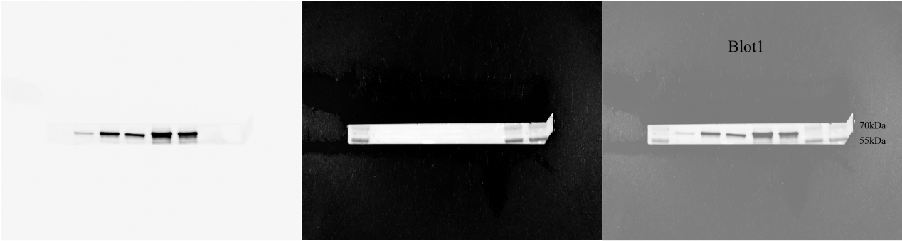
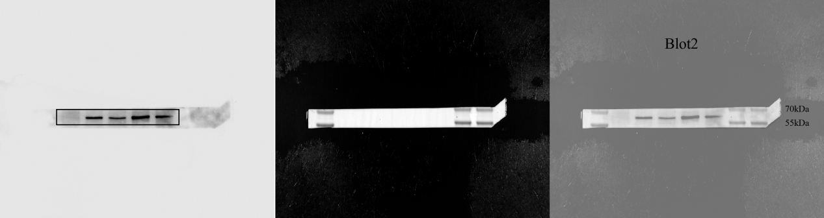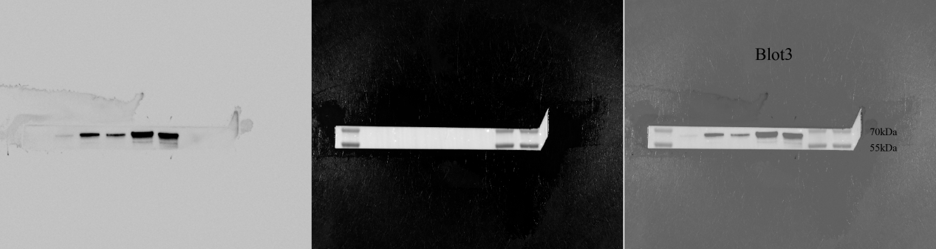
STING: 35-40kDa
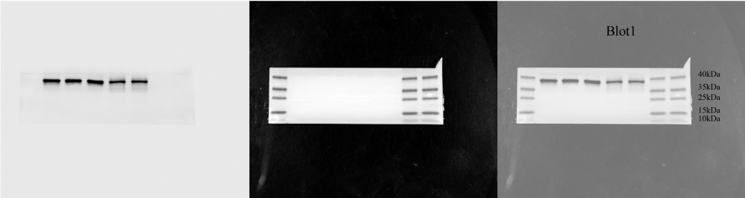
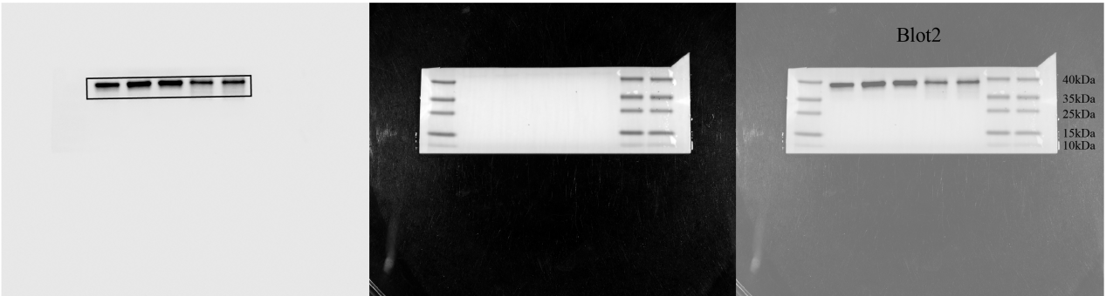
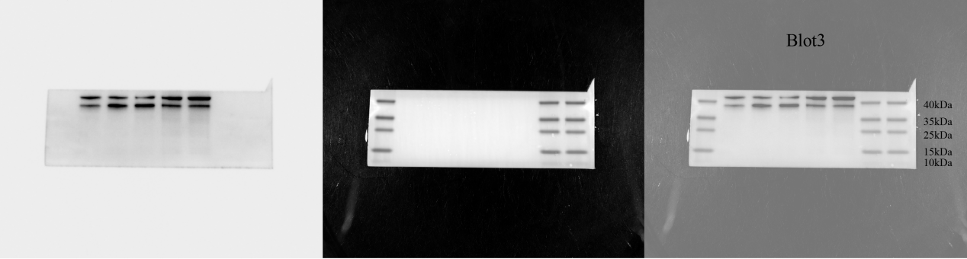
TBK1: 84kDa
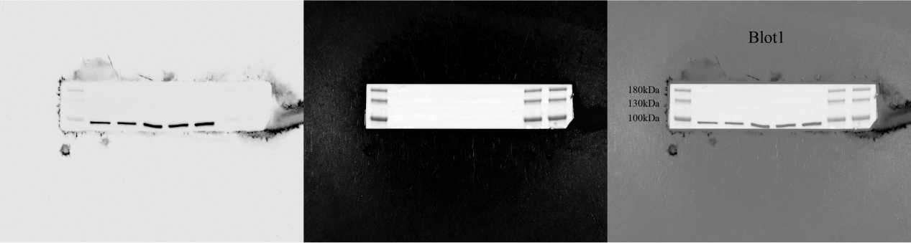
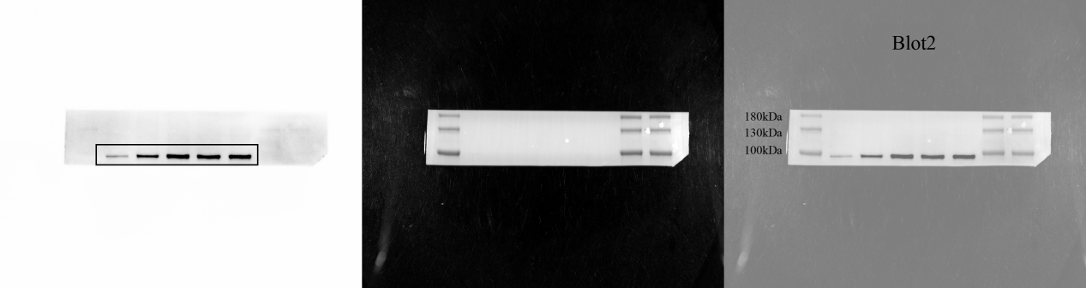
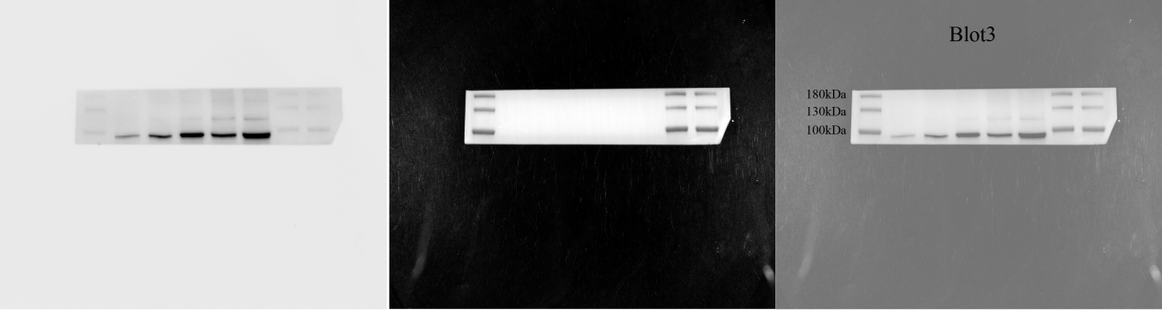p-TBK1: 84kDa
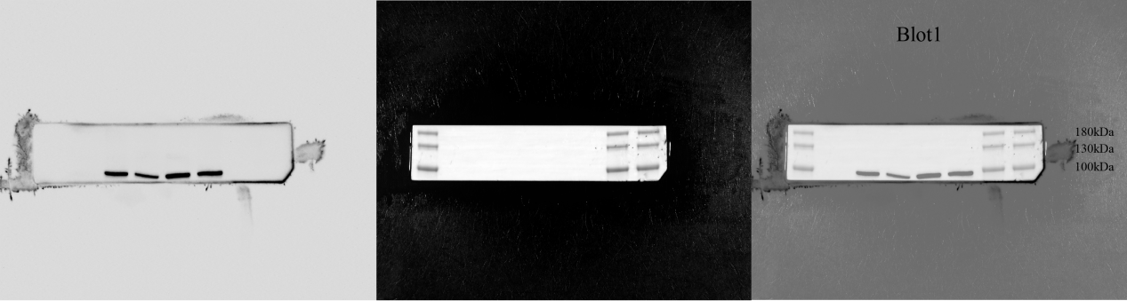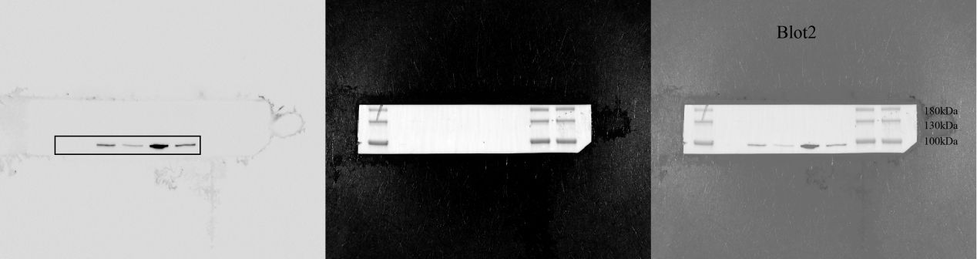
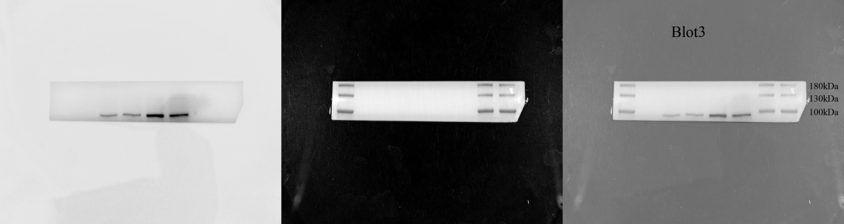
β-actin: 42kDa
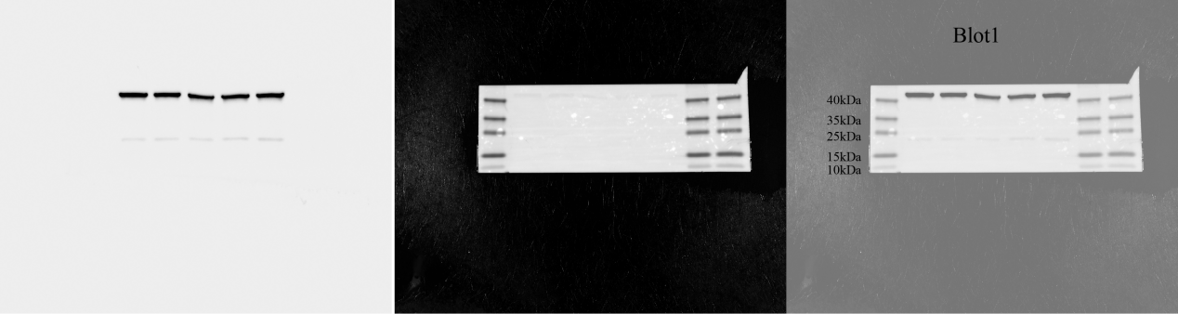
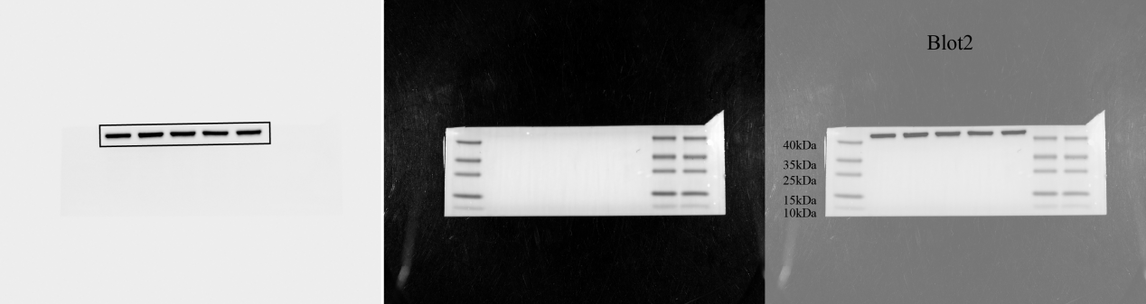
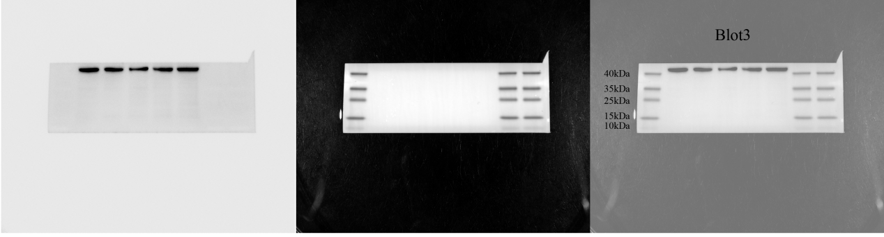
Whole membrane
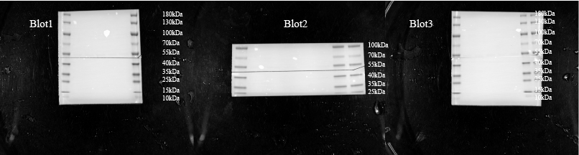
p-STING: 35-40kDa
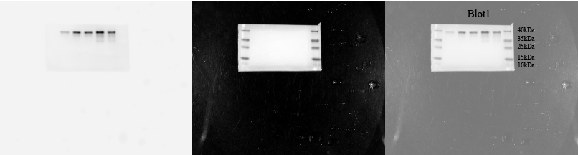
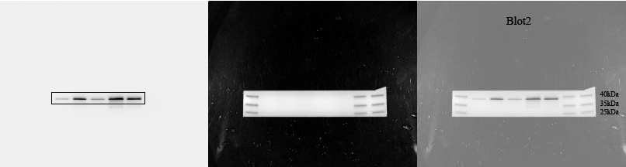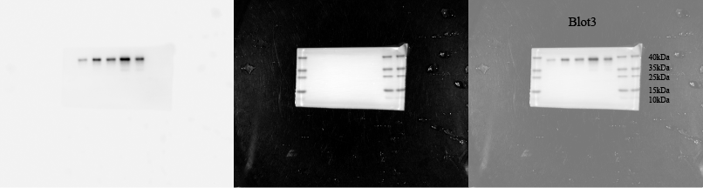
β-tubulin: 55kDa
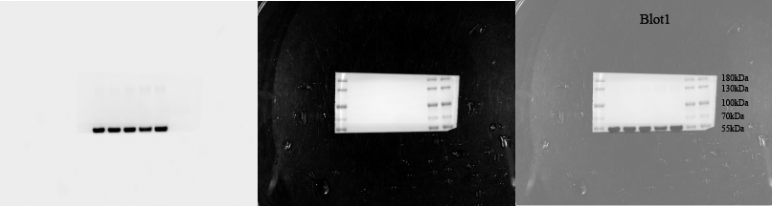
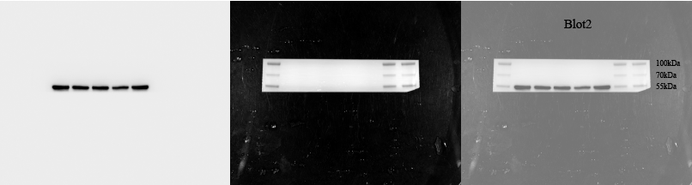
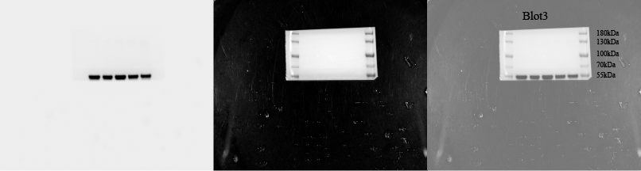

Figure 9 Full-length blots and biological repeats of Figure 7K.
Whole membrane
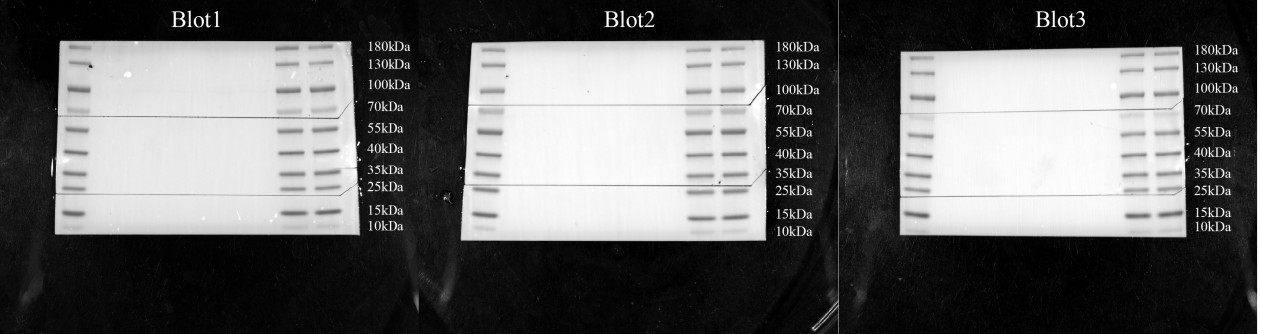
NLRP3: 118kDa
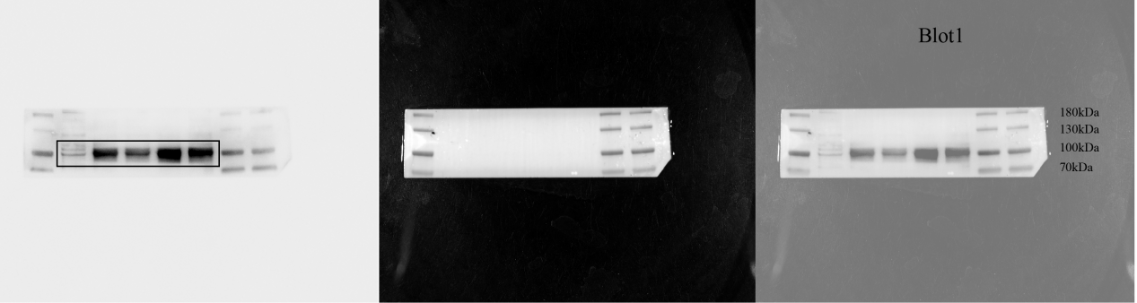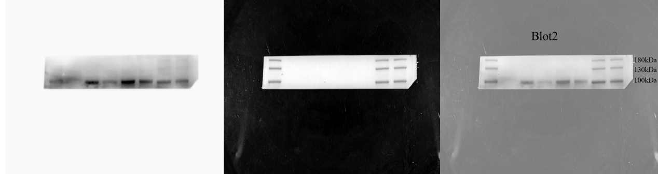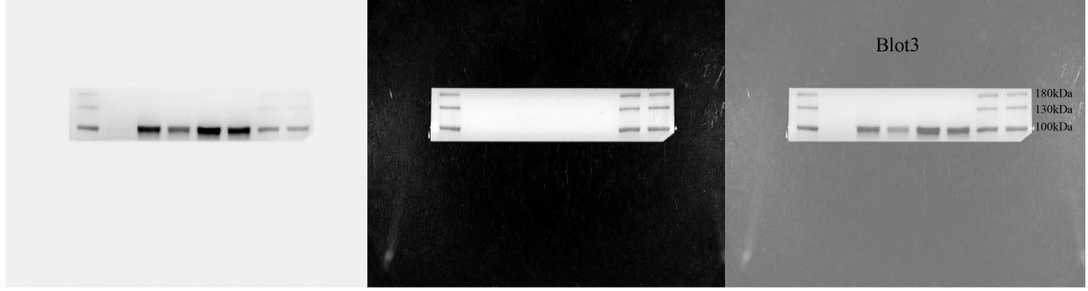
GSDMD: 55kDa GSDMD-NT: 35kDa
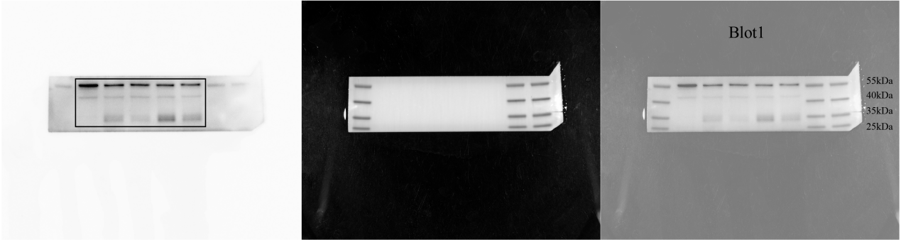
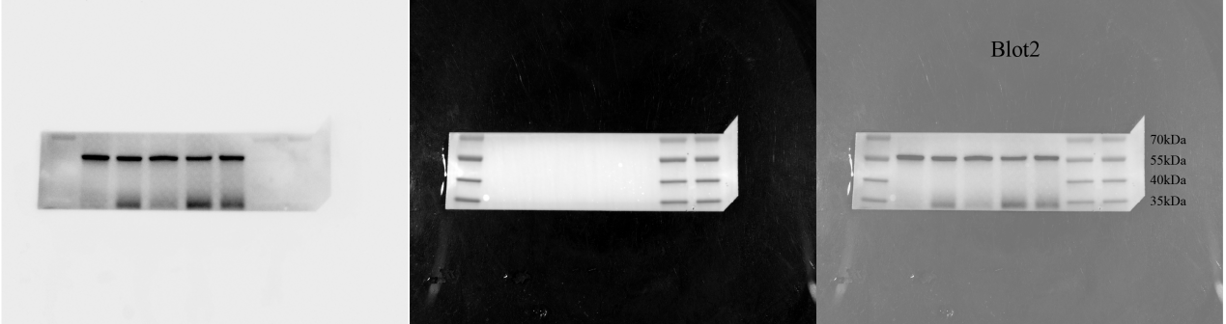
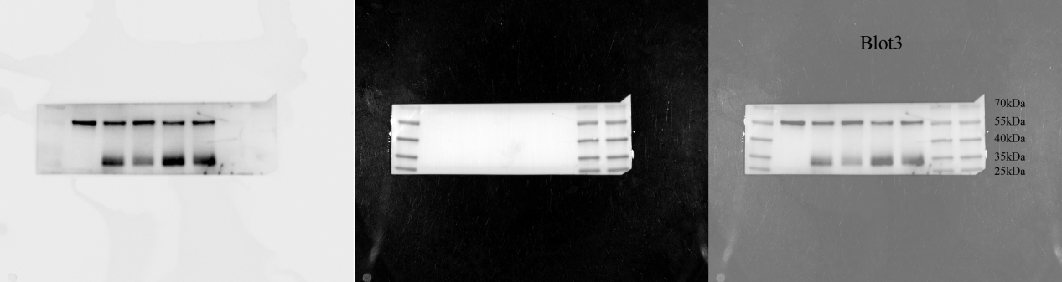
β-actin: 42kDa
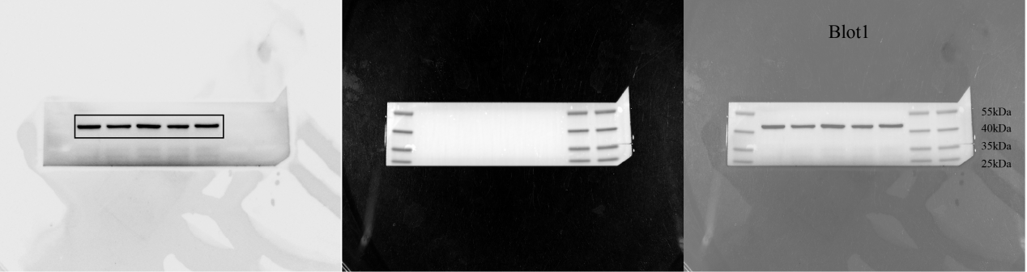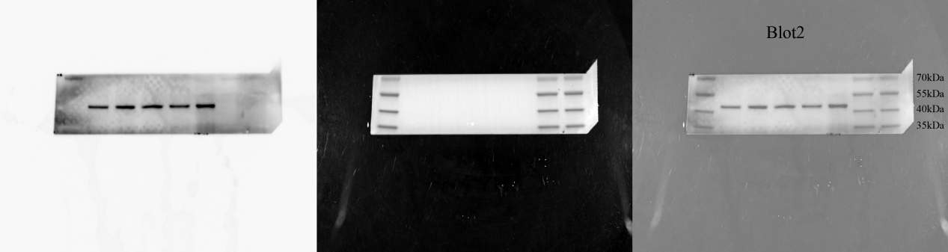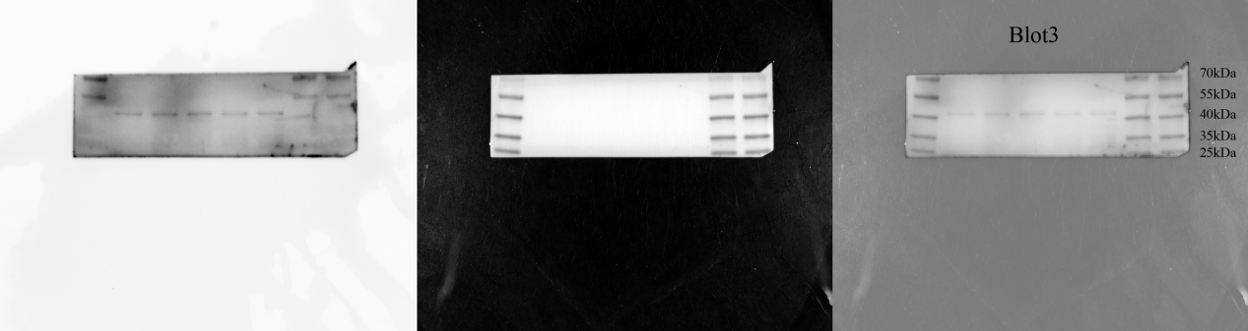

Figure 10 Full-length blots and biological repeats of Figure 8C.
Whole membrane
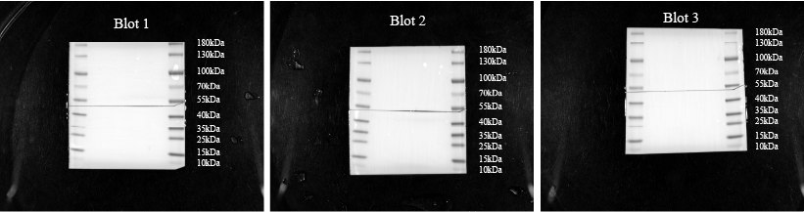
cGAS: 62kDa
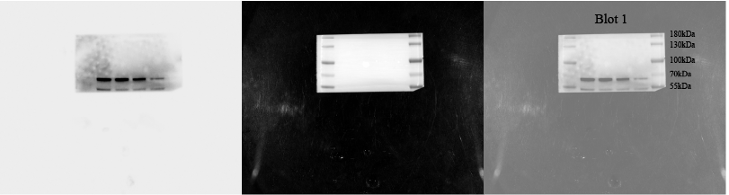
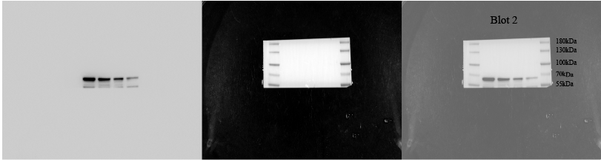
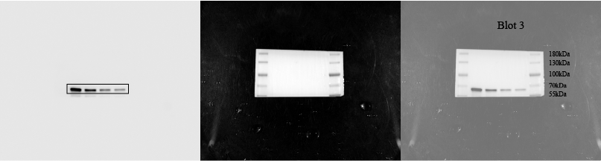
β-actin: 42kDa
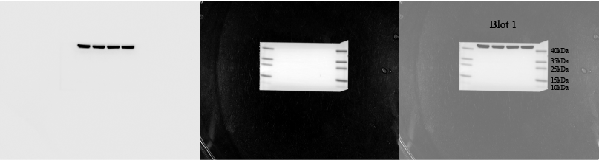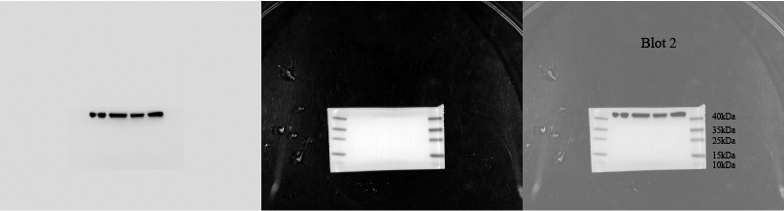
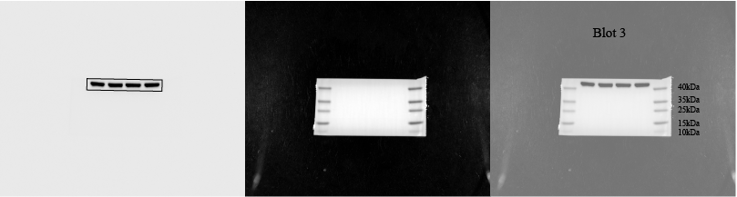

Figure 11 Full-length blots and biological repeats of Figure 8E.
Whole membrane
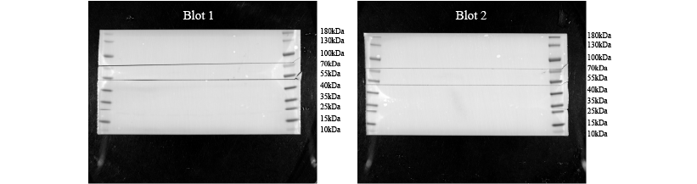
cGAS: 62kDa
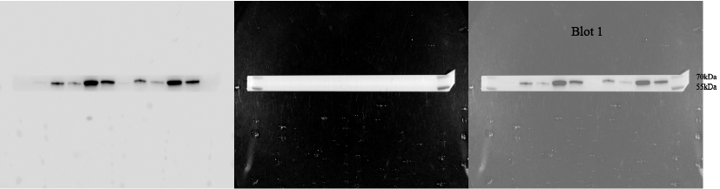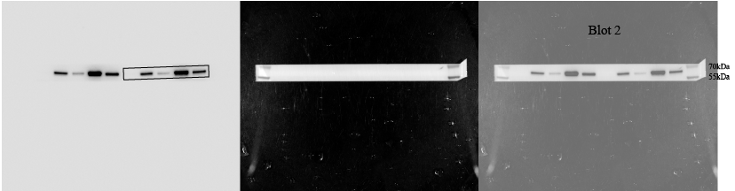
STING: 35-40kDa
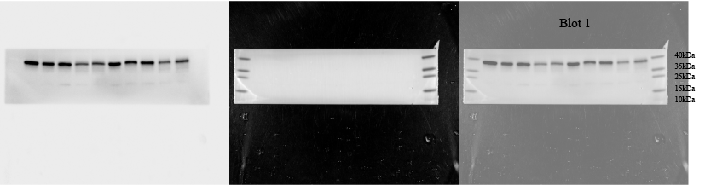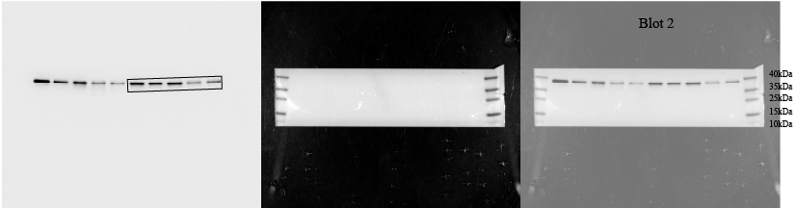
TBK1: 84kDa
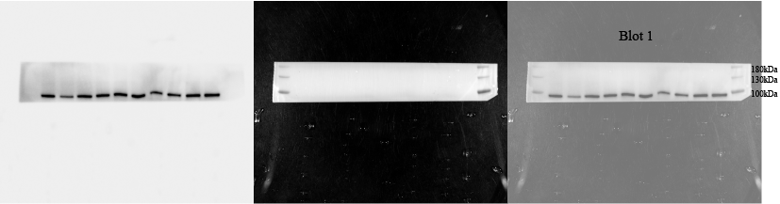
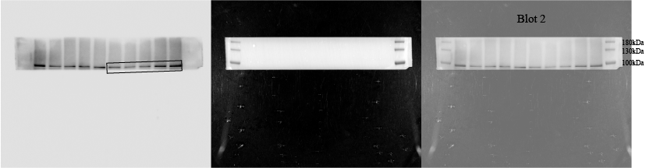
β-actin: 42kDa
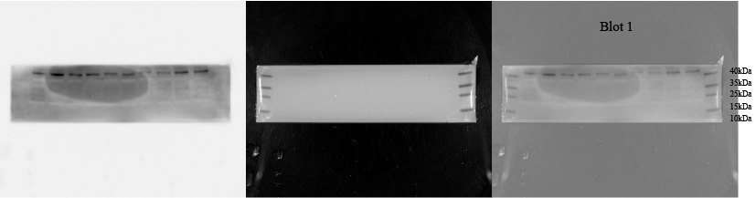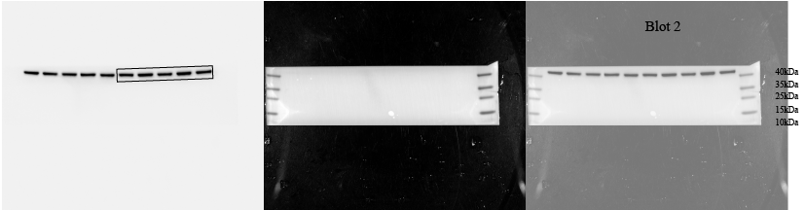
Whole membrane
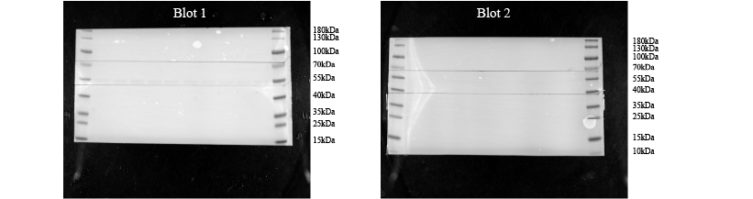
p-TBK1: 84kDa
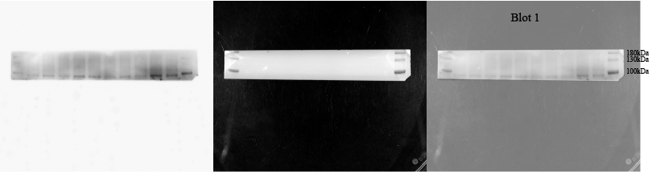
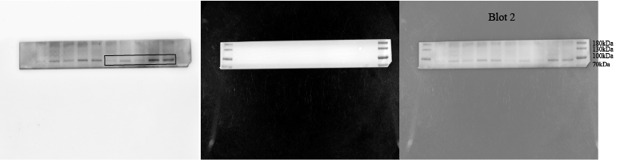
p-STING: 35-40kDa
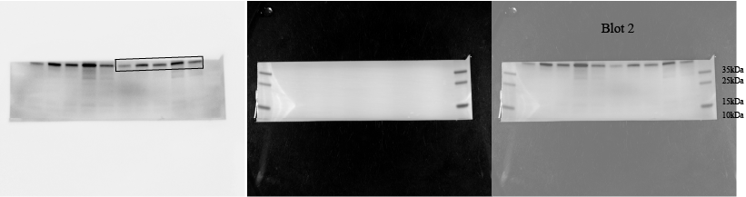
β-tubulin: 55kDa
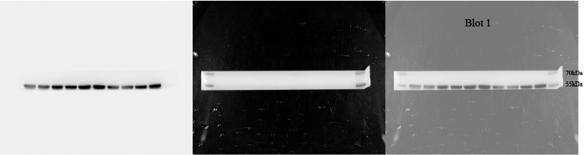
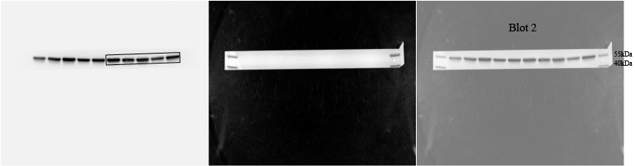

Figure 12 Full-length blots and biological repeats of Figure 8O.
Whole membrane
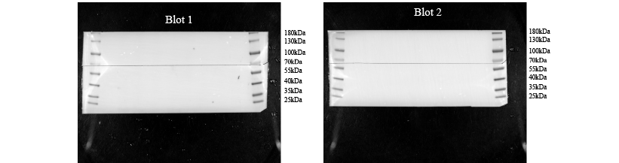
NLRP3: 118kDa
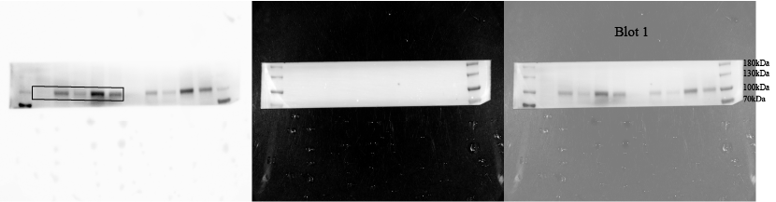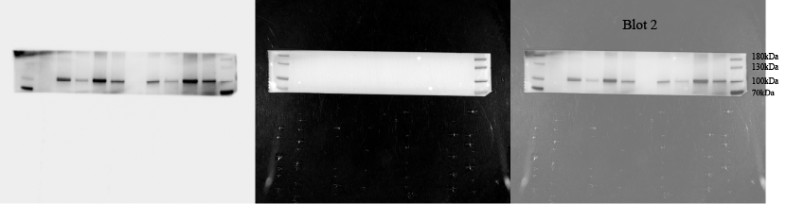
GSDMD: 55kDa GSDMD-NT: 35kDa
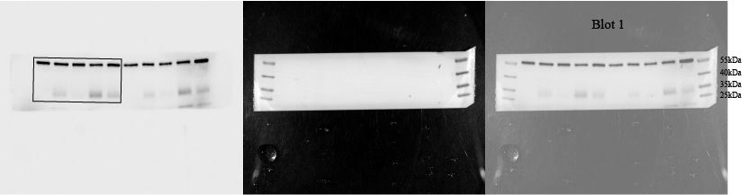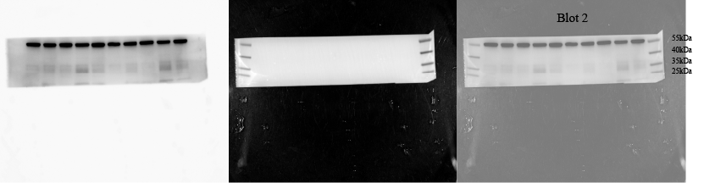
β-actin: 42kDa
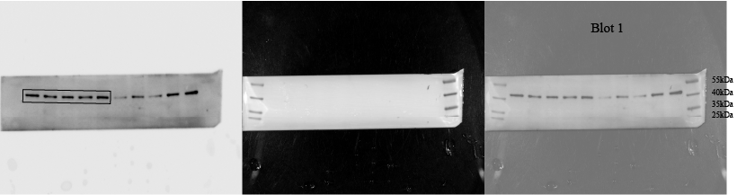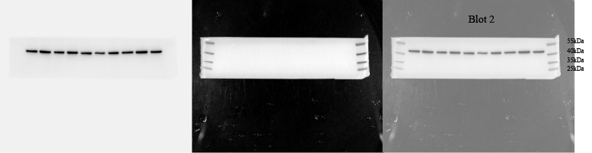

Figure 13 Full-length blots and biological repeats of Figure S4.
Whole membrane
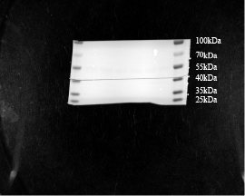
STING: 35-40kDa
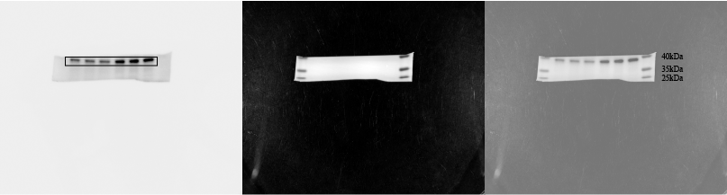
β-tubulin: 55kDa
