Supplementary information
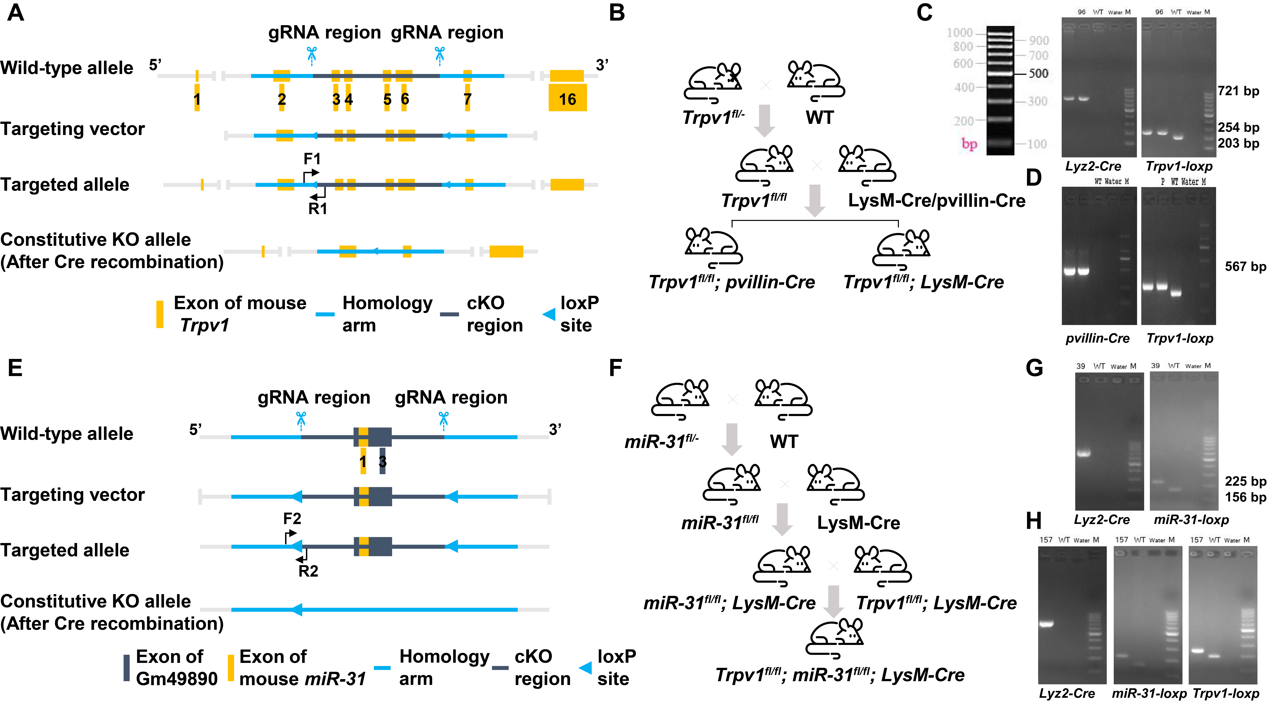
Supplementary Figure 1. Establishment of conditional knockout mice.
The gRNA to mouse Trpv1 and miR-31 gene, the donor vector containing loxP sites, and Cas9 mRNA were co-injected into fertilized mouse eggs to generate targeted conditional knockout offspring. (A) Trpv1 conditional knockout mice were designed and generated. (B) Breeding strategy. (C) Genotyping of Trpv1^{ΔMye} mice, DNA was prepared from tails. Primers for Lyz2-Cre PCR (Forword: 5’-CCCAGAAATGCCAGATTACG-3’, Reverse: 5’-CTTGGGCTGCCAGAATTTCTC-3’, Cre amplicon: 721 bp). And primers for Trpv1-loxP PCR (F1: 5’-CCAGGTACTTCAGCTTCACGTT-3’, R1: 5’-GTTGCCTTGGCCCTTATGAATG-3’, (Homozygous: 254 bp, WT: 203 bp). (D) Genotyping of Trpv1^{ΔIEC} mice, DNA was prepared from tails. Primers for pVillin-Cre PCR (Forword: 5’-GTGTTTGGTTTGGTTTCCTCTGCATAAGA-3’, Reverse: 5’-GCAGGCAAATTTTGGTGTACGGTCA-3’, Cre amplicon: 567 bp). And primers for Trpv1-loxP PCR. (E) miR-31 conditional knockout mice were designed and generated. (F) Breeding strategy. (G) Genotyping of miR-31^{ΔMye} mice, DNA was prepared from tails. Primers for miR-31-loxP PCR (F2: 5’-TTATGTTTAAGGGCTCATGGAGCAA-3’; R2: 5’-CATAGTCCATAGGAGTGCAGTGAC-3’). (Homozygous: 225 bp, WT: 156 bp). And primers for Lyz2-Cre PCR. (H) Genotyping of Trpv1^{ΔMye}; miR-31^{ΔMye} mice, DNA was prepared from tails. Primers for miR-31-loxP, Trpv1-loxP, and Lyz2-Cre PCR.
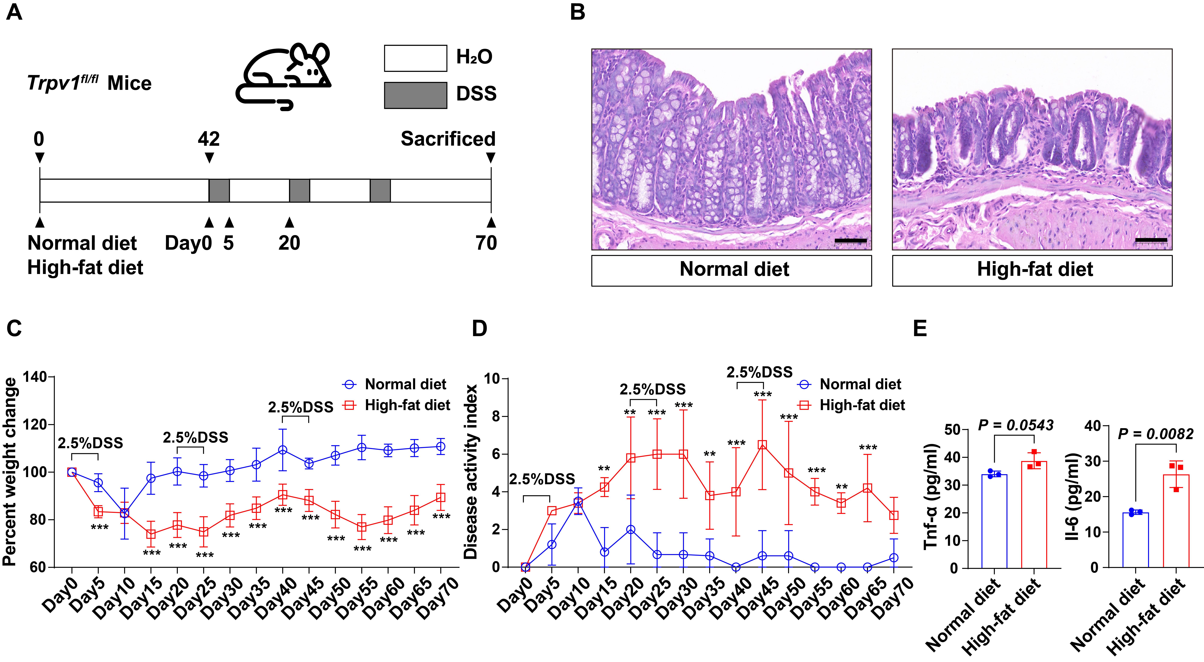
Supplementary Figure 2. Long-term exposure to HFD exacerbate DSS-induced chronic colitis in Trpv1^{fl/fl} mice
(A) Grouping method and examination time points of animal experiments. (B) Representative histopathological images, n = 3 mice per group, Scale bars 50 μm. (C) Percent weight change curves, n = 5 mice per group. (D) Disease activity index curves, n = 5 mice per group. (E) Pro-inflammatory cytokines levels in mouse serum, n = 3 mice per group. Data are Mean ± SD. *P < 0.05, **P < 0.01, ***P < 0.001 vs ND mice. All replicates were biological (independent mice). Histopathological images (B) are representative.
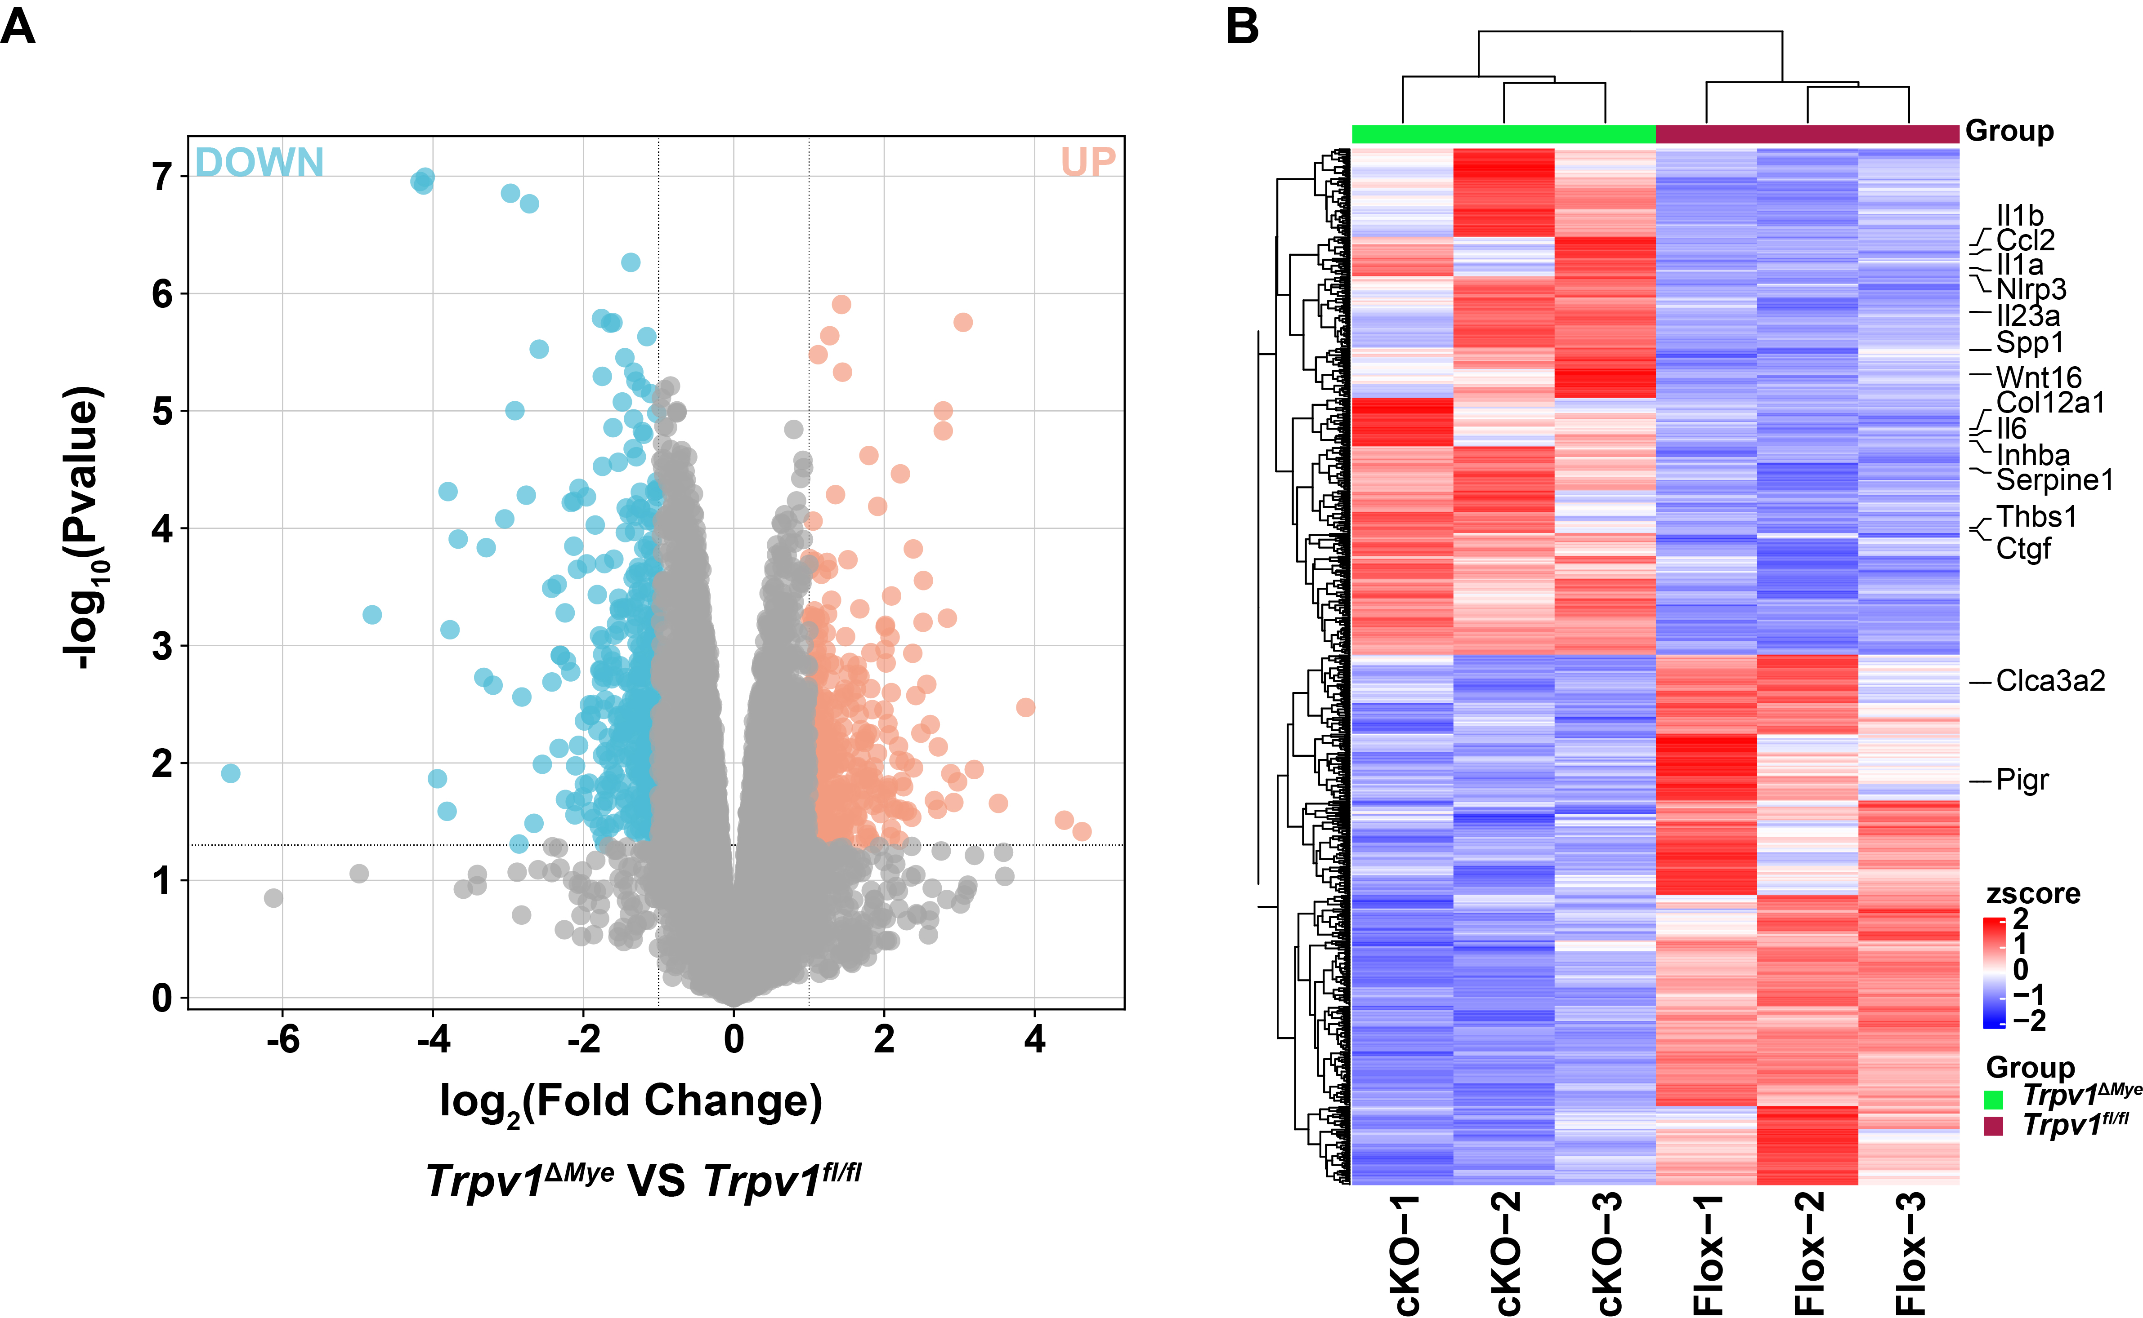
Supplementary Figure 3. RNA-seq reveals distinct transcriptional signatures in colon tissues of Trpv1^{fl/fl} and Trpv1^{∆Mye} mice with long-term HFD exposure.
(A) Volcano maps of DEGs between Trpv1^{∆Mye} and Trpv1^{fl/fl} mice colonic tissue, n = 3 mice per group (biological replicates) for the RNA-seq data. (B) Heat maps of DEGs between Trpv1^{∆Mye} and Trpv1^{fl/fl} mice colonic tissue.
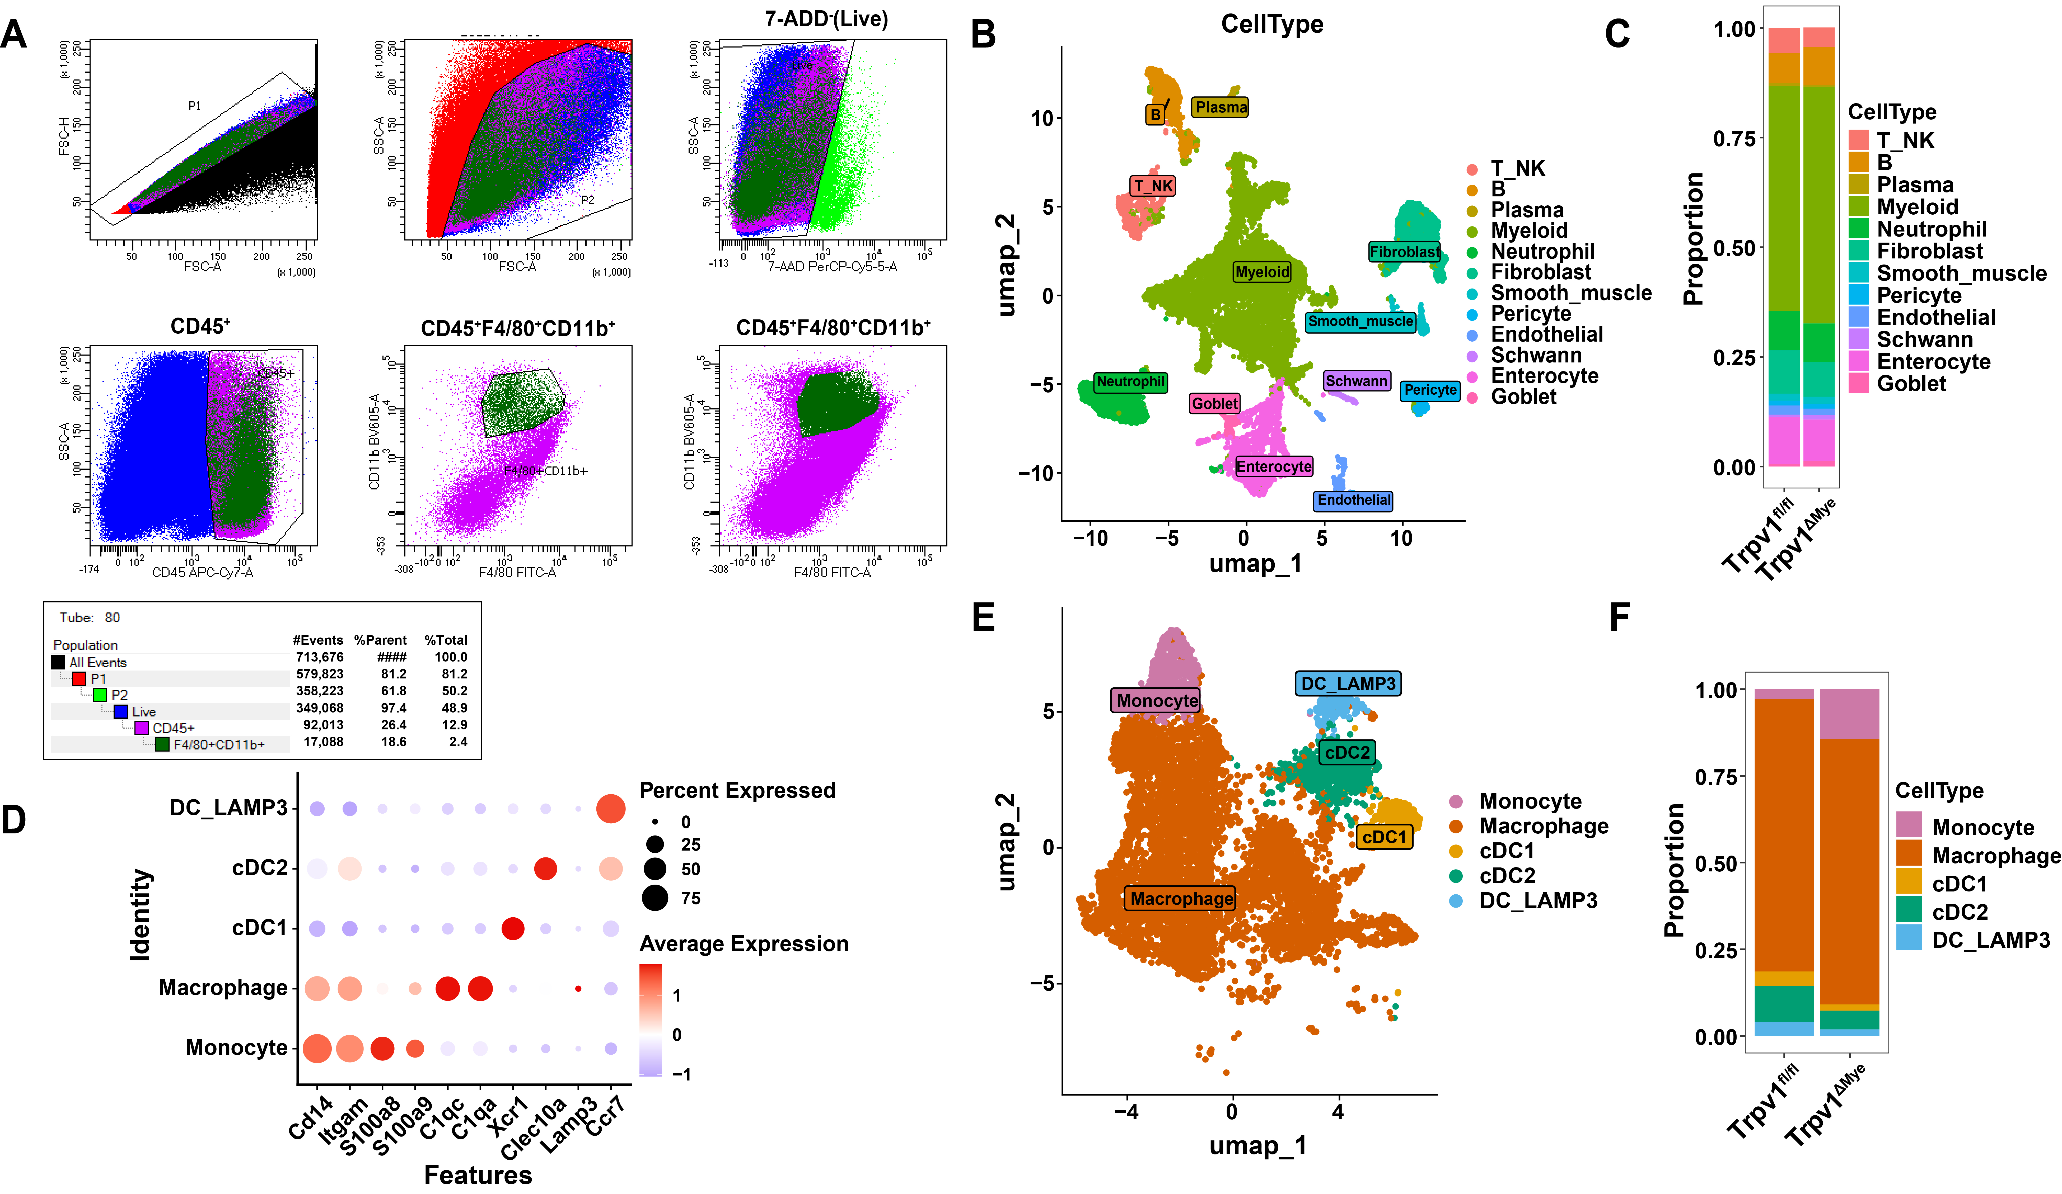
Supplementary Figure 4. Fluorescence-activated cell sorting-Based Isolation of CD45⁺CD11b⁺F4/80⁺ Macrophages from Colonic Tissue.
(A) Flow cytometry gating strategy for CD45⁺F4/80⁺CD11b⁺ macrophages from colonic tissues of Trpv1^{fl/fl} and Trpv1^{∆Mye} mice with chronic experimental colitis induced by long-term HFD exposure, n = 9 mice per group (biological replicates). (B, C) UMAP and graph visualization of colonic CD45⁺CD11b⁺F4/80⁺ macrophages, revealing 12 distinct clusters. (D) Dot plots show representative DEGs between colonic myeloid cells. (E, F) UMAP and graph visualization of colonic myeloid cells, revealing 5 distinct clusters.

