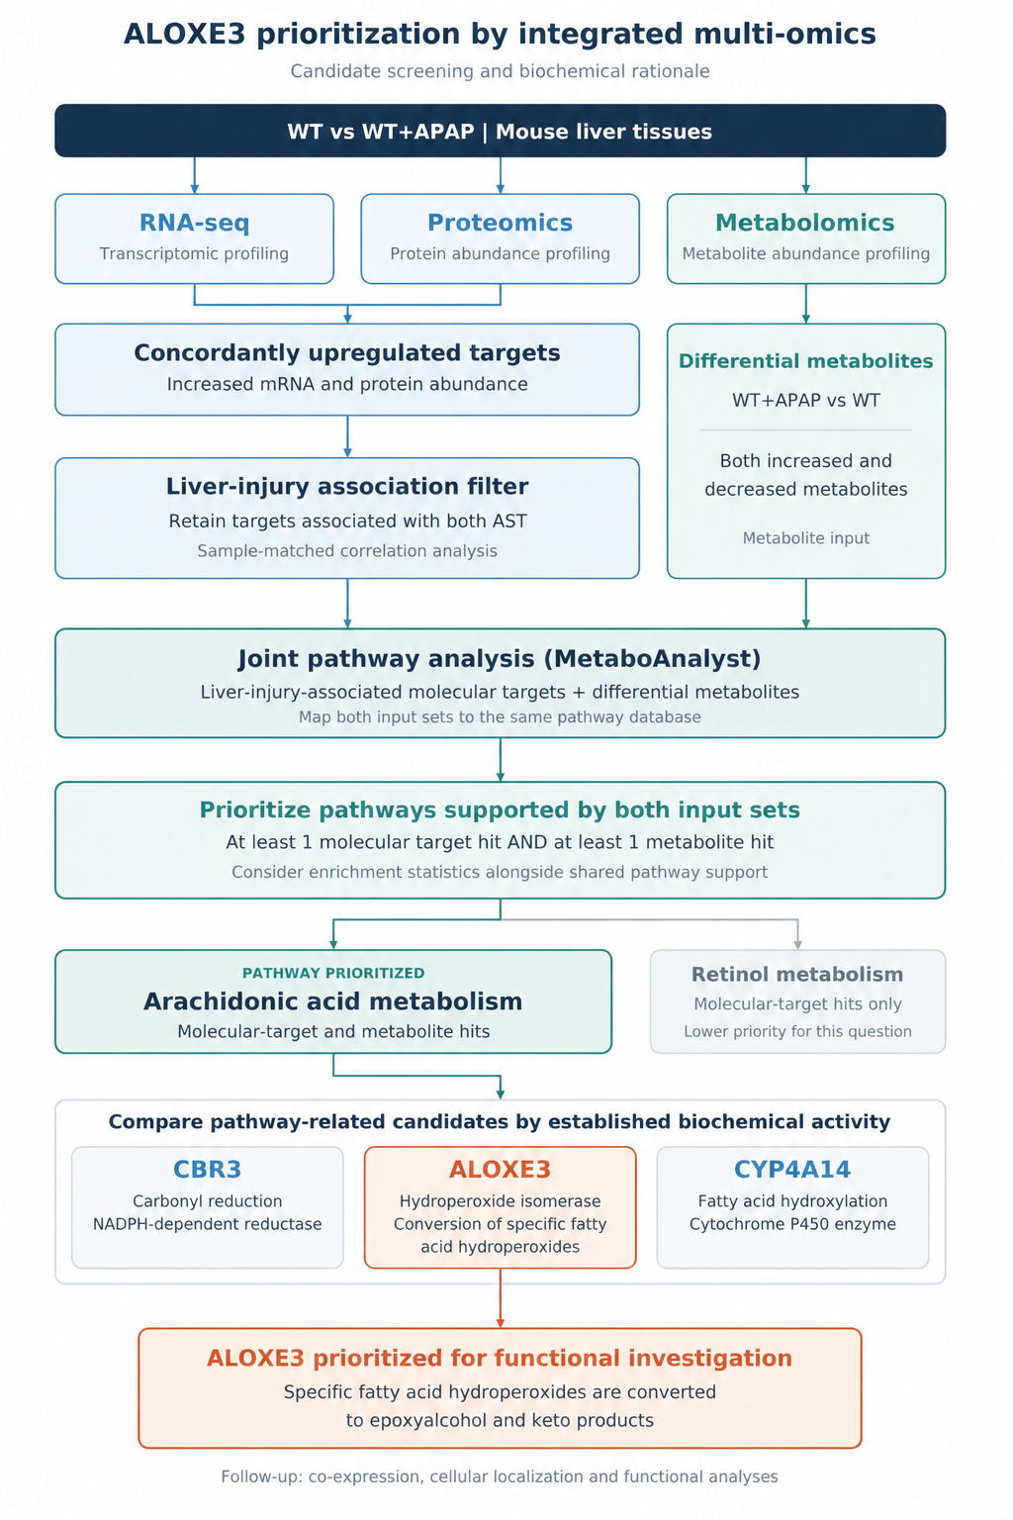
Figure S1. Integrated multi-omics screening and biochemical rationale for prioritizing ALOXE3.
Transcriptomic, proteomic, and metabolomic profiles were compared between control (WT) and APAP-treated (WT+APAP) mouse liver tissues. Targets showing concordant upregulation at the mRNA and protein levels were screened for associations with sample-matched serum AST measurements. Differentially abundant metabolites associated with AST were retained as the metabolite input. The resulting molecular targets and metabolites were integrated using MetaboAnalyst joint pathway analysis. Pathways containing at least one mapped molecular target and at least one mapped metabolite were prioritized, with enrichment statistics considered alongside support from both input sets. Arachidonic acid metabolism was selected for further investigation because it contained hits from both inputs, whereas retinol metabolism contained molecular-target hits only. Pathway-related candidates, including CBR3, ALOXE3, and CYP4A14, were subsequently compared according to their established biochemical activities. ALOXE3 was prioritized based on its hydroperoxide isomerase activity, which converts specific fatty acid hydroperoxides into epoxyalcohol and keto products, providing a biochemical rationale for investigating its role in responses to oxidized lipids. Subsequent analyses examined its co-expression context, cellular localization, and functional contribution to APAP-induced liver injury.

Figure S2. Intramodular connectivity, module membership, and AST association of Aloxe3 in the black co-expression module.(A) Intramodular connectivity (kWithin) of the 317 genes in the black module, ordered from highest to lowest. kWithin represents the sum of weighted connections between a gene and the other genes within the same module, excluding self-connections. Aloxe3, highlighted in red, had a kWithin of 67.25 and ranked 39th among the 317 genes (top 12.3%).(B) Correlation between Aloxe3 expression and the black module eigengene across 16 liver samples. Module membership (kME) was calculated as the Pearson correlation coefficient (r = 0.897; raw p = 2.50 × 10⁻⁶; Benjamini–Hochberg-adjusted p = 1.59 × 10⁻⁵).(C) Correlation between Aloxe3 expression and sample-matched serum AST measurements (Pearson r = 0.513; raw p = 0.0422). Gene significance for AST (GS_AST), defined as the absolute Pearson correlation coefficient, was 0.513. This association did not remain significant after correction for multiple testing (Benjamini–Hochberg-adjusted p = 0.366).In panels B and C, each point represents an individual mouse (WT, n = 8; WT+APAP, n = 8); blue and red indicate WT and WT+APAP samples, respectively. Dashed lines indicate fitted linear regression lines. Pearson correlation tests were two-sided, and Benjamini–Hochberg correction was applied across the 317 module genes separately for the module-membership and AST-association analyses.

Figure S3. Validation of AAV-mediated Aloxe3 modulation and quantification of 4-HNE protein adducts.
(A) Densitometric quantification of ALOXE3 protein abundance in bone marrow-derived macrophages (BMDMs) generated from mice receiving Aloxe3-knockdown AAV, Aloxe3-overexpression AAV , or the corresponding negative-control vectors. ALOXE3 signals were normalized to β-actin. (B) Densitometric quantification of 4-hydroxynonenal (4-HNE) protein adduct signals in Aloxe3-knockdown and Aloxe3-overexpressing BMDMs and their respective controls after 24 h of treatment with conditioned medium from APAP-exposed AML-12 cells (APAP-CM). Signals were normalized to β-actin. (C) Representative immunofluorescence images of liver sections from APAP-treated mice receiving the overexpression control vector, Aloxe3-overexpression vector, knockdown control vector, or Aloxe3-knockdown vector, shown from top to bottom. F4/80 (yellow) and ALOXE3 (green) channels are shown separately. Scale bars, 100 μm. (D) Quantification of ALOXE3-associated fluorescence intensity within F4/80-positive regions in the overexpression and knockdown experiments. Values were normalized to the mean of the corresponding negative-control group, which was set to 1. Each point represents one mouse (n = 6 mice per group). Comparisons in (D) were performed using two-sided unpaired Student’s t-tests. Data are presented as mean ± SD. Exact P values are shown for the indicated comparisons.
Figure S4. Exploratory ALOXE3 and GPX3 expression analyses in human liver datasets of APAP-induced liver injury.
(A) Correlation between ALOXE3 and GPX3 expression across three APAP-induced ALF samples and two healthy controls combined. (B) ALOXE3 and GPX3 expression in clinical APAP-induced ALF liver tissues and healthy controls. (C–D) Spatial mapping of macrophage-associated markers and identification of macrophage-enriched spots using a marker-based score threshold of >0.85 in GSE223559. (E) Spatial maps of ALOXE3 and GPX3 expression in relation to CYP2E1 expression. These exploratory analyses describe expression patterns and do not establish cell-specific protection or a functional relationship between ALOXE3 and GPX3.

